Content
- Scope
- Definitions and abbreviations
- Personnel qualifications
3.1 Medical fitness
3.2 Education and training
- Procedure
4.1 Principle
4.2 Samples
4.3 Equipment and materials
4.4 Reagents and solutions
4.5 Detailed instructions for use
4.6 Reading and recording
4.7 Quality control and maintenance
4.8 Waste management
- Related documents
Annex 1. Microscope components
Annex 2. Maintenance logbook

 | Compiled by |  | Examined by | Approved by | Replaced | New version
Name |  |  |  |  | Code: | Code:
Date
Signature
Laboratory area: |  | No of copies: |  | Reason for change:

- Scope
This SOP describes the optimal operation of a light microscope through regular servicing and preventive maintenance.
- Definitions and abbreviations
microscope magnification
Individual objective magnification x eyepiece magnification.
NA: not applicable
- Personnel qualifications
- Medical fitness
In accordance with national laws and practices, arrangements should be made for appropriate health surveillance of TB laboratory workers:
- before enrolment in the TB laboratory;
- at regular intervals thereafter, annually or bi-annually;
- after any biohazard incident;
- at the onset of TB symptoms.
Ideally, individual medical records shall be kept for up to 10 years following the end of occupational exposure.
Laboratory workers should be educated about the symptoms of TB and provided with ready access to free medical care if symptoms arise.
Confidential HIV counselling and testing should be offered to laboratory workers. Options for reassignment of HIV-positive or immuno-suppressed individuals away from the high-risk areas of the TB laboratory should be considered.
All cases of disease or death identified in accordance with national laws and/or practice as resulting from occupational exposure to biological agents shall be notified to the competent authority.
- Education and training
Education and training must be given on the following topics:
- potential risks to health (symptoms of TB disease and transmission);
- precautions to be taken to minimize aerosol formation and prevent exposure;
- hygiene requirements;
- wearing and use of protective equipment and clothing;
- handling of potentially infectious materials;
- laboratory design, including airflow conditions;
- prevention of incidents and steps to be taken by workers in the case of incidents (biohazard incidents, chemical, electrical and fire hazards);
- good laboratory practice;
- organization of work flow;
- use of equipment (operation, identification of malfunctions, maintenance).

The training shall be:
- given before a staff member takes up his/her post;
- strictly supervised;
- adapted to take account of new or changed conditions; and
- repeated periodically, preferably every year.
- Procedure
4.1 Principle
The light microscope is a precision instrument intended for microscopic detection of tubercle bacilli in specimens in the routine diagnostic TB laboratory (see Annex 1).
4.2 Samples
NA
4.3 Equipment and materials
- A binocular microscope (except for small-volume use in places where there is no electricity; in these cases a good monocular microscope may perform better).

Install the microscope on a rigid, flat, level surface.
Do not place the microscope where it could be exposed to direct sunlight, dust, vibration (e.g. from centrifuges), water (sink, spray from a tap), chemical reagents, or humidity.
If the microscope is to be used every day, try to keep it in the same place in the laboratory. In humid climates, however, where fungal growth is likely, the microscope is best kept overnight in a light box or cabinet equipped with a 20 W light bulb. Alternatively antifungal strips are obtainable from the manufacturers of some microscopes; replace strips every 18–24 months, according to the manufacturer’s recommendations. Silica gel desiccant may be used instead of an antifungal strip. Silica gel is blue when dry but turns pink when wet. Regenerate the gel by heating until it turns blue again.
- Lens paper, muslin or silk cloth, or fine-quality toilet paper to clean lenses without scratching.
- Plastic microscope cover. An intact cover is required in dusty areas and whenever the microscope is not in use.
- Storage cabinet or light box, for humid climates. The cabinet should have holes to permit circulation of air and should be fitted with a 20-W light bulb.

4.4 Reagents and solutions
- Synthetic, high-grade immersion oil, of medium viscosity and with a refractive index >1.5. Do not use cedarwood oil as it dries onto the oil immersion objective lens and will rapidly spoil the optical quality. Any dilution with xylene or other organic solvents is absolutely forbidden since it will very quickly spoil the oil immersion objective.
- Cleaning fluid as recommended by the manufacturer, or an 80:20 mixture of ethylether and alcohol, or 70% ethanol.
4.5 Detailed instructions for use
See SOP on Ziehl-Neelsen microscopy
4.6 Reading and recording
NA
4.7 Quality control and maintenance
4.7.1 Daily maintenance
The modern light microscope needs no particular maintenance, but considerable care is required in its use, regular cleaning, and protection from dust, sand and fungus.
- Each day before use, check for broken or damaged parts and ensure that the lenses, mirrors and other light-conducting surfaces are clean.
Check the lenses for dirt or grit; they may easily becomes scratched if they are wiped without first blowing away dust and small sand particles. First blow the lens clean, using a blower brush if available, then clean the lenses with clean, dry lens paper (or suitable equivalent). If this does not produce a clear image, try again using the cleaning fluid provided by the manufacturer, or 80/20 ethylether/alcohol or 70% alcohol on the lens paper (or suitable equivalent).
It is best not to remove eyepieces or objectives from their fixation holes but to clean only their external surfaces as needed. For proper cleaning of its lower lens, the condenser may have to be removed from its fixing. When replacing the condenser, ensure that slides moving over it cannot scratch its upper surface with the condenser in the uppermost position.
- At the end of each day, use lens paper (or suitable equivalent ) to carefully remove immersion oil from the 100x lens.
In humid climates, put the microscope into a light box or closed cabinet overnight to minimize fungal growth. If the microscope is stored in this way, do not place the plastic cover over it. About 250 g of silica gel should be placed in a dish in the bottom of the box to absorb humidity.
If the microscope is not stored in a box, cover it completely with a suitable plastic cover.
    - Monthly maintenance
Blow dust off the lenses, using a blower brush if available, before cleaning them. Then apply cleaning fluid (not xylene) to the lens paper (or suitable equivalent) and clean the lenses.
Remove the slide holder from the mechanical stage and clean it in the same way.
Wipe dust off the body of the microscope with soft tissue paper moistened with water.
Record maintenance in the logbook (Annex 2).

4.7.3 Quarterly maintenance
In climates with relative humidity in excess of 70% for more than just a few weeks a year, fungal growth may damage the microscope. Fungal growth occurs almost exclusively on the prisms in the binocular tube, causing haziness and then dimness, and finally obscuring the view completely. Check the microscope for fungal growth from time to time and whenever the view gets hazy. With the light on and the 10x objective in place, fungal growth can be seen easily by removing the eyepieces and looking into the binocular tube.
Fungal growth is best removed by a trained person. The binocular tube must be opened but the prisms must remain exactly as fixed by the factory: taking them out would destroy the microscope.
4.7.4 Troubleshooting
It may be possible to repair a faulty microscope by replacing easily removable parts (objectives, eyepieces, light bulbs, fuses); if this does not work, the microscope should be entrusted to a competent person for repair. Never attempt to dismantle any part of the microscope for repair.
Record troubleshooting and corrective action in the logbook (Annex 2).
It is equally important to make sure that holes for the eyepieces and objectives are never left open for more than a few minutes. If a lens is missing lens, close the fixation hole using the plug provided or by sticking adhesive tape over it, otherwise dust will enter and cause haziness of the remaining objectives.
Problem: the viewing field is too dim
Likely cause Solution
Condenser is too low Raise condenser to correct its position
Condenser iris diaphragm is closed Open diaphragm properly
Problem: there are dark shadows in the field that move as you turn the eyepiece
Likely cause Solution
Surface of eyepiece is scratched Replace the eyepiece
Eyepiece is dirty Clean the eyepiece
Problem: the image with the high power objective is not clear
Likely cause Solution
Slide is upside down Turn the slide over
There is an air bubble in the oil Move 100x lens quickly from side to side
There is dirt on the objective Clean the lens
The oil is too sticky Use thinner immersion oil (or the specified oil)
Problem: the image with the low-power objective is not clear
Likely cause Solution
There is oil on the lens Clean the lens
There is a layer of dust on the upper Clean the lens
surface of the objective

Problem: the viewing field is still dim and cloudy
Consider the following possible causes:
- Massive growth of fungus on the lenses or prisms due to storage in a high-humidity environment.
- Penetration of immersion oil between the lenses of the objective because of damaged lens cement (the result of using poor-quality oil such as cedarwood oil or of the misuse of xylene). This is almost certainly the cause if a completely hazy field becomes clear after changing the objective.
- A damaged objective (as a result of careless focusing, dropping, rough changing of slides).
  - Waste management
NA
- Related documents
Manufacturer’s manual, specific to each microscope
Basics of quality assurance for intermediate and peripheral laboratories, 2nd ed. Cairo, WHO Regional Office for the Eastern Mediterranean, 2002.
Kent PT, Kubica GP. Public health mycobacteriology: a guide for the level III laboratory. Atlanta, GA, United States Department of Health and Human Services, Centers for Disease Control, 1985.
Laboratory services in tuberculosis control. Part II: Microscopy. Geneva, World Health Organization, 1998 (WHO/TB/98.258).
Lumb R, Bastian I. Laboratory diagnosis of tuberculosis by sputum microscopy. Adelaide, Institute of Medical and Veterinary Science, 2005.
Maintenance and repair of laboratory, diagnostic imaging and hospital equipment. Geneva, World Health Organization, 1994.
Maintenance manual for laboratory equipment, 2nd ed. Geneva, World Health Organization, 2008 (available at www.who.int/entity/diagnostics_laboratory/documents/guidance/guidance2/en/)
Manual of basic techniques for a health laboratory, 2nd ed. Geneva, World Health Organization, 2003.
Rieder HL et al. Priorities for tuberculosis bacteriology services in low-income countries, 2nd ed. Paris, International Union Against Tuberculosis and Lung Disease, 2007.
http://wwwn.cdc.gov/dls/ila/acidfasttraining/
Annex 1. Microscope components

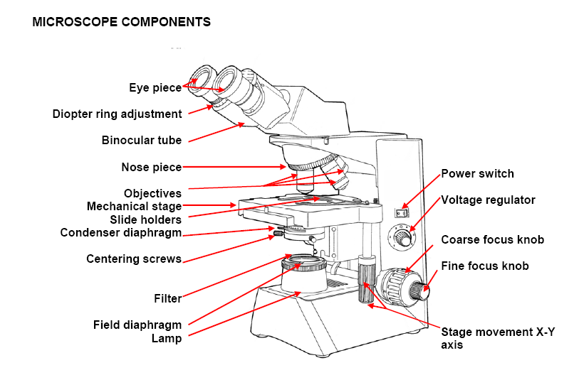

Annex 2. Maintenance logbook

ITEM IDENTIFICATION
Equipment: MICROSCOPE | Brand name:
Purchase date: | Model/type:
Location within the laboratory: | Serial no.
Warranty expiry date:
Manufacturer: |  | Tel:
Address:.
Contact person:
Technical service representative: |  | Tel:

PERIODICITY:
Date | Maintenance operation | Operator

FAILURE EVENTS
Date | Event | Corrective action taken | Operator

