**ALERE DETERMINE TB LAM Ag ASSAY FOR DETECTION OF MYCOBACTERIUM TUBERCULOSIS COMPLEX**

|  |  |  |  |
| --- | --- | --- | --- |
| **Country:** | **Department/ Division:** | | **Unit/ Team:** |
| **Document Number:** | **Version Number:** | | **Effective Date:** |
| **Reviewed by (name, signature, and date):** | | **Approved by (names, signatures, and dates):** | |
|  | |

1. PRINCIPLE

Early diagnosis and treatment of active tuberculosis (TB) in HIV-positive patients can be challenging. Lipoarabinomannan (LAM) is a cell wall component of mycobacteria which, when released from metabolically active or degrading bacterial cells during active TB infection, passes via the kidneys into the urine and can be detected. Tests based on LAM antigen in urine have emerged as potential point-of-care tests for TB in select HIV populations. Urine-based testing has advantages over sputum-based testing, including ease of collection and storage, along with lacking the infection control risks associated with collecting sputum.

The World Health Organization (WHO) first endorsed the use of the urine LAM assay in select HIV-positive patient populations in 2015, and updated guidance in 2019. Urinary LAM assays show significant sensitivity increases in patients with lower CD4 cell counts and are therefore not suitable as diagnostic tests for TB in all populations.

The TB LAM Ag assay is a lateral flow immunochromatographic test for the qualitative detection of lipoarabinomannan (LAM) antigen of mycobacteria in human urine, employing highly purified antibodies specific to the major polysaccharide antigen of LAM. These antibodies are used for both the capture as well as the detection tracer. Capture antibodies are adsorbed onto the test strip’s nitrocellulose membrane and the detection antibody is labeled by conjugation to colloidal gold particles.

The test is a rapid, low-cost assay performed manually by applying 60 μL of urine to the test strip and incubating at room temperature for 25 minutes. The colloidal gold conjugated antibodies attach to the LAM antigen and are released by the specimen from the conjugate pad. This immunological complex is then captured by anti LAM antibodies immobilized on the nitrocellulose membrane and made visible due to the presence of the colloidal gold label. The strip is inspected visually for the appearance of any visible bands. A positive result (a visible purple/gray line) indicates that LAM antigen of mycobacteria is present in the sample at or above the detection limit of the test; whereas a negative result (no visible purple/gray line) indicates it is not present or below detection limit. The intensity of any band is graded by comparing it with the intensities of the bands on a manufacturer-supplied reference scale card. The test also include an internal quality control test to ensure assay validity.

1. ABBREVIATIONS AND DEFINITIONS

LAM Lipoarabinomannan

LF Lateral flow

POC Point of care

QC Quality control

TB Tuberculosis

WHO World Health Organization

1. EQUIPMENT, MATERIALS AND REAGENTS

|  |  |  |
| --- | --- | --- |
| EQUIPMENT | MATERIALS | REAGENTS |
| Timer | Pipette capable of accurately delivering 60 μL; disposable pipette tips. | Alere TB LAM Ag test kit |
| Refrigerator, 2-80C | Permanent marker pens | Tuberculocidal disinfectant |
| Freezer, -200C or colder | Disposable gloves; coat/apron |  |
|  | Disposable biohazard bags |  |
|  | Sharps discard container |  |

1. SPECIMENS
2. Urine

* Morning urine specimen is ideal.
* Prior to collection, wash/dry hands, and clean the urogenital area well with a towelette.
* Collect midstream urine in a clean standard urine collection cup.
* Transport and store urine at 2-80C whenever possible.
* Urine specimens may be stored at 2-80C for up to three days before testing.
* If testing is delayed longer than 3 days, freeze urine at -200C or colder.

1. Do not test any other clinical samples – only urine is approved for testing with this system.
2. QUALITY CONTROL
3. Record each new lot number and new shipment of LAM kits and store at 2-300C until expiration date.
4. Perform quality control (QC) on each new lot number and shipment of LF-LAM Assay kits received and record QC results on LF-LAM Urine Assay Kit QC Record**.** Ensure results are as expected before placing new lots into use.
5. Leftover urine samples with 4+ positive LAM results can be aliquoted into small cryotubes and frozen (≤-200C ) for use as positive control samples.
6. Thaw one of the frozen aliquots and run QC for LAM test weekly or with each patient batch.
7. Use sterile saline or distilled water as a negative QC control.
8. Prior to each use, check reagents for expiration date and physical appearance. Do not use expired materials. Do not use materials that show signs of deterioration.
9. With each patient test, ensure the internal procedural control validates proper reagent function. If the control bar does not turn purple/gray by the end of assay completion, the test result is invalid, and the sample must be retested before reporting results. Record internal quality control results in the LAM result logbook.
10. SAFETY PRECAUTIONS
11. Wear protective disposable gloves, laboratory coats and other PPE appropriate for handling specimens and reagents. Refer to the Safety Manual for the proper use of PPEs.
12. Since LF-LAM is considered a POC test, it does not necessarily require testing in a BSL-3 lab; however, it is up to the individual facility to decide what biosafety level will be used for this testing.
13. Wash hands thoroughly after handling specimens and test reagents.
14. Treat all biological specimens, including used test cards, as possible infectious agents, following laboratory guidelines for universal precautions.
15. Follow laboratory’s environmental waste guidelines on proper disposal of used cards and urine specimens.
16. Use an appropriate tuberculocidal disinfectant to wipe minor spills. Paper towels soaked in freshly prepared 10% bleach can be used, followed with 70% alcohol or water wipe.
17. After work is completed, surface decontaminate all items and equipment, then clean work area with a tuberculocidal disinfectant. Follow the SOP for cleaning and waste disposal.
18. Always comply with the laboratory’s general safety precautions. Refer to the Safety Manual.
19. PROCEDURE – STEP BY STEP
    1. Work preparation
20. Determine how many samples are to be run and remove the desired number of test units from the 10-test card by bending and tearing at the perforation.
21. Start test removal from the right side of the test card, in order to preserve the lot number appearing on the left side of the card.
22. Immediately reseal all unused tests in the foil pouch containing the desiccant by pressing seal from end to end to close.
    1. Preparation of Samples
23. Wear appropriate PPE per laboratory’s safety manual guidelines.
24. Disinfect work area following routine laboratory procedures.
25. Remove refrigerated urine and bring to room temperature one hour prior to use.
26. For frozen urine samples:
27. Thaw urine specimen.
28. Centrifuge at 10,000 x g for 5 minutes at room temperature.
29. Carefully collect the clear supernatant to use for the test sample.
    1. Testing Procedure
30. Assemble test cards and label each with the applicable laboratory number.
31. Remove the protective foil cover from each test.

**Note:**  Initiate the assay within 2 hours after removing the protective foil cover from each test.

1. Pipette 60 µL of urine sample onto the white sample pad area.

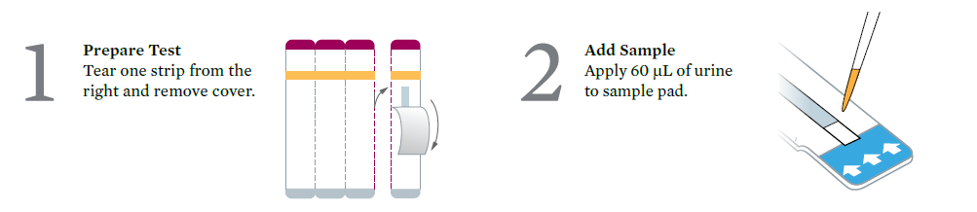

1. Set timer for 25 minutes.
2. Interpret result between 25 and 35 minutes after sample application.
3. Visualize the strip under standard indoor lighting conditions or in the shade. Do not visualize the strip under direct sun light.
4. **Do not** read result beyond 35 minutes.
5. INTERPRETATION OF RESULTS
6. To assist with results reading and interpretation, use the Reference Scale Card, provided in the test kit, by holding it alongside the patient window.

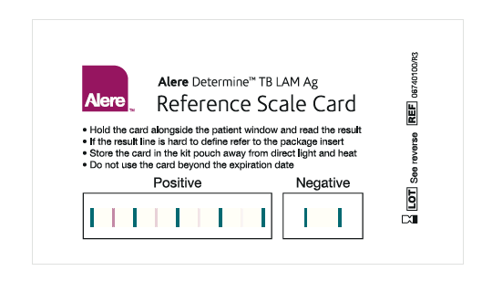

1. LAM antigen positive:
2. Purple/gray bars appear in both the control window and the patient window of the strip. The test is positive **only** if the color intensity of the “Patient” bar is equal to, or stronger than, any of the colored bars in the “Positive” range on the Reference Scale Card.

*Note: The test result is positive even if the patient bar appears lighter or darker than the control bar.*

1. LAM antigen negative:
2. One purple/gray bar appears in the control window of the strip and no purple/gray bar appears in the patient window of the strip.
3. Invalid test:
4. No purple/gray bar appears in the control window of the strip, whether or not a purple/gray bar appears in the patient window of the strip.
5. Result is invalid – repeat test.
6. Equivocal/Indeterminate test:
7. One purple/gray bar appears in the control window of the strip with unclear or incomplete purple/gray bar in the patient window; or
8. The color intensity of the bar in the patient window is less than Grade 1 on the Reference Scale Card.
9. Repeat the test or alternatively, collect a new urine sample from the patient the following morning and retest.

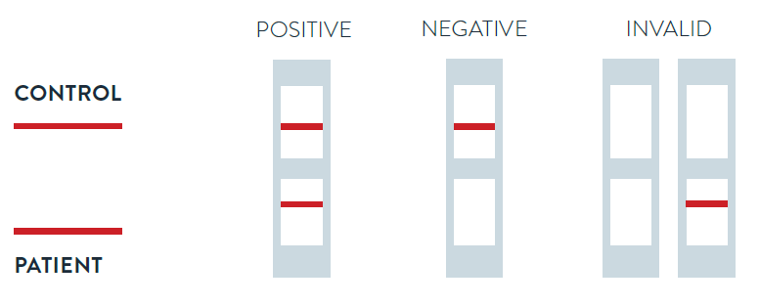

1. REPORTING
2. Release reports as soon as results are ready.
3. Report mycobacterial LAM detected or mycobacterial LAM not detected.
4. Report results as invalid or equivocal/indeterminate and repeat test per laboratory policy, requesting a new specimen as applicable.
5. Report results on the applicable specimen worksheet, results register and/or in LIMS.
6. PROCEDURAL NOTES
7. Proper use and storage of test cards are critical:
8. Store the test kits at 2°C–30°C.
9. Do not use reagents that have passed the expiration date.
10. Do not open test cards until ready to perform testing.
11. Use the test card within 2 hours after removing the protective foil cover.
12. Do not use materials that have become wet or if the packaging has become damaged.
13. Reliable results are dependent on proper specimen collection, handling, and storage. Erroneous test results might occur from improper specimen collection, failure to follow the recommended sample collection procedure, handling, or storage.
14. Avoid repeated freeze/thaw cycles of urine specimens. Specimens that have been frozen and thawed more than 3 times cannot be used. Preferably store specimen in non-self-defrosting freezers.
15. This antigen test does not differentiate between the various species of Mycobacterium, such as *M. tuberculosis, M. leprae,* and *M. avium.* In an area endemic for tuberculosis, the LAM antigen detected in a clinical sample is likely to be attributed to *M. tuberculosis.*
16. The intensity of the patient bar result does not necessarily correlate to the bacterial burden.
17. WASTE MANAGEMENT
18. At the end of each day, place all contaminated material (used urine container, test cards, etc.) in a biohazard bag and autoclave or incinerate daily, following the hospital/laboratory waste management system.
19. Keep the bag in a safe, closed bin, or large bucket until disposal.
20. RELATED DOCUMENTS
21. SOP on Collection and Transport of Specimens
22. Laboratory’s Safety Manual
23. Laboratory’s SOP on Quality Control
24. REFERENCES
25. Alere Determine TB LAM Ag. Package insert. IN02740004 Rev. 08 2019/03. Scarborough, ME, 2019.
26. Medecins Sans Frontieres - OCP. TB LAM Ag [Alere] SOP. Paris, France, 2017.
27. Michelle A. Bulterys, et. al. “Point-of-Care Urine LAM Tests for Tuberculosis Diagnosis: A Status Update.” *Journal of Clinical Medicine*. 2020, 9(1), 111.
28. Phindile Gina, et al. “Early morning urine collection to improve urinary lateral flow LAM assay sensitivity in hospitalized patients with HIV-TB co-infection.” *BMC Infectious Diseases.* May 2017, 17:339.
29. Stephen D. Lawn, et. al. “Diagnostic accuracy of a low-cost, urine antigen, point-of-care screening assay for HIV-associated pulmonary tuberculosis before antiretroviral therapy: a descriptive study.” *Lancet Infectious Diseases*. 2012 Mar; 12(3): 201–209.
30. Versalovic, J., Carroll, K., Funke, G., Jorgensen, J., Landry, M.L., Warnock, David. Manual of Clinical Microbiology. 10th edition. 2011. American Society for Microbiology, Washington D.C. U.S.A.
31. World Health Organization. Lateral Flow Urine Lipoarabinomannan Assay (LF-LAM) for the Diagnosis of Active Tuberculosis in People Living with HIV. Policy Update. WHO, 2019.
32. APPENDICES
33. Mentor4TB Toolkit FORM 11. LF-LAM Urine Assay Kit QC Record – New Lot/ New Shipment
34. Mentor4TB Toolkit INFO 7. LF-LAM Urine Testing Job Aid (may be attached to this SOP)