
Doc: 2.09- 0.1
Geneva, Switzerland
5 November 2009

Dear Colleagues and Friends,

Welcome to Geneva!

I am delighted that you are able to join us in Geneva for the 17th Stop TB Partnership Coordinating Board Meeting. I hope that your flight and arrival in Geneva went smoothly. I look forward to successful and focused two day meeting!

This letter contains practical information to help make your stay more enjoyable and our meetings more productive.

Stop TB Partnership Coordinating Board Meeting venue:

INTERNATIONAL LABOUR ORGANIZATION (ILO)
SALLE VII
4 ROUTE DES MORILLONS, CH-1211 GENEVA 22
SWITZERLAND
Website: http://www.ilo.org

Stop TB Partnership Coordinating Board Meeting Schedule:

Thursday 5 November 2009:

- 08.00 Registration Opens at ILO
- 09.00 Board meeting convened in Salle VII of the ILO
- 12.30 Lunch at the ILO restaurant; the Kochon Committee will also meet in at the ILO restaurant in a separate space between 12.30 and 14.00
- 18.30 Board Meeting adjourned
- 18.30 Cocktail reception at the ILO restaurant

Friday 6 November 2009-09-29

- 08.30 Board meeting re-convened in Salle VII of the ILO
- 12.30 Lunch at the ILO restaurant; a group of CB members will participate in a lunchtime seminar with Heads of WHO Country Offices (WHO HQ, Salle C)
- 18.00 Board Meeting adjourned

With my warmest regards,

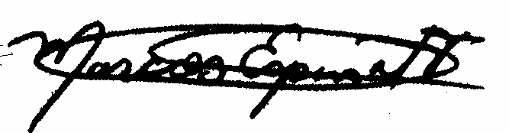
Marcos Espinal
Executive Secretary

If you need assistance during your stay, Stop TB Partnership personnel and Secretariat staff will be available to help.

For any additional assistance, please do feel free to get in touch with:
- Alan Esser |  | essera@who.int
- Louise Baker | +41 79 249 3519 (mobile) bakerl@who.int
- Winnie de Guzman | +41 22 791 4937 deguzman@who.int

