Guidance for countries
on the
preparation and implementation
of TB laboratory
standard operating procedures
(SOPs)

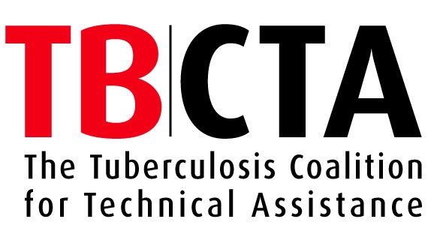

Contents
Preface
Acknowledgements
Scope and content

Section I. Guidance for countries
Introduction
Procedures for developing and implementing country-specific Standard Operating Procedures
Initial steps
Preparation and implementation of an approved national written SOP document
Protocol A – For countries with no written TB laboratory SOPs
Protocol B – For countries with written SOPs available
Section II. Generic TB laboratory Standard Operating Procedures

Preface
Tuberculosis (TB) is a major public health problem worldwide. The epidemiological changes of the past two decades, together with the HIV/AIDS pandemic and the increase in drug resistance, have tended to obscure the global TB burden. Despite the existence of long-established national TB control programmes and the general availability of DOTS – the internationally recommended strategy for TB control – the 2005 WHO targets of detecting 70% of new sputum smear-positive cases and successfully treating 85% of these cases have not yet been met by many countries. In 2006 the global case-detection rate was still only 62%.
Laboratory services play a pivotal role in global TB control. As highlighted in the WHO Stop TB Strategy, launched in 2006, quality-assured bacteriological diagnosis is vital for DOTS expansion and control of drug resistance. By responding quickly and providing quality services, laboratories enable the early diagnosis of tuberculosis facilitating appropriate treatment and minimizing the risk of transmission and disease-related complications, including death. A network of laboratories that perform consistently well is crucial for the proper functioning and performance of each TB control programme, yet the laboratories are often neglected components of these programmes.
Unsatisfactory performance of TB laboratory services is attributed to a combination of managerial and technical factors. Deficiencies in the quality assurance system for sputum microscopy, culture and drug susceptibility testing (DST) are some of the most frequent weaknesses. In addition to improving sputum smear microscopy, there is a need to build and strengthen capacity to perform culture and DST especially in areas with high rates of drug-resistant TB or a high burden of AFB smear-negative TB associated with HIV infection.
One of the mandates of the Global Laboratory Initiative (GLI) is to guide and coordinate the scaling-up of TB laboratory services. In order to assist the GLI in this, the Tuberculosis Control Assistance Project (TBCAP) partners have developed these generic TB Laboratory Standard Operating Procedures (SOPs), covering all the techniques that are needed to comply with the WHO Stop TB Strategy. Development and implementation of SOPs are key steps in realizing quality-assured TB laboratory services that provide reliable microscopy, culture and DST services.
This document also contains guidance to assist countries in either preparing their own SOPs or adapting the generic SOPs to their own particular situations. Use of approved SOPs will enable the laboratories in each country to work to the same standards and levels of reliability.
Acknowledgements
The document was developed by:
- V. Vincent, A. van Deun, K. Feldmann, L. Barrera, C.N. Paramasivan, K. Weyer, C. Mundy and G. Kahenya
with contributions from:
- M. Abdel Aziz, I. Bastian, F. Boulahbal, D. Cirillo, A. Fujiki, C. Gilpin, A. Gumusboga, K. Jost, I. Kantor, S.J. Kim, A. Laszlo, S. Labelle, R. Lumb, F. Piana, J. Ridderhof, L. Rigouts, N. Selvakumar, M. Shulgina, R. Urbanczik and S. van Beers
As part of the development process, the Standard Operating Procedures were piloted in Lesotho and Nepal. We gratefully acknowledge the valuable contributions of:
- L.B. Maama, Lesotho NTP manager, K. Kao, Director Laboratory Services, Lesotho Ministry of Health, D: Mothabeng, manager of the Lesotho Central TB laboratory, and M. Mareka, G. Kubendiran, L Marai and the team of the Central TB laboratory, Queen Elisabeth II Hospital, Maseru, Lesotho.
and:
- P. Malla, Nepal NTP manager, R. Bhandari, Head of the Laboratory of the Nepal National TB Centre, the team of the Nepal National TB Centre Laboratory, the Nepal SOP writing and piloting team, the directors and heads of laboratories of the Bir Hospital, Patan Hospital and Bhaktapur Hospital and their teams

“The Global Health Bureau, Office of Health, Infectious Disease and Nutrition (HIDN), US Agency for International Development, financially supports this document through TB CAP under the terms of Agreement No.GHS-A-00-05-00019-00.”

Scope and content
This document is divided into two sections:
- Section I
Section I provides guidance for countries on how to use and adapt the generic Standard Operating Procedures (SOPs) for local use. Although technical specifications (such as reagent grade, temperature, time of treatment/ incubation, etc.) cannot be modified, SOPs need to be adapted by individual countries to take account of the local infrastructure, human resources, facilities and available budget. Translation into national languages is also essential.
- Section II
Section II contains generic SOPs, which cover relevant technical procedures for microscopy, culture and drug susceptibility testing (DST) of Mycobacterium tuberculosis. Each SOP provides detailed instructions for quality-assured procedures. The technical procedures described are internationally accepted methods.
Each SOP follows the following format:
- Scope
- Definitions and abbreviations
- Personnel qualifications
3.1 Medical fitness
3.2 Education and training
- Procedure
4.1 Principle
4.2 Samples
4.3 Equipment and materials
4.4 Reagents and solutions
4.5 Detailed instructions
4.6 Reading, interpretation, recording and reporting
4.7 Quality control
4.8 Waste management and other safety precautions
- Related documents
- Rationale for change of SOP version
Each SOP details the staff expertise needed to perform the test procedures. Although the academic qualifications of staff are not specified, as these are likely to differ from country to country, it is essential that all laboratory personnel receive appropriate training – and periodic refresher training – to ensure that they have the necessary skills.
Because laboratory staff are entitled to work in a safe environment, the document contains specific SOPs on safety procedures. To control laboratory-acquired infections, it is important that arrangements are made for medical screening of staff before their employment in the TB laboratory and for access to free medical care if symptoms arise. SOPs therefore address medical fitness and gives recommendations for the medical surveillance of staff. Implementation of SOPs provides an opportunity for countries to organize regular medical surveillance for laboratory workers – a facility that is not in place in many countries at present.
The equipment and materials required for each technical procedure are listed. However, technical specifications for equipment and descriptions of the laboratory layout are beyond the scope of this document and are detailed in a separate publication.
Proper maintenance of equipment is essential for ensuring both personal safety and the quality of test results; this document therefore includes specific SOPs that describe the use and routine maintenance of microscopes, biosafety cabinets and other commonly used equipment.
The document includes examples of different forms that can be adopted by countries for:
- reporting, storing and archiving data in the laboratory,
- equipment maintenance, incident report and remedial action,
- requests for laboratory procedures, and
- transmission of bacteriological data.
However, if a country already has suitable forms for these same purpose, they should be used in preference to the forms included in this publication. Recommended interim formats for TB laboratory recording and reporting have been recently issued and should be checked with a view to adjusting or replacing the forms currently used.
The document lists a small number of reference works to point laboratory staff towards additional information in manuals, handbooks and training materials.
WHO recommends a prioritized and stepwise approach to the implementation of laboratory techniques, with quality-assured microscopy in place before culture. Liquid culture should be considered only when laboratory staff can demonstrate good management of culture on solid media. The sensitivity of the liquid culture technique and its advantages may be spoilt by high contamination rates in unskilled hands. The use of solid and liquid media, employing manual culture methods, is described in the document. The use of commercially available manual or automated liquid methods for purposes of culture and/or DST is not covered and should be referred to in individual manufacturer's instruction manuals. The use of line-probe assays for the detection of multidrug-resistant TB (MDR-TB ) will be addressed in a separate document.

SECTION I
Guidance for countries
on use of this document
in preparing and implementing
TB Laboratory
Standard Operating Procedures

Introduction
Importance and use of SOPs
What are SOPs?
Standard Operating Procedures provide detailed step-by-step instructions for carrying out a laboratory activity in a (bio)safe manner (for the laboratory staff, the community and the environment) and achieving accurate and reliable laboratory results. SOPs are used in the laboratory and written copies should be available (preferably displayed) at the work area or bench. They are important for the standardization of procedures, ensuring that every laboratory at each level of care performs national standard procedures and produces good-quality results.
TB laboratory SOPs:
- provide written standardized techniques for use in the laboratory;
- provide laboratory staff with instruction on how to consistently perform tests to an acceptable standard to ensure conformity in pre-analytical, analytical and post-analysis steps;
- avoid the performance of a test being changed by new staff and avoid shortcuts;
- maintain and improve the quality of TB laboratory services;
- improve the reliability of test results for clinical and epidemiological interpretation;
- promote safe laboratory practice.
This manual aims to provide countries with guidance on the development and revision of SOPs and to enable them to prepare country-specific SOPs, in an internationally acceptable form, appropriate for their local situation.

Features of TB laboratory SOPs
SOPs must be:
- prepared by a team of local laboratory experts;
- equivalent in standard to the generic TB SOPs;
- applicable and achievable in the laboratories in which they will be used;
- user-friendly;
- clearly written and easy to understand and follow;
- kept up to date by regular review and adoption of appropriate technologies.

Procedures for developing and implementing
country-specific SOPs

Figure 1. Process for developing a national SOP document
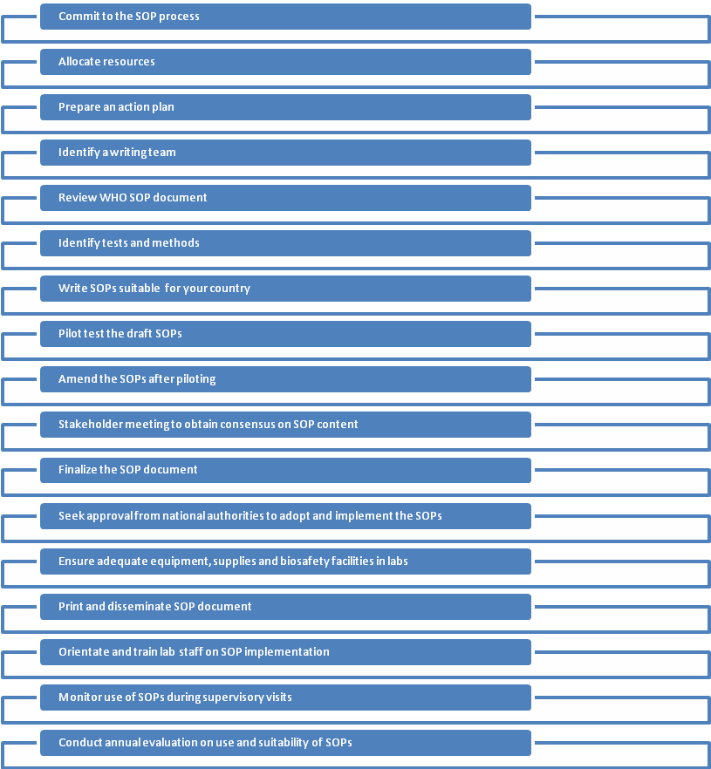

Initial steps
Deciding whether there is a need to develop or update SOPs for the TB diagnostic laboratories
Do we really need to develop SOPs? This is the first question to be asked by either the national TB programme (NTP) or the national laboratory services. In answering this question it is important to understand why SOPs are important and to take into account the current situation in the country concerned.
Review the contents of this SOP document and then ask the following questions:
- Do we have an up-to-date SOP document currently being used by all our laboratories for TB diagnostics tests (microscopy, culture, DST) and required biosafety procedures?
- Or do we have other documents (such as training manuals) that are being used instead of SOPs?
- Does our SOP (or other) document reflect the content of this SOP document?
- Do we need to develop new SOPs?
- Or do we need to modify and update our existing SOPs?
Honest answers to these questions honestly will help to guide the decision on how to proceed.
Ensuring political commitment to develop and use SOPs
Once a decision has been made to either develop TB SOPs or to modify the existing document, there must be commitment to the process. The NTP and the National Reference laboratory (NRL) must jointly recognize the need for and value of having up-to-date SOPs for all TB-related diagnostic tests, must be committed to working together to prepare (or modify as required) SOPs and to ensure that these are disseminated, implemented and adhered to by all laboratory staff.
Allocating resources for developing or modifying SOPs
Once the decision to develop or modify the country’s TB SOPs has been made, sufficient financial and human resources must be allocated for the process. NTPs, in consultation with NRL heads, are responsible for ensuring that the appropriate resources are available to develop and implement the SOPs and for monitoring and evaluation of their use. A dedicated budget, sufficient numbers of laboratory staff with adequate technical training and mechanisms for efficient procurement of laboratory equipment and supplies are essential.
Preparing an action plan
With the decision made and resources committed, prepare an action plan outlining each step in the process, the names of the person(s) responsible for ensuring that each step is completed and a realistic timeline for each step.
An example of an action plan template is shown at the end of Section I together with an example of the action plan used by the NTP in Nepal for their SOP development and piloting.
Preparation and implementation of an approved national written SOP document
This section provides guidance on all the steps involved in preparing and implementing an approved written SOP document.
Countries without any written SOPs should follow Protocol A; countries with (some) written SOPs available follow Protocol B.

Protocol A – for countries with no written TB laboratory SOPs (or in which written SOPs are not available)
Step 1: Writing of SOPs
- Appoint a team of laboratory experts to write the first draft of the laboratory SOPs. Include in this team at least one person from the NTP to ensure that the SOPs are in line with NTP diagnostic protocols and guidelines. The recommended size of the writing team is 4–8 people.
- Review the action plan and orient the writing team on the process for preparing the SOPs, piloting, review, approval and subsequent implementation. Where necessary, amend or update the action plan and ensure that each team member understands his or her roles and responsibilities and is committed to the process.
- Look at the recommended format of the SOPs in this document and then develop your own standard format. Ensure that each SOP contains the information in the table below. Each SOP you write should conform to the format you have chosen.
Section II of this document contains a Master SOP, which provides a model format and details the exact information to be included under each section.
- Identify the tests required for TB diagnosis and monitoring at each level of care according to the country’s basic health care package (or essential laboratory tests at each level of care) and in line with the diagnostic protocols of the NTP for AFB (acid-fast bacilli) microscopy, TB culture and DST services and other new diagnostic tests as and when they become available.
- In line with NTP guidelines and using this document as a reference, prepare a list of methods to be used at each level of care for all TB-related laboratory activities, including sputum smear microscopy, TB culture, DST, identification of mycobacterial isolates, equipment maintenance and biosafety measures.
- Use this document as a guide for developing the draft national SOPs, suitable for the local conditions in your country. Ensure that laboratory quality standards are upheld and that the SOPs are in line with NTP protocols.
Do not copy the SOPs verbatim from this document. Look at the method and write your own SOP, using language and terminology that can easily be understood by the laboratory staff in your country. Ensure that you use the standard SOP format that you have agreed for your country.

- Ensure that everyone in the writing team is in agreement with the content and wording of each SOP.
- Where required, arrange for the completed draft to be translated into the language normally spoken by the laboratory staff who will use the SOPs. A translator will be required for this purpose. However, caution is needed in translating technical terms to ensure that the correct meaning is maintained and that the terms will be understood.
- Print copies of the draft SOPs, in sufficient number for the piloting process described below.

Content of a Standard Operating Procedure
Each SOP must contain the following information as a minimum:
- The name and location of laboratory, the responsible person/laboratory head.
- A descriptive title, identification number (code), no, of version.
- Page number (out of total number of pages of the SOP).
- Date, and name and signature of the person who wrote the SOP, the person who examined it and the person who authorized its release.
- Information on who introduced the new version of the SOP, ensured that all old versions were replaced and informed the staff about this change.
- Scope of the SOP
- Definitions and abbreviations used
- Personnel qualifications (Medical screening and appropriate training of staff able to perform the SOP).
- Procedure, including a short description of the SOP principle; sample details; equipment and materials required; reagents and solutions required; detailed instructions; reading, interpretation, recording and reporting of results; quality control; waste management.
- Related documents and annexes including laboratory forms
Note: SOPs should include all forms for reporting and archiving results, equipment maintenance and all other necessary documentation.

Step 2: Piloting of the draft SOPs
Piloting of the SOPs, in a small number of selected laboratories, is important to ascertain that each of the SOPs that has been written can be understood by local laboratory staff, that the staff are able to follow them, and that all necessary steps and instructions are included and are accurate.
- In consultation with the NTP and the head of laboratory services, appoint external senior TB laboratory experts to act as facilitators for the piloting process.
- Select sites for piloting of the SOPs. For microscopy, 4–6 sites should ideally be selected, which should include some peripheral laboratories or health centres and a range of laboratory staff with various capabilities (technologists, technicians, assistants, microscopists, etc). For culture and DST and other new tests, it may be possible to select only one or two sites to pilot the SOPs.
- The NTP director and/or the head of laboratory services must contact the management of each selected for piloting the SOPs to ascertain both their willingness to participate in the process and the availability of laboratory staff for the pilot.
- Once the management of the health facility has agreed to the pilot, visit the health facility to discuss the process, timetable and arrangements for piloting the SOPs with the management and the laboratory staff.

- As far as possible, no member of the original writing team should be involved in the actual piloting of the SOPs. When a member of the writing team works in a piloting laboratory, ensure that other staff actually conduct the pilot.
- Inspect each laboratory to ensure that the site selected for piloting has adequate safety facilities to carry out the tests in question. On no account must safety be compromised.
- Provide each pilot laboratory with all the necessary equipment, reagents and supplies to carry out the tests for piloting the designated SOPs.
- Ensure that each pilot laboratory has sufficient specimens or samples to process. If not, make arrangements to obtain these from another laboratory.
- The facilitator should ask the staff in each laboratory to read the draft SOPs and to use follow the instructions exactly in performing the test.
- The facilitator should observe but not participate in the piloting tests. Strict observation by the facilitator is important to ascertain whether the laboratory staff are able to understand and follow all the written instructions and achieve a reliable result. Observation will also reveal to the facilitator any of the steps in the SOP that are unclear, erroneous or missing.
- The facilitator should make notes on what he or she observes and should subsequently meet with the laboratory staff to obtain their feedback on the usefulness and user-friendliness of the SOPs.
- Each facilitator should prepare a written report on the exercise, noting positive and negative aspects and providing a list of required modifications to the SOPs.
Step 3: Amendment of the draft SOPs following the piloting process.
- Following the piloting process, the facilitators meet to discuss their findings and recommendations. Ideally, they should consolidate their reports into a single report with clear recommendations on what needs to be changed, modified, corrected or rewritten in the draft SOP document.
- The facilitators should present their final report and recommendations to the writing team with a request that they amend or modify the draft SOPs as needed.
Step 4: Obtaining consensus from key stakeholders
Once the writing team has amended the SOPs, you need to obtain a consensus from the major stakeholders in your country, who will be expected to implement and use the SOPs.

To ensure local ownership, it is vital that a representative cross-section of laboratory staff is involved in this review of the SOPs.

- Select a wide range of laboratory experts from different levels of the health system to take part in a consensus meeting to review the amended draft SOP document.
- Print copies of the amended draft SOP document and the final report of the piloting process and send to each person taking part in the consensus meeting, well in advance of the meeting. Ask them to review the document and prepare written notes on major points to be discussed at the meeting. It is important to stress that they should not be concerned with minor editorial issues, spelling or grammar, which will be dealt with by an editor before the final printing. Rather, they should provide feedback on the content and technical accuracy of the document.
- Engage two external facilitators, who have not been involved in any way in the development or piloting of the SOPs, to manage the consensus meeting.
- Appoint a secretary to record the proceedings and make note of agreed changes to the SOPs.
- At the consensus meeting, review each SOP in turn, ensuring that the views and opinions of each participant are heard.
- Reach a consensus agreement on the content of each SOP.
- The secretary records all the proceedings of the meeting, carefully documenting all decisions made, and presents this to the writing team.
Step 5: Finalizing the SOP document
- After the consensus meeting, the writing team should finalize the draft SOPs, ensuring that all corrections, comments and changes agreed at the meeting have been taken into account.
- Once the draft has been finalized, it should be sent to an editor to check spelling, grammar and formatting before printing.
Step 6: Seeking approval to adopt and implement the SOPs
- Seek approval from the competent national authorities to adopt and implement the SOP document as official and binding. The procedure for this will vary from country to country.
- As part of this approval process, it may be necessary for the NTP or NRL to further amend or adapt the document.
- At the same time, seek agreement on the policy for “Change of SOP” and the time period required for review of SOPs to ensure they are kept up to date.
Step 7: Ensuring adequate equipment, supplies and biosafety facilities to implement the SOPs
- Make a physical check of biosafety facilities in every laboratory and ensure that necessary modifications or improvements are made before introducing any new tests or implementing the SOPs.
- Use the SOP document to identify the essential equipment, reagents and other consumables required at each level of health care for carrying out the agreed test procedures. Prepare lists of essential equipment, reagents and supplies that can be used by the medical stores (or other body responsible for equipment and supplies) for procurement purposes.
- Provide the medical stores (or other body responsible for equipment and supplies) with the technical specifications for each item of capital equipment and for each reagent and consumable. This is essential information required by those responsible for tendering, procurement and ordering from suppliers.
- Assess the availability and status of appropriate equipment and quality reagents in the country. Identify gaps in equipment and supply provision and arrange for ordering and distribution to the laboratories.

Laboratories should not be expected to start implementing SOPs until they have the required biosafety facilities and have received all the necessary items of equipment and supplies.
Step 8: Dissemination and implementation of the SOPs
- Print sufficient copies of the SOPs for all laboratories expected to use them and distribute the copies.
- Arrange site visits or orientation meetings for the laboratory staff on the use of the new SOPs in their workplace and the process and timetable for implementation.
- Where necessary, plan, budget and arrange for technical training of laboratory staff in new or updated test methods. This can be done in phases. As a first step, consider a “training of trainers’ conducted by expert staff from the national TB reference laboratory,. Arrange for the new trainers to roll out the training to regional and district facilities.
- For laboratories carrying out TB culture and DST, all staff need to be trained and receive regular updating in the current methods.
- Once oriented and trained, all laboratory staff must agree to use the SOPs and must sign to say that they have read, understood and agreed to implement and adhere to the SOPs.
Step 9: Monitoring and evaluation

Regular support supervision visits and monitoring are essential to ensure that laboratory staff are satisfactorily implementing the SOPs.

- Develop a checklist and indicators to monitor ongoing laboratory use of and adherence to the SOPs.
- Monitor the use of SOPs during quarterly supervisory visits
- Conduct an evaluation on use of SOPs once a year.
- Ask for or suggest improvements, changes, revisions or updating of SOPs as required.

Protocol B – for countries with written SOPs available, who wish to revise, amend or update their existing SOPs
Step 1: Writing of SOPs and revisions to existing SOPs
- Assemble a team of laboratory experts to review the existing TB laboratory SOPs, to compare these with this SOP document and to rewrite or revise the laboratory SOPs. Include in this team at least one person from the NTP to ensure that the SOPs are in line with NTP diagnostic protocols and guidelines. The recommended size of the writing team is 4–8 people.
- Review the action plan and orient the writing team on the process for revising the SOPs, piloting, review, approval and subsequent implementation. Where necessary, amend or update the action plan and ensure that each team member understands his or her roles and responsibilities and is committed to the process.
- Look at the recommended format of the SOPs in the WHO manual and compare this with your own standard format. Ensure that each SOP contains the information in the box below. Decide whether or not to change the standard format: each SOP written or revised should conform to the chosen format.
Section II of this document contains a Master SOP, which provides a model format and details the exact information to be included under each section.
Content of a Standard Operating Procedure
Each SOP must contain the following information as a minimum:
- The name and location of laboratory, the responsible person/laboratory head.
- A descriptive title, identification number (code), no, of version.
- Page number (out of total number of pages of the SOP).
- Date, and name and signature of the person who wrote the SOP, the person who examined it and the person who authorized its release.
- Information on who introduced the new version of the SOP, ensured that all old versions were replaced and informed the staff about this change.
- Scope of the SOP
- Definitions and abbreviations used
- Personnel qualifications (Medical screening and appropriate training of staff able to perform the SOP).
- Procedure, including a short description of the SOP principle; sample details; equipment and materials required; reagents and solutions required; detailed instructions; reading, interpretation, recording and reporting of results; quality control; waste management.
- Related documents and annexes including laboratory forms
Note: SOPs should include all forms for reporting and archiving results, equipment maintenance and all other necessary documentation.

- Review the tests required for TB diagnosis and monitoring at each level of care according to the country’s basic health care package (or essential laboratory tests at each level of care) and in line with the diagnostic protocols of the NTP for AFB microscopy, TB culture and DST services and other new diagnostic tests as and when they become available.
- In line with the NTP guidelines and using this SOP manual as a reference, review and prepare an updated list of methods to be used at each level of care for all TB-related laboratory activities, including sputum smear microscopy, TB culture, identification of mycobacterial isolates, DST, equipment maintenance and biosafety measures.
- Use this updated list of methods to decide which SOPs need to be revised (i.e. rewritten) and whether any new SOPs are needed.
- Use the generic TB laboratory SOPs as a guide for developing a new draft national SOP document, suitable for local conditions. This will contain SOPs from the original document that required no change, revised SOPs, and new SOPs. Ensure that laboratory quality standards are upheld and that the SOPs are in line with NTP protocols.
Do not copy the SOPs verbatim from the generic SOPs. Look at the method and write your own SOP, using language and terminology that can easily be understood by the laboratory staff in your country. Ensure that you use the standard SOP format that you have agreed for your country.

- Ensure that everyone in the writing team is in agreement with the content and wording of each SOP written or revised.
- Where required, arrange for the completed draft to be translated into the language normally spoken by the laboratory staff who will use the SOPs. A translator will be required for this purpose. However, caution is needed in translating technical terms to ensure that the correct meaning is maintained and that the terms will be understood.
- Print copies of the draft SOPs, in sufficient number for the piloting process described below.
Once you have completed Step 1, proceed with Steps 2–9 following all the instructions described above under Protocol A.

CASE STUDY: Nepal TB Control Programme develops
SOPs for microscopy laboratories

In May 2008, Nepal’s national TB control programme used the WHO generic SOP document to develop and pilot its own SOPs. The programme had never had an official SOP document but did have a TB laboratory training manual with very useful pictures and diagrams that could easily be incorporated into the SOP document to enhance it and facilitate understanding. A small writing team worked with WHO colleagues to start the SOP development process and to plan the course of action. It took five working days for the team to write and finalize nine SOPs for TB microscopy, of which it was decided to pilot six. These were translated into Nepali and 40 copies were printed to facilitate piloting.
Three hospital laboratories (Bhaktapur, Patan and Bir) were jointly selected jointly by the TB programme and the head of the laboratory services to pilot the six draft SOPs. After negotiations with the hospital authorities and laboratory staff, the implementing teams conducted a baseline evaluation of the TB microscopy and safety practices in each laboratory to identify problems that needed to be rectified to ensure safety and quality.
Laboratory staff at each site received 3 days’ training on the content and use of the SOPs. Further information and follow-up was provided by telephone and on two subsequent site visits. The staff at each site had to deal with a range of different challenges from renovating the microscopy laboratory to making major technical changes.
During the follow-up visits, the monitoring team noted that introducing the SOPs resulted in several technical improvements relating to sputum collection and labelling, reorganization of work flow, filtering of staining solutions, use of alarm clocks to time the staining process, proper use of disinfectants and introduction of procedures for waste management. The laboratory staff were completely satisfied with the SOPs, reporting “I feel more confident in my work” and “I feel safer now”. Following this initial positive experience, the Nepal TB programme is planning to finalize these SOPs and introduce them in a wider range of laboratories.

EXAMPLE – part of the Action Plan devised by the NTP Nepal to pilot test the SOPs for TB microscopy

SECTION II
Generic TB laboratory
Standard Operating Procedures

