

What is an X PRIZE?

An X PRIZE is a $10 million+ award given to the first team to achieve a specific goal, set by the X PRIZE Foundation, which has the potential to benefit humanity. Rather than awarding money to honor past achievements or directly funding research, an X PRIZE incites innovation by tapping into our competitive and entrepreneurial spirits. There are many types of competitions and awards around the world, but an X PRIZE is in a class by itself. What sets us apart from other non-profit organizations is our ability to frame a challenge and incentivize a solution in a way that our efforts and funds are multiplied exponentially by the teams who strive to compete and win the prize.

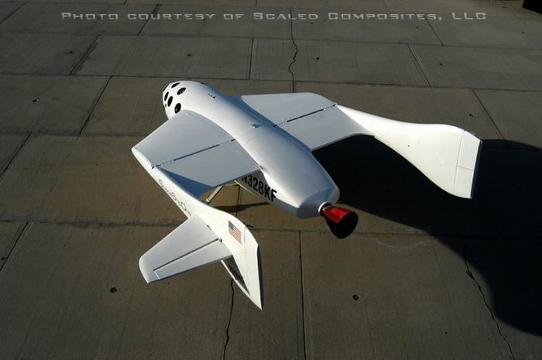
In 2004, the Foundation created the first private race to space and gave birth to a new industry with dramatic technological and social opportunities. On October 4, 2004, the X PRIZE Foundation captured the world's attention when we awarded the largest prize in history, the $10 million Ansari X PRIZE, to Scaled Composites, for their craft SpaceShipOne. To win the prize, famed aerospace designer Burt Rutan and financier Paul Allen led the first private team to build and launch a spacecraft capable of carrying three people to 100 kilometers above the earth's surface, twice within two weeks.

The $10 million Ansari X PRIZE garnered more than five billion media impressions, and the winning spaceship is now hanging in the Smithsonian National Air & Space Museum next to the Spirit of St. Louis and the vehicle flown by the Wright Brothers at Kitty Hawk. Most importantly, children and adults around the world now believe that traveling to the stars is possible in their future. Since October 2004 when SpaceShipOne won the prize, there has been more than $1.5 billion dollars in public and private expenditure in support of the private spaceflight industry. Spaceflight was no longer the exclusive realm of government. With that single flight, and the winning of the $10 million Ansari X PRIZE, a new industry was born.

In 2006 the Foundation caught the world’s attention again with the launch of the Archon Genomics X PRIZE, a $10 million prize to sequence 100 genomes in 10 days, thereby catalyzing medicine to be proactive and preventive as opposed to reactive and ‘too little too late’. 2007 brought about the launch of the $35 million Google Lunar X PRIZE, challenging teams from around the world to land a privately funded robotic rover on the Moon, capable of roving 500 meters, and sending data and videos back to earth. The Moon is ripe with natural resources and a stepping stone to the rest of the universe. Finally, the $10 million Progressive Insurance Automotive X PRIZE was launched earlier this year to help inspire a new generation of viable, super-efficient vehicles that help break our addiction to oil and stem the effects of climate change.

The Foundation carries forward the principles established by earlier prize efforts that the systematic awarding of inducement prizes directed at specific societal challenges are the most effective and efficient means to stimulate revolutionary breakthroughs. The Foundation bestows far more than financial rewards for achieving precise goals. By clearly defining the finish line up front, we indirectly manufacture breakthrough results. People stop asking “can it be done?” and start thinking “how will we be the first to do it?” In the jargon of science, a paradigm shift occurs. Limits become mere challenges, and barriers all of a sudden become breakable. Suddenly it’s no longer a question of “if” but rather “when”.

We do not impose budgets, reporting requirements or overhead because we offer prizes, not grants. We free entrepreneurs from the very constraints they find most limiting, and encourage them to invest every intellectual and financial resource at their command to solve the problem, reach the goal, and win the prize.

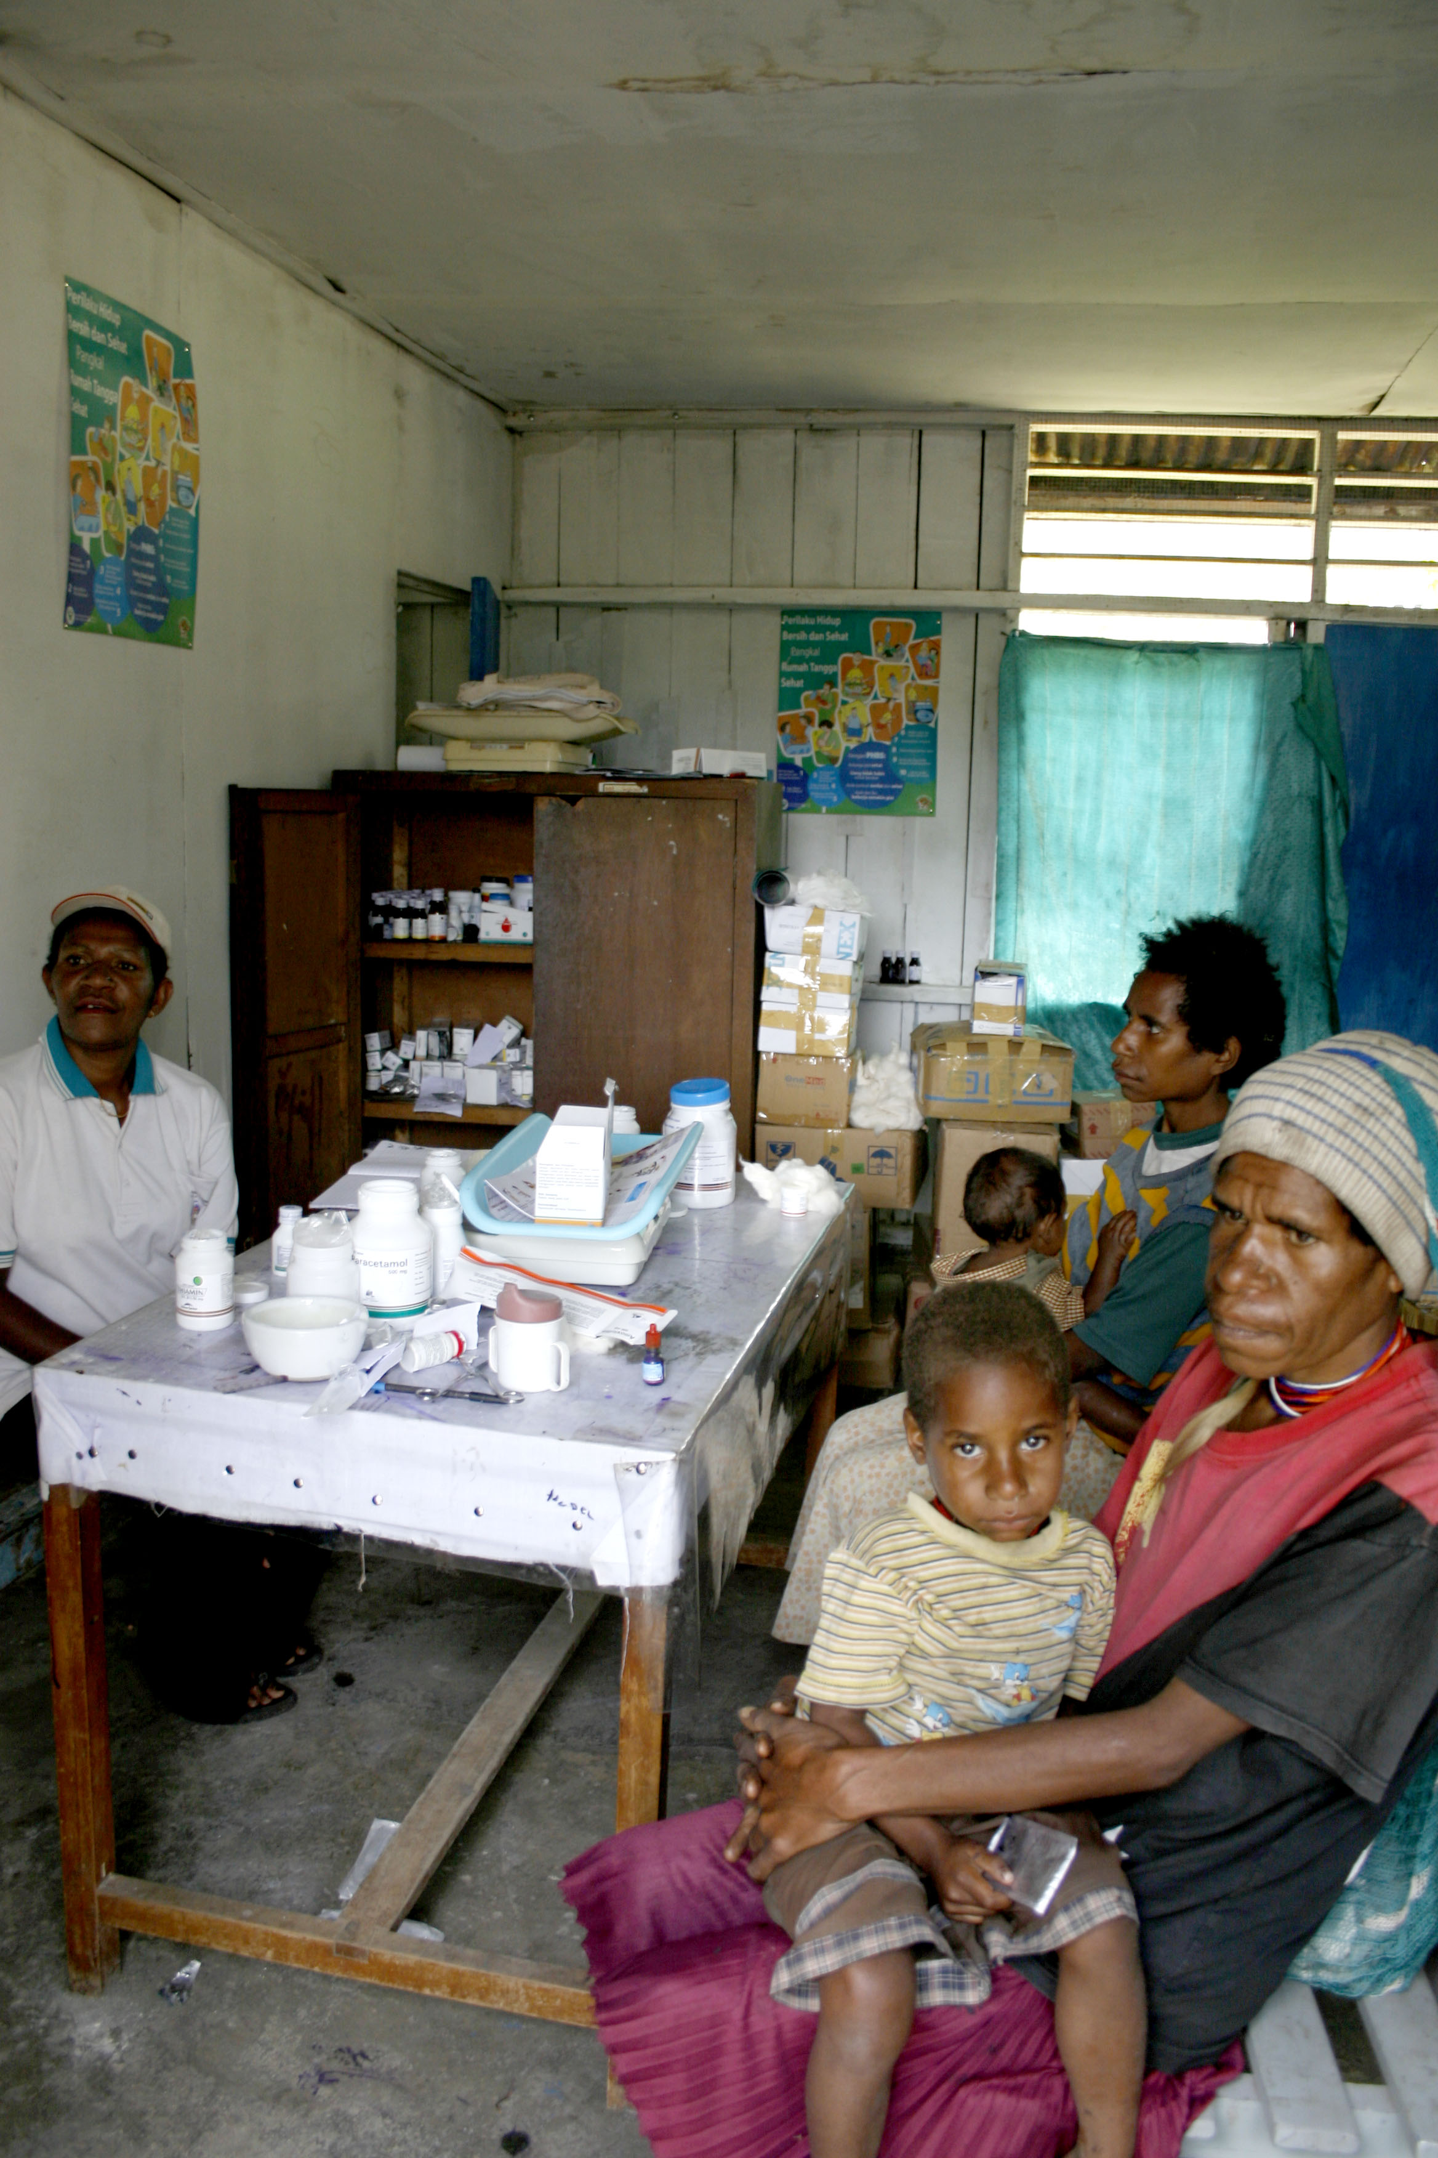
Society ultimately benefits from all the prize efforts; many may prove to have commercially-viable applications even if they are not the first to reach the finish line. The concept of prize philanthropy is enormously powerful. The purpose of the X PRIZE is to reinvent the proven model of prize philanthropy with an expanded mission to create substantial breakthroughs, in a wide range of endeavors, for the benefit of humanity. X PRIZEs represent an exciting addition to the creativity portfolio. We complement and amplify traditional sources of research funding, including foundation and government grants as well as angel and venture capital.

Tuberculosis Diagnostics X Prize

The X PRIZE Foundation’s mission is “to bring about radical breakthroughs for the benefit of humanity.” It has demonstrated expertise in identifying the principal impediments to progress, whether a lack of established commercial markets or the need for advances in technology. Now, the Foundation is moving to build on its success and extend the prize model to other important categories that appear to be structurally, culturally, economically or technologically stagnant: assays to diagnose tuberculosis (TB). The X PRIZE Foundation aims to develop a prize that stimulates the innovation and implementation of an accurate, simple, and easy-to-use diagnostic for TB that is used as a basis for treatment in primitive, health care settings. Today, nearly 50% of TB patients are not diagnosed, and therefore not treated. Two million adults continue to die each year. We believe a significant prize will spur innovation of an effective diagnostic tool and revolutionize the delivery of health care for TB patients.

Objectives of the TB X Prize

Direct Observed Therapy Short-course (DOTS) has been expanded to over 180 countries worldwide, yet the number of patients detected each year remains below what is expected and shows no signs of improving. DOTS is a comprehensive program that enables health facilities or health centers with infrastructure to perform smear microscopy for tubercle bacilli, to treat and follow up patients who are positively diagnosed with low-cost medicines, and also to monitor the outcomes of patients who are on treatment. What is the reason for the plateau in the number of patients diagnosed? Low-cost treatment for TB is available, and infrastructure exists to provide and monitor treatment, so why do we continue to see few being diagnosed and treated? The answer lies in the diagnosis method and its access by at-risk populations.

Currently, diagnosis relies heavily upon microscopy centers that use sputum smear that has a low sensitivity; detection limits are ~10,000 bacilli/mL of sputum; however, patients are spreading the infection by exposing other members of their household with bacteria levels in sputum that are well below 10,000 bacilli/mL. Sputum smear microscopy was invented nearly 100 years ago and is not only insensitive, but also laborious and requires costly infrastructure such as microscopes, laboratories, and trained health workers. We are not catching those with TB and providing them with the available treatment (through referral to a treatment center). With each undiagnosed and untreated patient, additional members of their community are at risk of infection.

In addition to ineffective diagnostic tools, obstacles that reduce the number of patients referred for treatment include significant financial and logistical barriers that prevent patients from traveling to distant smear microscopy centers. Those patients who do manage to navigate these obstacles are presented with health workers who are not only overburdened with many other duties such as measurement of blood counts, screening blood slides for malaria, and cross-matching blood for transfusion, but are also armed with inefficient and ineffective TB diagnostic tools; this effectively inserts another bottleneck into the health care delivery pathway. These health and diagnostic centers are critical locations where patients converge to receive care; however, they are understaffed and cannot provide the diagnosis services needed by TB patients. Consequently, fewer patients enter the DOTS regimen for treatment. Health centers are the most peripheral diagnostic and treatment point within the health care system. Over the next 5-7 years, as infrastructure expands and the reach of health centers with DOTS expands further into more peripheral, remote communities, the clearest step forward in interrupting the continued spread of TB is to rapidly and efficiently diagnose those patients who do reach the health center, in order to immediately refer them to the TB treatment program.

To succeed, we need a new and powerful diagnostic tool that i) provides accurate and timely results to increase the likelihood of a patient beginning treatment, ii) enables health workers to diagnose more patients by reducing turn-around time for results and by eliminating the need for costly and unnecessary infrastructure, such as advanced laboratory facilities and highly trained staff, and iii) encourages a patient to seek treatment without delay. This diagnostic will thereby not only empower health workers and patients, but also increase access to diagnosis and care.

A true revolution in health care delivery and patient care will occur only when increasing numbers of patients who are positively diagnosed with an accurate and reliable diagnostic begin to demand treatment and ready access to that treatment without delay. Treatment will then have to be expanded beyond the current operational and/or referral centers to areas that are accessible by the most afflicted and marginalized populations. The demands of patients will require that the health care delivery chain respond by providing treatment more efficiently and effectively.

We must provide the diagnostics tools needed by patients within their communities. A multimillion dollar prize for an appropriate TB diagnostic can spur the required innovation by companies and organizations around the world. We believe that for a diagnostic to have the largest public health impact in the 5 to 7-year horizon of the X PRIZE will be one that addresses the following:

Ease of sample collection
Cold chain requirements
Test Specificity
Test Sensitivity
Waste disposal
Operator time
Price and affordability
Instrumentation
Training of health workers
Storage and stability
Ease-of-use
Lab infrastructure requirements
Portability

Ancillary Benefits

An X PRIZE has the ability to change public perception, create awareness and catalyze change around an issue that has to date failed to garner the necessary attention. Not only can a prize generate great financial leverage, it can also spawn a range of ancillary benefits An X PRIZE validates a market and exposes millions to its potential. In the case of a Tuberculosis Diagnostic X PRIZE, benefits may include the emergence of new social venture firms that attempt to invest equity capital into the entrants, or a revolution in the manner in which businesses invest and design technologies for developing countries. The prize competition and entrants will pave the path for future businesses to enter unfamiliar markets, to develop technologies, and to develop sustainable business models for those markets. Moreover, high profile marketing and media coverage can encourage countries to compete, cut back red tape and spur deregulation.

As the need for a TB diagnostic is highest in the developing world and resource-poor settings, such a product would have to be marketed at a cost affordable to the general population. Creating an economic incentive through a significant prize purse would produce a beneficial market that formerly did not exist. The impact of such an incentive includes both radical and measurable changes — the cumulative benefit of prize-induced innovation, subsequent large-scale adoption, and increased collaboration between the public and private sectors. The development of the guidelines for the prize has been driven by the needs of patients and community health workers in the field, and guided with the support and advice of leading clinicians, members of industry, scientists, health workers, and representatives of major public health agencies.

Contact information: Amy P. Wong, PhD (amywongxpf@gmail.com), Project Manager

