Truenat™ Tests for the Detection of TB and Rifampicin Resistance Central-Level Training
Participant Guide

Table of Contents
Module 1: Introduction to Truenat 0
Session Focus 0
TB Context 0
Plenary Session 2
TB Laboratory Tests 3
Placement of Truenat in Diagnostic Networks 7
Diagnostic Accuracy of Truenat 9
Activity: Which Test Should I Use? 13
Summary 15
Knowledge Check 15
Module 2: Diagnostic Algorithm and Results Interpretation 16
Session Focus 16
WHO Recommendations 16
Truenat Algorithm 18
Algorithm Part 1: Isolate DNA 20
Algorithm Part 2: TB Test 22
Algorithm Part 3: RIF Resistance Test 25
Activity: Truenat Algorithm Scenario 28
Patient Flow 29
Questions to Answer About Patient Flow 30
Digital Results Reporting 34
Summary 34
Knowledge Check 35
Module 3: Operational Aspects 36
Session Focus 36
Truenat TB PCR Test Introduction 36
Equipment & Supplies 37
Truenat Test Procedures 41
Waste Management 48
Errors and Troubleshooting 49
Activity: Fix the Error 52
Infrastructure Requirements 54
Recording Testing Activities 56
Warranty 56
Summary 58
Knowledge Check 59
Module 4: Order Planning and Quality Assurance (QA) and Control 60
Session Focus 60
Forecasting and Quantification 60
Activity: Calculating Metrics 64
Stock Management 66
Quality Assurance and Control 68
Monitoring Quality 76
Summary 78
Knowledge Check 79
Module 5: Monitoring and Evaluation (M&E) 80
Session Focus 80
M&E for Truenat 80
Indicators 81
Summary 85
Knowledge Check 85
Module 6: Biosafety and Specimen Collection and Referral 86
Session Focus 86
Biosafety Measures and Risks 86
Assessing Risk 87
Laboratory Infrastructure 88
Personal Protective Equipment 89
Biosafety Cabinets 90
Generation and Prevention of Aerosols 91
Managing Spills 92
Waste Disposal 93
Specimen Collection Procedures 95
Specimen Referral 97
Summary 101

Module 1: Introduction to Truenat

Session Focus
Introduction
In this session, we will learn to:
- Describe the global and country-specific context of TB.
- List the different laboratory tests used to diagnose TB and drug resistance, and WHO’s recommendations for each.
- Describe the advantages of introducing Truenat within a TB diagnostic network.
- Compare the diagnostic accuracy of Truenat to other TB laboratory tests.

TB Context
Global TB Context
Global Context
- 10 million people fall ill with tuberculosis (TB) ever year.
- 1.5 million people die from TB each year – making it the world’s top infectious killer.
- TB is the leading cause of death of people with HIV and a major contributor to antimicrobial resistance
WHO End-TB Strategy
- WHO-recommended rapid TB diagnostics (WRDs) should be available to all persons with signs or symptoms of TB
- All bacteriologically confirmed TB patients should receive drug susceptibility testing (DST) at least for rifampin (RIF)
- All patients with RIF-resistant TB should receive DST at least for fluoroquinolones (FQs)
WHO Guidelines on DST
- Updated WHO guidelines stress the importance of DST prior to treatment, especially for the medicines for which WHO-recommended rapid molecular tests are available.
Question: How many people fall ill each year with TB? ________________________________________________________________________
Discussion Question: To what extent do you think your country is meeting the goals of the WHO End-TB Strategy? ________________________________________________________________________________________________________________________________________________________________________________________________________________________________________________________________________________________________________________________________________________________________________________________________________________________________________________________________________
Question: WHO-recommended rapid molecular tests exist for which medicines?
- _____________________________
- _____________________________
- _____________________________
Other Notes:
____________________________________________________________________________________________________________________________________________________________________________________________________________________________________________________________________________________________________________________________________________________
Country TB Context
Notes:
____________________________________________________________________________________________________________________________________________________________________________________________________________________________________________________________________________________________________________________________________________________________________________________________
____________________________________________________________________
____________________________________________________________________
____________________________________________________________________
____________________________________________________________________

Plenary Session
Plenary Session
Notes:
____________________________________________________________________________________________________________________________________________________________________________________________________________________________________________________________________________________________________________________________________________________________________________________________
____________________________________________________________________________________________________________________________________________________________________________________________________________________________________________________________________________________________________________________________________________________________________________________________

TB Laboratory Tests
Menu of TB Lab Tests
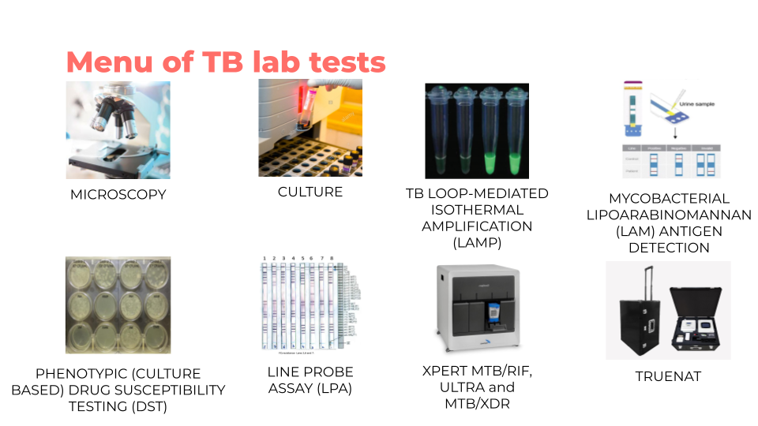

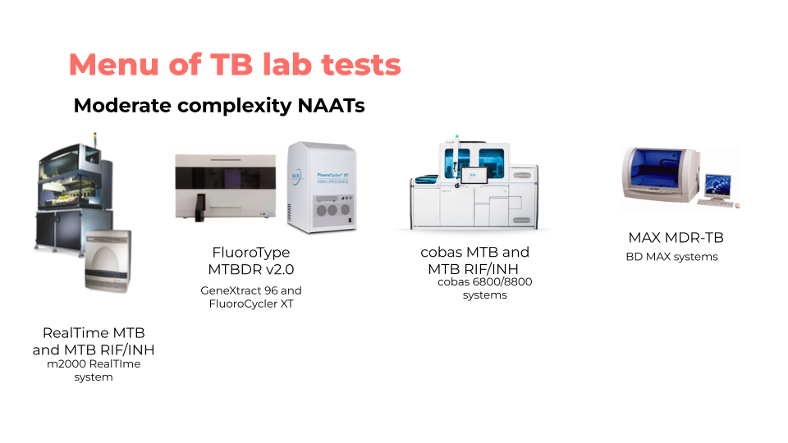

Lab Tests for TB
 | Uses | Benefits | Limitations | WHO Recommendation
AFB-Smear Microscopy | - Used as an initial diagnostic test for the detection of AFB  - Monitors response to therapy | - Can be done safely with minimal biosafety precautions | - Limited sensitivity, which is further reduced in HIV-positive individuals | WHO recommends that in all settings LED fluorescence microscopy should be phased in to replace conventional bright-field microscopy and Ziehl-Neelsen staining
Xpert MTB/RIF or Xpert Ultra | - Detects both mycobacterium tuberculosis complex bacteria (MTBC) and RIF resistance | - Fast turnaround (<2 hours), high sensitivity, low risk in terms of biosafety | - Requires an uninterrupted and stable electrical power supply, yearly calibration of the modules and an ambient temperature of 15-30 °C.  - Cannot be used to monitor treatment  - Does not detect anti-TB agents other than RIF | WHO recommends the use of Xpert MTB/RIF or Ultra as an initial diagnostic test for TB and detection of rifampicin-resistance detection rather than smear microscopy/culture and phenotypic drug-susceptibility testing
Culture | - Used as an initial diagnostic for TB as well as to isolate cultures for DST  - Monitors MDR-TB treatment | - Most sensitive test for the detection of MTBC  - Provides an isolate for DST | - Requires a high level of biosafety precautions  - Liquid culture is more expensive than solid culture  - Rapid identification of species is recommended | WHO recommends the use of liquid culture and rapid species identification within the context of country specific, comprehensive plans for laboratory capacity strengthening and based on a step-wise approach
TB-LAMP | - Diagnosis of pulmonary TB | - Requires minimal infrastructure and has biosafety requirements similar to smear microscopy  - Can be read by the naked eye under ultraviolet light  - Requires less than one hour to perform | - Most suitable for settings with low prevalence of HIV and MDR-TB  - Cannot be used to monitor treatment  - Does not detect RIF resistance | WHO suggests using TB-LAMP as a replacement test for sputum smear microscopy for the diagnosis of pulmonary TB
LF-LAM Antigen Detection | - Rapid test to detect MTBC antigens in urine | - Requires no equipment | - Does not provide any information on drug resistance  - Cannot be used to monitor treatment | WHO recommends using Alere Determine™ TB LAM Ag to assist in the diagnosis of active TB in HIV-positive adults, adolescents, and children with signs and symptoms of TB, who are seriously ill, or have a CD4 cell count of less than 100 cells/mm3  AlereLAM is also recommended for use in HIV-negative persons under certain circumstances
Phenotypic (culture-based) DST | - Detection of resistance to anti-TB drugs | - Culture-based, phenotypic DST remains essential for drugs for which there are not yet reliable molecular tests  - Phenotypic DST for second-line agents is required to confirm or exclude XDR-TB | - Requires a high level of biosafety precautions, highly skilled staff and strict quality control  - Culture-based phenotypic DST can take weeks to months to generate results  - Reliable phenotypic DST methods are not always available | DST remains essential for drugs for which there are not yet reliable molecular tests.
Xpert MTB/XDR | - Detects resistance to isoniazid and fluoroquinolones, ethionamide and second-line injectable drugs (amikacin, kanamycin and capreomycin) | - Fast turnaround (<2 hours), high sensitivity, low risk in terms of biosafety  - Automated one step process  - High sensitivity and specificity  - Reflex testing after Xpert MTB RIF resistance result  - Testing can be done on unprocessed sputum and concentrated sputum sediments | - Requires an uninterrupted and stable electrical power supply, yearly calibration of the modules and an ambient temperature of 15-30 °C.  - Only compatible with 10-color GeneXpert modules  - Does not detect resistance to new drugs (e.g., Bedaquiline) | WHO recommends the use of Xpert MTB/XDR as:  - the initial test for the detection of resistance to INH and FQs rather than culture-based phenotypic DST in people with bacteriologically confirmed pulmonary TB  - initial test for the detection of ethionamide resistance rather than DNA sequencing of the inhA promoter in people with bacteriologically confirmed PTB and RR  - initial test for the detection of the resistance to amikacin rather than culture-based phenotypic DST in people with bacteriologically confirmed PTB and RR
LPA Genotype MTBDRplus/sl | - Detection of resistance to anti-TB drugs | - Specifically detects the specific MTB strain and determines its drug resistance profile | - Requires at least 3 separate rooms to avoid cross-contamination and moderate to high levels of biosafety precautions  - Cannot be used to monitor treatment | - FL-LPA is recommended for use on smear-positive sputum specimens and M. tuberculosis isolates as the initial test instead of phenotypic culture-based DST to detect resistance to RIF and INH.  - WHO suggests using SL-LPA as the initial test instead of phenotypic culture-based DST to detect resistance to FQs and AMK directly from patient specimens or cultures
LPA Genoscholar PZA-TB | - Based on the same principle as Genotype LPA but uses hybridization probes to cover the full pnCA gene to detect resistance to PZA | - Faster results than phenotypic DST  - High sensitivity (>80%) and specificity (>95%) for the detection of PZA resistance  - Hybridization can be performed on the TwinCubator instruments used for LPAs | - Too many probes lead to crowding on the strips so requires careful attention to avoid errors.  - High risk of cross-contamination  - Requires highly skilled and competent personnel | WHO recommends the use of high complexity reverse hybridization NAATs in people with bacteriologically confirmed TB for the detection of PZA resistance rather than culture-based phenotypic DST
Realtime MTB RIF/INH | - Real-time pCR for the detection of TB and RIF/INH resistance | - Automated DNA extraction amplification and detection  - High throughput: ~96 tests/run  - Multi-disease testing possibilities (HIV, HCV, HBV, HPV, CTNG, SARS-Cov-2)  - LOD for TB: 17 CFU/ml | - Requires highly skilled personnel  - Some of the reagents require freezer storage | WHO recommends that in people with signs and symptoms of pulmonary TB, moderate complexity NAATs be used on respiratory samples for the detection of PTB, Rif resistance and INH resistance rather than culture and phenotypic DST.
Max MDR/TB | - Real-time PCR for the detection of TB and RIF/INH resistance | - Automated sample preparation and real-time PCR  - Untreated sputum samples transported and stored at room temperature can be tested up to 3 days post collection.  - Medium throughput ~48 tests / 8-hour workday  - Reagents do not require freezer storage  - LOD for TB: 0.5 CFU/ml | - Requires highly skilled personnel
FluoroType MTB and MTBDR v2.0 | - Real-time PCR for the detection of TB and RIF/INH resistance | - Automated amplification and detection within 3 hours  - Both manual and automated options for DNA extraction  - Medium throughput ~ 12 samples/run  - LOD for TB: 15 CFU /ml | - Requires highly skilled personnel  - BSL requirements as testing can only be done on decontaminated sputum
Cobas MTB and MTB-RIF/INH | - Real-time PCR for the detection of TB and RIF/INH resistance | - Automated DNA extraction, amplification and detection  - High throughput ~ 1056 tests/8-hour workday.  - Global pricing available through Roche’s Global Access Program  - Multi-disease testing capacity (HIV, Hepatitis (A_C), CMV, HSV, Syphilis, immunoassays)  - LOD for TB: 7.6 CFU/ml | - Requires highly skilled personnel
Truenat | - First WHO-recommended molecular test for TB and RIF resistance that can be used in peripheral settings with limited infrastructure | - Designed to be operated in peripheral laboratories with minimal infrastructure and minimally trained technicians  - Battery-powered and uses room temperature stable reagents  - Can generate results for TB in one hour and for RIF resistance in one additional hour | - RIF resistance test is a reflex test  - Electricity still required for charting batteries  - More manual steps than the Xpert MTB/RIF test | In adults and children with signs and symptoms of pulmonary TB, the Truenat MTB or MTB Plus may be used as an initial diagnostic test for TB rather than smear microscopy/culture.  In adults and children with signs and symptoms of pulmonary TB and a Truenat MTB or MTB Plus positive result, Truenat MTB-RIF Dx may be used as an initial test for RIF resistance rather than culture and phenotypic DST.

Placement of Truenat in Diagnostic Networks
Lab Tests for TB: Placement in the Network
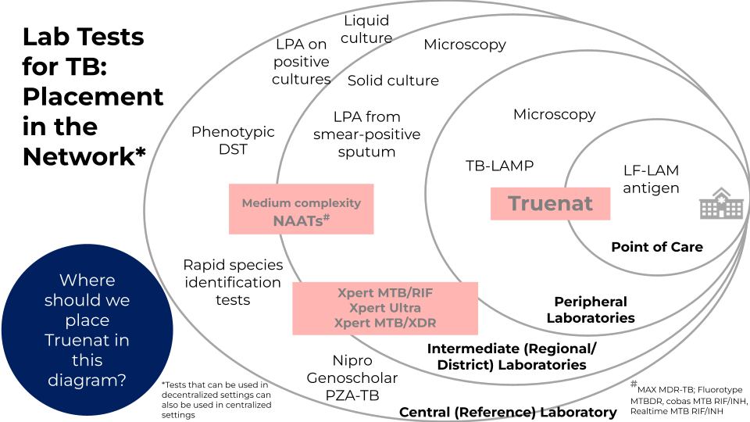

Notes:
________________________________________________________________________________________________________________________________________________________________________________________________________________________________________________________________________________________________________________________________________________________________________________________________________________________________________________________________________
Discussion Question: Indicate in the picture above where you think Truenat should be placed in this diagram.
____________________________________________________________________________________________________________________________________________________________________________________________________________
Positioning vs. Xpert or LAMP
**Truenat is not a replacement for existing Xpert networks
- A country can use more than one test for rapid testing
- Truenat and TB-LAMP can be placed at lower levels than Xpert
- Placement at lower levels can increase patient access to rapid molecular testing for TB, decentralize testing for RIF resistance, and reduce need for patient travel
Notes:
____________________________________________________________________________________________________________________________________________________________________________________________________________________________________

Placement of Truenat in Diagnostic Networks
- Truenat can be placed at peripheral health centres to replace microscopy as the initial diagnostic test for TB
- X-ray may be used as a screening tool for confirmatory testing with Truenat
- Specimen referral networks may be needed to allow for further DST
Notes:
____________________________________________________________________________________________________________________________________________________________________________________________________________________________________

Diagnostic Accuracy of Truenat
Diagnostic accuracy relative to culture, in microscopy center settings
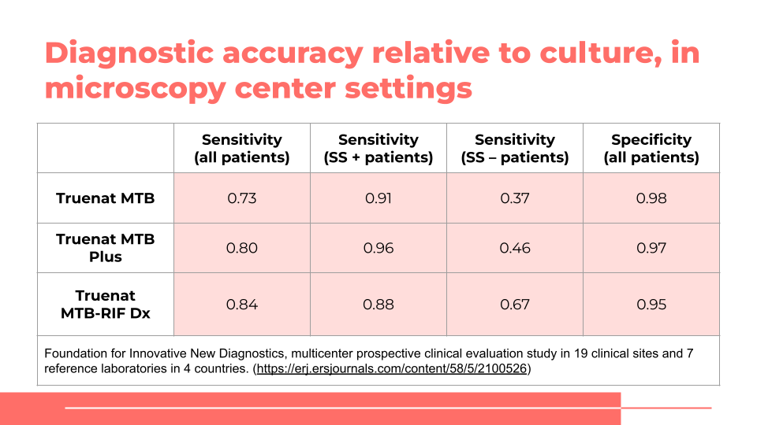

Question: What are sensitivity and specificity? ____________________________________________________________________________________________________________________________________________________________________________________________________________________________________________________________________________________________________________________________________________________________________________________________
Question: What do you notice about the specificity and sensitivity of Truenat relative to culture? (What is the main point of this table?)
____________________________________________________________________________________________________________________________________________________________________________________________________________________________________________________________________________________________________________________________________________________________________________________________
Diagnostic accuracy relative to culture among individuals being evaluated for TB, reference laboratory settings
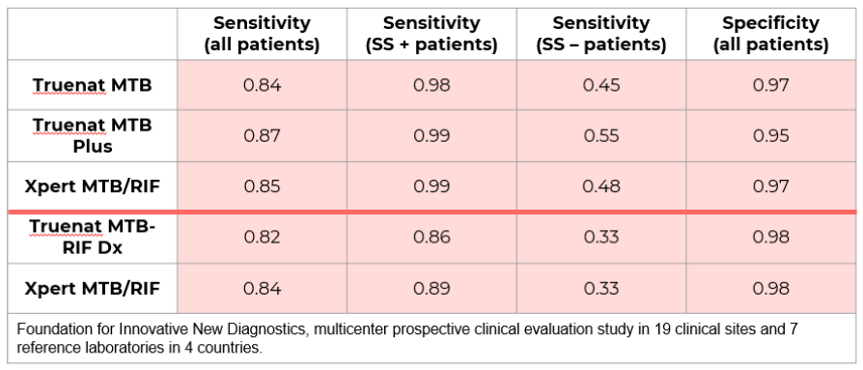
Question: What is the main point of this table?
________________________________________________________________________________________________________________________________________________________________________________________________________________________________________________________________________________________________________________
Effect of prior treatment on specificity
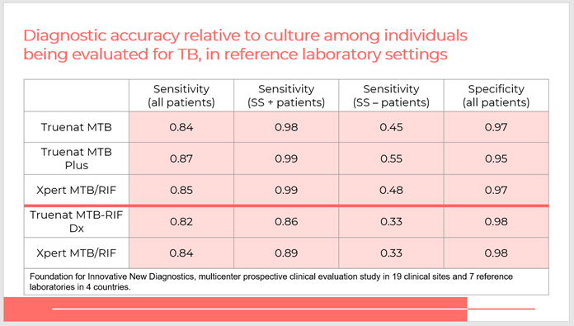
Question: What is the main point of this table?
____________________________________________________________________________________________________________________________________________________________________________________________________________________________________
Sensitivity and Specificity Tradeoffs
- In deciding whether to select Truenat MTB or MTB Plus, countries will need to consider the possible trade-offs between higher or lower sensitivity and higher or lower specificity based on the prevalence of:
  - TB
  - DR-TB
  - TB/HIV co-infection

Question: Why might a country with a high DR-TB burden choose not to use MTB Plus? ________________________________________________________________________________________________________________________________________________________________________________________________________________________________________________________________________________________________________________
High HIV Burden Settings
- In a population with a high prevalence of HIV, a more sensitive test (i.e., Truenat MTB Plus) may be the more appropriate test because of its increased sensitivity for the detection of MTBC in smear-negative samples.

Notes:
____________________________________________________________________________________________________________________________________________________________________________________________________________________________________________________________________________________________________________________________________________________________________________________________
Advantages of Truenat
- Cost-effectiveness
  - Low equipment and test costs
  - In – built connectivity allows for use of digital data including rapid reporting of results to clinicians.
- Patient access
  - Use of Truenat at primary healthcare level can reduce the need for sample transport for detection of RIF resistance
  - Near Point of care technology POC), battery operated and portable
  - Can be used for active case finding strategies remotely in rural areas
- Time taken for the assay
  - MTB detection is completed in 35 minutes and the RIF assay is done only as a reflex test
- Availability of DNA
  - With Truenat, DNA is available for repeat testing and any further investigation and quality control purposes
Discussion Question: In your opinion, which of these advantages is the most important in your country? Why?
____________________________________________________________________________________________________________________________________________________________________________________________________________________________________________________________________________________________________________________________________________________________________________________________

Activity: Which Test Should I Use?
Activity: Which Test Should I Use?
Directions: Read each scenario below to determine if Truenat should be used to test for TB or not. Circle the correct answer and write your rationale. You have 10 minutes to complete your answers. Be prepared to share with the whole group.
Scenario 1:
You are working in a primary care clinic. A 33-year-old woman presents with a low-grade fever and a persistent cough. The woman informs you that she has been coughing for the last two weeks.
Which test(s) should you order? ____________________________________________
Why?
________________________________________________________________________________________________________________________________________
________________________________________________________________________________________________________________________________________
Scenario 2:
A patient presents with trouble breathing and coughing that she has experienced for the last week. She tells you that last year she was treated for an illness but she doesn’t know what it was, only that she had to take medicine every day. You do not have access to her health record.
Which test(s) should you order? ____________________________________________
Why?
____________________________________________________________________
____________________________________________________________________
Scenario 3:
A patient enters your clinic with a bad cough that has lasted for two months. Sometimes the cough produces blood. He is also suffering from malaise. You work in a city where there is a high prevalence of HIV.
Which test(s) should you order? ____________________________________________
Why?
____________________________________________________________________
____________________________________________________________________

Summary
Summary
- Truenat is a promising new TB diagnostic tool
  - More sensitive and specific than microscopy
- Truenat has minimal infrastructure requirements and can be used at POC/near-POC
  - Results are rapidly available allowing for same-day diagnosis
- Truenat can detect RIF resistance within two hours
  - Can be used as initial resistance test
Notes:
____________________________________________________________________________________________________________________________________________________________________________________________________________________________________________________________________________________________________________________________________________________________________________________________

Knowledge Check
Notes:
____________________________________________________________________________________________________________________________________________________________________________________________________________________________________________________________________________________________________________________________________________________________________________________________

Module 2: Diagnostic Algorithm and Results Interpretation

Session Focus
Introduction
In this session, we will learn to:
- Implement the WHO recommendations for using Truenat
- Follow the Truenat algorithm and decision tree to use Truenat
- Understand patient flow within the TB diagnostic network and describe procedures for patient referral

WHO Recommendations
WHO Recommendations – Diagnostic Algorithm and Results Interpretation
MTB or MTB Plus
May be used as an initial diagnostic test for TB rather than smear microscopy or culture in adults and children with signs and symptoms of pulmonary TB.
MTB Plus
MTB
MTB-RIF Dx
WHO suggests using Truenat MTB-RIF Dx as the initial test for detection of RIF resistance rather than culture and phenotypic DST persons with a Truenat MTB or MTB Plus positive result.
MTB-RIF Dx
Notes:
____________________________________________________________________________________________________________________________________________________________________________________________________________________________________________________________________________________________________________________________________________
WHO Recommendations – Diagnostic Algorithm and Results Interpretation
Truenat can be used for all adults and children with signs and symptoms of pulmonary TB.
Question: What are the signs and symptoms of pulmonary TB?

______________________________________________________________________________________________________________________________________________________________________
Question: Which persons have an elevated risk of RIF-resistant (RR)-TB?

______________________________________________________________________________________________________________________________________________________________________
Question: What are the signs and symptoms of extrapulmonary TB?

______________________________________________________________________________________________________________________________________________________________________
Question: What tests can you use for TB treatment monitoring?

______________________________________________________________________________________________________________________________________________________________________

Truenat Algorithm
Truenat Algorithm
The Truenat algorithm breaks down the testing approach for using Truenat to detect pulmonary TB and RIF-resistance.

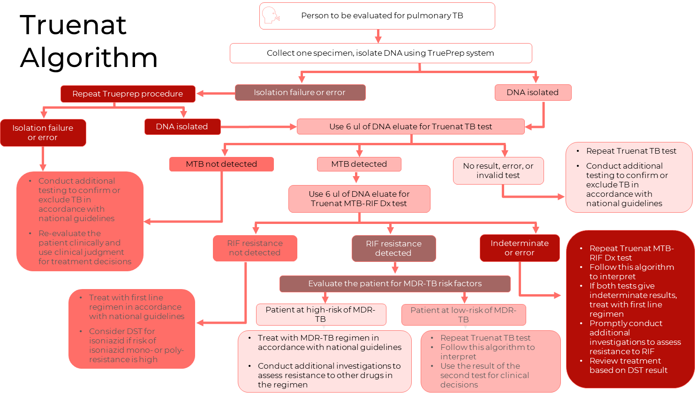

Algorithm Part 1: Isolate DNA

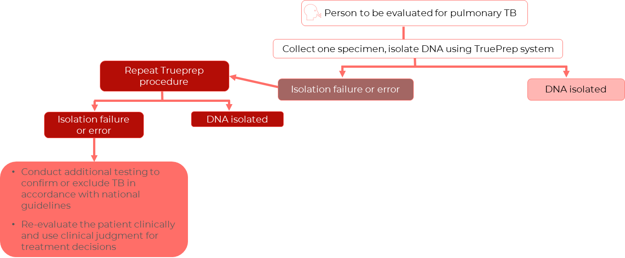

Truenat Algorithm Part 1: Isolate DNA
Programs may consider collecting two specimens upfront
- 1st specimen: Should be promptly tested using Truenat TB test
- 2nd specimen: Use for additional testing in the algorithm
Sputum is the recommended specimen
- Insufficient evidence of how test performs with other specimens
Prepare the sample using the Trueprep AUTO MTB Sample Pre-treatment Pack
Isolate DNA using:
- Trueprep AUTO v2 Universal Cartridge Based Sample Prep Kit
- Trueprep AUTO v2 Universal Cartridge Based Sample Prep Device
Question: What should you do if you receive an isolation failure or error twice when trying to isolate the DNA?

________________________________________________________________________________________________________________________________________________________
Notes:
________________________________________________________________________________________________________________________________________________________________________________________________________________________________________________________________________________________________________________
Truenat Algorithm Part 1: Isolate DNA
If DNA isolation is unsuccessful:
- Repeat the DNA isolation with Trueprep using the same prepared sample and a second Trueprep cartridge
If second attempt is also unsuccessful:
- Consider collecting a fresh specimen and processing again with Trueprep system
- Conduct additional testing to confirm or exclude TB in accordance with national guidelines.
Unsuccessful isolations are typically related to cartridge errors.
Discussion Question: What are some additional tests you could do if the second attempt is also unsuccessful?

________________________________________________________________________________________________________________________________________________________
____________________________________________________________________________
Notes:
______________________________________________________________________________________________________________________________________________________________________
__________________________________________________________________________________

Algorithm Part 2: TB Test

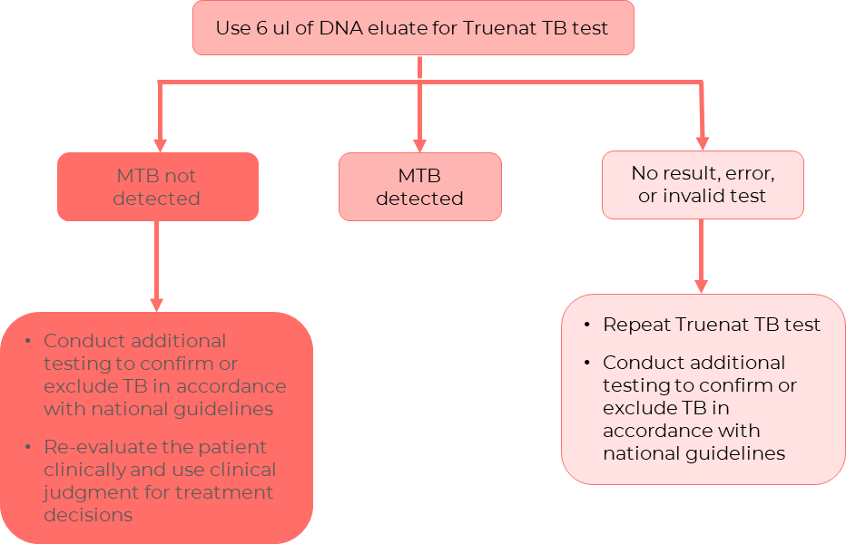

Truenat Algorithm Part 2: TB Test
If TB test result is MTB Not Detected
- Re-evaluate the patient and conduct additional testing in accordance with national guidelines.
- Consider the possibility of clinically defined TB (TB without bacteriological confirmation)
  - Use clinical judgment for treatment decisions.
If TB test result is MTB Detected
- MTB detected results appears as:
  - Truenat MTB: ‘detected.’
  - Truenat MTB Plus: ‘detected high,’ ‘moderate,’ ‘low,’ or ‘very low.’
If the TB test is inconclusive
- Test result reads “Error” or “No result”
  - Repeat Truenat TB test with a new specimen
  - Start anew with the same sample preparation and DNA isolation
- If the repeated test has a valid result, continue with the algorithm
If a second attempt is also inconclusive
- Conduct additional testing to confirm or exclude TB in accordance with national guidelines
Notes:
____________________________________________________________________________________________________________________________________________________________________________________________________________________________________________________________________________________________________________________________________________
If TB test result is MTB Not Detected
- Re-evaluate the patient and conduct additional testing in accordance with national guidelines.
- Consider the possibility of clinically defined TB (TB without bacteriological confirmation)
- Use clinical judgement for treatment decisions
Activity Directions: Take 2 -3 minutes and list as many re-evaluation options to consider if TB test result is MTB not detected below. Be prepared to share your answers with the class.

________________________________________________________________________________________________________________________________________________________________________________________________________________________________________________________________________________________________________________
If TB test result is MTB Detected
- MTB detected results appear as follows:
  - Truenat MTB: ‘detected’
  - Truenat MTB Plus: ‘detected high’, ‘moderate’, ‘low’, or ‘very low’
Notes:
____________________________________________________________________________________________________________________________________________________________________________________________________________________________________________________________________________________________________________________________________________
Truenat Algorithm Part 2: TB Test
If TB test result is inconclusive
- Test result reads “Error” or “No result:”
  - Repeat Truenat TB test with second portion of the remaining DNA or new sample
- Test result reads “invalid:”
  - Repeat Truenat TB test with new specimen
  - Start anew with the sample preparation and DNA isolation
- If repeated test has a valid result, continue with algorithm
If second attempt is also inconclusive
- Conduct additional testing to confirm or exclude TB in accordance with national guidelines
Notes:
____________________________________________________________________________________________________________________________________________________________________________________________________________________________________________________________________________________________________________________________________________

Algorithm Part 3: RIF Resistance Test
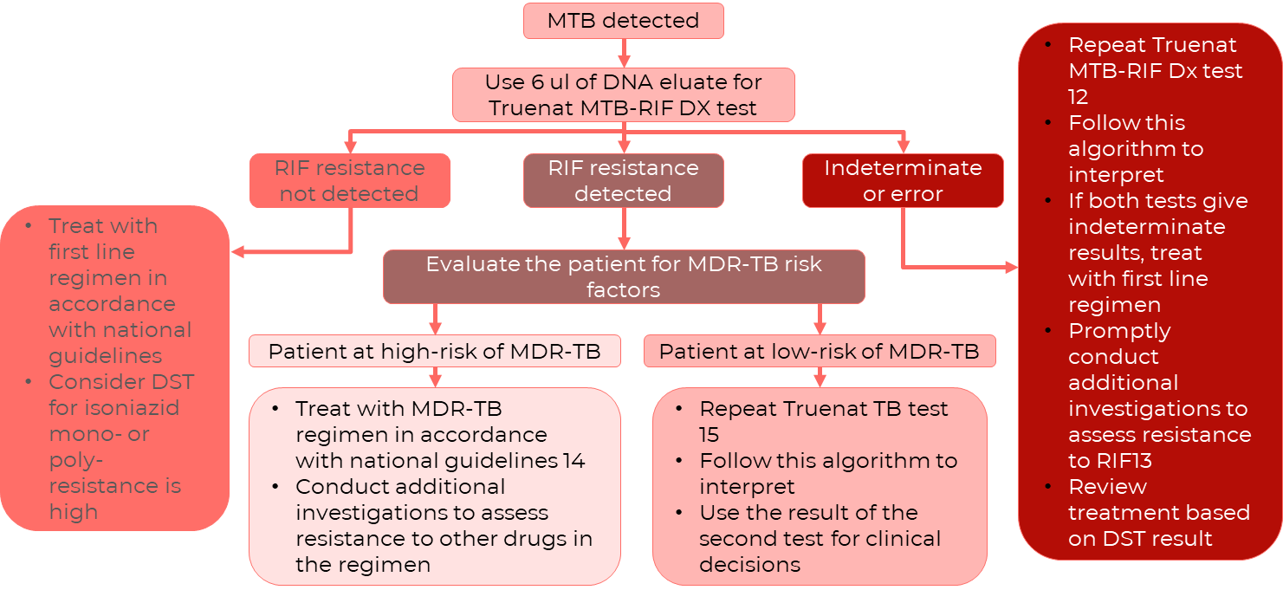

Truenat Algorithm Part 3: RIF Resistance Test
Notes:
____________________________________________________________________________________________________________________________________________________________________________________________________________________________________
Truenat Algorithm Part 3: RIF Resistance Test
If MTB-RIF Dx test result is RIF Resistance Not Detected
- Initiate patient on appropriate regimen using first-line TB drugs in accordance with national guidelines
  - If a patient is very high risk for MDR-TB, initiate a MDR-TB regimen
Consider requesting additional DST in accordance with national algorithms.
Notes:
____________________________________________________________________________________________________________________________________________________________________________________________________________________________________
If MTB-RIF Dx test result is RIF Resistance:
- Assess whether the patient is at high risk for MDR-TB
If Patient is High Risk: | If Patient is Low Risk:
- Consider the RIF-resistant test result definitive  - Initiate the patient on a regimen for RR-TB or MDR-TB in accordance with national guidelines and WHO recommendations | - Repeat the Truenat TB test and MTB-Rif Dx test on a fresh sample  - If second test also indicates RIF resistance, initiate an MDR-TB regimen in accordance with national guidelines  - If second test indicates RIF resistance not detected, assume false-positive and initiate treatment with a first-line regimen in accordance with national guidelines.
Discussion Question: Write your response to the following questions. Be prepared to share.
- What types of patients are high-risk for MDR-TB?

_______________________________________________________________________________________________________________________________________________________________________________________________________________
Notes:
____________________________________________________________________________________________________________________________________________________________________________________________________________________________________
For all patients with RR-TB or MDR-TB:
- Conduct additional investigations to assess resistance to the other drugs in the treatment regimen.
- Rapid molecular methods are preferred.
Notes:
____________________________________________________________________________________________________________________________________________________________________________________________________________________________________
If MTB-RIF Dx test result is RIF indeterminate
- Initiate patient on TB treatment regimen using first-line TB drugs in accordance with national guidelines
  - Unless the patient is very high risk for MDR-TB, in which case initiate on an MDR-TB regimen
RIF resistance indeterminate result is usually caused by a paucibacillary TB load in the sample.
- In this case, consider repeating the Truenat MTB-RIF Dx test using a DNA eluate from a fresh specimen or another aliquot of the DNA eluate
- Follow steps previously described based on the second result
Notes:
____________________________________________________________________________________________________________________________________________________________________________________________________________________________________

Activity: Truenat Algorithm Scenario
Activity: Truenat Scenarios
Directions: Use the Truenat Algorithm to answer the questions in this scenario.
Scenario:
- A patient comes to your clinic and has a severe cough and malaise. Her X-ray shows abnormalities on her lungs that suggest pulmonary TB. What should you do first?

____________________________________________________________________________________________________________________________________________________________________________________________________________________________________
- You have now collected your specimen and attempted to isolate the DNA, but it was unsuccessful. What should you do?

____________________________________________________________________________________________________________________________________________________________________________________________________________________________________
- After your second attempt, your DNA isolation was successful. What are the possible outcomes of the TB Test?

____________________________________________________________________________________________________________________________________________________________________________________________________________________________________
- The test results are MTB Detected. What additional test do you need to perform?

____________________________________________________________________________________________________________________________________________________________________________________________________________________________________
- The next test revealed that the MTB-RIF Dx test result detected RIF resistance. Your patient does not think she has ever had or been treated for TB. What should you do?

____________________________________________________________________________________________________________________________________________________________________________________________________________________________________

- The test returns with the results of RIF resistance not detected. What are your next steps?

____________________________________________________________________________________________________________________________________________________________________________________________________________________________________

Patient Flow
Patient Flow
Patient flow will vary based on where the Truenat is placed in the diagnostic network, i.e. at point of care or in peripheral labs
- Extremely important that patients are linked to additional testing as needed, treatment, and care
Discussion Question: Based on your experience, what are some key considerations to think about in developing patient referral pathway for Truenat in your country?

________________________________________________________________________________________________________________________________________________________________________________________________________________________________________________________________________________________________________________
Notes:
________________________________________________________________________________________________________________________________________________________________________________________________________________________________________________________________________________________________________________

Questions to Answer About Patient Flow
Questions About Patient Flow
Answer the following questions about the patient flow and optimal sample flow for your country?

- How are patients referred for TB screening and testing?

_______________________________________________________________________________________________________________________________________________________________________________________________________________
- Are patients referred from the community to the facility for TB testing?

____________________________________________________________________________________________________________________________________________________________________________________________________________
- Are samples collected at the community level and transported to the facility for testing, or are they tested at the community level and TB patients referred to the facility for TB/DR-TB Rx initiation?

____________________________________________________________________________________________________________________________________________________________________________________________________________
- How are results transmitted to the clinician/facility/patient?

____________________________________________________________________________________________________________________________________________________________________________________________________________
- How are diagnosed patients referred for TB/DR-TB clinical treatment?

____________________________________________________________________________________________________________________________________________________________________________________________________________
Example DS-/DR-TB Patient Referral Pathway
Example DS-DR-TB Patient Referral Pathway
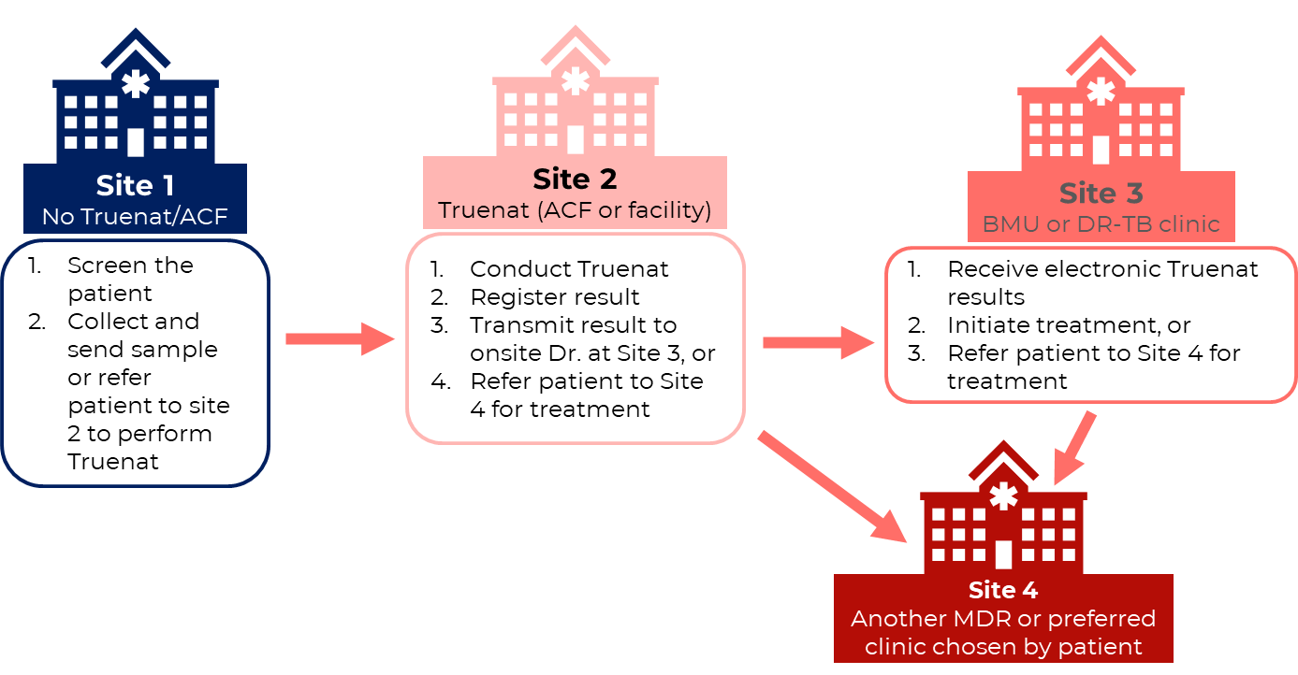
Notes:
________________________________________________________________________________________________________________________________________________________________________________________________________________________________________________________________________________________________________________

Procedures for Patient Transfers and Referrals
Patient Transfers and Referrals
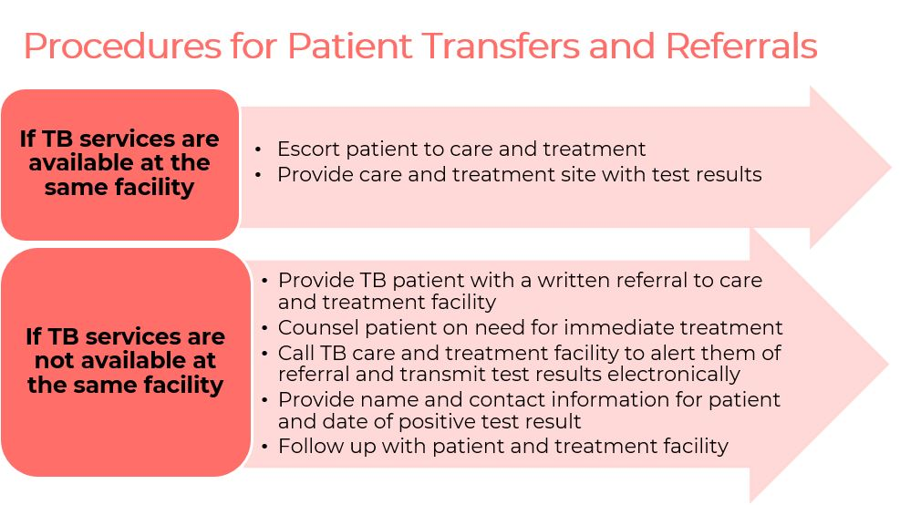
Notes:
________________________________________________________________________________________________________________________________________________________________________________________________________________________________________________________________________________________________________________

Digital Results Reporting
Digital Results Reporting
- The Truelab instrument has built-in software for digital results reporting
- Third-party connectivity software platform (Aspect and DataToCare) companies are currently working to allow for smooth flow of data to these platforms
- Digital results reporting can be used to:
  - Send test results to clinicians
  - Send information about performance and issues to Molbio (error reads, sample processing information)
  - Send data to national servers for surveillance purposes
Notes:

____________________________________________________________________________________________________________________________________________________________________________________________________________________________________________________________________________________________________________________________________________

Summary
Summary
- WHO recommends using Truenat MTB or MTB Plus and MTB-RIF Dx for all adults and children with signs and symptoms of pulmonaryTB
- The Truenat algorithm breaks down the testing approach for using Truenat to detect MTBC and RIF-resistance.
- The procedures for patient transfer or referral will be country specific. In cases of TB-positive results, the patient must be referred to TB care and treatment services.

Notes:
________________________________________________________________________________________________________________________________________________________________________________________________________________________________________________________________________________________________________________

Knowledge Check
Notes:
____________________________________________________________________________________________________________________________________________________________________________________________________________________________________________________________________________________________________________________________________________________________________________________________

Module 3: Operational Aspects

Session Focus
Introduction
In this session, we will learn to:
- List the equipment and supplies needed to run Truenat tests
- Describe the procedures for running a Truenat test
- Describe the infrastructure requirements for using Truenat equipment

Learning Objectives
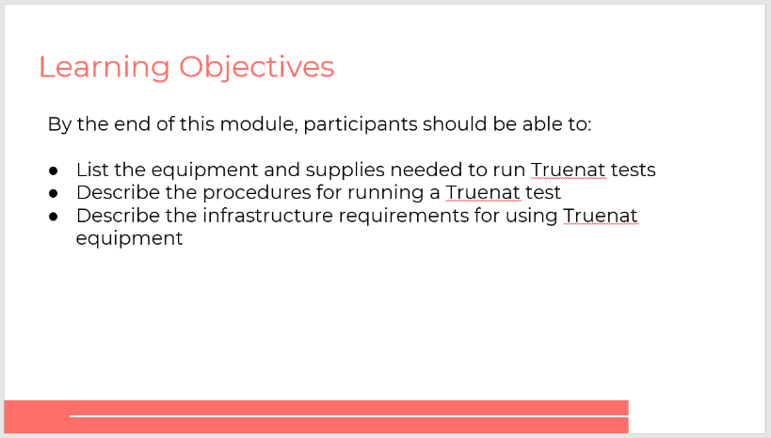

Truenat TB PCR Test Introduction
Introduction to Truenat TB PCR Testing
The Truenat TB test is a chip-based Real-Time Polymerase Chain Reaction (PCR) test for the semi-quantitative, detection and diagnosis of mycobacterium tuberculosis complex bacteria (MTBC) in human sputum samples.
Testing involves the following steps:

Notes:

____________________________________________________________________________________________________________________________________________________________________________________________________________________________________________________________________________________________________________________________________________

Equipment & Supplies
Equipment - Trueprep
Truenat AUTO v2 Universal Cartridge Based Sample Prep Device (Trueprep)
- For automated extraction and amplification of DNA

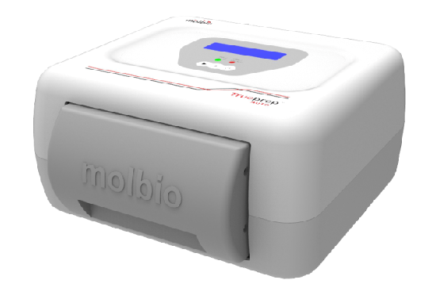

Notes:
_________________________________________________________________________________________________________________________________________________________________________________________________________________________________________________________
Equipment - Truelab
Truelab Real Time micro-PCR Analyzer
- For performing PCR
- Comes in three versions
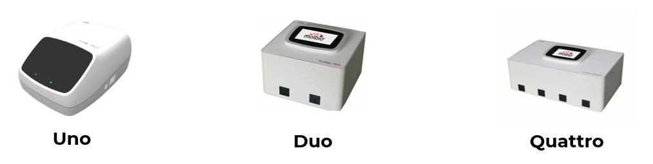

Notes:
_________________________________________________________________________________________________________________________________________________________________________________________________________________________________________________________
Different Models of Truenat Analyzers to Match Anticipated Throughput
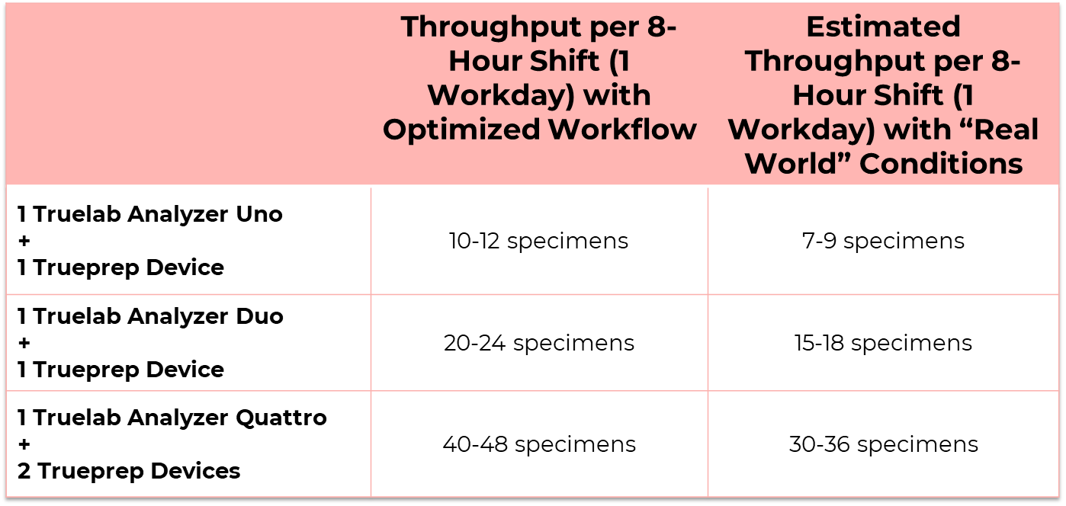
Notes:

_________________________________________________________________________________________________________________________________________________________________________________________________________________________________________________________
Truelab Micro PCR Printer
Truelab Micro PCR printer
- Bluetooth printer, wirelessly prints the results of the PCR tests performed by Truelab Uno Dx/Duo/Quattro
Notes:

_________________________________________________________________________________________________________________________________________________________________________________________________________________________________________________________
Reagents and Consumables
There are three packets that include the reagents and consumables needed to run Truenat.
- Trueprep AUTO MTB Sample Pretreatment Pack
  - Graduated transfer pipettes (1 ml)
  - Lysis buffer bottle (2.5 ml of buffer)
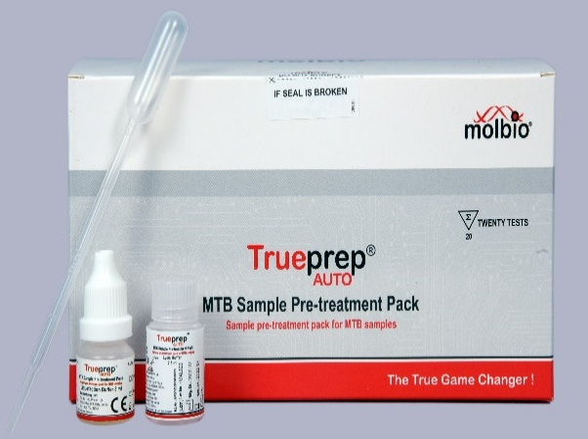
  - Liquefaction buffer bottle
- Trueprep® AUTO v2 Universal Cartridge Based Sample Prep Kit (for 5, 25 or 50 tests)
  - Reagent pack
  - Transfer pipettes (3 ml)
  - Cartridge pouches
    - Cartridge
    - Elute collection tube (ECT)
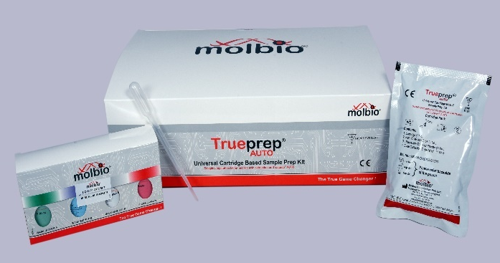
    - Transfer pipette
- Truenat Chip Pack (for 5, 20, or 50 tests)
  - Truenat chip pouches
  - Microtube containing freeze-dried PCR reagents
  - Filter barrier pipette tip
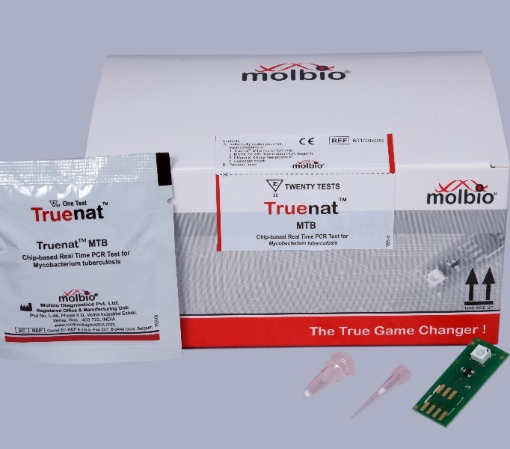
  - Desiccant pouch
  - Reminder: Truenat has three types of chips, so three different types of chip packs
    - MTB: For the detection of TB
    - MTB Plus: A more sensitive test for the detection of TB
    - MTB-RIF Dx: For the detection of RIF resistance
Notes:

_________________________________________________________________________________________________________________________________________________________________________________________________________________________________________________________

Truenat Test Procedures
**The process flow for using the Truenat equipment is outlined in two job aids from Molbio (included in this participant guide).
Prepare Samples and Extract DNA
Truenat- A Point-of-Care Real Time PCR Test for Tuberculosis – YouTube: https://www.youtube.com/watch?v=ydR2I5S2v3c
Equipment & Supplies for Preparing Samples and Extracting DNA
- Equipment
  - Trueprep
- Supplies (Sample Prep Kit)
  - Reagent pack
  - Transfer pipettes (3 ml)
  - Cartridge pouches, each containing:
    - Cartridge
    - Elute collection tube (ECT)
    - Transfer pipette
Process Flow for Preparing Samples and Extracting DNA
- Make sure you wear the appropriate gloves for specimen handling.
- Collect 2-5ml adult pulmonary sputum sample in sputum cap and label with patient details.
- Add two drops of liquefaction buffer to the sputum cup.
- Close the cap and swirl gently to mix.
- Incubate for 10 minutes at room temperature. If your sample is not pipetteable after 10 minutes, incubate for another five minutes with swirling at two-minute intervals.
- Transfer 0.5 ml of liquefied sputum sample into the lysis buffer bottle using a 1 ml transfer pipette.
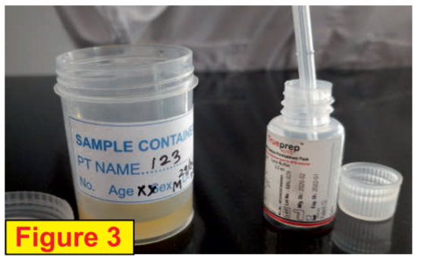
- Add two drops of liquefaction buffer into the lysis buffer bottle, swirl gently to mix and incubate for three to five minutes.
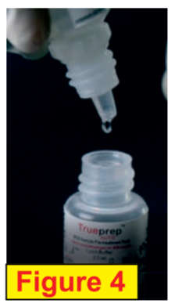
- Remove the cartridge from the pouch, label it and place it on the cartridge stand. Take out the elute collection tube (ECT) and label it appropriately. Keep it aside for later use. Keep the elute transfer pipette in the pouch for later use.
- Transfer the entire contents of the lysis buffer tube to the sample chamber (black cap) of cartridge using 3ml transfer pipette.
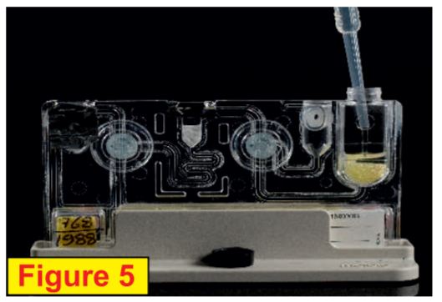
- Switch “on” the Trueprep Auto v2 device. Press “eject” button to open and gently pull out the cartridge holder.
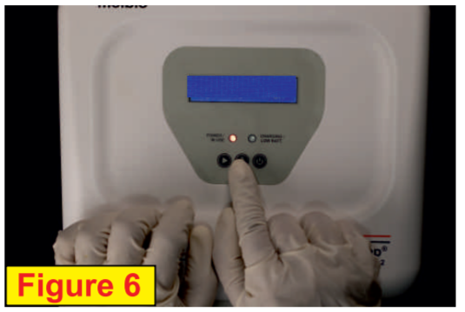
- Place the cartridge in the tray in the orientation and gently push to close the catridge holder. Press “start.”
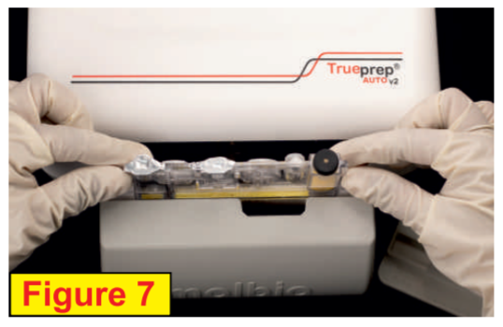
- The device will beep at the end of the DNA extraction process and the cartridge holder will eject automatically. This will take 20 minutes.
- Gently pull out the cartridge holder, remove cartridge, and place it on the cartridge stand.
- Carefully pierce the elute chamber with the provided elute transfer pipette, and transfer the entire elute into the ETC. Discard the transfer pipette and cartridge.
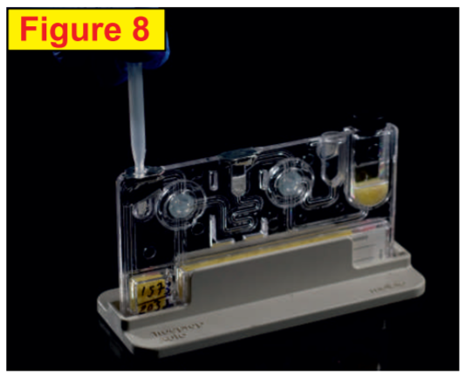
Notes:

_________________________________________________________________________________________________________________________________________________________________________________________________________________________________________________________
Run a PCR TB Test
Truenat- A Point-of-Care Real Time PCR Test for Tuberculosis – YouTube: https://www.youtube.com/watch?v=ydR2I5S2v3c
Equipment & Supplies for Running a PCR TB Test
- Equipment
  - Truelab micro–PCR Analyzer (Uno, Duo or Quattro)
- Supplies (Chip Pack)
  - MTB or MTB Plus Truenat chip
  - Truepet 6µl Precision Micropipette

Process Flow for Running a PCR TB Test
- Switch “on” the Truelab micro-PCR analzyer by pressing the red button in the back right corner for seconds. Wait for 30-50 sections for the “boot-up screen” to appear followed by the “home screen.”
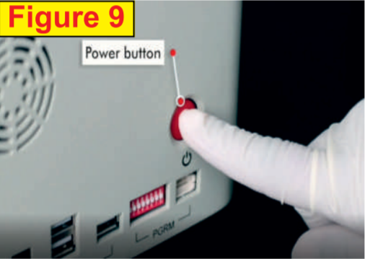
- Select USER ID and enter your password. Press “Sign in” to log in.
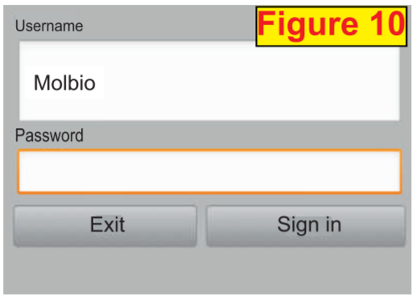
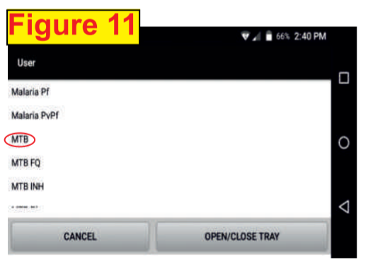
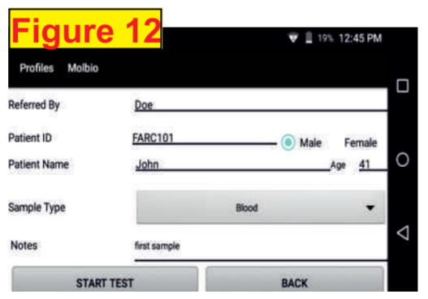
- Select test profile “MTB.” To confirm selection tap “PROCEED” and enter patient details.
- Select sample type (sputum).
- Press “START TEST” on the screen. Chip tray opens. “Please Load Sample” will appear. Be sure not to press “YES” until the chip loading is complete.
- Open a Truenat MTB chip pouch. Remember to pull out the desiccant pouch and confirm that it is blue.
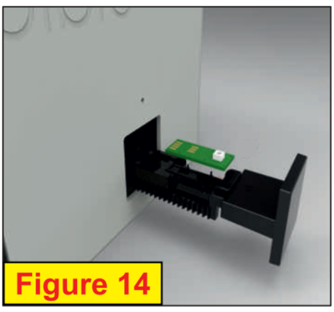
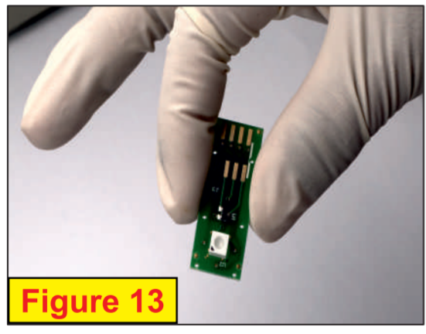
- Gently take out the chip without touching the white well portion and place it on the chip tray.
- Open the mastermix tube, discard the stopper and place the tube in the microtube stand. Be sure to check for white cake at the bottom of the microtube.
- Next, attach the 6ul micro tip provided in the pouch to the single push pipette.
- Then transfer 6ul of the elute from ECT into the mastermix tube.
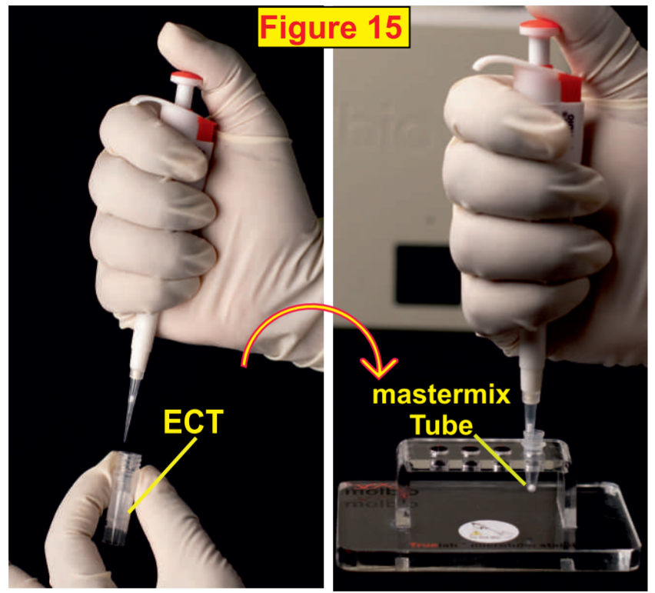
- Allow the mastermix to stand for 30 seconds to get a clear solution. Make sure you do not mix by tapping, shaking or reverse pipette. Do not discard the pipette tip.
- Transfer the elute from the mastermix tube to the white reaction well of the chip. Be sure to avoid spillage of the clear solution outside the white reaction well. Then discard the pipette tip and mastermix tube.
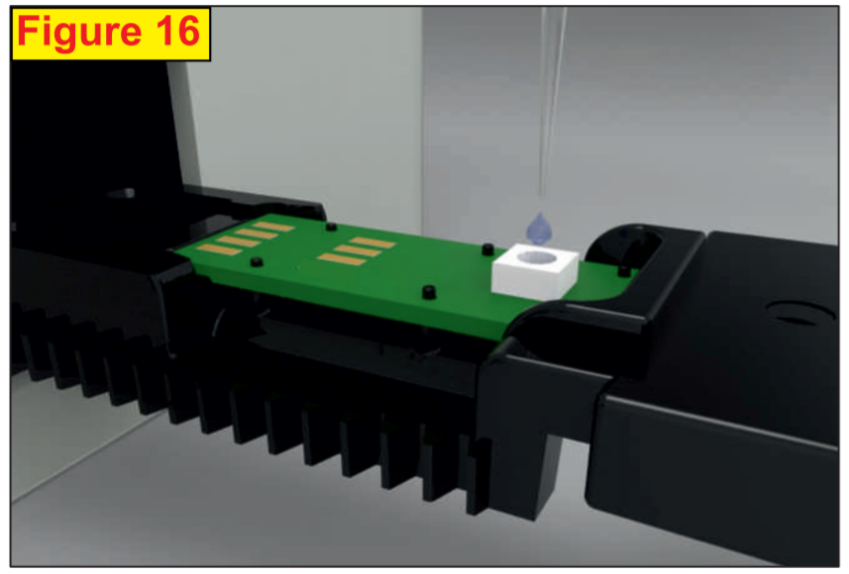
- Click “YES” on the device screen to start the test. It takes 35 minutes for the PCR test to complete.
- Tap the “Open/Close Tray” button to eject the chip tray and discard the used chip immediately after the reaction.
- If MTB is detected, test the same elute for RIF resistance using the Truenat MTB RIF Dx chip as a follow-on test.
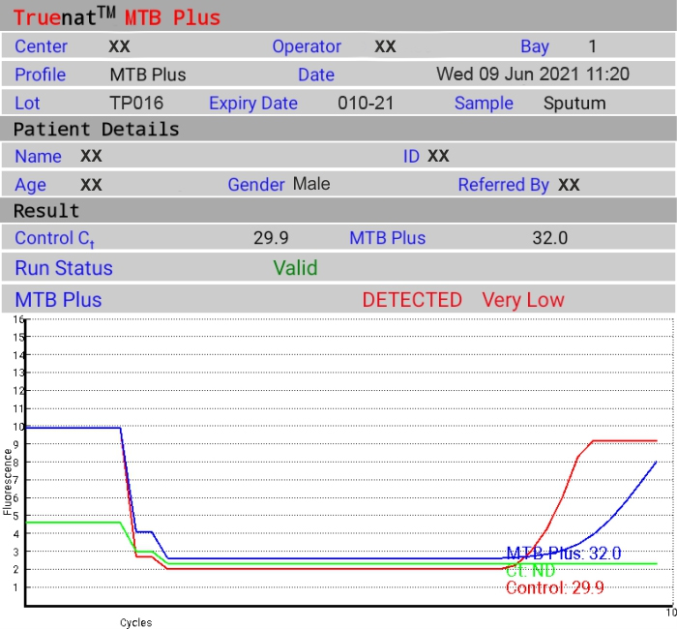
- Press “Print” to print the result page using the Truelab micro-PCR print. This is optional.
Notes:

_________________________________________________________________________________________________________________________________________________________________________________________________________________________________________________________
Run a RIF-Resistance Test
Equipment & Supplies for Running a PCR TB Test
- Equipment
  - Truelab micro PCR Analyzer (Uno, Duo or Quattro)
- Supplies (Chip Pack)
  - MTB-RIF Dx Truenat chip
  - Truepet 6µl Precision Micropipette
Process Flow
- If MTB is detected in a sample, you should run a RIF resistance test.
- A portion of the same DNA eluate can be used to test for RIF resistance using a Truenat MTB-RIF Dx chip.
- Start by returning to Step 3 in the PCR TB test process and repeat for RIF-resistance
  - Select “MTB RIF” as the test type in the Truelab micro PCR Analyzer.
- RIF-resistance testing takes an additional 60 minutes
Notes:

_________________________________________________________________________________________________________________________________________________________________________________________________________________________________________________________

Waste Management
Waste Management
- Truenat tests generate a significant amount of plastic waste
- Dispose or incinerate per national guidelines
- Decontaminate samples and consumables prior to disposal

- The following items are considered RED biohazardous waste and should be disinfected in freshly prepared 1% sodium hypochlorite solution and processed as plastic waste:
  - Transport media tubes
  - Lysis buffer tubes
  - Transfer pipettes (1ml and 3ml)
  - Cartridges
  - Microtubes
  - Elute transfer pipettes
  - Microchips
  - Gloves (even if contaminated) should also be disposed of as hazardous waste
- PPE made of fiber material or other materials except disposable plastic is considered YELLOW hazardous waste and should be disposed of as infectious waste, including:
  - Face masks
  - Gowns
  - Caps
- PPE made of fiber material or other materials except disposable plastic should be disposed of as infectious waste, including:
  - Face masks
  - Gowns
  - Caps
- Other items should be disposed of as general waste in a waste disposal color code BLACK including:
  - Cartridge pouches
  - Chip pouches
  - Transfer pipette wrappers
  - Dessicant pouches
  - Sleeves
Notes:
_________________________________________________________________________________________________________________________________________________________________________________________________________________________________________________________

Errors and Troubleshooting
**Molbio has created a Troubleshooting, Alerts and Errors handout for Trueprep and Truelab (included in your participant guide)
Errors and Troubleshooting
- Truenat machines will prompt you in case of hardware malfunction or errors encountered when performing a test
- Truelab Duo automatically records data within the system whenever it encounters an error.
  - Users can generate a log file to send to Molbio to help resolve errors – instructions can be found in the user guide
  - If a test is in progress when the error occurs, you should create the log file before beginning the next test.
Trueprep Error Messages
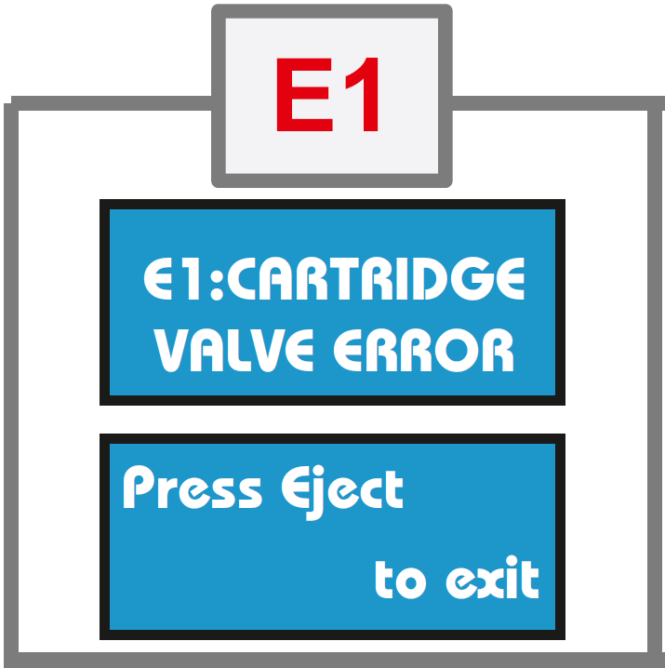 | Error 1: Cartridge Valve Error  - Meaning: Cartridge valve is damaged  - Solution: Start over. Process remainder of sample in lysis buffer and load into new cartridge.
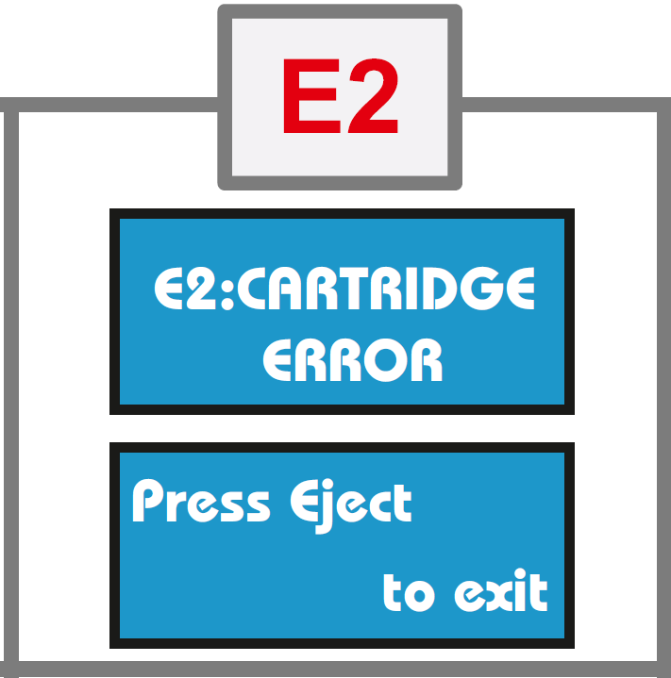 | Error 2: Cartridge Error  - Meaning: Pressure drop error  - Solution: Start over. Process remainder of sample in lysis buffer and load into new cartridge.
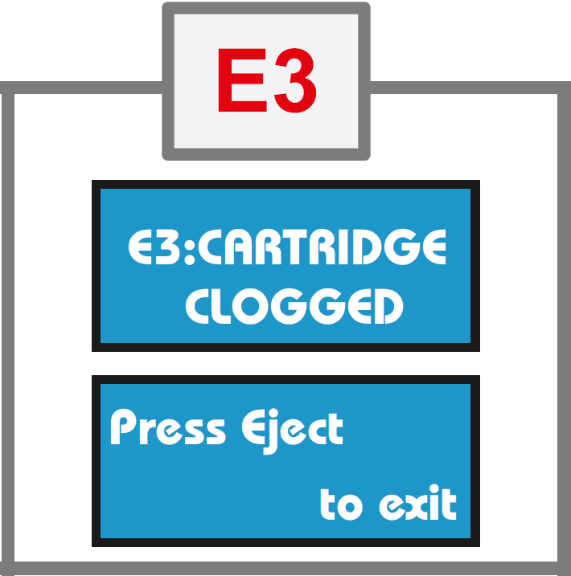 | Error 3: Cartridge Clogged  - Meaning: Sample/specimen is too thick  - Solution: Ensure sample is liquefied and pipettable. Repeat extraction with new cartridge/request for new sample.
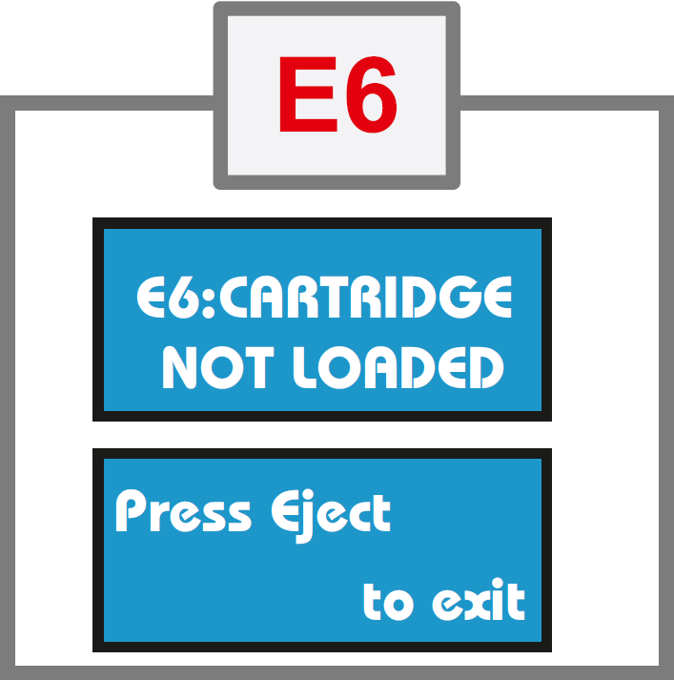 | Error 6: Cartridge not Loaded  - Meaning: Cartridge not detected  - Solution: Ensure cartridge is loaded properly in correct orientation
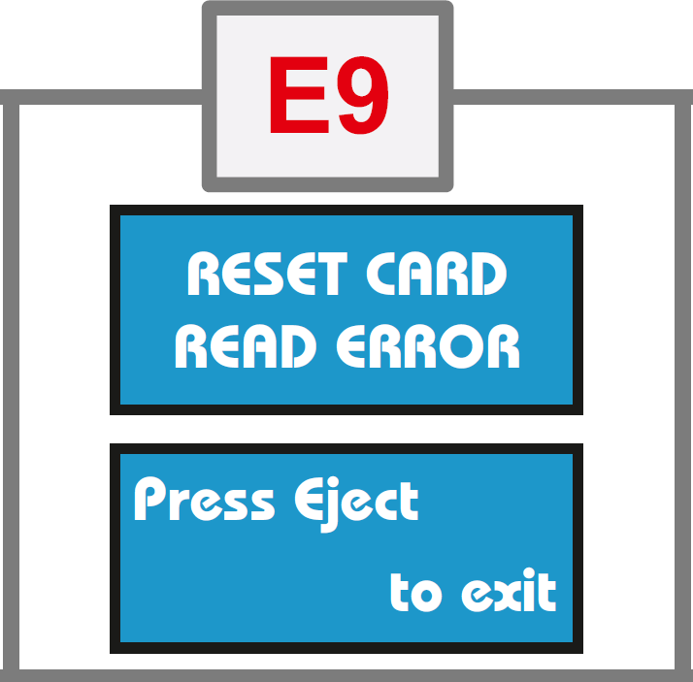 | Error 9: Reset Card Error  - Meaning: Problem with the reset card or QR code reader  - Solution: Contact Molbio support
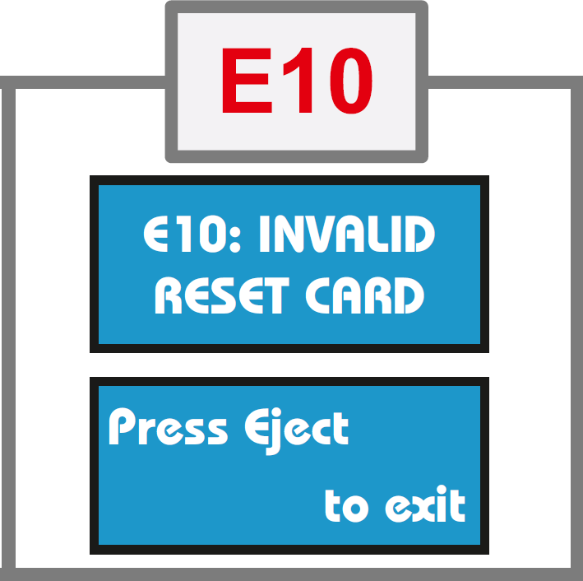 | Error 10: Invalid Reset Card  - Meaning: Problem with the reset card or QR code reader  - Solution: Contact Molbio support
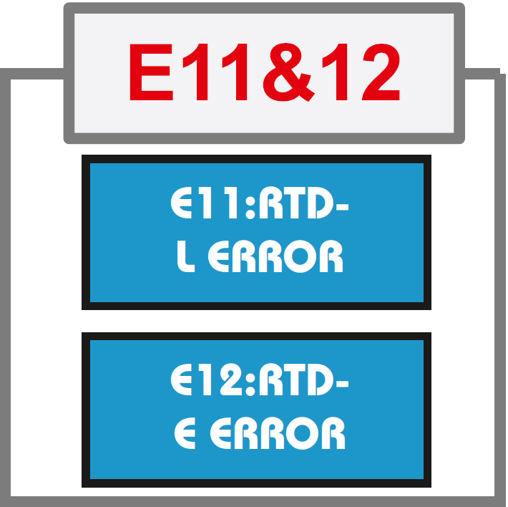 | Error 11: RTD-L Error  - Meaning: Device heater plates not working  - Solution: Contact Molbio support  Error 12: RTD-E Error  - Meaning: Device heater plates not working  - Solution: Contact Molbio support
Notes:
_________________________________________________________________________________________________________________________________________________________________________________________________________________________________________________________
Truelab Error Messages
Error 1: Runtime error  Error 2: Test stopped manually  Error 1: Probe check error  Error 1: Incorrect optical profile  Error 1: Thermal cycling error |  | Solution: Repeat the run using a fresh chip and reload the elute by pressing the repeat button. Follow user guidelines for proper loading of elute onto the white reaction well of the chip. Contact the Molbio support team if the problem persists.
INVALID |  | Meaning: Internal control did not amplify in PCR or improper sample extraction.  Solution: Process the sample again and run elute using another chip. If invalid again, request a fresh sample. Contact the Molbio support team if the problem persists.
Truelab Alert Messages
Meaning: Analyzer was unable to read chip memory.
Solution: Check if chip was loaded properly into the tray.
Remove the chip and re-select the profile from Status Screen and repeat the steps.
If message reappears, load a new chip and re-load the elute again.
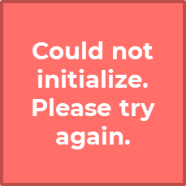 |  | Meaning: The system was unable to establish an internal connection.  Solution: Attempt the test again by using a new chip and re-loading the elute again.
Meaning: User loaded a used chip or expired chip in the tray.
Solution: Use a fresh chip and re-load the elute.

Activity: Fix the Error
Activity: Fix the Error Slide: 53
Directions: There are times when you are preparing for extraction with Trueprep that you will receive an error message. Work by yourself. Based on the situations below, choose the best method to fix the error. You have 10 minutes to complete the activity. Be prepared to share your answers with the class.
- You are preparing a sample and extracting DNA. You switch on the Trueprep AUTO v2 device and pull out the cartridge holder. You place your cartridge in the tray, close the door and receive a E3: Cartridge Clogged error. What does this error mean and what are your next steps?

_________________________________________________________________________________________________________________________________________________________________________________________________________________________________________________________
___________________________________________________________________________________
- You are extracting DNA using the Trueprep AUTO v2 device and receive an error message that says “cartridge clogged.” What does this mean and how do you fix it?
_________________________________________________________________________________________________________________________________________________________________________________________________________________________________________________________
___________________________________________________________________________________
- You are using the Trueprep AUTO v2 device when you receive an alert that says “unable to read chip information.” You know you have completed each step carefully, but continuously get this message. What should you do? What should you do if it happens again?

_________________________________________________________________________________________________________________________________________________________________________________________________________________________________________________________
___________________________________________________________________________________

Infrastructure Requirements
Power
Electricity
- Equipment is battery operated for up to 8 hours
- Electric or solar power required for re-charging
- Electric power allows charging and testing at the same time
- Devices are able to operate within the 100-240 voltage range
- Electrical power may be needed to cool rooms in areas where temperature exceeds 30C
Solar Power
- Panel: 150 Watts. Dimensions (LxWxH): 1490 x 665 x 35 mm
- Battery: 12V 18Ah Lead Acid
- Solar Charge Controller + DC to DC boost converter (12V to 170V, 100 Watts)
- Controller and converter available from Molbio; panel, battery and installation to be locally sourced
Room Layout
Room Layout
- Trueprep and Truelab instruments should be installed on a flat, stable surface
  - Minimum surface dimensions of 1.2 m by 0.6 m
- Install away from instruments that cause vibrations or electromagnetic interference
- Install away from machines that generate or radiate heat and out of direct sunlight
Three well-grounded electrical outlets are recommended for operating or charging the instruments at once
Ambient Temperature
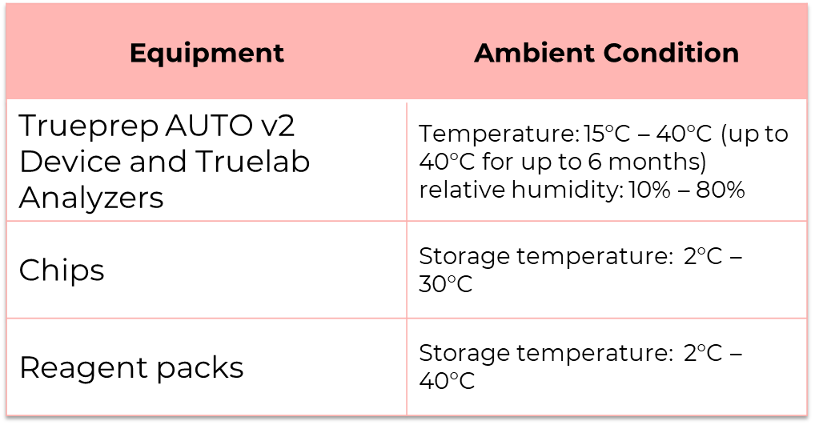
Dust
- The Truelab® Real Time micro PCR Analyzer does not require air intake to allow for the PCR process, so Truenat use will not be compromised in dusty settings.
- The manufacturer recommends installing the instruments in a dust-free environment when possible.
Biosafety
- Truenat TB tests require the same biosafety precautions as microscopy, Xpert MTB/RIF or TB-LAMP
  - Operate in a well ventilated room
  - Use of PPE (lab coats and gloves) per national guidelines
  - Biosafety cabinets are not needed
  - Follow recommendations for low-risk procedures from the WHO Tuberculosis Laboratory Biosafety Manual
- Take standard precautions in handling sputum samples, including:
  - Minimize aerosols
  - Open specimen containers carefully to avoid splatters and spills
  - Keep specimen containers upright
  - Decontaminate leaky containers with disinfectant
  - Wash hands
- Decontaminate samples and consumables prior to disposal by submerging used consumables in freshly prepared 0.5% sodium hypochlorite solution for 30 minutes. This includes TruenatTM chips, microtube, microtube cap, transfer pipette, pipette tips, reagent bottles, etc.
Security
- Equipment should be kept in a secure, lockable facility
- Equipment can be transported in the portable Truelab Real Time PCR Workstation Field case
Preventive Maintenance
- Daily maintenance
  - Clean work area
  - Discard used chips and cartridges
- Monthly maintenance
  - Disinfect instrument surfaces
  - Clean Truelab bays
  - Temperature calibration
  - Verification of the fixed 6µl pipette
- As necessary
  - Flush protocol for the Trueprep instrument
  - Spillage tray or linear motion guide tray replacement
  - Slider glass replacement -indicate bay
**An example of a Preventive Maintenance Log can be found in Annex 4 of the Truenat Implementation Guide

Recording Testing Activities
Recording Testing Activities
- May be necessary to revise the requisition forms (specimen examination request) for Truenat
- Laboratory and clinical registers may also need to be modified to record the results of Truenat tests
  - Forms and registers being used for the Xpert MTB/RIF test may be suitable for use with the Truenat TB tests.
    - Xpert MTB/RIF tests generate the same type of information as Xpert (e.g., MTB detected or not detected)
Notes:

_________________________________________________________________________________________________________________________________________________________________________________________________________________________________________________________

Warranty
Warranty Conditions
- To activate the warranty, the customer must fill and sign the installation report & warranty certificate and return the slip to Molbio Diagnostics Private Limited
- Molbio Diagnostics Private Limited, guarantees that all its instruments are free from manufacturing defects or faults.
- Molbio undertakes repair or free of charge substitution/replacement of spare part which may be found to have manufacturing defects.
- Repair and interventions carried out during the period of the warranty do not extend or renew the period of warranty.
- The repairs of the instrument will be carried out onsite (except in case of major repairs where the instruments will have to be shipped to Molbio’s head-office or Country Partner’s location) by Molbio’s authorized engineer/country partner representatives only.
- In the event Molbio is unable to repair the instruments onsite, it reserves the right to recall the instrument for repair at the head office/country partner locations if major/frequent problem has been observed in the instrument.
Termination of Warranty
The warranty shall be terminated at the end of the warranty period & also in the following cases:
- Where attempts to make repairs or alterations have been made by unauthorized person &/or with spare parts which are not originals.
- Alteration have been made to the serial number of the product on either the certificate or on the instrument.
- The instrument is transferred to a new location without following the appropriate processes as per Installation Qualification (IQ)/ Operational Qualification (OQ)/ Performance Qualification (PQ) or prior written approval from Molbio Diagnostics Private Limited or Molbio Country Partners
  - ***In order to transfer an instrument to a new location without termination of the warranty, contact Molbio/Molbio local partners to inform them and take their assistance. Molbio/Molbio local partners will request that you confirm that the new site will conform with the pre-installation requisites (see next slide). The pre-installation requisites will need to be checked again once the transfer has taken place.***
  - This point about transferring to a new location does not apply to a situation when an end user has initially installed the instruments in a mobile vehicle that moves from place to place, and the instruments remain installed on the same bench in the mobile vehicle
Preinstallation Requisites
Check for the following parameters with respect to location of installation:
- Workstation should be positioned on the workplace/table/workbench in an upright position on flat and dry surface.
- Installation site should be away from direct sunlight or any radiating or heating apparatus.
- Installation area should be free of devices which may cause vibrations or electromagnetic interference.
- Installation site should be free from any atmosphere of potentially explosive liquids, vapors and gas.
- Room temperature should be between 15ºC and 40ºC.
- Relative humidity (RH) should be between 10% - 80% (non-condensing).
- Power Supply minimum requirement is 100 to 240V/5Amps AC for all the devices as AC to DC adapters which are provided along with the device for charging an Inbuilt Battery can function.
- Check for Earthing Voltage which should be less than 5V
- Dimensions of our Devices are as Follows:
  - Trueprep Autov2: 215 mm x 235 mm x 115 mm
  - Truelab Quattro: 400 mm x 242 mm x 159 mm
  - Truelab Duo: 240 mm x 242 mm x 159 mm
  - Truelab UnoDX: 248 mm x 185 mm x 112 mm
- Table space requirement should be after taking other accessories like MicroTube stand, Cartridge stand, Thermal Printer (small Size) and MicroPipette (6uL) Stand also into consideration. Minimum table dimensions:
  - Truelab Duo Workstation with Accessories: 118 cm X 60 cm
  - Truelab Quattro Workstation with Accessories: 148 cm x 60 cm
Other Warranty Information
Validity and duration:
- This warranty shall be considered valid only on the condition that this certificate is accompanied by the installation report.
- The warranty is valid for a period of 12 months from the date of successful installation or 14 months from the date of invoice whichever is earlier.
The following damage & faults are not covered under this warranty:
- Damage deriving &/or originating from an insufficient or inadequate electric circuit or from the area where the instrument is set up & used.
- Breakdowns caused by careless handling, imprudence, lack of expertise & in any case caused by lack of skill or any degree of negligence on the part of the operator.
- Damage, defects & faults deriving from unexpected events, accidents during transport by the purchaser, due to FORCE MAJEURE & in any case, due to situation which can in no way be attributed to manufacturing &/or material defects.
- Molbio shall accept no responsibility whatsoever for damage either directly or indirectly to persons or materials from the use of the instrument.

Notes:

_________________________________________________________________________________________________________________________________________________________________________________________________________________________________________________________

Summary
Summary
Truenat TB test is a chip-based Real-Time Polymerase Chain Reaction (PCR) test that involves the following steps:
- A sputum specimen is liquefied lysed.
- The DNA from the sample is then extracted.
- The extracted DNA is amplified.
- The amplified DNA is tested.
Three pieces of equipment are used for Truenat:
- Trueprep
- Truelab (Uno, Duo, or Quattro)
- Optional micro PCR printer
Procedures for operating Truenat are summarized in an easy-to-follow job aid
Truenat equipment requires minimal infrastructure and minimal preventive maintenance
Notes:

_________________________________________________________________________________________________________________________________________________________________________________________________________________________________________________________

Knowledge Check
Notes:
____________________________________________________________________________________________________________________________________________________________________________________________________________________________________________________________________________________________________________________________________________________________________________________________

Module 4: Order Planning and Quality Assurance (QA) and Control

Session Focus
Introduction
In this session, we will learn how to:
- Explain how to forecast for Truenat supplies.
- List the key elements of good stock management.
- Identify some quality assurance procedures for Truenat testing.

Reagents and Consumables
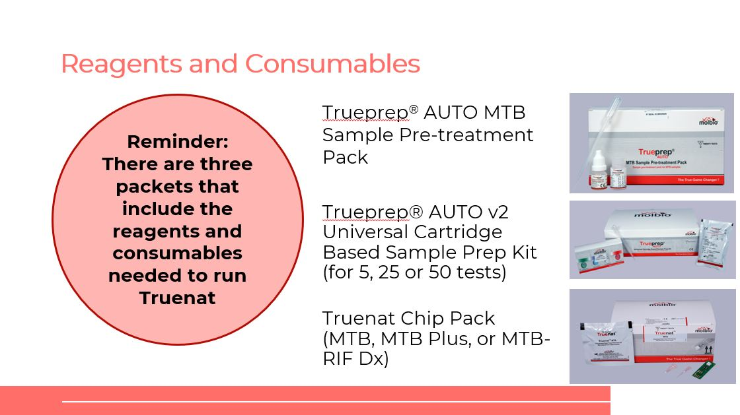

Forecasting and Quantification
Reagents and Consumables
Reagents and disposables are required for Truenat testing. When you are ordering reagents and consumables there are several questions you should answer. The questions are:
- What to order?
- From where?
- How much?
- How often?
- How to assess the correctness of an order?
- What is the reserve (buffer) stock needed?
- Who is responsible for placing orders?
Notes:
____________________________________________________________________________________________________________________________________________________________________________________________________________________________________________________________________________________________________________________________________________________________________________________________
Pricing
Pricing of equipment, reagents and service packages through Stop TB Partnership’s Global Drug Facility (GDF) is outlined in the GDF Diagnostics Catalog.
Notes:
____________________________________________________________________________________________________________________________________________________________________________________________________________________________________________________________________________________________________________________________________________________________________________________________
Storage Conditions and Shelf-Life of Consumables
The chart below explains the storage conditions and shelf-life of consumables.
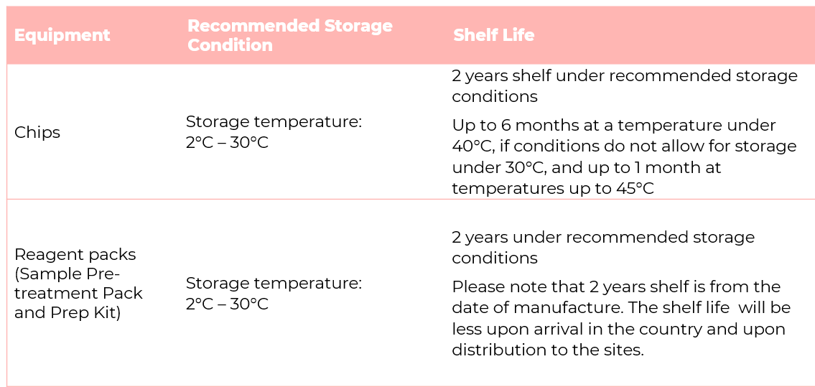
Notes:
____________________________________________________________________________________________________________________________________________________________________________________________________________________________________________________________________________________________________________________________________________________________________________________________
Quantities for an Initial Order of Reagents
This table shows the number of reagents to order for one year of testing based on planned average number of tests per day in 260 working days.
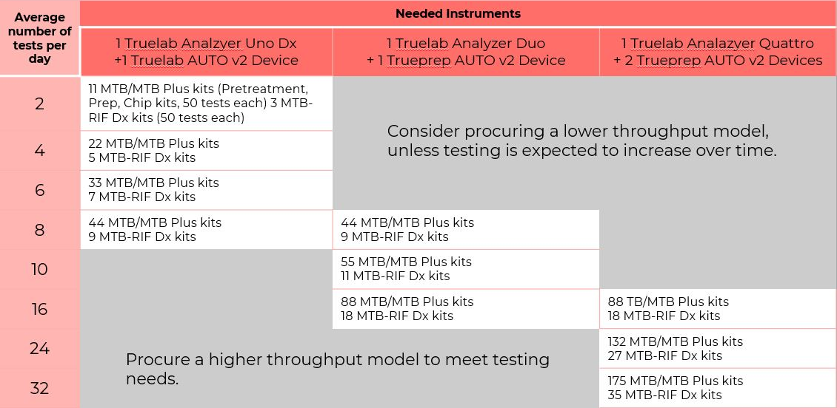
Notes:
_______________________________________________________________________________________________________________________________________________________________________________________________________________________________________________________________________________________________________________________________
Data Needed for Regular Forecasting
_____________________________________
Order Quantities
How to calculate how much to order of any supply that requires 1 item per test:**
- Calculating how much to order:
  - a = quarterly (or other unit) number of tests performed (e.g, 210 tests)
  - b = number of months in a quarter (or other unit) (e.g, 3 months)
  - c = average usage per month (a ÷ b) (e.g, 210 ÷ 3 = 70 tests per month)
  - d = lead time (e.g, 4 months)
  - e = stock in-hand (e.g, 80 cartridges)
  - f = recommended buffer stock (2 months average usage = 140 tests)
- Minimum quantity to order: (c × d) – e + f = (70 × 4) – 80+140 = 340 cartridges.

**The number of MTB-RIF Dx kits to order will depend on the anticipated proportion of people tested that will be MTB positive, and therefore in need of a test for rifampicin resistance.
Notes:
____________________________________________________________________________________________________________________________________________________________________________________________________________________________________

Activity: Calculating Metrics
Quarterly Supply Requirements for Truenat Testing
Laboratory: Regional Reference Laboratory
Region: Western Region |  |  | Supply Quarter 3
District: Urban |  |  | Year: 2021
Total MTB tests performed in previous quarter, including failed tests (A): 630
Item | Quantity Needed per Test (B) | Stock for one month (C) = (A/3) * B |  | Buffer stock requirement  (2 months average usage) | Stock for quarter with 1 month buffer (D)= C*4 | Stock on hand (E) | Calculated request (F) = D-E | Order unit (G) | Actual order (H) = F/G (round up)
Trueprep® AUTO MTB Sample Pre-treatment Pack |  |  |  |  |  | 450
Trueprep® AUTO v2 Universal Cartridge Based Sample Prep Kit (for 25 tests) |  |  |  |  |  | 420
Truenat MTB Chip Pack |  |  |  |  |  | 300

Notes:
____________________________________________________________________________________________________________________________________________________________________________________________________________________________________________________________________________________________________________________________________________________________________________________________

Stock Management
Stock Management
There are six key components to maintain adequate stock of Truenat supplies.
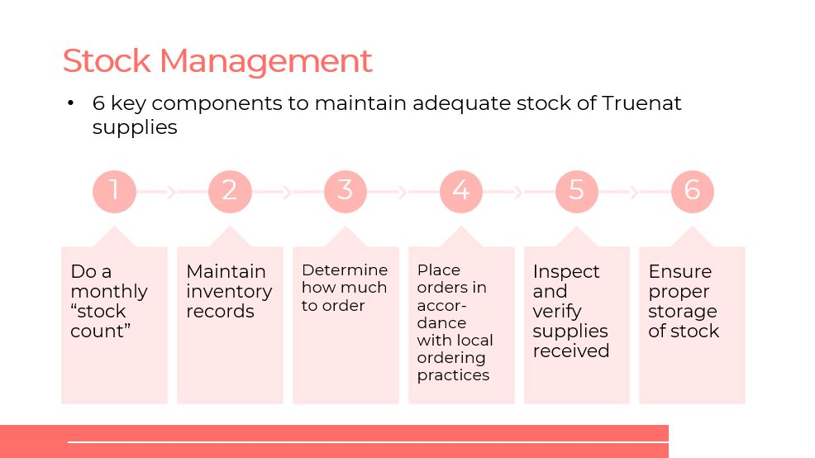
Notes:
____________________________________________________________________________________________________________________________________________________________________________________________________________________________________

Stock Management: Stock Log
Notes:
____________________________________________________________________________________________________________________________________________________________________________________________________________________________________
Stock Management: Temperature and Shelf Life
- Recommended storage conditions for the Truenat TB chips: 2°C–30°C.
- Shelf-life of reagents under recommended storage conditions: 2 years (at date of manufacture).
  - GDF-negotiated minimum shelf life at time of readiness for delivery is 19 months.

Notes:
____________________________________________________________________________________________________________________________________________________________________________________________________________________________________
Stock Management: Storage and Expiry
Organize existing and new shipments by the expiry date
Notes:
____________________________________________________________________________________________________________________________________________________________________________________________________________________________________

Quality Assurance and Control
QA and Control
Discussion Question: What types of quality control processes do you currently institute in your lab that would be relevant to Truenat?
________________________________________________________________________________________________________________________________________________________________________________________________________________________________________________________________________________________________________________
Roles in Ensuring Quality
- Laboratory manager is responsible for overseeing QA activities at larger facilities.
- The Health Facility Quality Committee (HFQC) may provide oversight and coordination for QA activities at larger facilities.
Notes:
____________________________________________________________________________________________________________________________________________________________________________________________________________________________________________________________________________________________________________________________________________________________________________________________

Quality Assurance Program
**A comprehensive discussion of the essential elements of a quality assurance program for any rapid TB diagnostic test may be found in the GLI Practical Guide to Implementing a Quality Assurance System for Xpert MTB/RIF Testing
Quality Assurance Program Components
Standardized documents
Use of good molecular biology practices
Competency assessment
Internal quality controls
External quality assessment (EQA)
On-site supervision
Continuous quality improvement processes
Notes:
____________________________________________________________________________________________________________________________________________________________________________________________________________________________________________________________________________________________________________________________________________________________________________________________
Good Molecular Biology Practices
- The Truenat TB test procedures require multiple hands-on steps as well as precision micro-pipetting.
- Laboratory technicians should be trained on good molecular biology practices before operating Truenat.
- One procedure that requires special care in training technicians is the micropipetting/dispensing of 6μl of DNA eluate solution into the well of the Truenat chip: a “steady hand” may also be an asset.
Notes:
____________________________________________________________________________________________________________________________________________________________________________________________________________________________________________________________________________________________________________________________________________
Competency Assessment
- Competency assessments of laboratory technicians should be performed after training and periodically (annually).
- The positive and negative controls in the Truenat Positive Control Kit-Panel I can be used for competency testing during hands-on training.

Notes:
____________________________________________________________________________________________________________________________________________________________________________________________________________________________________________________________________________________________________________________________________________
Standardized Documents (SOPs)
- SOPs should be provided as reference materials for technicians
- Job aids are available in Annex 11 of the Truenat Implementation Guide:

Notes:
_________________________________________________________________________________________________________________________________________________________________________________________________________________________________________________________
Internal Quality Control (IQC)
- Internal quality controls are designed to detect, prevent, and minimize erroneous results in laboratories’ internal processes from pre-analytical, analytical and post-analytical phases.
- Truenat TB assays incorporate an internal positive control that undergoes the same processes as the specimen; from extraction to amplification, thereby assessing the validity of the test run from sample to result.
- The positive and negative controls in the Truenat control kit panel can also be used for lot-to-lot verification and assessment of reagents if the temperature of storage areas falls outside of the recommended ranges.

Notes:
_________________________________________________________________________________________________________________________________________________________________________________________________________________________________________________________
External Quality Assessment (EQA)
- External quality assessment programmes for Truenat are not yet available.
- EQA should include proficiency testing (PT) or blinded rechecking during assessments.
  - It can be modeled after the proficiency testing programme used for the Xpert MTB/RIF test.
  - At least 10-15 specimens per week should be tested to maintain proficiency of staff conducting the Truenat TB tests.

Notes:
____________________________________________________________________________________________________________________________________________________________________________________________________________________________________________________________________________________________________________________________________________
Initial Calibration/ Verification Panels
New Lot Testing (Lot-to-Lot Verification)
- Controls can be purchased as part of the Truenat Positive Control Kit-Panel 1.
Positive and Negative Controls
- Run positive and negative controls whenever:
  - A new shipment of Truenat TB test kits is received.
  - For each new test kit lot
  - To assess reagents if temperature of storage areas falls outside of recommended ranges
Maintaining and Monitoring QC Records of Lot Testing
- Review by testing site manager
- Retention onsite for a period according to local or national policy
Notes:
____________________________________________________________________________________________________________________________________________________________________________________________________________________________________________________________________________________________________________________________________________________________________________________________

Test Validity
The Truenat TB assays incorporate an internal positive control that undergoes all the processes that the specimen undergoes, from extraction to amplification, thereby assessing the validity of the test run from sample to result.
Notes:
________________________________________________________________________________________________________________________________________________________________________________________________________________________________________________________________________________________________________________
Regular Maintenance
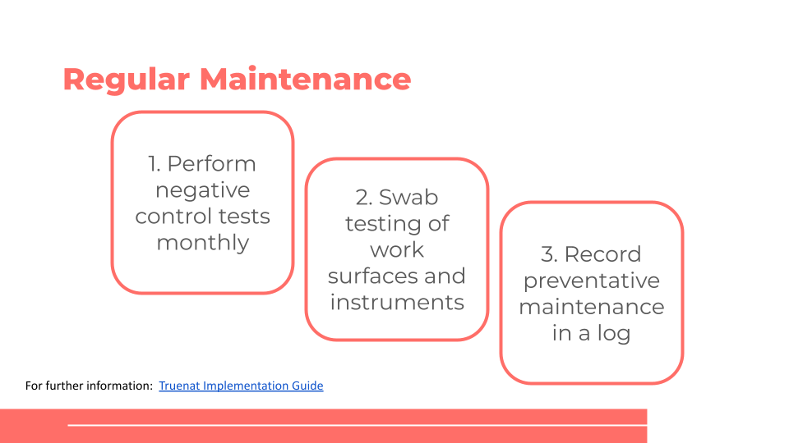

Notes:
____________________________________________________________________________________________________________________________________________________________________________________________________________________________________________________________________________________________________________________________________________________________________________________________
Warranty and Repair
1, 2, 3, 4, and 5-year extended warranties are available from Molbio for $1,220 per year through GDF
- Comprehensive maintenance contract includes:
  - Remote assistance/visit of service engineer
  - Repair and replacement of parts
  - In country travel and labor of company’s local agent
  - Calibration chips and material which is used as service items
Notes:
____________________________________________________________________________________________________________________________________________________________________________________________________________________________________________________________________________________________________________________________________________________________________________________________

Monitoring Quality
General Laboratory Performance Indicators
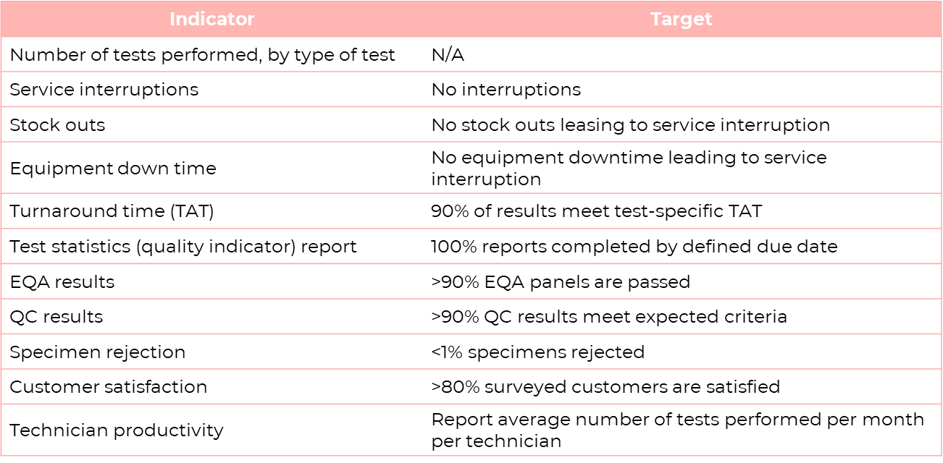
Performance Indicators for Truenat TB Tests
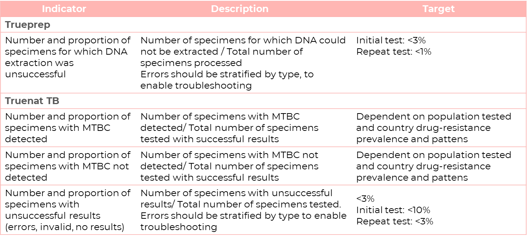
Notes:
____________________________________________________________________________________________________________________________________________________________________________________________________________________________________________________________________________________________________________________________________________
Performance Indicators for Truenat TB Tests
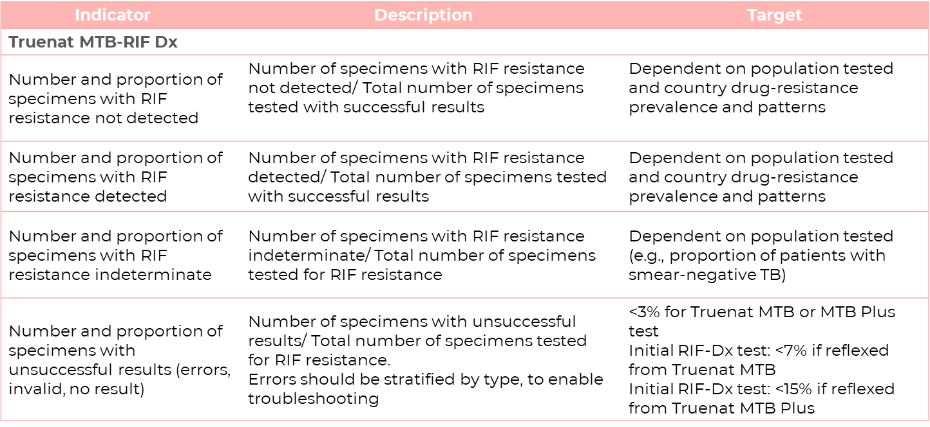
Notes:
____________________________________________________________________________________________________________________________________________________________________________________________________________________________________________________________________________________________________________________________________________
Performance Indicators for Monitoring Patient and Sample Flow
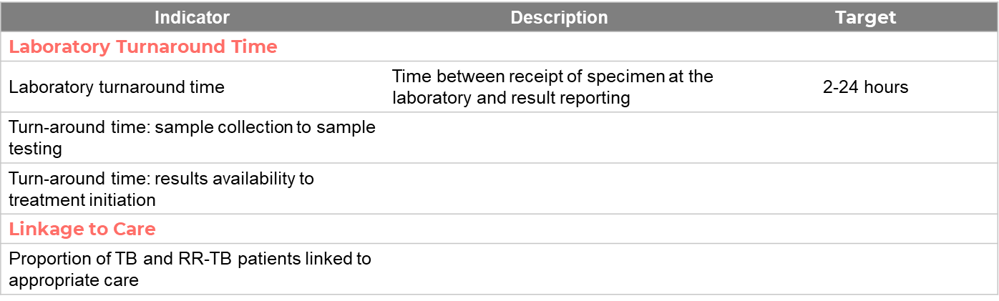
Discussion Question: What targets would you set for these indicators?
____________________________________________________________________________________________________________________________________________________________________________________________________________________________________________________________________________________________________________________________________________

Summary
Summary
Forecasting and Quantification
- It is important to monitor inventory, ensure supplies have not expired and forecast for consumables.
Quality Assurance and Control
- There are procedures and programs that allow for oversight and coordination of QA activities.
Monitoring Quality
- Performance indicators help track and monitor each testing site to ensure tasks are carried out appropriately and at high quality.
Notes:
____________________________________________________________________________________________________________________________________________________________________________________________________________________________________________________________________________________________________________________________________________

Knowledge Check
Notes:
____________________________________________________________________________________________________________________________________________________________________________________________________________________________________________________________________________________________________________________________________________________________________________________________

Module 5: Monitoring and Evaluation (M&E)

Session Focus
Introduction
In this session, we will learn how to:
- Outline a general approach to monitoring and evaluating the impact of Truenat on TB-related targets and goals.

M&E for Truenat
M&E for Truenat
- Integration of Truenat should help a country meet its existing targets for case detection, bacteriological confirmations, drug resistance testing, etc.
- If adding Truenat does not help to achieve these targets, then either the targets need to be revised a different solution is needed.
Discussion Question: What targets will introducing Truenat help achieve?
________________________________________________________________________________________________________________________________________________________________________________________________________________________________________________________________________________________________________________
QA vs M&E
- The QA indicators described in the previous module should be used to monitor performance of the instruments.
- Impact indicators described in this module should be used to monitor and evaluate progress towards achieving broader goals of the health system related to TB.
- Both sets of indicators should be considered when developing a recording and reporting system and plans for reviewing data.
Notes:
____________________________________________________________________________________________________________________________________________________________________________________________________________________________________________________________________________________________________________________________________________

Indicators
Monitoring Outcomes and Impact – Key Indicators
Key Indicators
- Key indicators and milestones to monitor the implementation process of Truenat should be identified at the outset.
- High-level checklist in Annex 2 of the Truenat Implementation Guide may be useful for monitoring implementation and introduction of Truenat.
- Utilization (the rate or number of tests ordered) of Truenat testing services should be tracked once the instruments are introduced to determine if clinical staff at all sites that should offer the test, actually order the test.
Notes:
____________________________________________________________________________________________________________________________________________________________________________________________________________________________________________________________________________________________________________________________________________

WHO Indicators for Laboratory Strengthening
WHO Indicators for Laboratory Strengthening | WHO Target
Percentage of notified new and relapse TB cases testing with a WHO-approved rapid diagnostic test (WRD) as the initial diagnostic test (End TB Strategy Laboratory Indicator 2) | 80% (2020)
Percentage of notified new and relapse TB cases with bacteriological confirmation (Indicator 3) | 80% [relapse: 90%] (2020)
Percentage of testing sites using a WRD at which a data connectivity system has been established that transmits results electronically to clinicians and to an information management system (Indicator 4) | 100% (2020)
Percentage of notified bacteriologically confirmed TB cases with DST results for RIF (Indicator 7) | 100% (2020)
Percentage of notified RIF-resistance TB cases with DST results for fluroquinolones and second-line injectable agents (Indicator 8) | 100% (2020)

Notes:
____________________________________________________________________________________________________________________________________________________________________________________________________________________________________________________________________________________________________________________________________________________________________________________________

Other Possible Impact Indicators
Proportion of specimens collected for WRD testing for which a result was received by the ordering clinician within the specified target time (i.e., time from collection of a specimen to receipt of results
Number and proportion of presumptive TB patients for whom test results are reported to the clinician and that are notified of the result
Number and proportion of presumptive TB patients for whom a test is conducted and for whom test results are reported to the clinician
Number and proportion of presumptive TB patients whose specimen is received at the testing laboratory and for whom a test is conducted
Number and proportion of presumptive TB patients for whom a specimen is collected and whose specimen is received at the testing laboratory
Number and proportion of presumptive TB patients for whom a test is ordered and who provide a specimen for testing
Number and proportion of presumptive TB patients that reach a diagnostic center and for whom a TB test is ordered
Number and proportion of presumptive TB patients that have been tested with a WRD
Proportion of the population that has access to WRD within a 5-kilometer distance
Number and proportion of estimated TB patients that are evaluated for TB (i.e., reach a diagnostic center)

Notes:
____________________________________________________________________________________________________________________________________________________________________________________________________________________________________
________________________________________________________________________________________________________________________________________________________
Diagnostics Connectivity
- Software can rapidly and automatically calculate many of the key performance indicators and facilitate the M&E process.
- Third-party connectivity software platform (Aspect and DataToCare) companies are currently working to allow for smooth flow of data to these platforms​.
- Digital results reporting can be used to send data to national servers for M&E and surveillance purposes​.
Notes:
____________________________________________________________________________________________________________________________________________________________________________________________________________________________________________________________________________________________________________________________________________
Progress toward achieving WHO indicators for laboratory strengthening should be measured to assess the impact of Truenat.
Other indicators may also be selected by national programs to supplement WHO indicators.

Summary
Summary
Monitoring and Evaluating the Impact of Truenat
- Progress toward achieving WHO indicators for laboratory strengthening should be measured to assess the impact of Truenat.
- Other indicators may also be selected by national programs to supplement WHO indicators.
Notes:
____________________________________________________________________________________________________________________________________________________________________________________________________________________________________________________________________________________________________________________________________________

Knowledge Check
Notes:
____________________________________________________________________________________________________________________________________________________________________________________________________________________________________________________________________________________________________________________________________________________________________________________________

Module 6: Biosafety and Specimen Collection and Referral

Session Focus
Introduction
In this session, we will learn how to:
- Demonstrate good biosafety practices when using Truenat
- Collect and pretreat a sputum sample
- Describe storage requirements for collected specimens
- Describe packaging of specimens for transportation
- Understand the process for specimen referral

Biosafety Measures and Risks
General Principles of Biosafety
Biosafety has three key parts, all of which are needed to handle TB bacilli safely:
- Primary: Safe working practices to minimise creation of infectious aerosols and prevent spills Equipment that is ‘fit for purpose’, correctly used and maintained
- Secondary: Infrastructure and layout to support the primary activities
- Tertiary: Buildings to contain the laboratory and its activities

Importance of Biosafety
The level of biosafety risk depends on:
- Type of procedure
- Workload
- Consistency
- Bacillary load
The main procedural risk in a TB laboratory is the generation of aerosols.

Notes:
____________________________________________________________________________________________________________________________________________________________________________________________________________________________________________________________________________________________________________________________________________________________________________________________

Assessing Risk
Risk Biosafety Levels
The primary risks that determine levels of containment are:
- Infectivity
- Severity of disease
- Transmissibility
- Nature of the work conducted
- Origin of the microbe or the agent in question
- Route of exposure

Characteristics of Biosafety Levels / Biosafety Measures
Notes:
________________________________________________________________________________________________________________________________________________________________________________________________________________________________________________________________________________________________________________________________________________________________________________________________________________________________________________________________________________________________________________________________________________________________________________________________________________________________________________________________________

Laboratory Infrastructure
Ventilation and Laboratory Setup
- A biosafety cabinet is not essential for Truenat testing on sputum.​
- When climate prevents windows from being opened, considerations should be given to using mechanical ventilation systems, e.g., exhaust fans
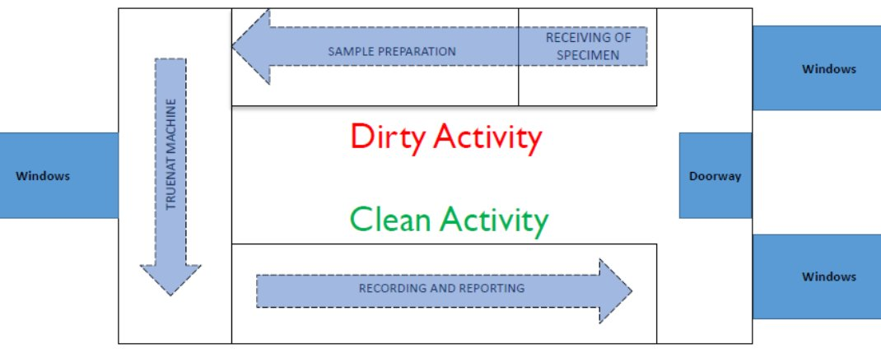
Notes:
____________________________________________________________________________________________________________________________________________________________________________________________________________________________________________________________________________________________________________________________________________________________________________________________

Personal Protective Equipment
Matrix of Recommended PPE According to Activity
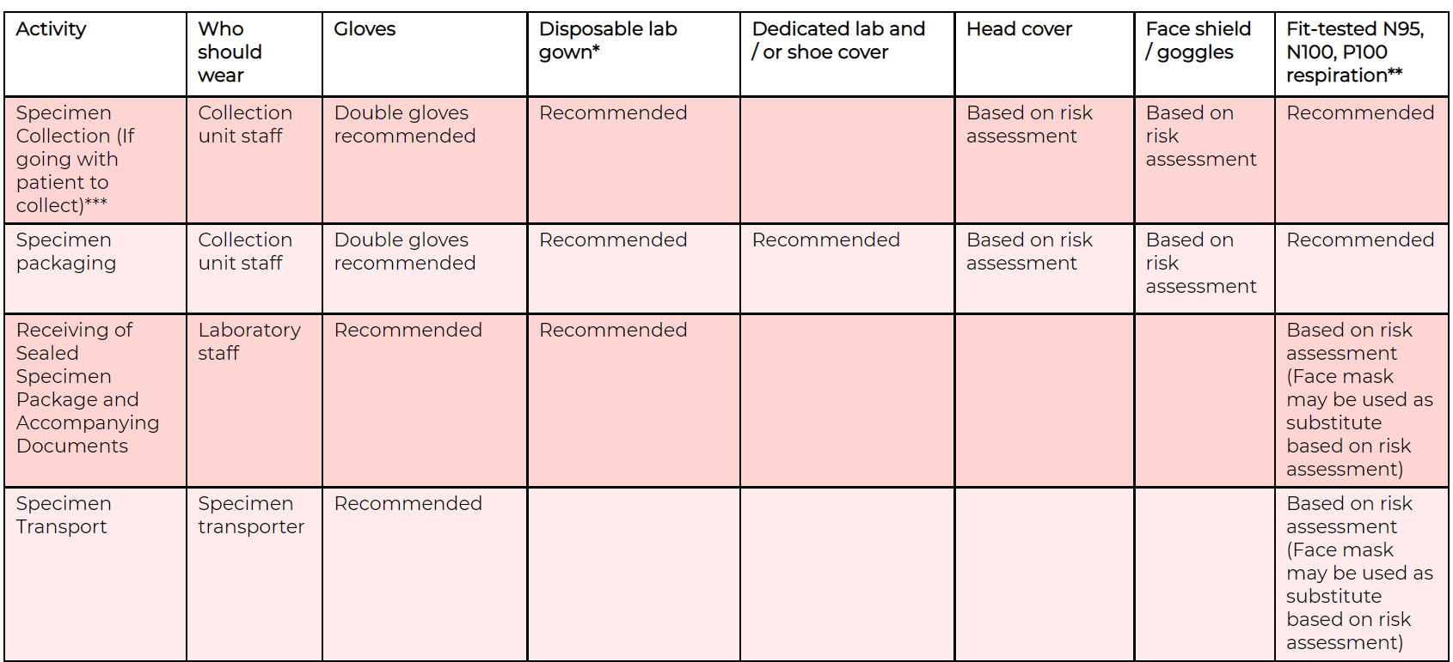
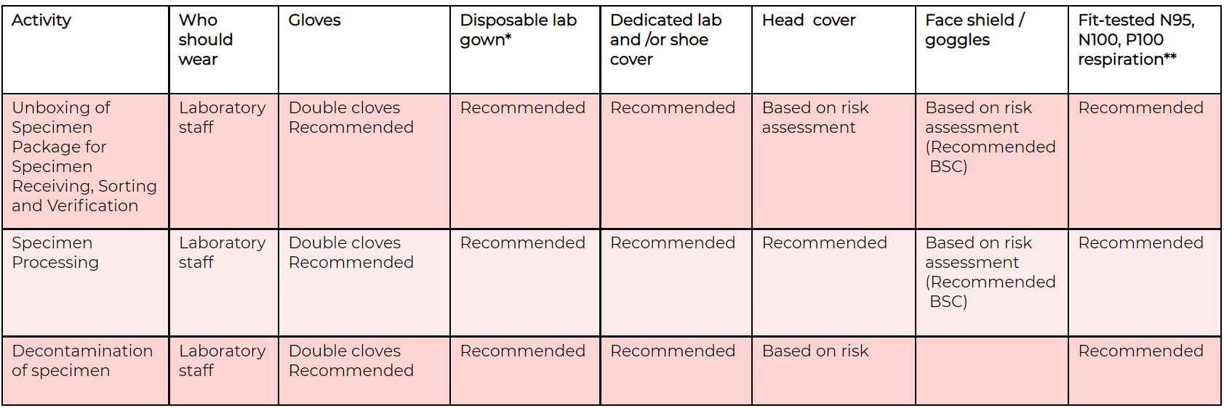
Notes:
___________________________________________________________________________________________________________________________________________________________________________________________________________________________________________________________________________________________________________________________________________________________________________________________
Proper Order of Donning PPE
Notes:
___________________________________________________________________________________________________________________________________________________________________________________________________________________________________________________________________________________________________________________________________________________________________________________________
PPE: Gloves and Shoes, Laboratory Coat and Gown, Respirators and Masks, Face Shields and Goggles
Notes:
___________________________________________________________________________________________________________________________________________________________________________________________________________________________________________________________________________________________________________________________________________________________________________________________

Biosafety Cabinets
Biosafety Cabinets
Biosafety cabinets are categorized as Class I, Class II or Class III​
- Class II BSCs draw around 70% of purified air from the HEPA filter above the work area and around 30% air through the front grille.​
- Class II provides protection for the user, environment and the work area.​
- There are four types of Class II: A1, A2, B1 and B2​
  - Class II, Type A2 BSCs are recommended for all TB work; however, they are not necessary for Truenat
Notes:
___________________________________________________________________________________________________________________________________________________________________________________________________________________________________________________________________________________________________________________________________________________________________________________________
Performing Tests without BSC
Point of care assays, like Truenat, can be performed on the bench without BSC when local risks dictate that the following conditions are met:​
- Absorbent liner​
- Well-ventilated windows​
- Appropriate PPE​
- Well-trained staff on GMP​
- No rush or increase pressure in TAT​
- Validated infectious process is in place
Notes:
___________________________________________________________________________________________________________________________________________________________________________________________________________________________________________________________________________________________________________________________________________________________________________________________

Generation and Prevention of Aerosols
Generating Aerosols
High-risk procedures and practices that may increase the potential of creating aerosols (which then become droplet nuclei) include
- Mechanical (vortexing, centrifugation, shaking)
- Pouring/tipping
- Pipetting
Notes:
___________________________________________________________________________________________________________________________________________________________________________________________________________________________________________________________________________________________________________________________________________________________________________________________
Minimizing Aerosol Formation
Allow enough contact time of liquefaction buffer to sample, including adequate standing time, which ensures:
- Adequate liquefaction of samples will enable complete exposure of TB bacilli to lysis buffer​
- Pipettable consistency of the sample to prevent forceful pipetting​
- Settlement of aerosols possibly produced during swirling/gentle mixing
Steps for minimizing aerosol formation:
- Do not forcibly expel air from a pipette when aspirating the liquefied and lysed sputum sample
- Place the pipette against the inner wall of the lysis buffer bottle when dispensing liquified sputum sample
- Do not forcibly expel lysis buffer sample while dispensing into the cartridge
Notes:
___________________________________________________________________________________________________________________________________________________________________________________________________________________________________________________________________________________________________________________________________________________________________________________________

Managing Spills
Managing and Responding to Spills
Recommended spill kit contents:
- Laboratory gowns (disposable) and goggles
- Box of gloves (different sizes) and respirators (N95/FFP2)
- Paper towel, cotton wool or absorbent cloth
- Soap and chloramine tablets
- Dustpan and sharp container

Commonly Used Disinfectants for Spills
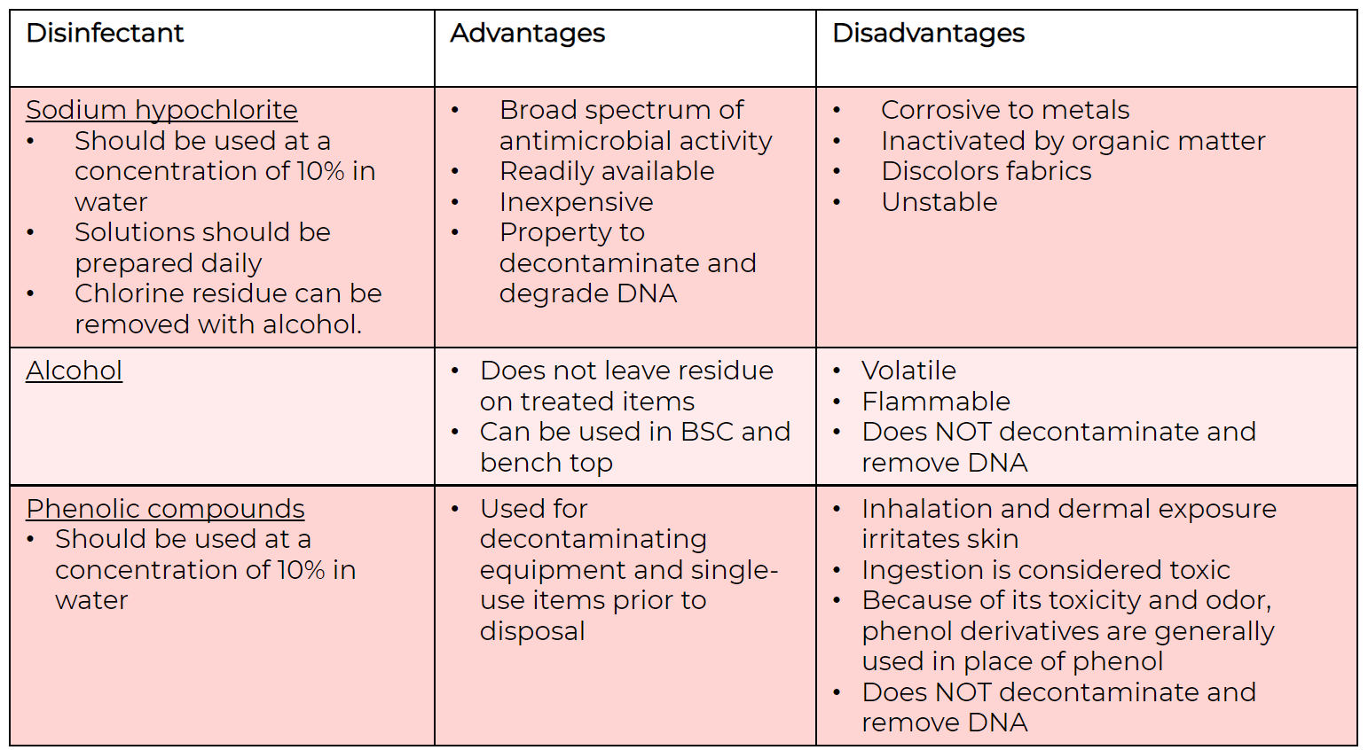
Notes:
____________________________________________________________________________________________________________________________________________________________________________________________________________________________________________________________________________________________________________________________________________________________________________________________

Waste Disposal
Laboratory Waste Management & Disposal
- Where decontamination cannot be performed in the laboratory area or onsite:
- Package the contaminated waste in an approved (sealed and leak-proof) manner for transfer to another facility with decontamination capacity.
- Handle waste from testing (suspected or confirmed) TB patients as all other biohazardous waste in the laboratory.
- Completely soak waste materials in a 1:10 dilution of household bleach
- Disposal should be carried out following existing local and national regulations on management of healthcare waste
All materials used should be considered contaminated!

Notes:
____________________________________________________________________________________________________________________________________________________________________________________________________________________________________________________________________________________________________________________________________________________________________________________________
Mental Checklist for Biosafety and Risk Management
- Correct PPE
- Adequate collection supplies
- Collect the appropriate specimen
- Use appropriate collection material/equipment
- Practice IPC during/after collection
- Label specimen
- Decide where to test
- In house or refer? Referral contact and process
- Adequate material for storage
- Adequate material for packaging and shipping
- Labels and documentation
- Appropriate handling of medical waste
Notes:
____________________________________________________________________________________________________________________________________________________________________________________________________________________________________________________________________________________________________________________________________________________________________________________________

Useful Biosafety Resources
- WHO Tuberculosis Laboratory Biosafety Manual; Available at: https://www.who.int/publications/i/item/9789241504638
- WHO Laboratory Biosafety Manual, 4th Edition; Available at: https://www.who.int/publications/i/item/9789240011311
- CDC Biosafety in Microbiological and Biomedical Laboratories (BMBL), 6th Edition; Available at: https://www.cdc.gov/labs/pdf/SF__19_308133-A_BMBL6_00-BOOK-WEB-final-3.pdf

Specimen Collection Procedures
Specimen Collection
Collecting a Good Quality Specimen
- Induced or expectorated sputum samples may be used
- Spot and morning sputum samples can be collected from each patient
- Algorithm describes the collection of one initial specimen to be used for Truenat TB testing and the collection of additional specimens as needed
- Sputum samples with contaminants such as betel nut, khat, tobacco, or food particles should be rejected.

Notes:
____________________________________________________________________________________________________________________________________________________________________________________________________________________________________________________________________________________________________________________________________________________________________________________________
Packaging and Storing the Specimen
All samples should be triple-packaged:
- Primary packaging
  - Wrap the leak-proof container in cotton wool or paper towels in a sufficient quantity to absorb the entire contents in case of leaks
- Secondary packaging
  - Place the wrapped container inside a secondary container, such as a self-sealing plastic bag or another container
  - Place secondary container in a rack to prevent leakage
- Tertiary packaging
  - Place the secondary container and its contents in an approved safety cooler box or another appropriate container in an upright position
  - Place a biohazard sign – with markings and labelling appropriate for the specimen category – on the tertiary container
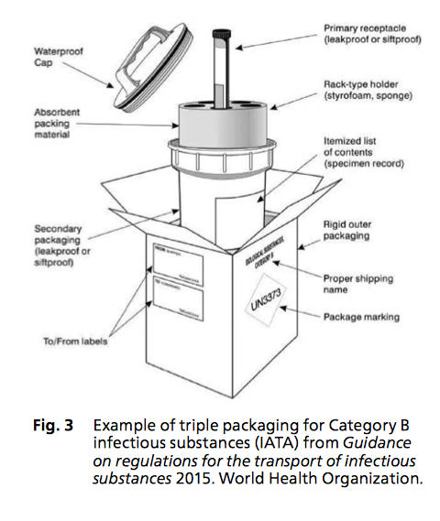
- Samples should be stored in the fridge or a coolbox between 2°C to 8°C and transported to the testing lab.

Specimen Referral
Lab Forms
Notes:
____________________________________________________________________________________________________________________________________________________________________________________________________________________________________________________________________________________________________________________________________________________________________________________________
Integrated Specimen Referral Systems
- A specimen referral system may need to be developed for Truenat.
- Truenat testing should be incorporated into larger diagnostic network specimen referral system.
- GLI’s Guide to TB Specimen Referral Systems and Integrated Networks provides guidance on establishing integrated solutions for specimen referral.
Notes:
____________________________________________________________________________________________________________________________________________________________________________________________________________________________________________________________________________________________________________________________________________________________________________________________
Specimen Referral Transportation
- During transportation, samples should be kept between 2°C to 8°C in ice packs.
Results Reporting
- Electronic reporting of didital results should be used where available followed by paper reporting
- Truenat testing sites MUST ensure that results are transmitted back to the requesting site or community HCW (no GX)
Notes:
____________________________________________________________________________________________________________________________________________________________________________________________________________________________________________________________________________________________________________________________________________________________________________________________
Questions to Consider about Sample Flow
How are patients referred for TB screening and testing? Are patients referred from the community to the facility for TB Testing?
____________________________________________________________________________________________________________________________________________________________________________________________________________________________________________________________________________________________________________________________________________________________________________________________
Are samples collected at the community level and transported to the facility for testing or are they testing at the community level and TB patients referred to the facility for TB/DR-TB Rx initiation?
____________________________________________________________________________________________________________________________________________________________________________________________________________________________________________________________________________________________________________________________________________________________________________________________
How are diagnosed patients referred for TB/DR-TB clinical monitoring?
____________________________________________________________________________________________________________________________________________________________________________________________________________________________________________________________________________________________________________________________________________________________________________________________
Example of a Sample Referral System
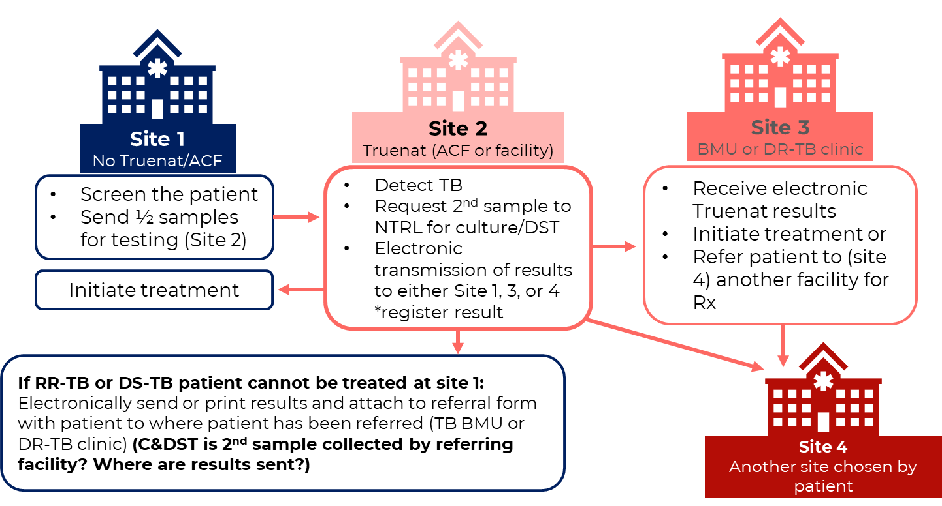
Notes:
____________________________________________________________________________________________________________________________________________________________________________________________________________________________________________________________________________________________________________________________________________________________________________________________

Summary
Summary
Biosafety​
- Biosafety is the safe handling and containment of infectious microorganisms and hazardous biological materials.​
- The main procedural risk in a TB laboratory is generation of aerosols.​
- Use of engineering controls, PPE, and administrative controls are important components of TB laboratory biosafety.
Specimen Collection​
- Procedures for completing lab request forms, sputum collection, packaging, storage, and transportation is by collecting good quality specimens, using the algorithm to describe the collection of specimen and results reporting. ​
Specimen Referral​
- When a specimen is not collected on site, you must store at the collection site following the appropriate temperature and transportation process.
Notes:
____________________________________________________________________________________________________________________________________________________________________________________________________________________________________________________________________________________________________________________________________________________________________________________________

Knowledge Check
Notes:
____________________________________________________________________________________________________________________________________________________________________________________________________________________________________________________________________________________________________________________________________________________________________________________________

