Computer-Assisted Detection of Tuberculosis using Ultra-Portable X-Ray
Central-Level Training
Facilitator’s Guide

Table of Contents

Table of Contents 2
Introduction 4
Training Schedule 4
Customizing this Training 4
Training Format 5
Facilitator Preparation 5
Course Introduction 6
Module 1: WHO Guidance on TB Screening for Early Case Finding: Recommended Tools and Algorithms 7
Target Audience 7
Learning Objectives 7
Materials 7
Advance Preparation 7
Lesson Plans 7
Introduction 8
TB Context 9
TB Screening Tools 12
TB Screening Algorithms Overview 16
Country TB Context 19
Plenary Session 21
Summary 22
Knowledge Check 23
Module 2: New Tools for TB Screening: Introduction to Computer-Aided Detection (CAD) and Ultra-Portable X-Ray 25
Target Audience 25
Learning Objectives 25
Materials 25
Advance Preparation 25
Introduction 26
Computer-Aided Detection (CAD) Software for Screening and Triage of TB 28
CAD Products in the GDF Catalogue 35
Introducing Ultra-Portable X-Ray 39
Delft Light 40
Summary 43
Knowledge Check 43
Module 3: Program Planning and Implementation Considerations 46
Target Audience 46
Learning Objectives 46
Materials 46
Advance Preparation 46
Introduction 47
General Screening Workflow 48
Implementation Considerations – Delft Light 49
Challenges and Lessons Learned from Early Users of CAD and UP-XR 54
Summary 56
Module 4: Introduction to Threshold Selection 57
Target Audience 57
Learning Objectives 57
Materials 57
Advance Preparation 57
Introduction 58
Threshold Score Selection 59
How to Select a Threshold Score Suitable for the Local Context 63
Threshold Score in This Programme 64
Summary 65
Knowledge Check 65
Module 5: Monitoring & Evaluation for CAD-enabled digital X-ray as part of TB screening​ 68
Target Audience 68
Learning Objectives 68
Materials 68
Advance Preparation 68
Introduction 69
Connecting CAD-Enabled X-Ray to Confirmatory Diagnosis 71
Closure 72

Introduction
The Computer-Assisted Detection (CAD) of Tuberculosis using Ultra-Portable X-Ray Central-Level Training was developed to provide countries with a tool to introduce ultra-portable x-ray instruments equipped with artificial intelligence-enabled interpretation to key stakeholders in their country. This training is intended to be delivered at a central or national level, with additional hands-on onsite training from Delft Imaging and FujiFilm, the manufacturers of ultra-portable x-ray equipment and artificial intelligence software, for radiologists. The training is divided into five modules:
- WHO Policy Update on TB Screening for Early Case Finding: Recommended Tools and Algorithms
- Introduction to Computer-Aided Detection (CAD) and Ultra-Portable X-Ray
- Program Planning and Implementation Considerations
- Introduction to Threshold Selection
- Integration of CAD-enabled X-ray into diagnostic algorithms and monitoring & evaluation frameworks

This training is based on and intended to serve as a complement to the Screening and Triage for TB using Computer-Aided Detection (CAD) Technology and Ultra-portable X-Ray Systems: A Practical Guide developed by the Stop TB Partnership. Two versions of the modules are available: one for decision makers and one for end users. This version of the facilitator guide is for the end-user version of the training modules.

Training Schedule
 | Estimated Instructional Time | Participants
Module 1 | 2 hours | Clinicians and radiology personnel (optional)
Module 2 | 2 hours | X-ray technicians, radiographers, clinicians
Module 3 | 4 hours | X-ray technicians, radiographers;
Module 4 | 4hours | Clinicians and radiology personnel (optional)
Module 5 | 2 hours | Clinicians, radiology personnel, technicians, radiographers (optional)

Customizing this Training
This training is designed to be customized by countries to meet their individual needs and two different versions are available, tailored to decision makers and end-users respectively. In the PowerPoint slides, text that is highlighted in yellow is intended to be replaced with information pertinent to the country. All other text should also be reviewed by national program managers and may also need to be customized.
Countries will, through the course of the training, develop a CAD / X-Ray implementation plan that identifies items such as where in the diagnostic network ultra-portable X-ray instruments will be placed, who will be trained to use ultra-portable X-ray, which forms and reporting tools need to be developed, and how patients and results will flow through the diagnostic network.
The PowerPoint slides use a basic template that was designed to convey information visually and be easy to understand. Countries might consider uploading their logo to the existing template using the Slide Master. They can also change the template to a national one using these instructions from Microsoft. The slides use the Montserrat font – if this font is not installed on training facilitators’ computers, it can either be downloaded or installed or the font can be changed in the slide master. Similarly, colors can also be changed in the slide master and then using the “reset function” on each slide.
Please note that any customization to the training may require changes to the facilitator guide and PowerPoint slides.

Training Format
This training is designed to be delivered in person but can be slightly modified to be delivered virtually if preferred. The main changes that need to be considered will be to the activities and discussion questions. Instructors should consider using features such as breakout rooms, poll questions, and the chat function. Participants should be encouraged to participate as much as possible, preferably by coming off mute in a small group, or through the chat if in a large group.

Facilitator Preparation
Instructors can use the checklist below to help successfully plan and deliver each training module.
SESSION PREPARATION
Customize PowerPoint slides and facilitator guide as needed
Familiarize yourself with the facilitator guide and the Stop TB Practical Guide
Review and test materials requiring technology (website links, video links, etc.)
Confirm meeting room and technology equipment for date and time of session (if needed)
REGULAR SESSION MATERIALS
Gather the following materials for each session:
Facilitator Guide
Stop TB Practical Guide
Nametags or name tents
PowerPoint presentation
Timer (watch, clock, or phone app) (Use the timer to keep activities within the time limits)
Pens or pencils
Index cards
DAY OF SESSION
Arrive early
Arrange tables and chairs in a formation that invites large and small group discussion.
Test technology (computer, projector, internet) to make sure it is working.
Write down needed text on a flipchart or whiteboard to prepare for session activities, if needed
Greet participants

Course Introduction
Before beginning the course, the instructor should provide a basic overview of the training, including what ultra-portable X-ray and artificial intelligence (AI)-powered computer-aided detection (CAD) products are, why the training is being delivered, how long the training will last and the schedule/structure of each day. They should also explain to participants that note-taking is encouraged. The instructor should emphasize that this is a highly participatory training and facilitate an “ice breaker” for participants to get to know one another. If the training is being delivered virtually, an overview of the technology should also be provided.

The audience should be aware that these trainings are designed to complement those given by the manufacturers of the relevant products and are not intended to give detailed, hands-on training with the products, but provide a comprehensive, impartial background.

Module 1: WHO Guidance on TB Screening for Early Case Finding: Recommended Tools and Algorithms

Target Audience
The target audience for this course is:
  - Clinicians
  - Radiology personnel (X-ray operators, technicians, radiographers).

Learning Objectives
Terminal Objective
- At the end of this session, participants should understand the WHO-recommended screening methods for TB case detection.

Module Objectives
- By the end of this module, participants should be able to
  - Understand the requirements and role of systematic screening in the global TB response.
  - Describe the advantages and disadvantages of each of the WHO-recommended screening tools.
  - Recognize the different TB screening algorithms appropriate for the general population, persons living with HIV, and children.
  - Describe the current TB situation in the country, including screening and diagnostic practices.

Materials
- Facilitator Guide
- Pens/Pencils

Advance Preparation
- Instructors will need to customize slides in module for the country’s TB context and challenges (slides 28 , 29 , 30, 31 , and 32 ).

Lesson Plans
NOTE TO PRESENTER:
Wherever you see highlighted text, please adjust your language to refer to your specific country and data/context.

Introduction

Introduction | Slide: 2
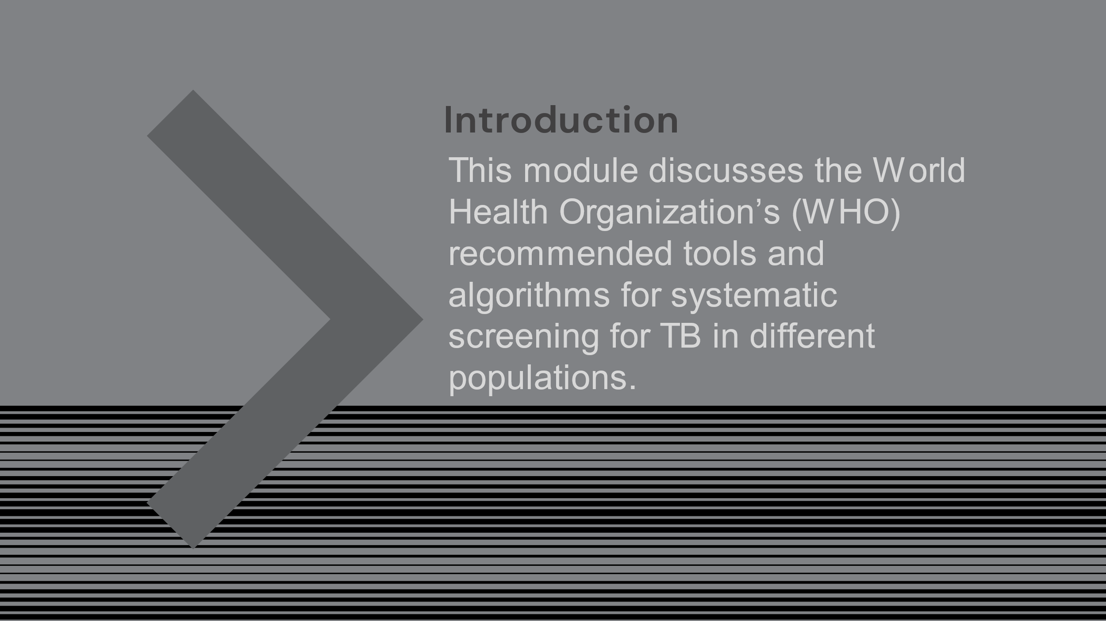
SAY: Our first topic is discussion of TB screening in general and the challenges with detecting TB globally and in our country. We will discuss the current WHO recommendations for TB screening and look at some algorithms for systematic screening across various populations.
The ultimate goal of this training is to determine how ultra-portable x-ray technology may be integrated into our country’s screenings for tuberculosis.

Introduction | Slide: 3
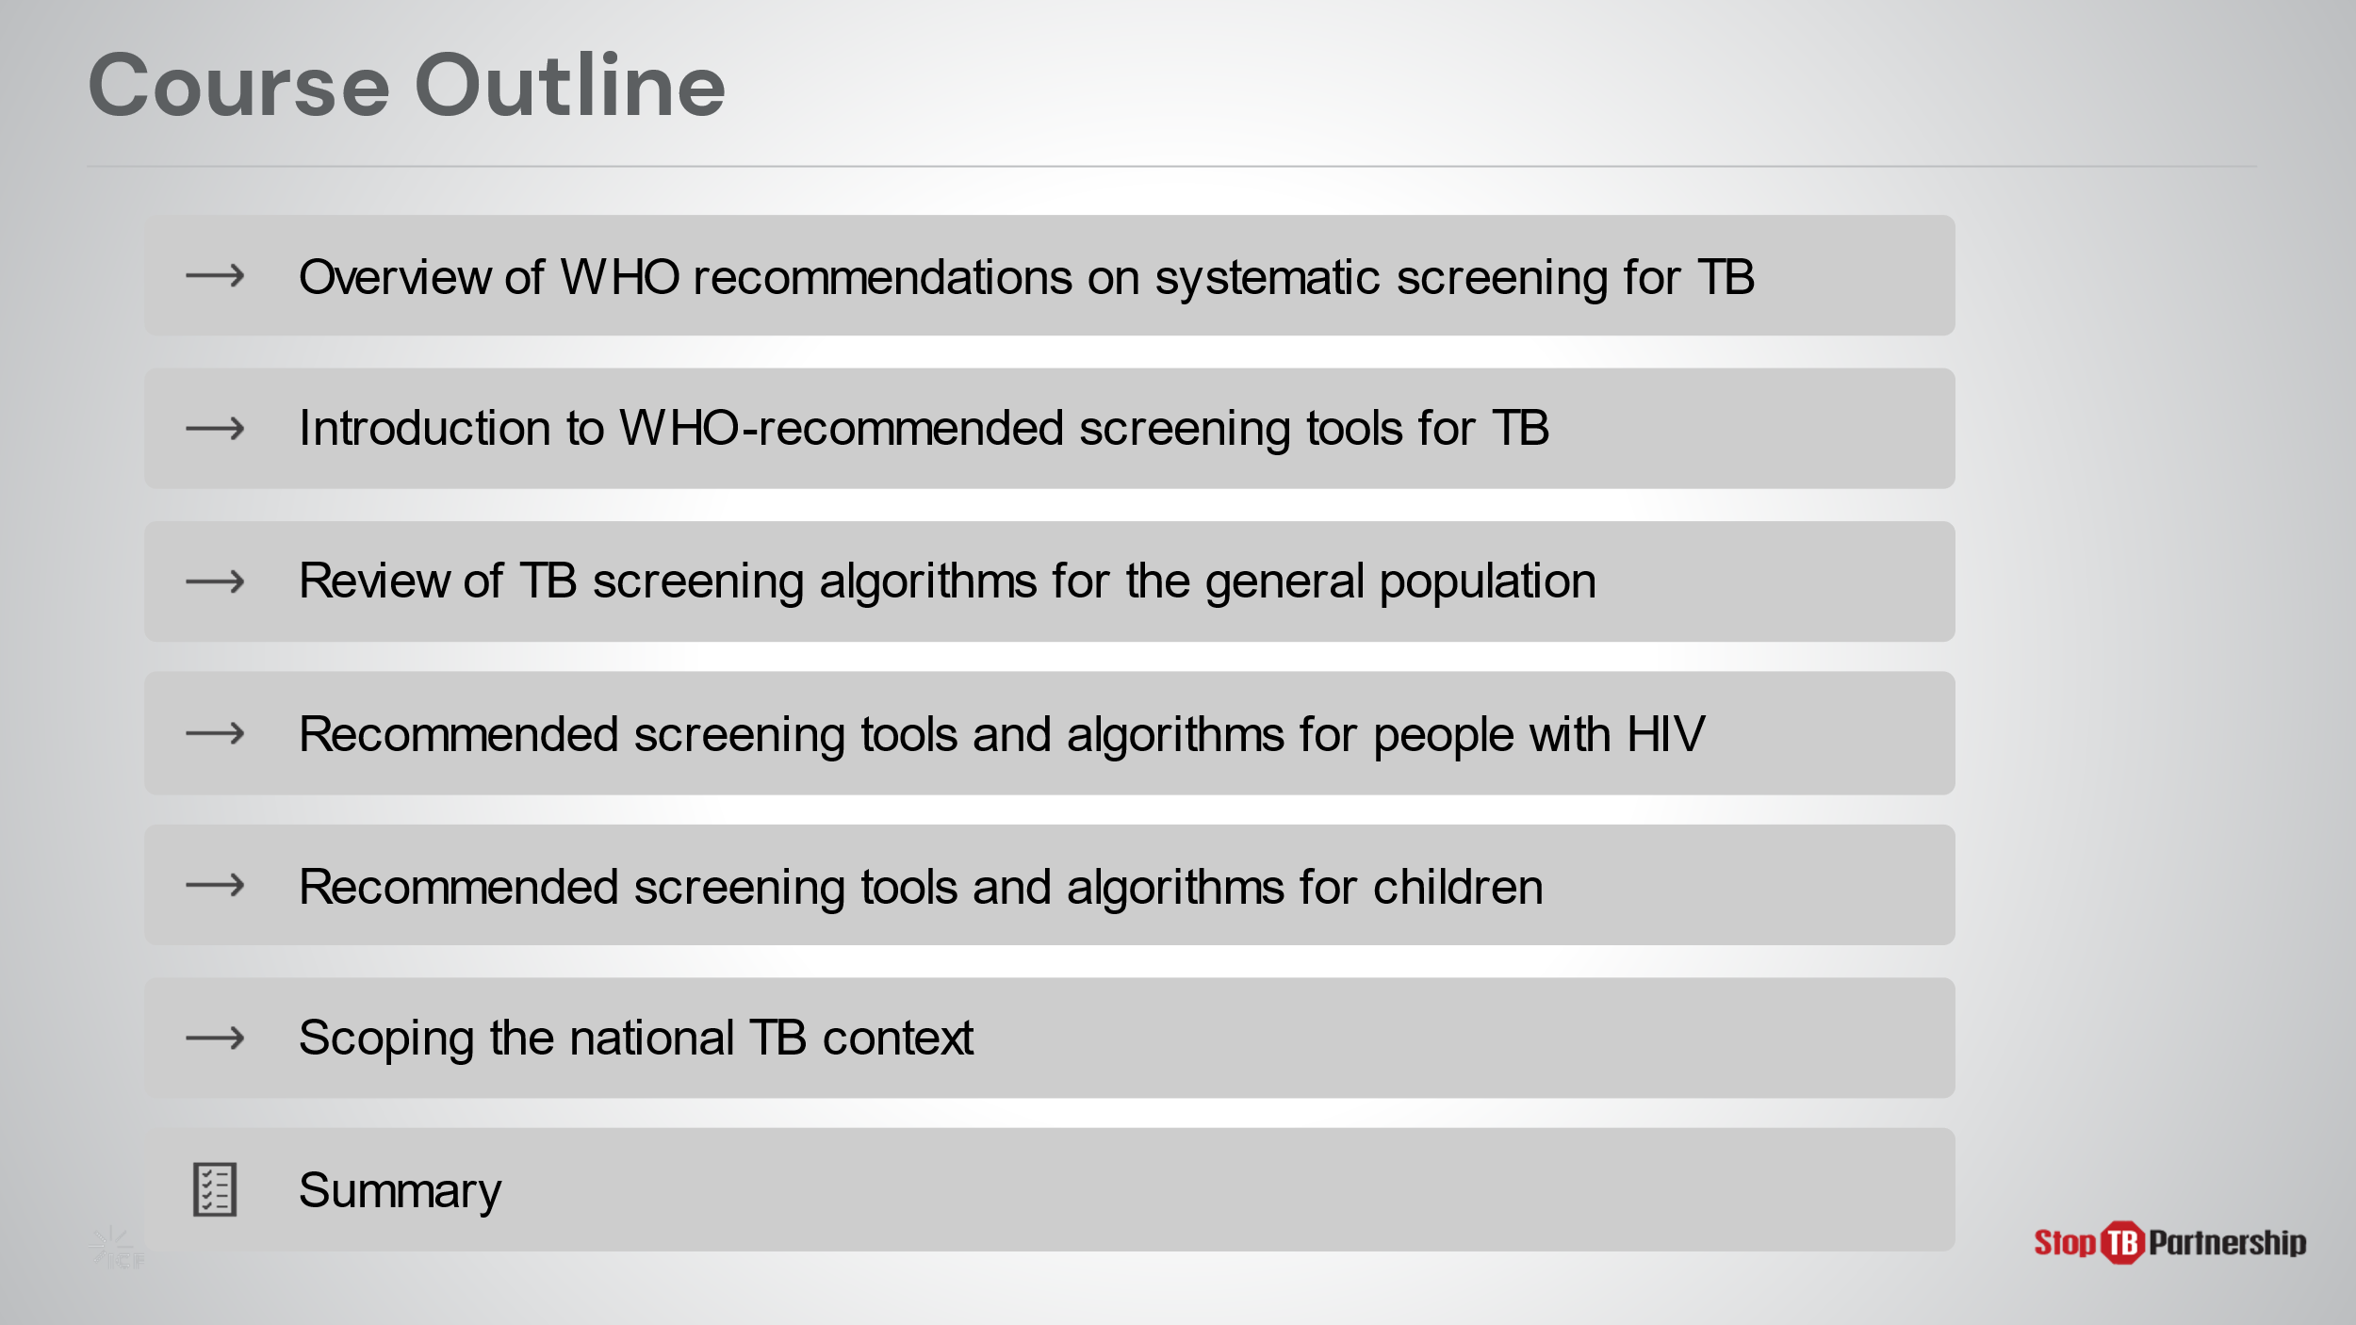
SAY: In this module, we will look at WHO’s recommendations for screening, introduce recommended tools, including the use of x-ray, and explore screening algorithms and tools for the general population, as well as higher risk populations, such as those with HIV and children. Finally, we will take a look at this information in the context of your country and explore how ultraportable x-ray might fit into your existing efforts.

Introduction | Slide: 4
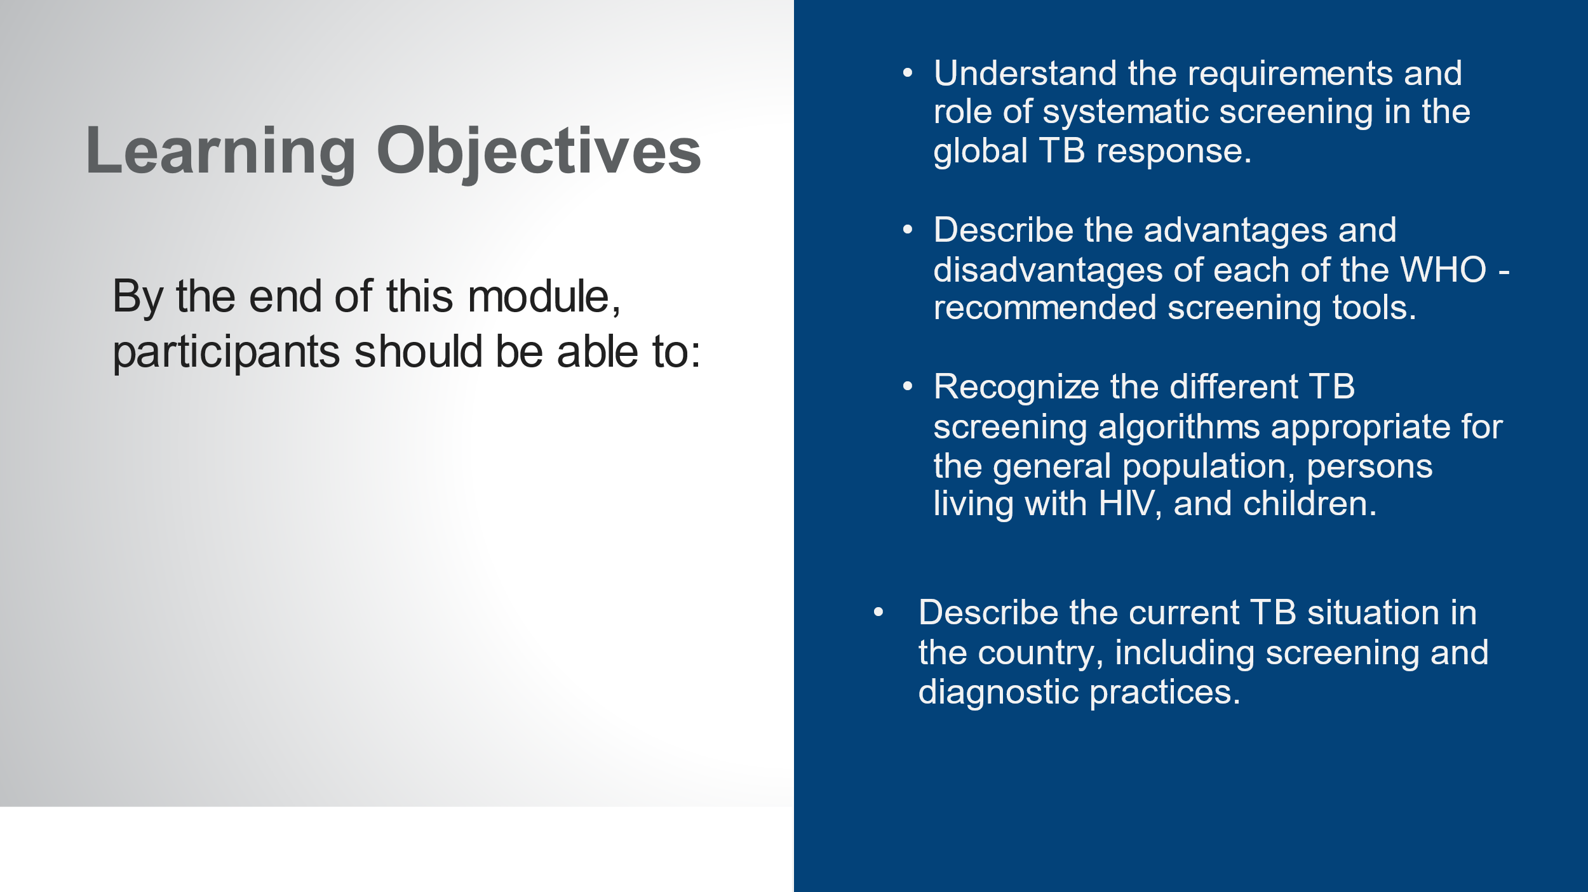
SAY: By the end of this module, you will be able to:
- Understand the requirements and role of systematic screening in the global TB response.
- Describe the advantages and disadvantages of each of the WHO-recommended screening tools.
- Recognize the different TB screening algorithms appropriate for the general population, persons living with HIV, and children.
- Describe the current TB situation in your country, including screening and diagnostic practices.
ASK: What questions do you have before we move into the first lesson for this training?
DO: Allow participants time to ask questions and respond appropriately.

TB Context
Global TB Situation: Global Context | Slide: 6
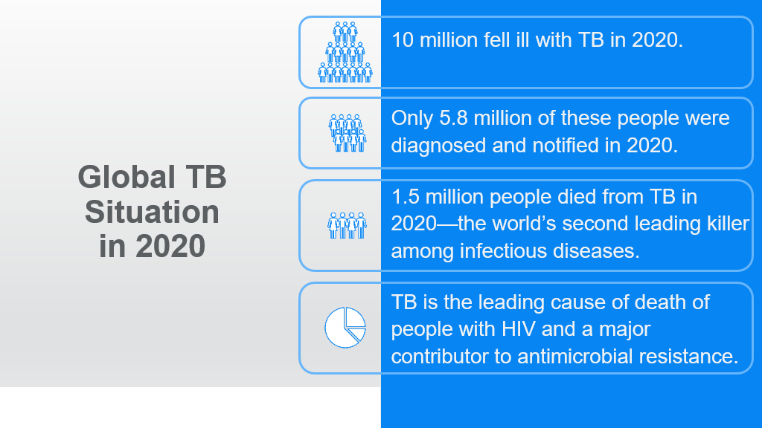
SAY: Let’s take a look at the current tuberculosis situation around the world.
ASK: How many people do you think are infected with TB every year, globally?
DO: Collect responses from participants. Click on the slide for animation to bring up the content.
SAY: 10 million people fell ill with TB in 2020.
ASK: How many of you were close in your estimation? (show of hands)
SAY: 10 million infected, and yet only 5.8 million diagnoses…
ASK: How many of you were closer to the 5.8 million figure in your estimations? (show of hands)
DO: Ensure that participants record the numbers of ill versus diagnosed in their notes.
SAY: TB is the world’s second-leading cause of death from an infectious disease; second only to Covid-19. One and a half million people die from TB each year. Statistics show that TB is the leading cause of death of people with HIV. It also contributes to antimicrobial resistance. IT is also a leading cause of maternal and childhood mortality.
SAY: We will discuss your country’s TB context in a while, so write in your notes what you think these statistics may look like in our country. We will come back to these estimates later.
Global TB Situation: WHO Guidelines on Systematic Screening | Slide: 8
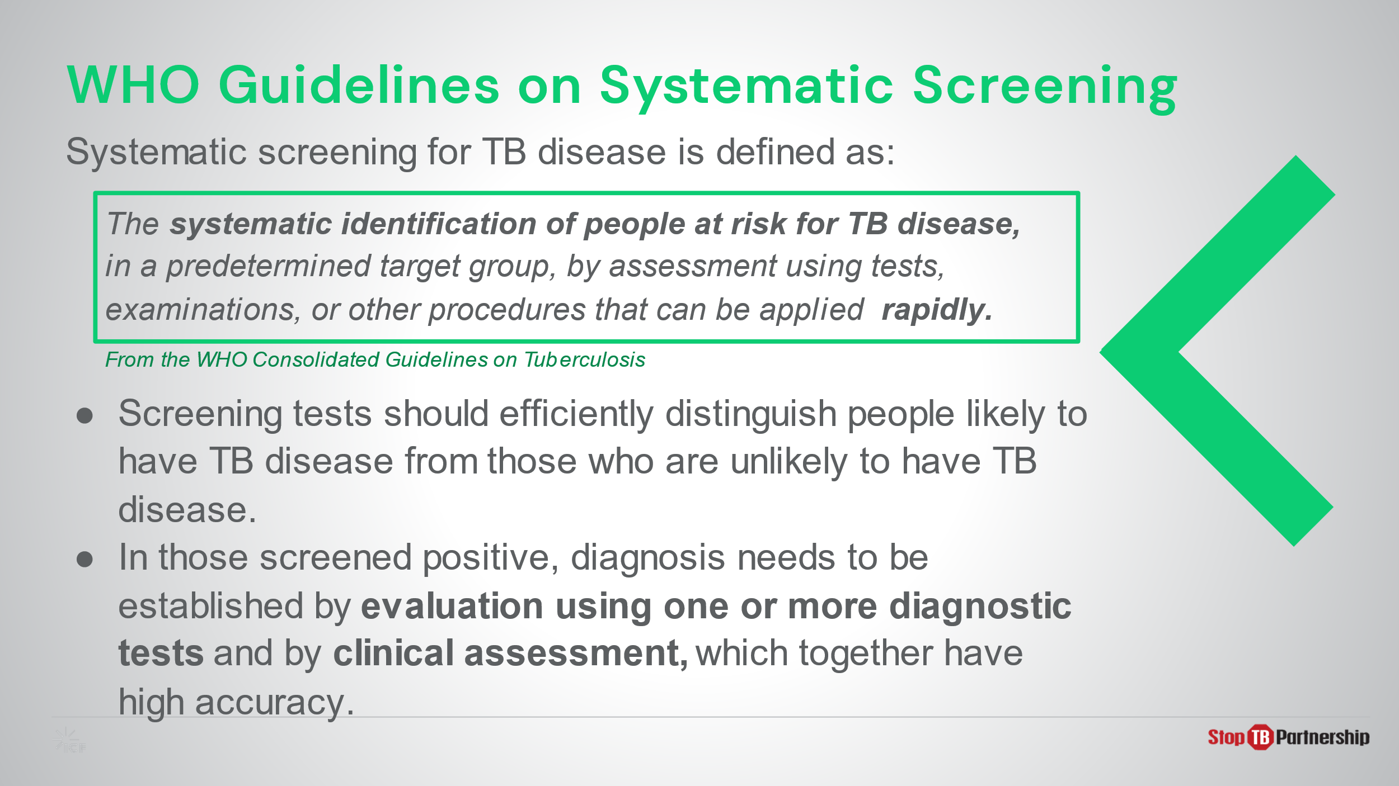
SAY: The World Health Organization (WHO) begins its recommendations by defining systematic screening for TB. You will see that a keyword in this definition is “rapidly.”
Within these recommendations, the WHO states, “screening tools should efficiently distinguish between persons likely to have active TB from those who are unlikely to have active TB.” In other words, these tools should offer both high sensitivity and high specificity.
Persons screening positive for TB need to be evaluated bacteriologically and clinically for diagnostic confirmation for high accuracy. This should follow soon after the screening process.

Global TB Situation: WHO Guidelines on Systematic Screening | Slide: 9
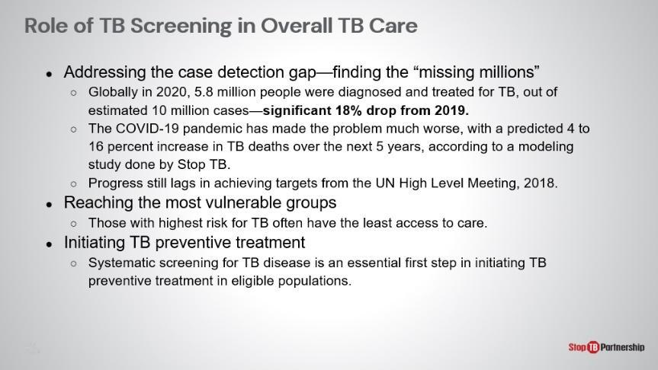
SAY: TB screening helps to close the gap of the “missing millions.” It can be tailored to vulnerable and under-served groups and enable preventive treatment. As we discussed earlier, only 5.8 million of 10 million cases were diagnosed worldwide, meaning roughly 42 % were not reported. The COVID-19 pandemic has exacerbated the problem; a modeling study conducted by Stop TB has predicted that TB-related deaths will increase 4-16% over the next 5 years. This further stalls progress towards achieving the United Nations high level meeting targets set in 2018.
SAY: Screening is a valuable tool for reaching the most vulnerable groups, with the highest levels risk often have the least access to care. Additionally, for those who are high risk but screen negative for TB, we should be engaging with them to initiate preventative care to halt the chain of transmission.

Global TB Situation: WHO Guidelines on Systematic Screening | Slide: 10
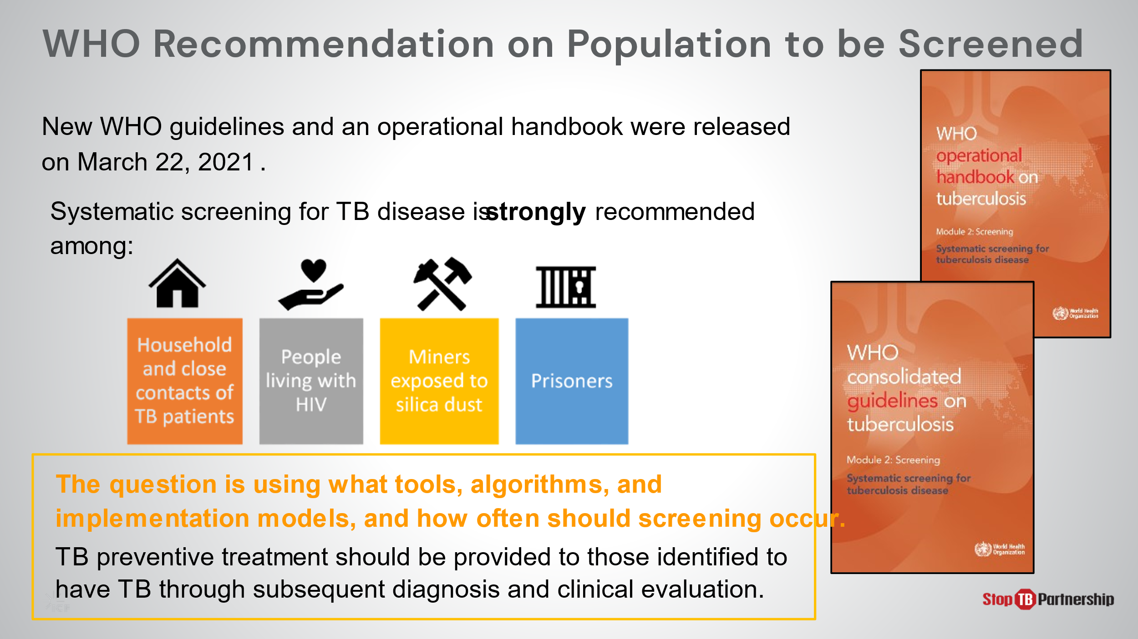
SAY: In March 2021, the WHO released guidelines and operational support for systematic screening for TB disease in. In these documents, recommendations were made for which populations should be subject to screening: those in close contact with TB patients, those living with HIV, those with occupational risks (like miners exposed to silica dust), and those who have been internally displaced (such as prisoners). The questions on our minds should be: What tools, models, and algorithms can be used? How often should we engage in screening? How can we link preventative and disease treatment with those who have undergone the screening process?

Global TB Situation: WHO Guidelines on Systematic Screening | Slide: 11
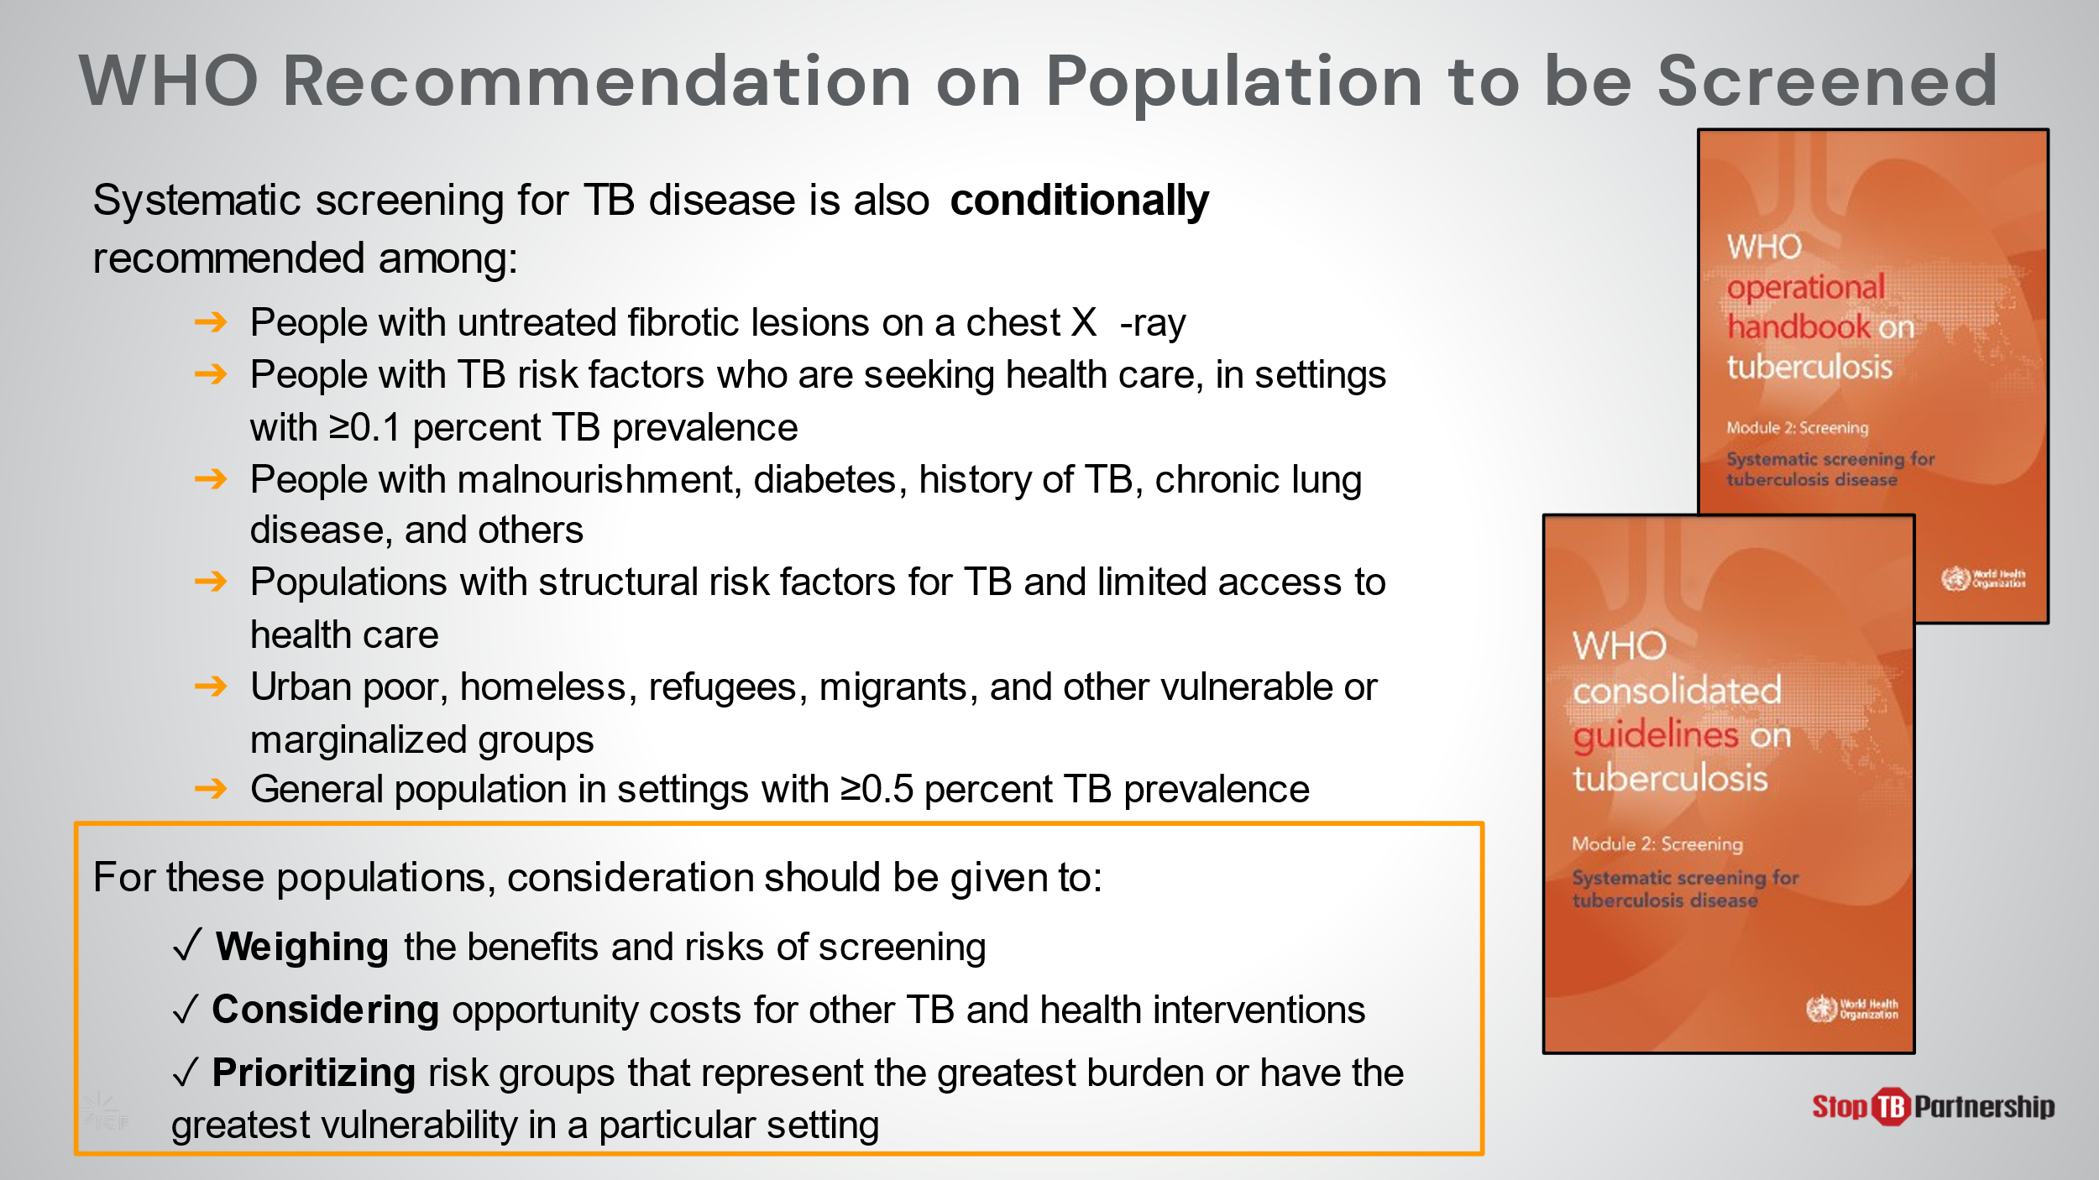
SAY: Systematic screening is also conditionally recommended, in consideration of these factors. [If these cannot easily be read by participants, read them aloud, and/or summarize them]. When deciding whether systematic screening is appropriate for these portions of the population, we need to weigh the benefits and risks of screening, consider opportunity costs, and prioritize those with the greatest risk/vulnerabilities.
SAY: Let’s pause and reflect from these global recommendations and guidelines to your experience?
ASK: To what extent do you think your country is meeting the WHO-recommended goals for TB screening?
DO: Allow participants to share their experiences.
ASK: To what extent has the Covid-19 pandemic impacted your TB efforts in this country?
DO: Allow participants time to respond. Encourage them to take notes.
ASK: In your country, what populations and groups are targeted for screening? What tools and methods are currently used?
DO: Allow participants to share their experiences. Encourage them to take notes.
ASK: What conditionally recommended populations are prevalent in your country? Which (if any) would you recommend as priorities for screening at this point? Or if, not at this point, which would be priorities in the future?
DO: Allow participants to share their experiences. Encourage them to take notes.

TB Screening Tools

Recommended Tools to Screen | Slide: 13
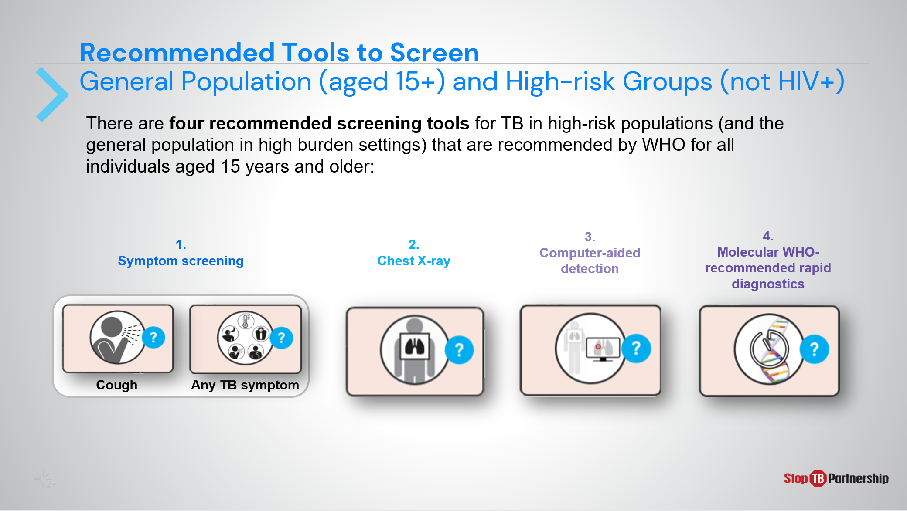
SAY: The four WHO recommended tools to screen general populations aged 15 or older and high risk groups excluding those with HIV include symptom screening, chest x-ray, computer-aided detection, and rapid molecular diagnostics.

Symptom Screening | Slide: 14
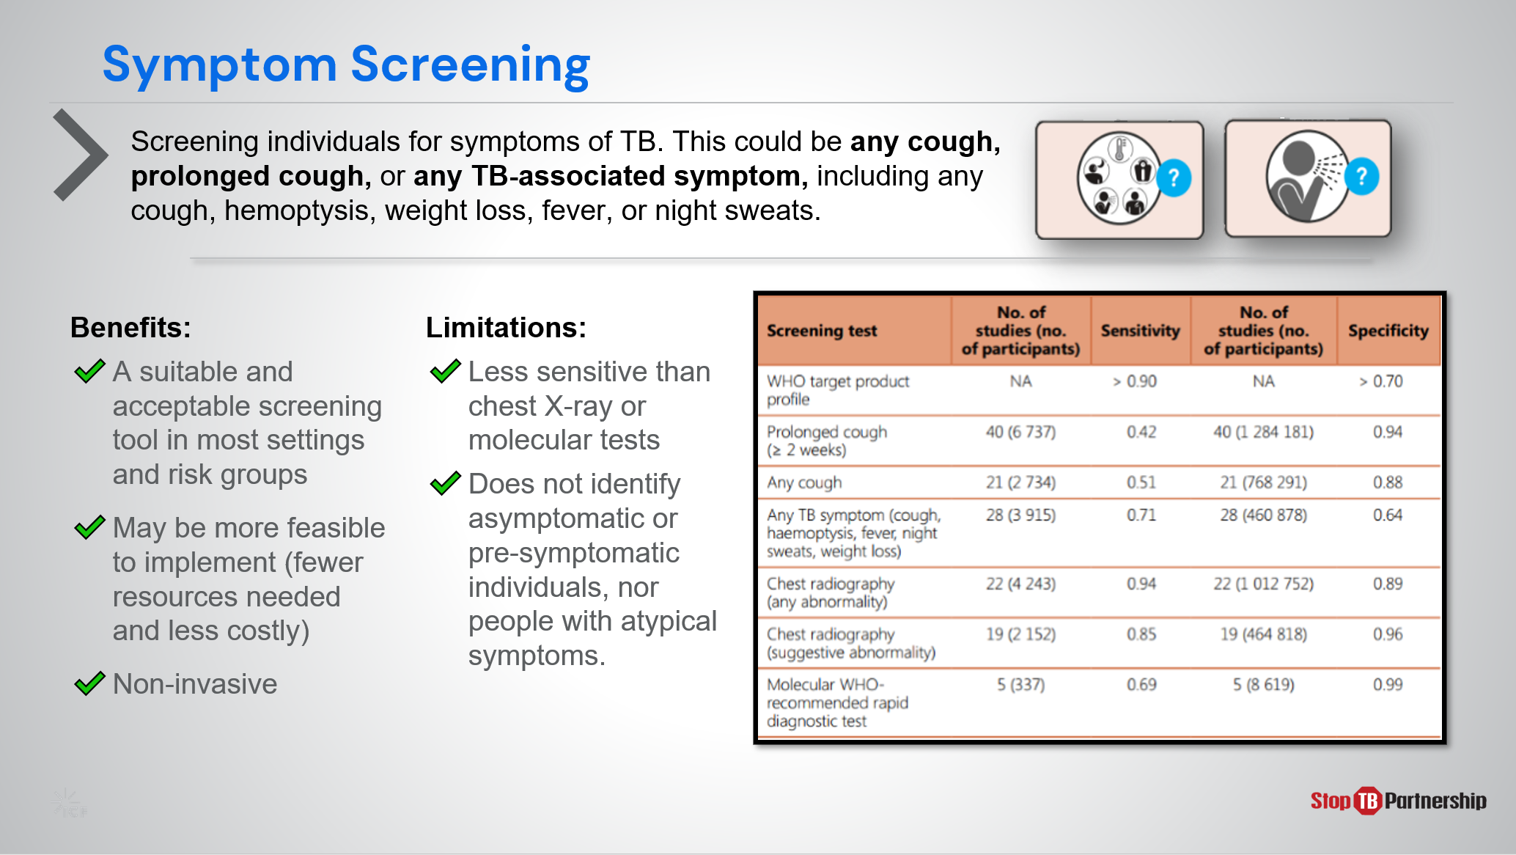
SAY: When implementing symptom screening as a tool, we are looking for common symptoms of TB, such as cough (any or for longer than 2 weeks), hemoptysis, weight loss, fever, or night sweats. This tool is generally beneficial in that it is rapid, simple to implement, non-invasive, requires minimal resources, generally acceptable in most settings and risk groups. However, it faces limitations in sensitivity and will not identify asymptomatic individuals or those with atypical symptoms.

Chest X-ray | Slide: 15
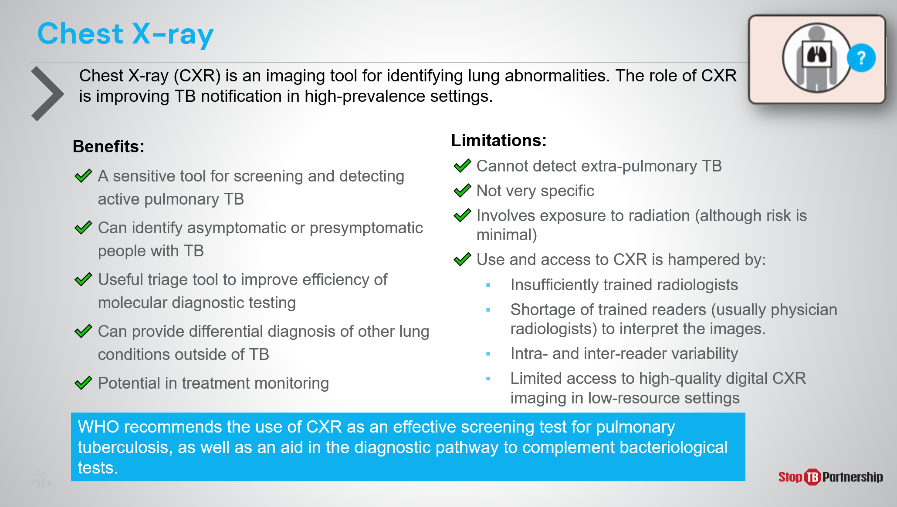
SAY: Chest x-ray is one of the most commonly used tools for TB screening and has been part of the diagnostic algorithm for decades. It has relatively high sensitivity , can identify asymptomatic individuals or those with atypical symptoms, serves as triage to improve molecular rapid testing efficiency, can provide potential diagnosis of non-TB lung conditions, and demonstrates potential in treatment monitoring.

Chest x-ray is not without limitations. It cannot detect extra-pulmonary TB, is not highly specific, and involves some – though minimal – exposure to radiation. Its largest limitations reside in the resources required for proper implementation. Radiologists must be sufficiently trained, and there is often a shortage of trained readers, and a disparity among those trained in their efficiency and accuracy. Access to high quality digital CXR imaging is also quite limited in certain settings.
ASK: To what extent are digital chest X-rays available in your country?
DO: Allow participants time to respond. Encourage them to take notes.

Computer-aided Detection Software | Slide: 16
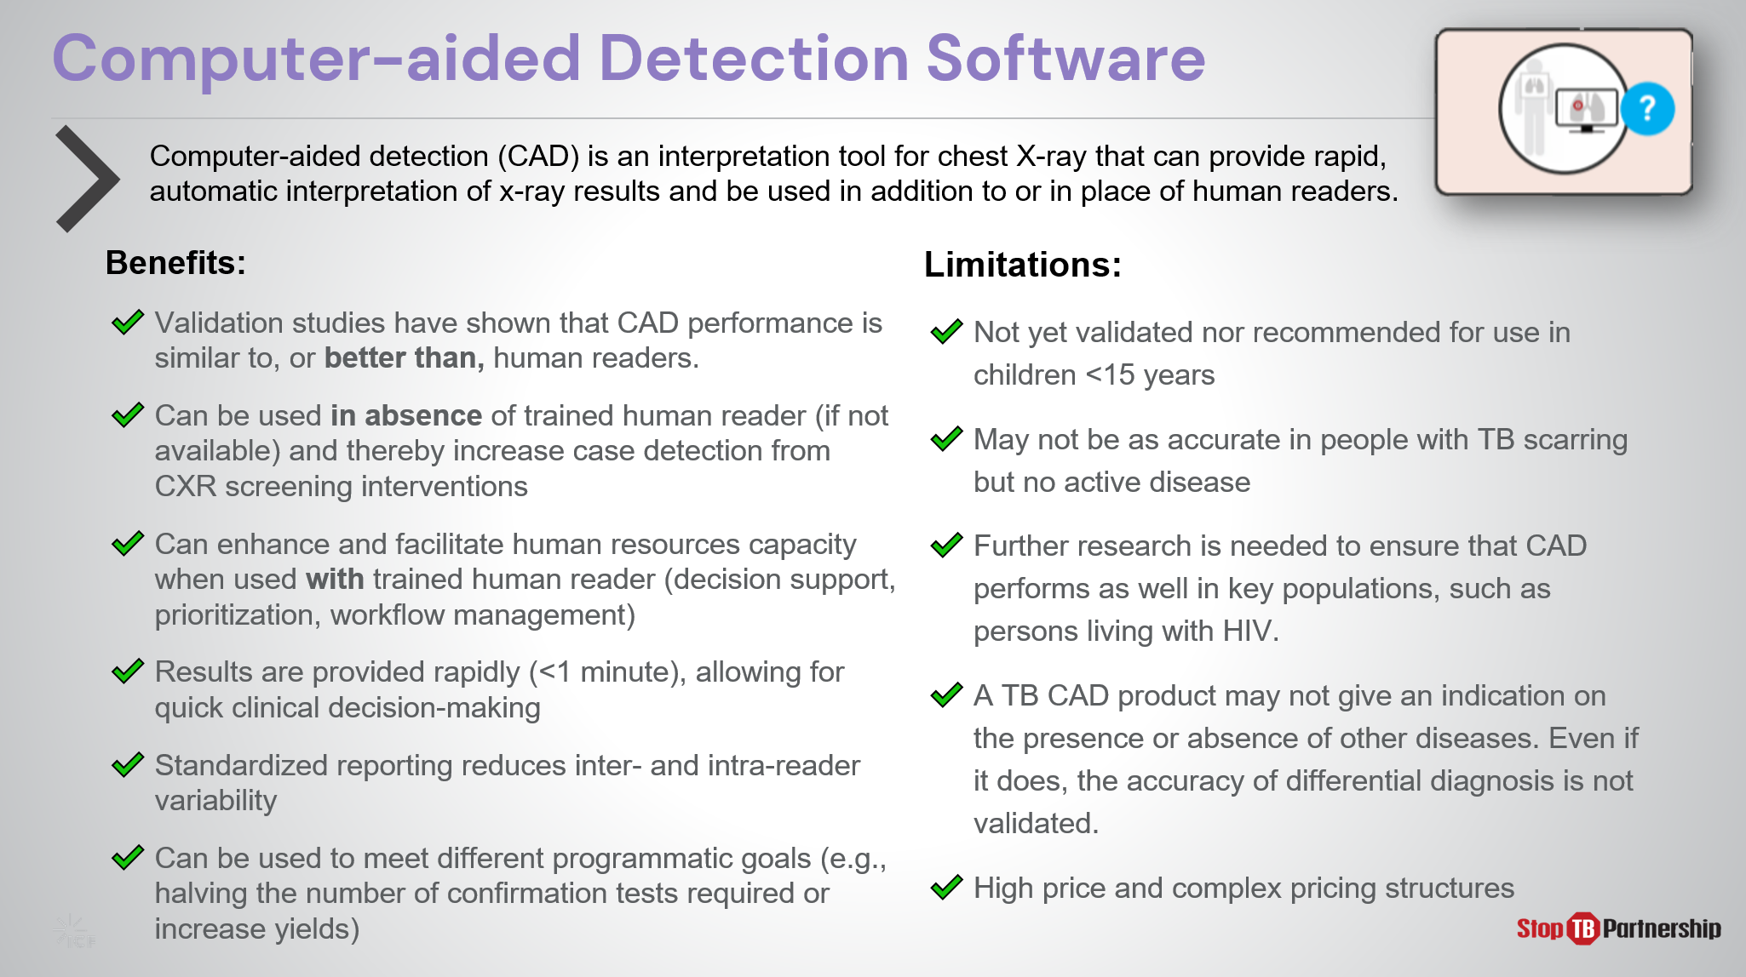
SAY: CAD software is a way to help reduce the burden on radiology resources. It can be used as an interpretation tool for chest X-ray, providing rapid, automatic interpretation of screening x-ray results. Validation studies have shown that CAD performance is similar to, and in some cases better than that of human readers; thus, CAD technology enhances and facilitates human resource capacity when used with trained human reader (decision support, prioritization, workflow management) and can be used in place of a human reader when none is available . This increased availability can improve CXR screening intervention case detection. Results are provided in less than a minute, allowing for quick clinical decision-making, and standardized reporting reduces inter- and intra-reader variability. CAD’s potential to triage can be modified to meet program goals or resource limitations such as availability of confirmation tests.
However, this technology is not without limitations. For example, it is not yet validated or recommended for children under 15 years of age and may be less accurate for patients with TB scarring but no active disease. Further research is also needed to ensure that CAD performs well in key populations, such as persons living with HIV. A TB CAD product may not give an indication on the presence or absence of other diseases and even if it does, the accuracy of differential diagnosis is not validated. Finally, we cannot ignore the cost. This tool requires specialized software and there is a “per screen” pricing structure when procured directly from the manufacturers, though a lower price and more appropriate pricing structure is available through Stop TB Partnership’s GDF Catalog.

Molecular WHO-recommended Rapid Diagnostics | Slide: 17
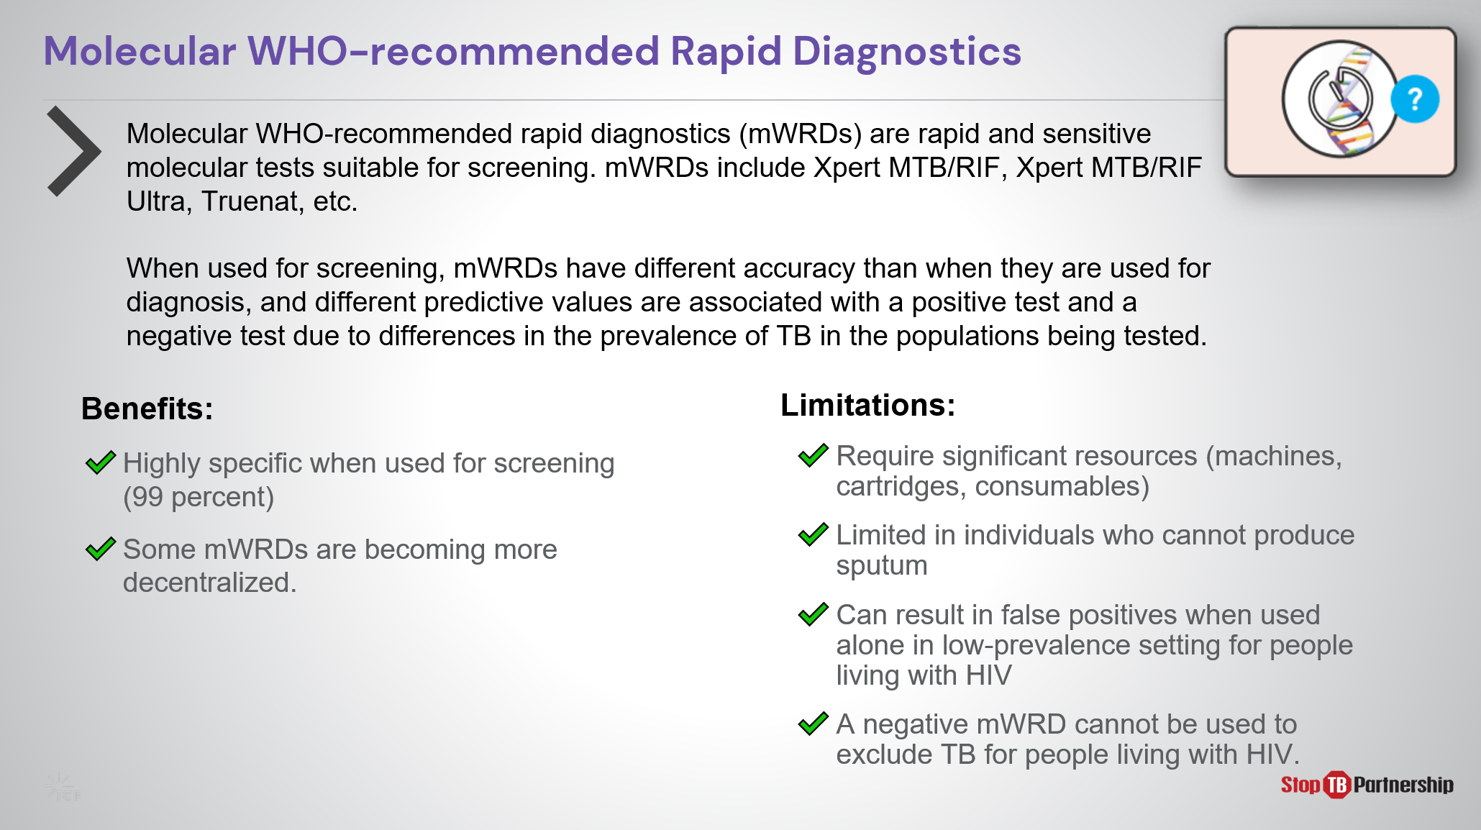
SAY: mWRDs are rapid and sensitive molecular tests suitable for screening. These are rapid, sensitive molecular tests, including Xpert, Xpert Ultra, and Truenat. [if country uses them for diagnosis, mention here]. mWRDs have different accuracy when used for screening than when they are used for diagnosis, with different predictive values are associated with a positive test and a negative test due to differences in the prevalence of TB in the populations being tested. When screening, they are highly specific, and some rapid molecular tests are becoming decentralized. However, these tests require significant resources – financial and infrastructure - and cannot serve individuals who are unable to produce sputum. Additionally, these tests can result in false positives if used alone in a low prevalence setting or among those with HIV. Finally, we must remember that these tests cannot be used to exclude TB for people living with HIV and AIDS.

Tools for Screening People Living with HIV | Slide: 18
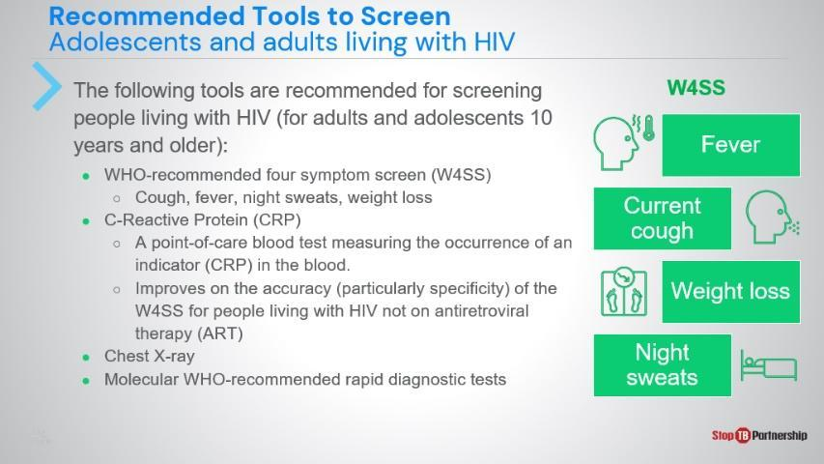
SAY: Because many of the tools already discussed have limitations involving people living with HIV, we need to employ different tools to serve this portion of the population. We start with the recommended 4-symp om screen, which looks for cough, fever, night sweats, and weight loss. Then we can use the C-reactive protein test, which measures the occurrence of this indicator in the blood. Chest x-ray and molecular rapid tests can also be used.

C-Reactive Protein | Slide: 19
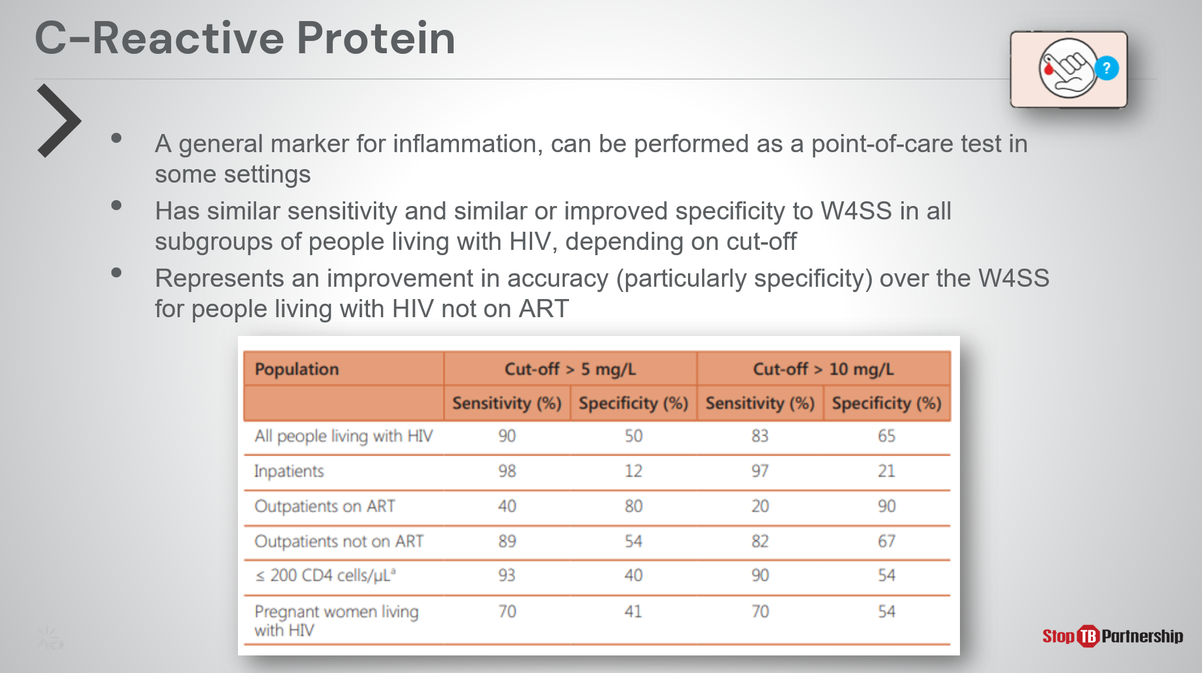
SAY: As we just discussed, the C-reactive protein test is best used as a follow-up to a 4-symptom screening. This test has a higher specificity in people with HIV compared to the 4 symptom- screen , especially in those not on antiretroviral therapy.

Tools for TB Screening in Children | Slide: 20
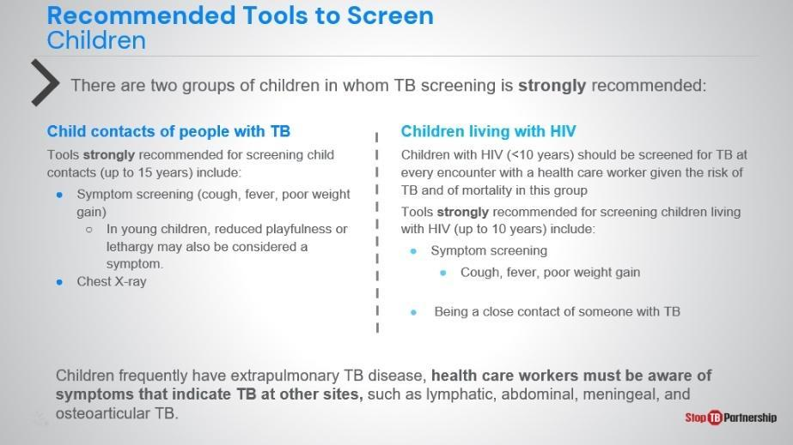
SAY: Just as the general population screening methods are different from methods for those living with HIV, we also need alternate tools when screening children. The WHO strongly recommends TB screening for two groups of children: those under 15 in contact with people who have TB, and those living with HIV -especially those under 10.

For children in contact with TB-positive patients, we use symptom screening and chest x-ray. We look for symptoms in older children, such as cough, fever, and poor weight gain, and in young children, reduced playfulness or lethargy may also be considered symptoms.

Children living with HIV should undergo symptom screening for TB at every encounter with a health care worker, as they are at high risk of TB and mortality. They should also be screened if they are a close contact of someone with TB.

However, we must remember that children frequently have extrapulmonary TB disease, so we must be aware of symptoms that indicate TB at other sites, such as lymphatic, abdominal, meningeal, and osteoarticular TB.
ASK: Thinking back on all the screening tools that we discussed in different populations, which of these are being used in your country? What do you think are the advantages and disadvantages of these tools?
DO: Allow participants to share their experiences. Encourage them to take notes.

TB Screening Algorithms Overview

Overview of TB Screening Algorithms | Slide: 21
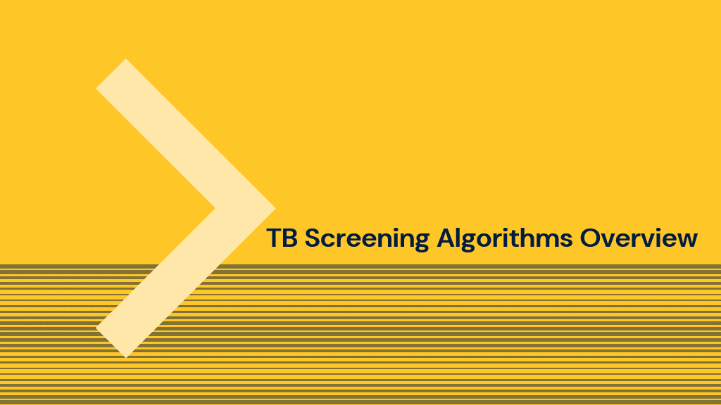
SAY: We have talked a great deal about the tools recommended by the WHO, now let’s pivot a bit and discuss how screening is performed by applying those tools into a screening algorithm.

Overview of TB Screening Algorithms | Slide: 22
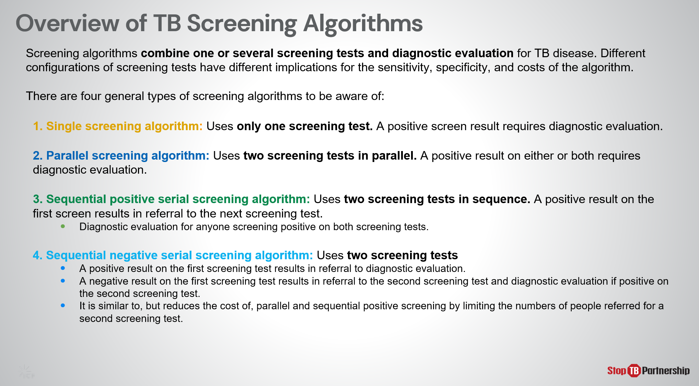
SAY: Screening algorithms combine one or more screening tests and diagnostic evaluation for active TB disease. Different configurations of screening tests have different implications for the algorithm’s accuracy and cost.
There are 4 general types of screening algorithms: Single, Parallel, Sequential Positive, and Sequential Negative.
- A Single screening algorithm uses just one screening test, using any of the tools we previously discussed. In this algorithm, a positive screen result requires diagnostic evaluation.
- Parallel and Sequential algorithms each employ 2 screening tests, but the sequencing varies. In parallel screening, these tests are run at the same time. A positive result on either or both requires diagnostic evaluation.
- Sequential algorithms employ two tests, one after the other.
  - In sequential positive serial screening, a positive result on the first screen results in referral to the next test. Diagnostic evaluation follows for anyone screening positive on both tests.
  - In sequential negative serial screening, a negative result on the first test results in referral to the second screening test. A diagnostic evaluation follows for anyone screening positive during either the first or second test.
Sequential negative serial screening reduces costs of parallel and sequential positive screening by limiting the numbers of people referred for a second test.

General Population (aged 15+) and High-risk Groups (not HIV+) | Slide: 23
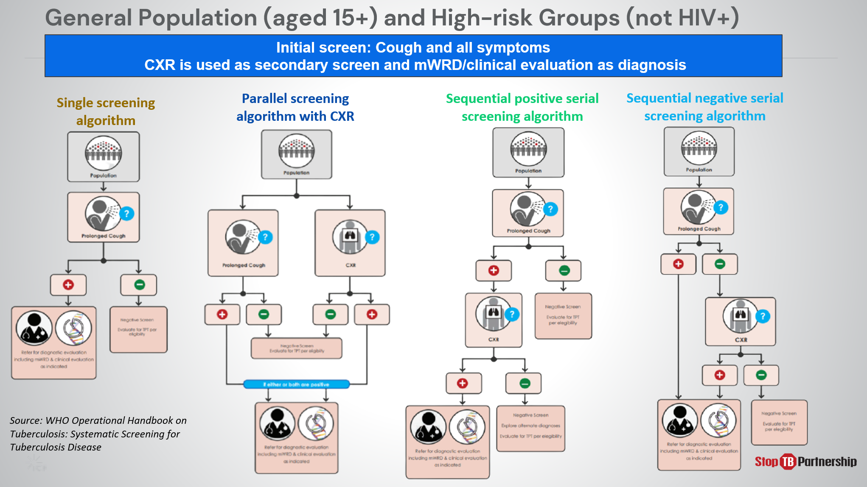
SAY: And here we present an example of each algorithm for use in the general population (15+ years old) and high-risk groups (not HIV). All use symptom as the initial screen. CXR is used as a secondary screen, and mWRD for diagnosis.
ASK: Do any of these algorithms represent the way you are currently screening for TB? What considerations have led to the employment of these methods?
DO: Allow participants to share their experiences. Encourage them to take notes.

General Population (aged 15+) and High-risk Groups (not HIV+) | Slide: 24
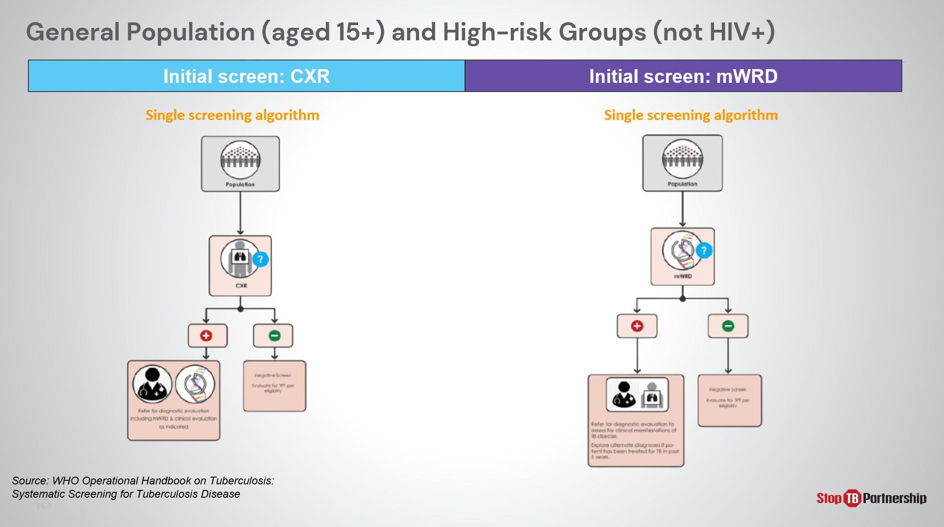
SAY: When we look at the general population and high-risk groups, we may also use chest x-ray or molecular diagnostics as an initial screening tool. [walk through an example of each].

Screening Algorithms for Adults and Adolescents Living with HIV involving X-ray | Slide: 25
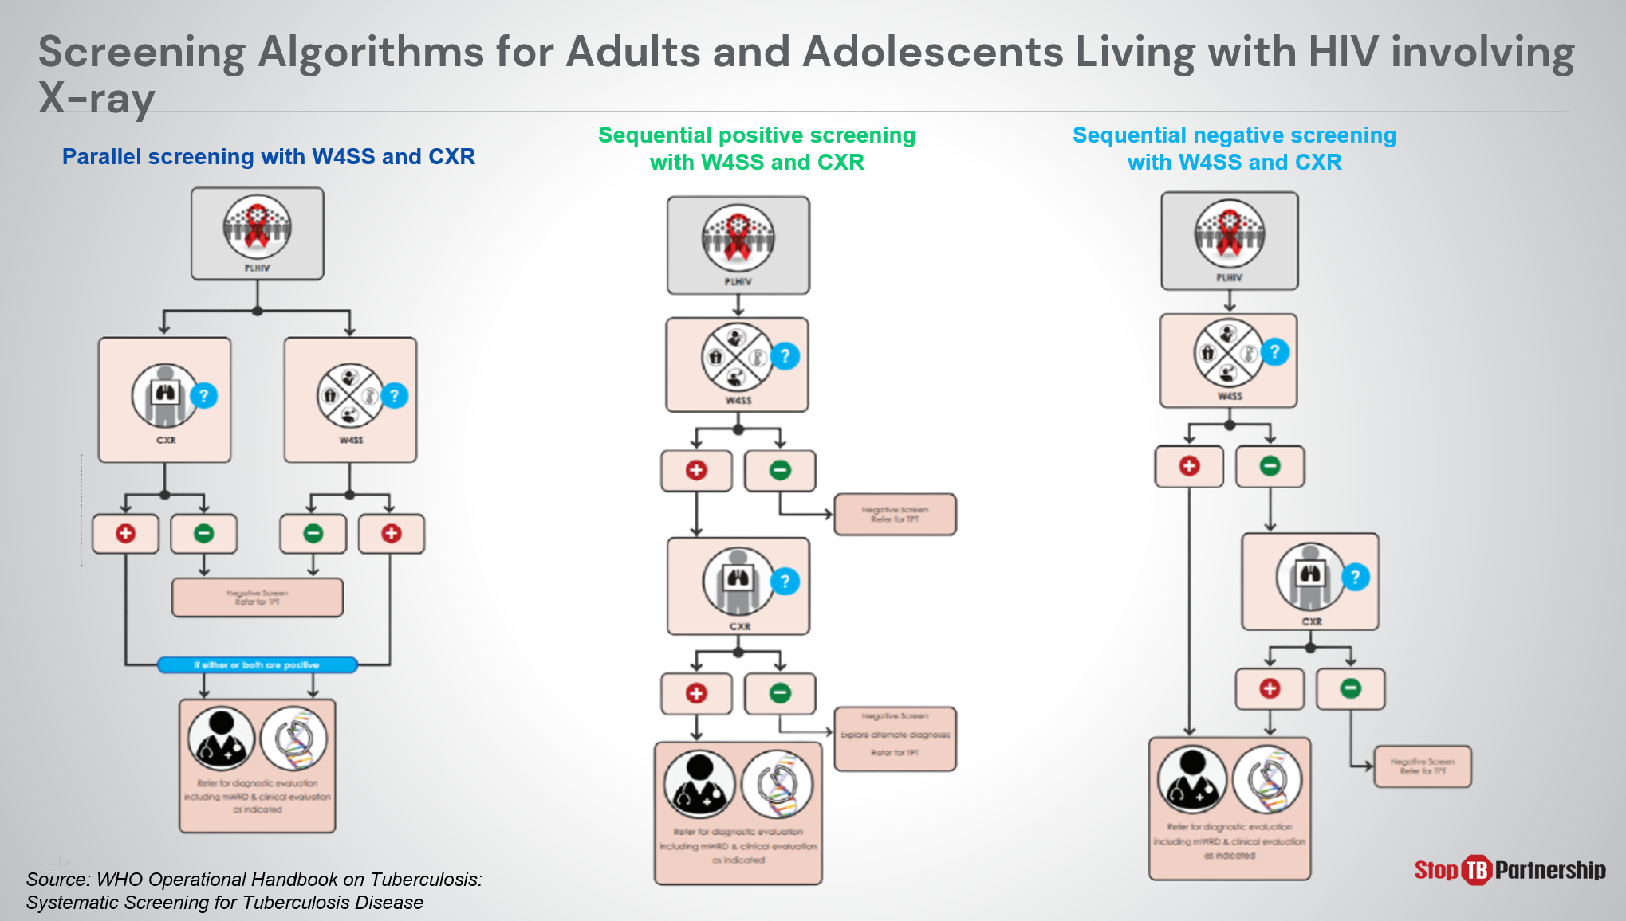
SAY: For adults and adolescents living with HIV, chest X-ray may be used in combination with other recommended screening tools for this group. For example [walk through an example]

Screening Algorithms for Children involving X-ray | Slide: 26
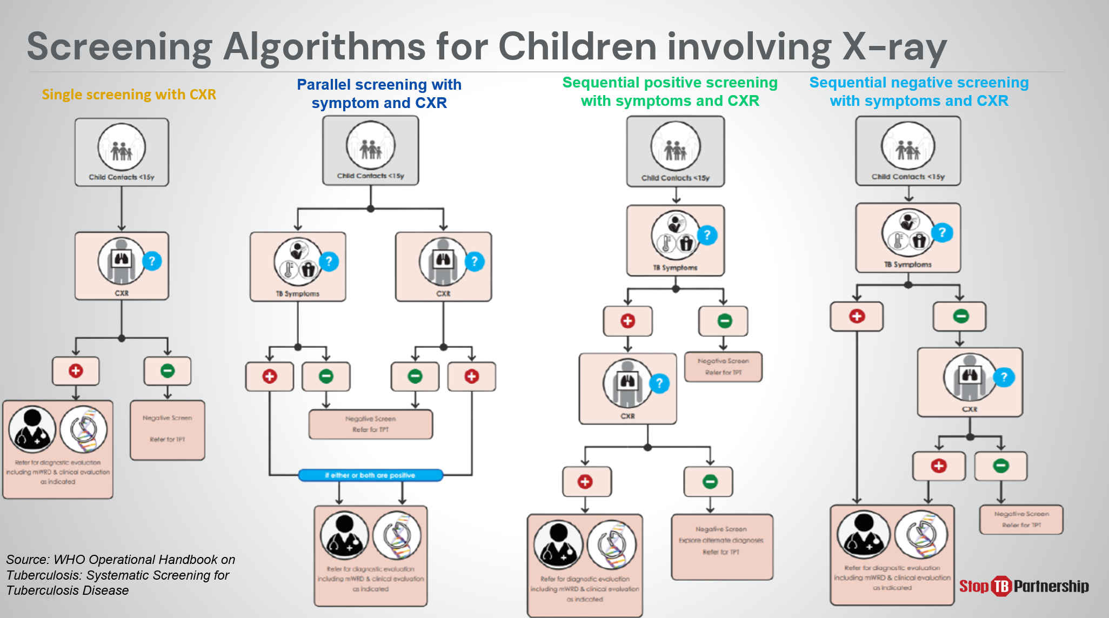
SAY: When screening children, we may also employ chest X-ray in a single screening algorithm or in combination with other recommended screening tools for this group. [walk through an example ].

Country TB Context

TB Data/Prevalence | Slide: 28
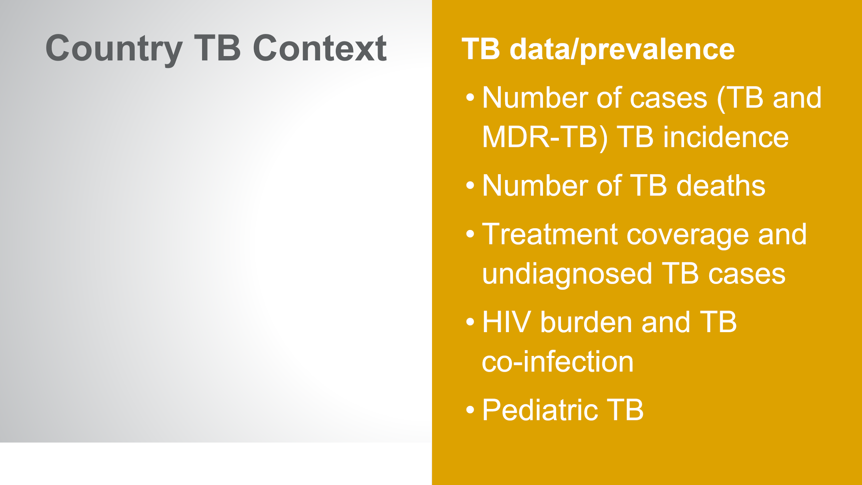
SAY:
ASK: How does this data compare with your initial estimates you logged in your notes from the beginning of this session? Do any figures surprise you?
DO: Allow participants to share their experiences. Encourage them to take notes.

National Priorities | Slide: 29
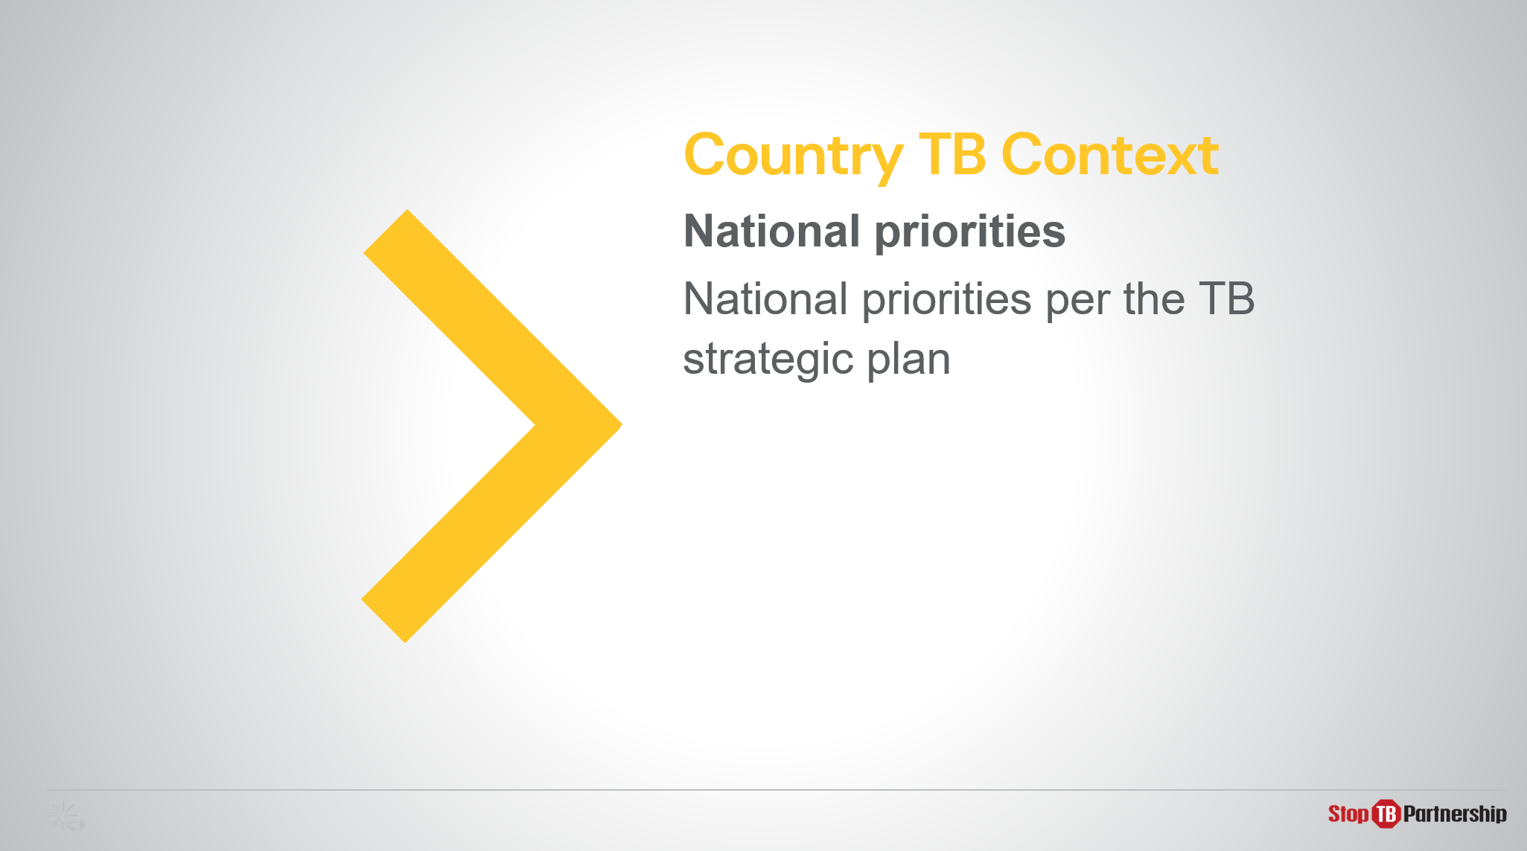
SAY:
ASK: How do these priorities align with your experiences?
DO: Allow participants to share their experiences. Encourage them to take notes in their guide.

National TB Screening Tools and Algorithm | Slide: 30
SAY: This shows an overview of the current tools and national algorithm currently used in TB screening in country
ASK: Does anything stand out to you?
DO:

Project TB Screening Population | Slide: 31
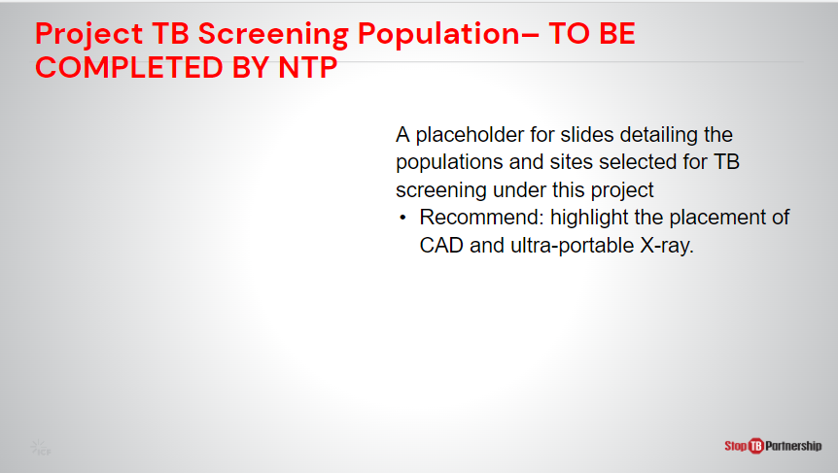
SAY:
ASK: Does this project align with your notes from earlier? What information stands out to you?
DO: Allow participants to share their experiences. Encourage them to take notes.

Plenary Session
Key Challenges | Slide: 32
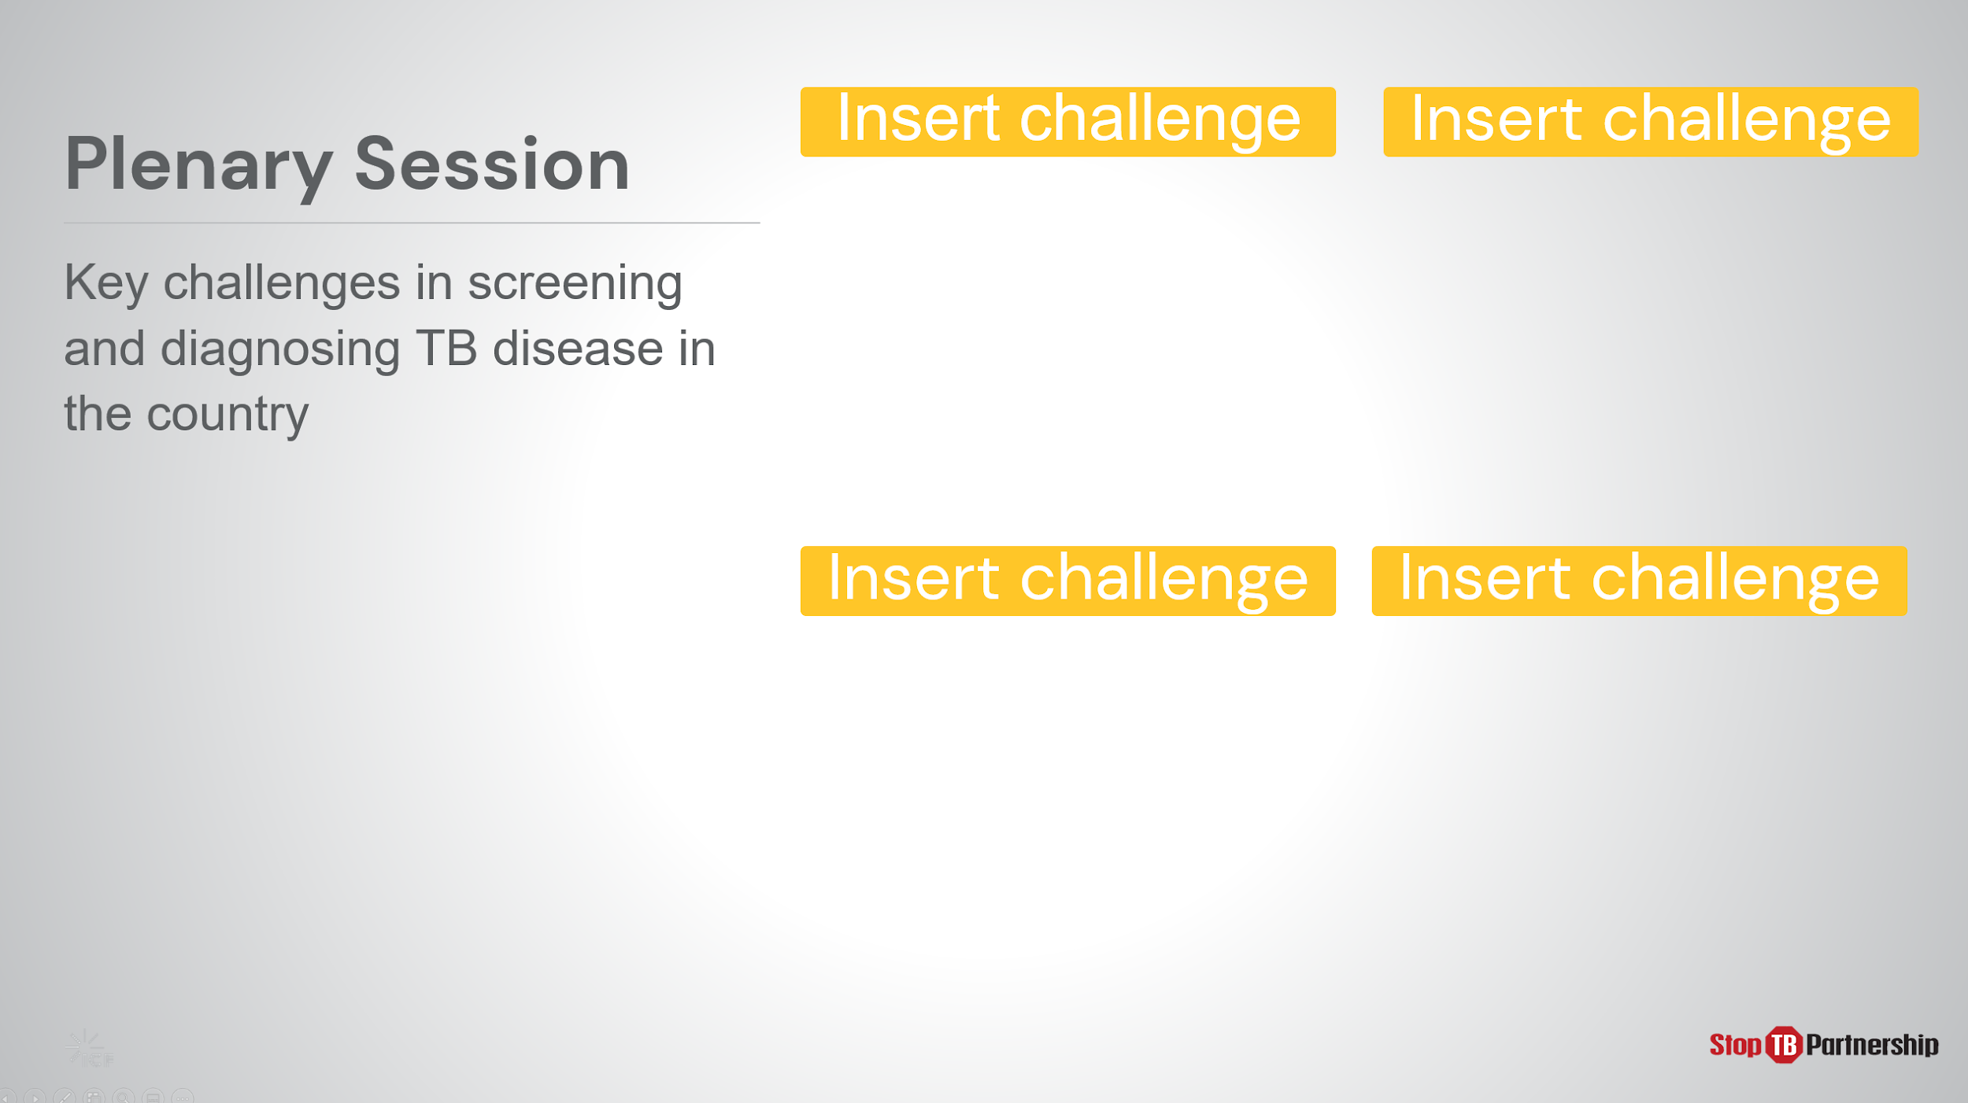
ASK: Along the way, I have asked several times that we pause and jot down our challenges and lessons learned. Can anyone share with me some of the challenges you have note? Would you say this challenge aligns with one of the challenges listed here?
DO: Allow participants to share their experiences. If possible, record the responses and their prevalence.

Summary
Summary | Slide: 33
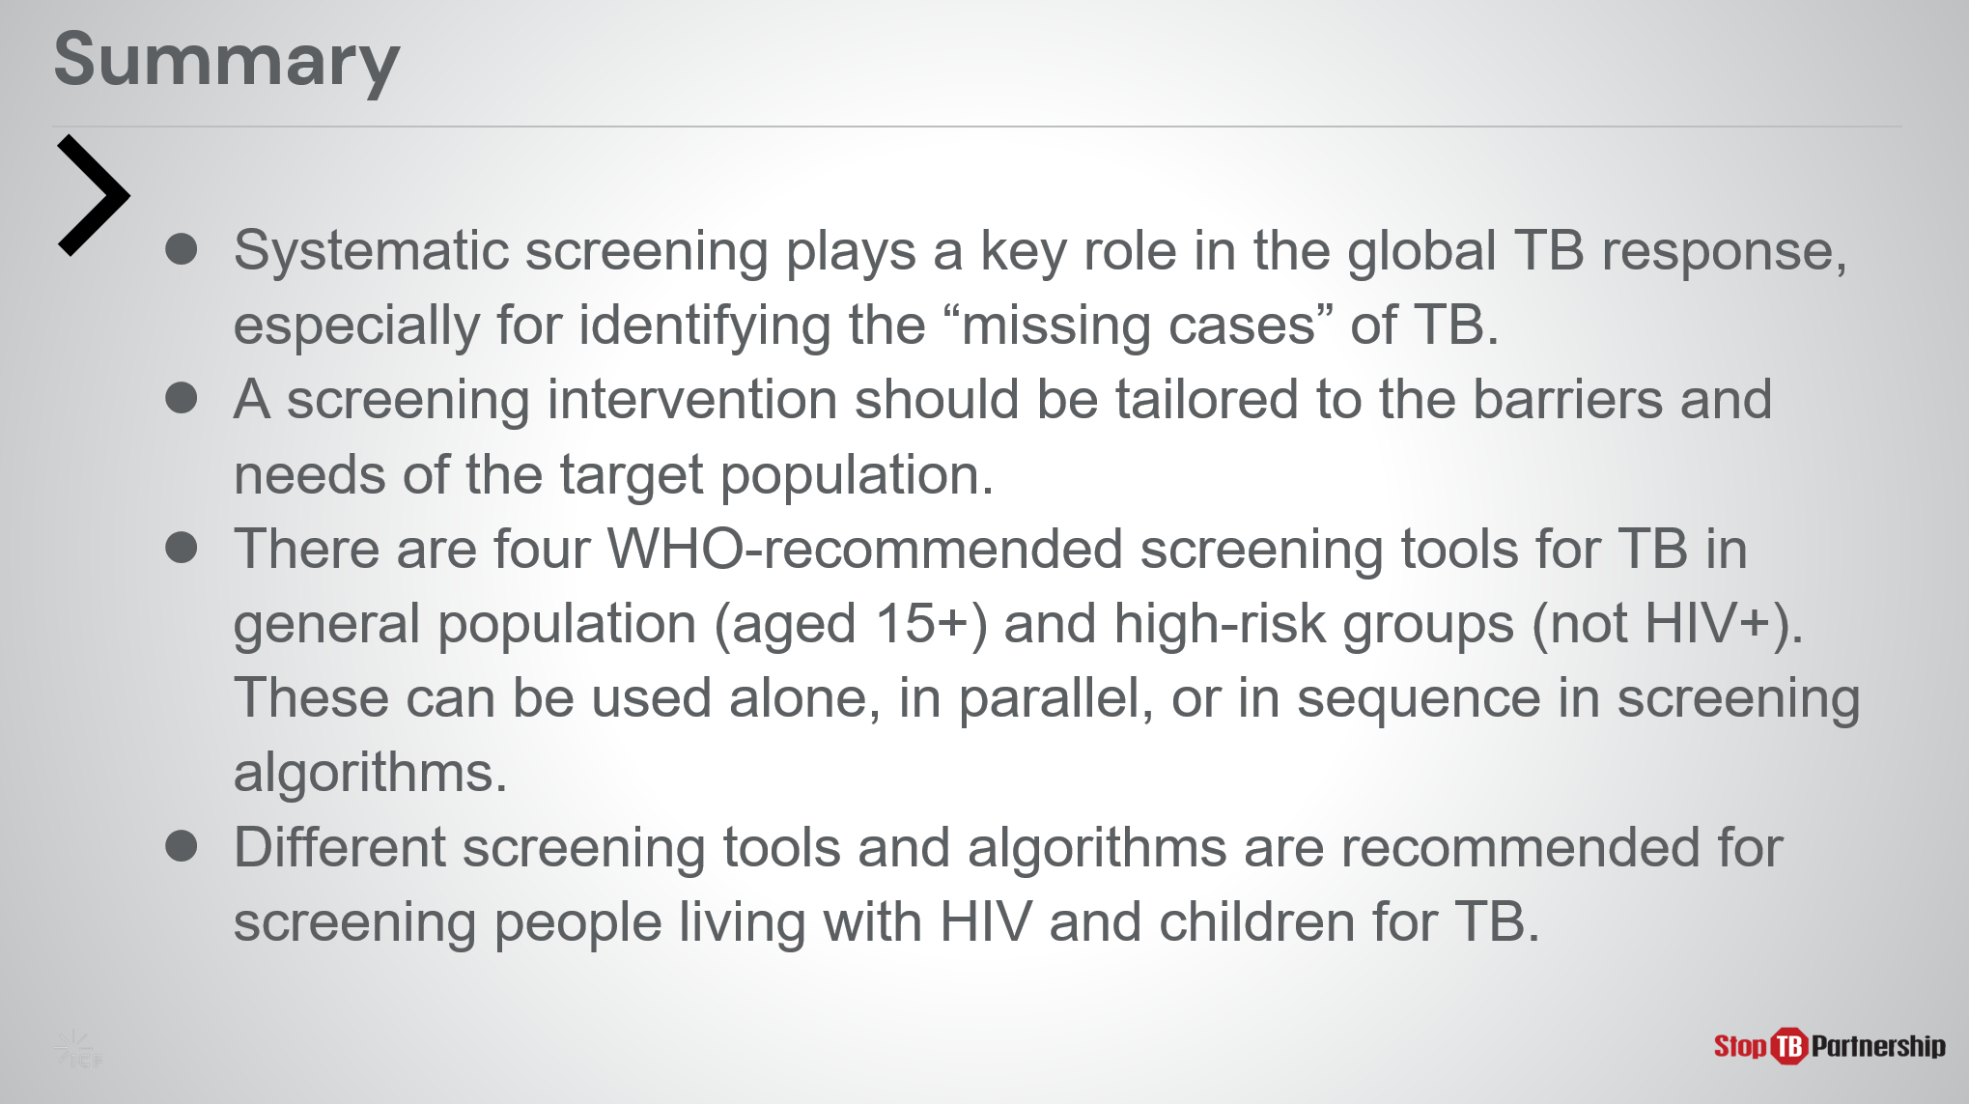
SAY:
- Systematic screening plays a key role in the global TB response, especially for identifying the “missing cases” of TB.
  - The gap is substantial, and further exacerbated by COVID 19. In 2020, we saw more than 4 million missing cases, but even before that - in 2018 and 2019, we saw roughly 3 million missing cases. To close the gap, we will need better screening tools.
- Screening interventions should be tailored.
  - Remember, identifying the target population to be screened is the first step. Once we have identified this target population, we can design a screening intervention that will accommodate that population’s needs and work through the barriers.
- The four WHO-recommended screening tools for TB (symptom screening, chest x-ray, CAD, and rapid molecular diagnostics) can be used alone, in parallel, or in sequence within screening algorithms.
  - These tools are meant for individuals 15 and older, and not intended for those living with HIV.
- Different screening tools and algorithms are recommended for screening people living with HIV and at-risk children.

Knowledge Check

Knowledge Check
Slide: 35, 36, 37, and 38
DO: Explain that you will ask participants four knowledge check questions and may call on participants randomly to provide an answer. (These can also be programmed as poll questions in a virtual training – ensure that all participants respond before proceeding if using the poll feature).

If an answer provided is incorrect , ask if other participants would like to answer. Correct any incorrect answers that are given. If multiple participants get a question wrong, you may need to revisit the topic.

Note that knowledge check questions are not included in participant guides to avoid participants seeing them during the lesson and only focusing on those pieces. Encourage participants to write down the answers in their guides in the notes field for future reference.
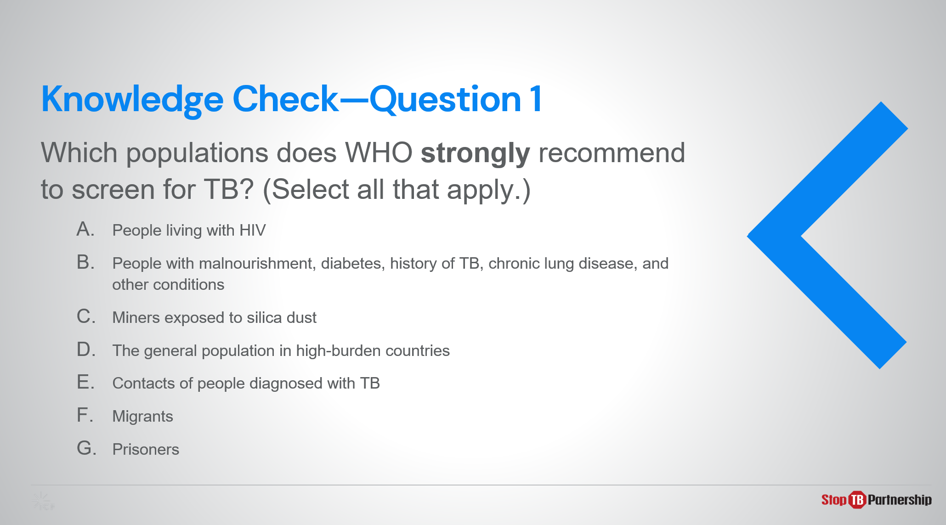
Answer: A, C, E ,G are correct
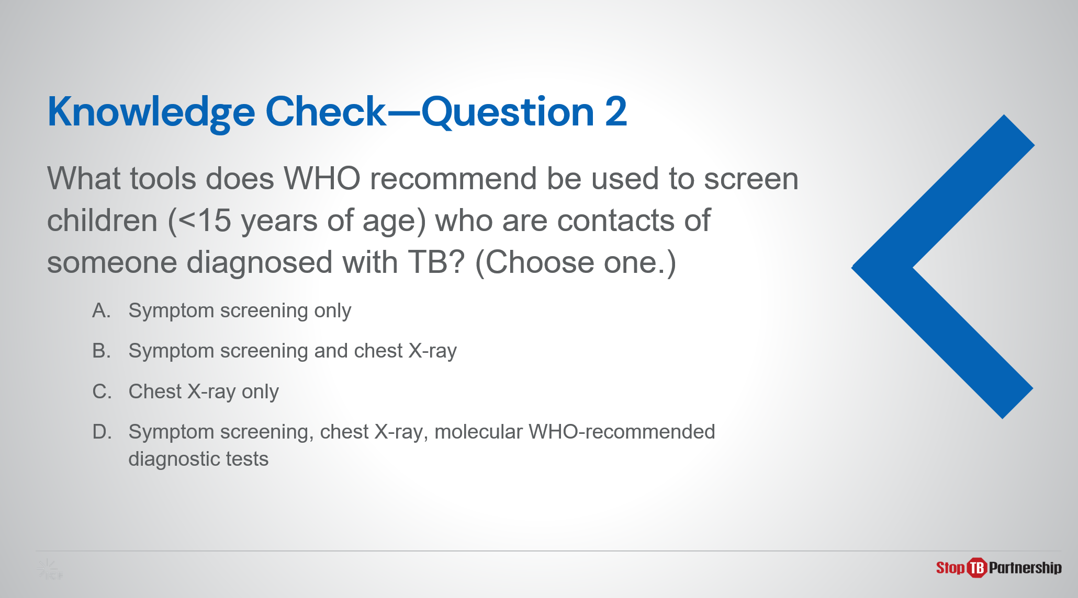
Answer: B correct
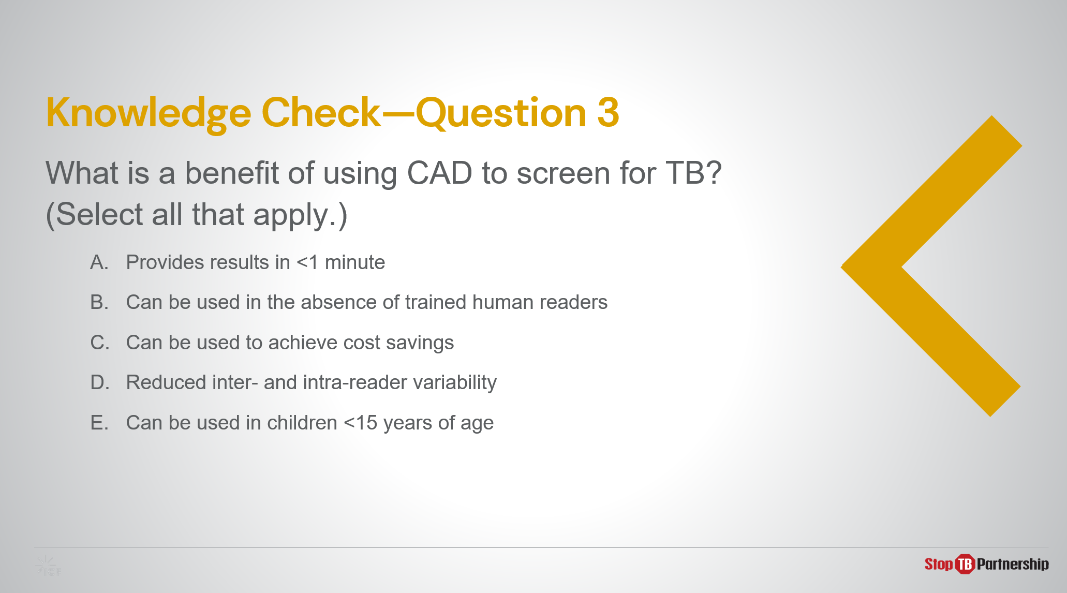
Answer: All except E
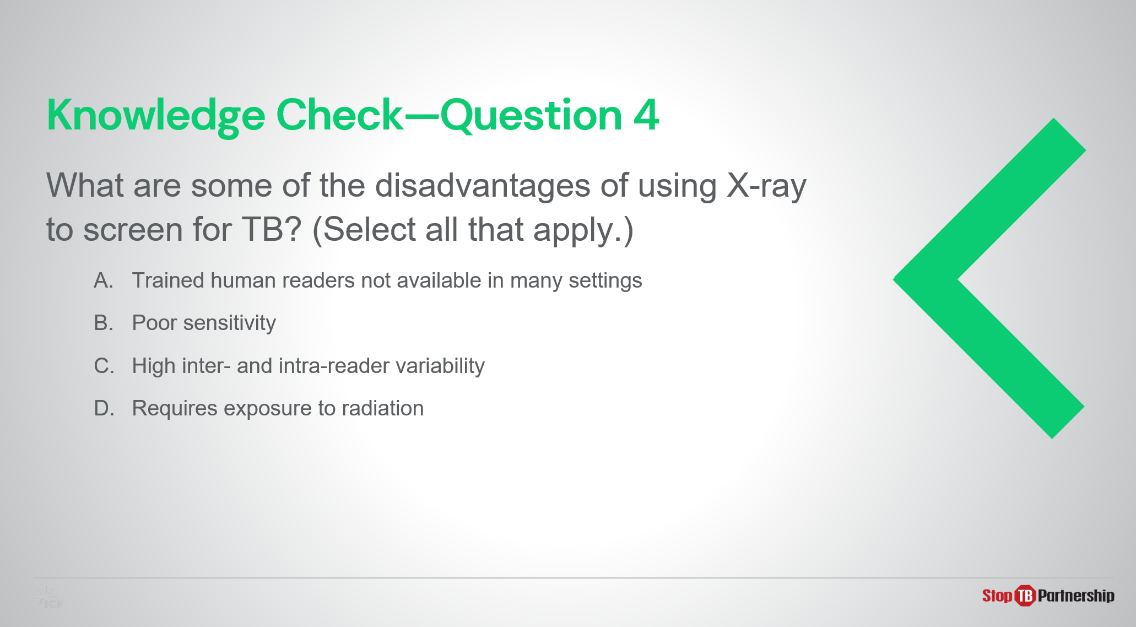
Answer: All except B are correct, specificity is poor not sensitivity

Module 2: New Tools for TB Screening: Introduction to Computer-Aided Detection (CAD) and Ultra-Portable X-Ray

Target Audience
The target audience for this course is:
- X-ray technicians, radiographers
- Clinicians

Learning Objectives
Terminal Objective
- At the end of this module, participants should understand the fundamentals of CAD and ultra-portable X-ray devices, particularly those featured in the GDF catalog.

Module Objectives
- By the end of this module, participants should be able to
  - Describe what CAD technology is and how it can be applied in TB screening.
  - Know the key features of the CAD products available from the GDF catalog.
  - Understand what is meant by “ultra-portable X-ray” and the advantages and disadvantages of using it.
  - Detail the components and pricing of the ultra-portable X-ray systems available in the GDF catalog.
  - Understand the different ways CAD and ultra-portable X-ray can be integrated for use in TB screening and triage.

Materials
- Facilitator Guide
- Pens/Pencils

Advance Preparation
- Instructors will need to customize slides for where CAD is used in the project screening algorithm (slide 15)

Introduction
Introduction | Slide: 2
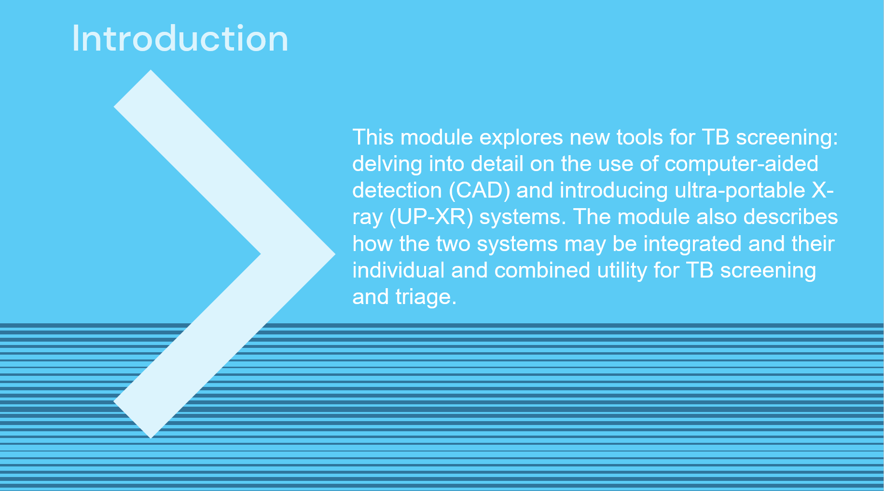
SAY: In this module we will get to grips with how to use the new TB screening tools – CAD and ultra-portable X-ray- with a focus on products available in Stop TB Partnership’s GDF Catalog. The ultimate goal is to provide a foundation of knowledge that we will draw upon in Modules 3-5.

Course Outline | Slide: 3
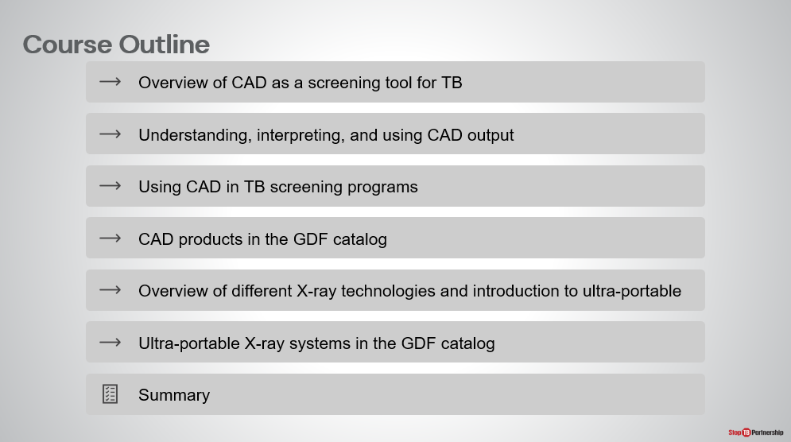
SAY: We will start this module with a focus on CAD technology, how it works, and how to use the CAD output, before looking at the specifics of the CAD product (CAD4TB) that is provided through Stop TB’s GDF Catalog. Next, we will summarize X-ray technology in general before introducing and contextualizing the new ultra-portable X-ray technology. Again, we will narrow our scope to focus on the [either Delft Light/Fujifilm Xair] which this project will be using.

Learning Objectives | Slide: 4
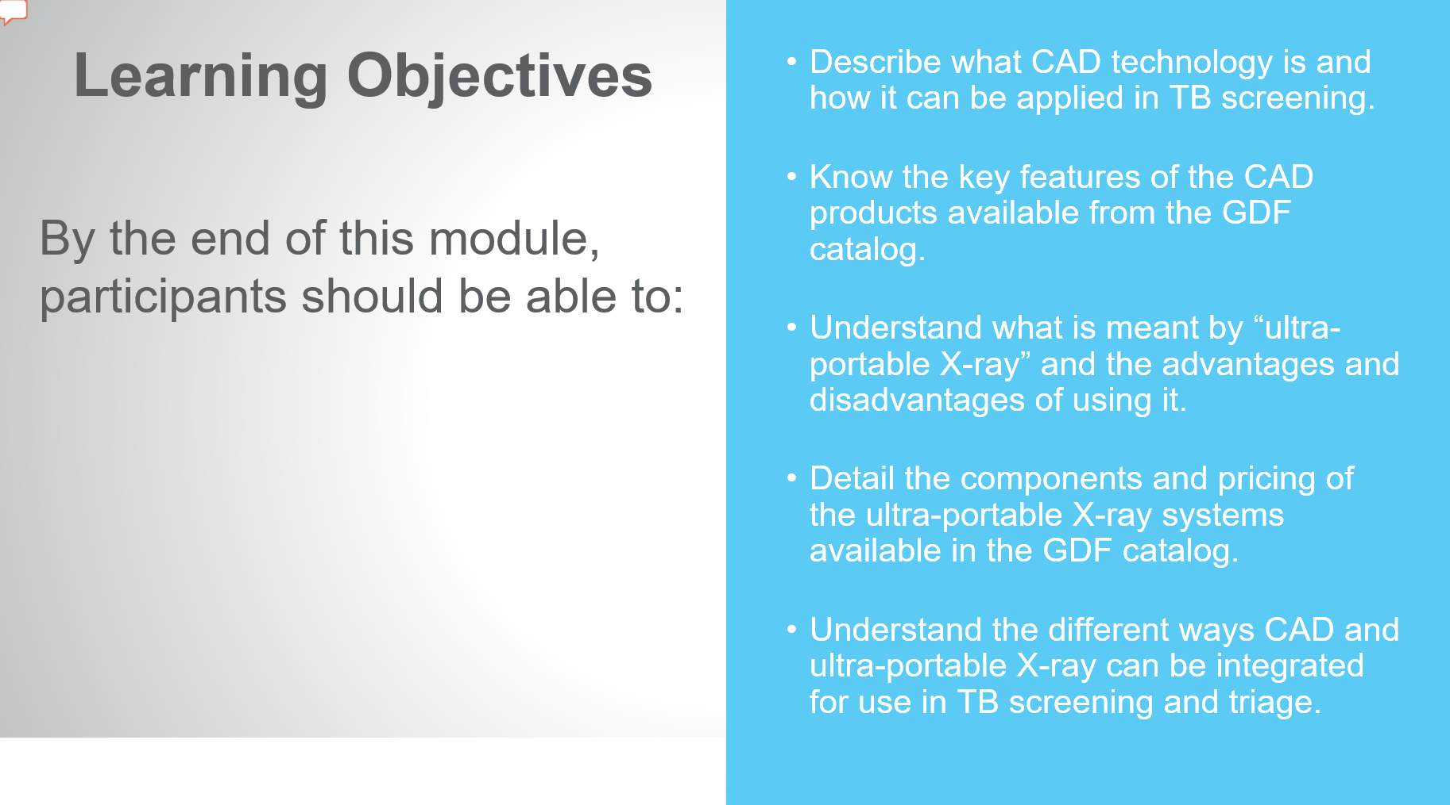
SAY: By the end of this module, you will be able to:
- Describe what CAD technology is and how it can be applied in TB screening
- Know key features of CAD products, particularly those available from the Stop TB’s GDF catalog
- Understand what we mean when we say “ultra-portable X-ray” as well as the advantages and disadvantages of using it.
- Detail the components and pricing of the [Delft Light/ Fujifilm Xair] provided through the GDF catalog
- Understand how CAD and ultra-portable X-ray can be integrated and used together for TB screening and triage.
ASK: Before we briefly recap the relevant content from Module 1, are there any questions?
DO: Allow participants to ask questions and respond appropriately.
Reminder: WHO Guidelines on Systematic Screening | Slide: 5
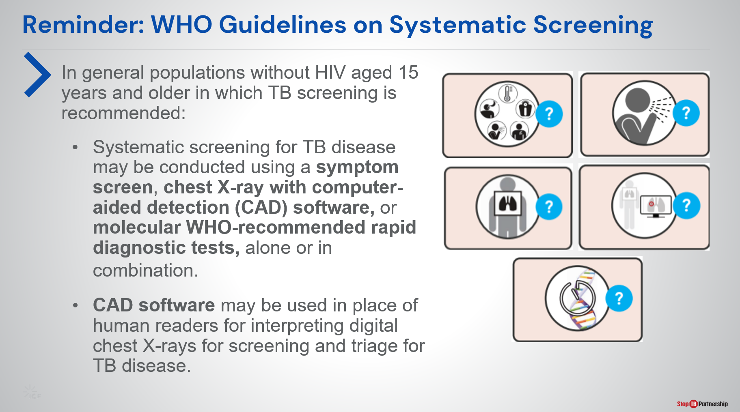
SAY: First, let’s revisit Module 1. Here, we introduced five WHO-recommended screening tools for TB as per the March 2021 TB screening guideline update. You can see that CAD is recommended for the first time alongside symptom screening (any symptom or prolonged cough), chest X-ray, and molecular WHO-recommended rapid diagnostic tests. These may be used to screen for TB alone or in combination.

According to the policy update, CAD can be used in place of human readers for screening chest X-rays for TB in individuals 15 years and older. How exactly this can be done will be explored in this module.

Computer-Aided Detection (CAD) Software for Screening and Triage of TB
Overview of CAD as a Tool to Screen and Triage TB | Slide: 7
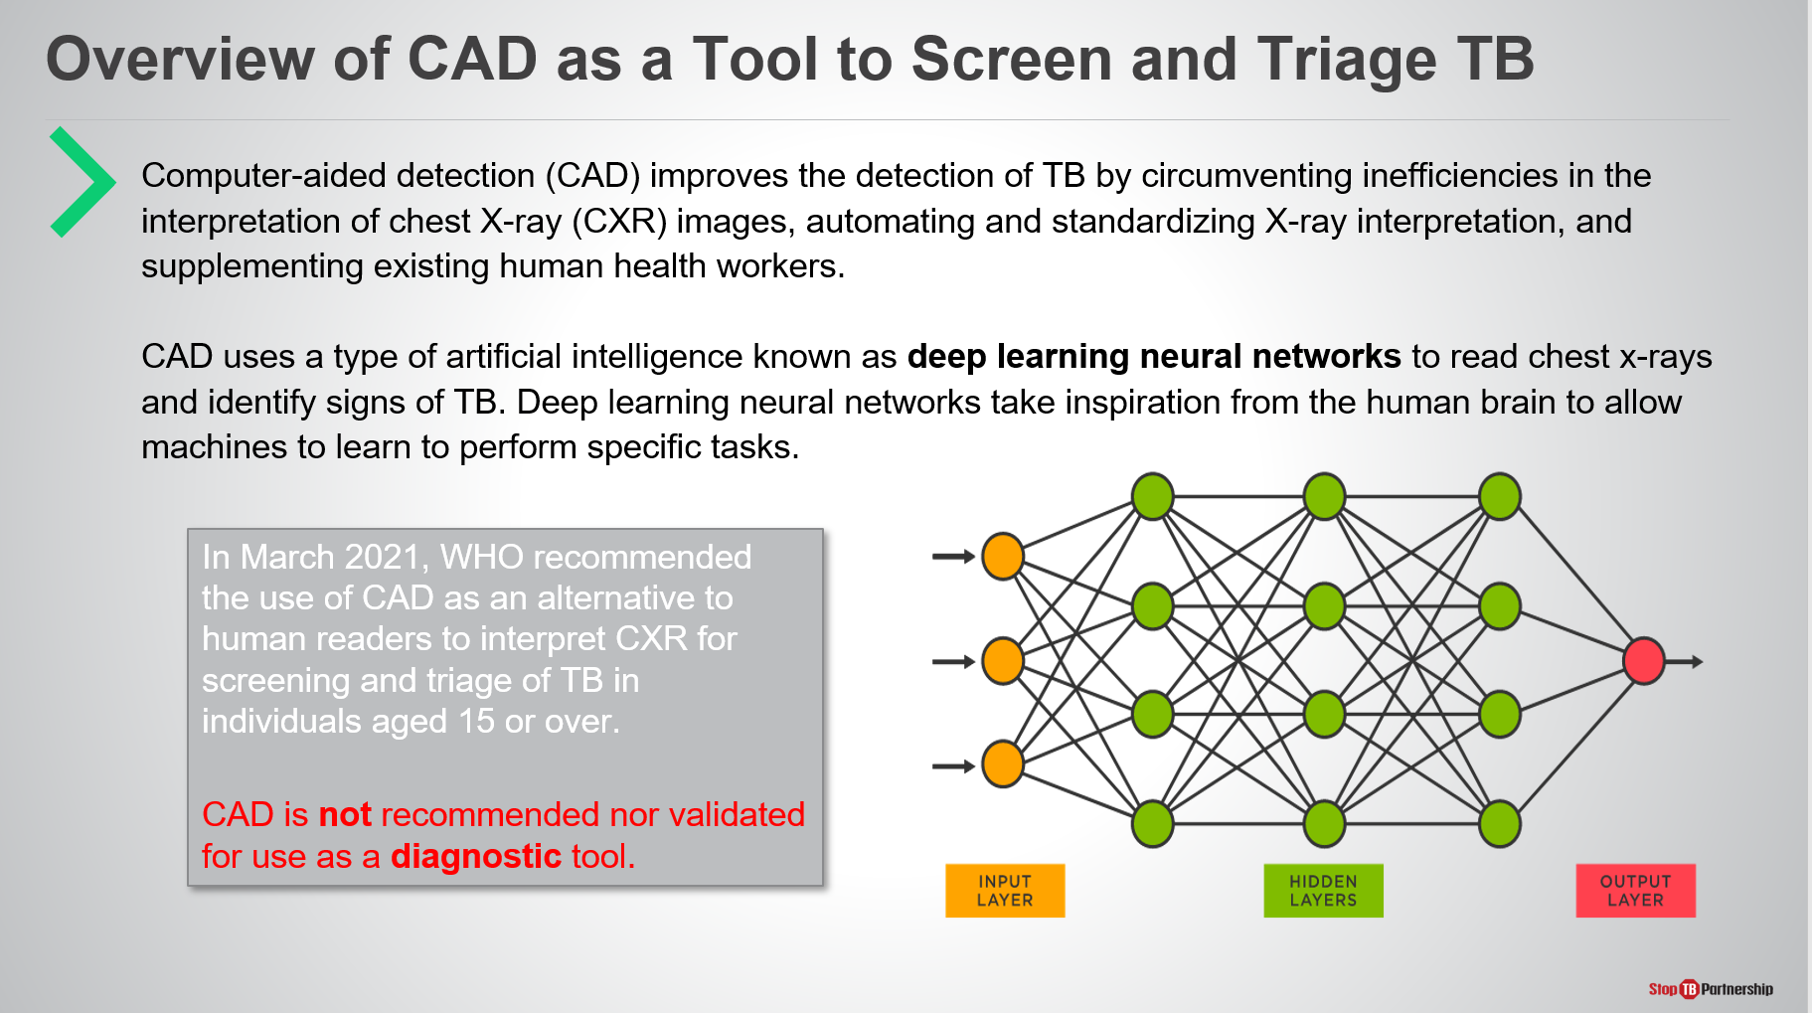
SAY: We will start by understanding the technology behind CAD’s decision – artificial intelligence (AI). Though AI is often the stuff of science fiction, it is increasingly used in today’s world, for example for personalizing music or film recommendations, social media feeds, and increasingly in health care.

The type of AI used in CAD is a called a deep learning neural network.
DO: Direct the audience (through mouse, pointing) to the figure on the slide when talking about deep learning networks.
SAY: This diagram shows us a simplified deep learning neural network. Modelled on those in the human brain, you can see it is structured in layers: the orange layer receives the input – the chest X-ray- the green layers process the input, and provide their collective analysis to the red layer, which generates the output.

The neural network is perfected by training AI on vast quantities of data to perform the desired task, with the neural network evolving during training. For our purpose AI is trained to identify TB in chest X-rays.

Before using CAD, it is essential to know that the CAD result is NOT for diagnosis of TB and individuals identified by CAD as possibly having the disease should receive a diagnostic test.

CAD Output | Slide: 8
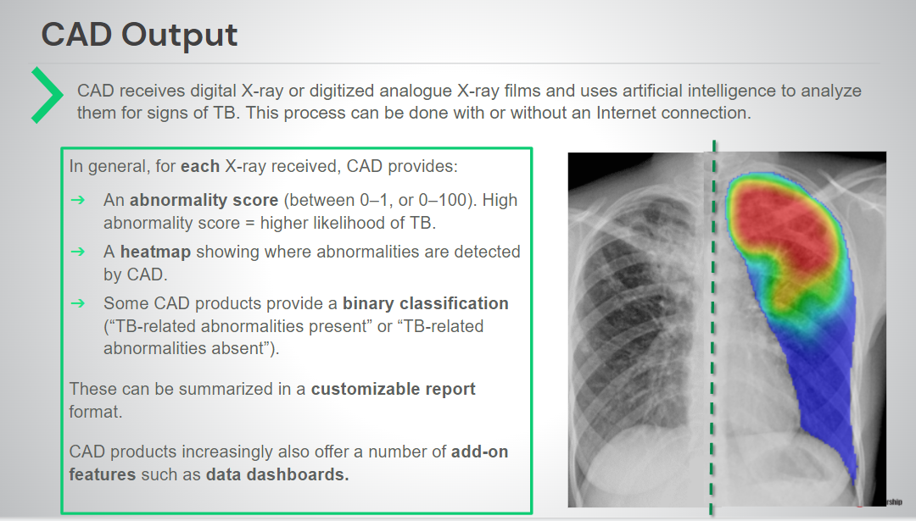
SAY: CAD receives the input- digital X-ray or digitized analog X-ray films- and analyzes them for signs of TB.

For each X-ray image provided, CAD provides:
- An abnormality score (between 0-1 or 0-100) indicating the likelihood of TB presence in the image.
- A heatmap or bounding box diagram showing where abnormalities are detected, if any.
- Some CAD provide a classification “Possibility of TB” or “No TB”

These are often summarized in a customizable radiologist-style report format by the program. In addition to these outputs, the AI analysis is often provided within a package of add-on tools, such as data dashboards.

How to Understand the CAD Output | Slide: 9
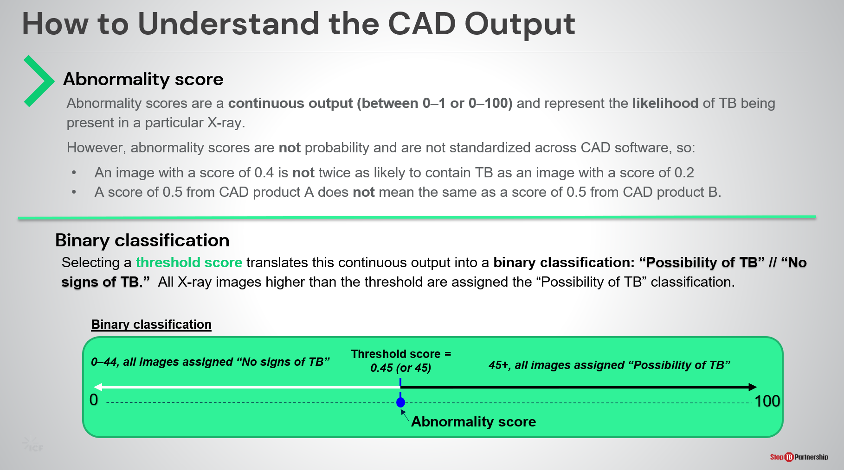
SAY: Let’s take a closer look at the abnormality score and classification outputs.

First, the abnormality score is a number calculated by CAD for each chest X-ray it reads. A high score indicates a high likelihood of TB in the X-ray.
When interpreting the abnormality score an important thing to keep in mind is that the scores are not standardized across the X-ray datasets nor across different CAD products. This has two important implications:
- An image with a score of 40 is not twice as likely to contain TB as an image with a score of 20
- A score of 50 from CAD product A does not mean the same as a score of 50 from CAD product B.

Turn your attention to the lower half of the slide. A threshold abnormality score can be selected, which CAD uses to classify X-ray images depending on whether their abnormality score is above or below the threshold. This helps with interpretation of the continuous abnormality score output, translating the number into the text “Possibility of TB” or “No signs of TB” which is also assigned to the X-ray.

DO: Direct audience to the diagram on the slide
SAY: In this diagram the chosen threshold score is 45. This means that all images assigned a score higher than this, for example an image with a score 56, will receive the classification “Possibility of TB” by CAD. The opposite is also true, X-rays with a score lower than 45, for example 19 would be assigned the classification “No signs of TB” by CAD.

How to choose this threshold score will be explored in Module 4.

Detecting Non-TB Abnormalities by CAD | Slide: 10
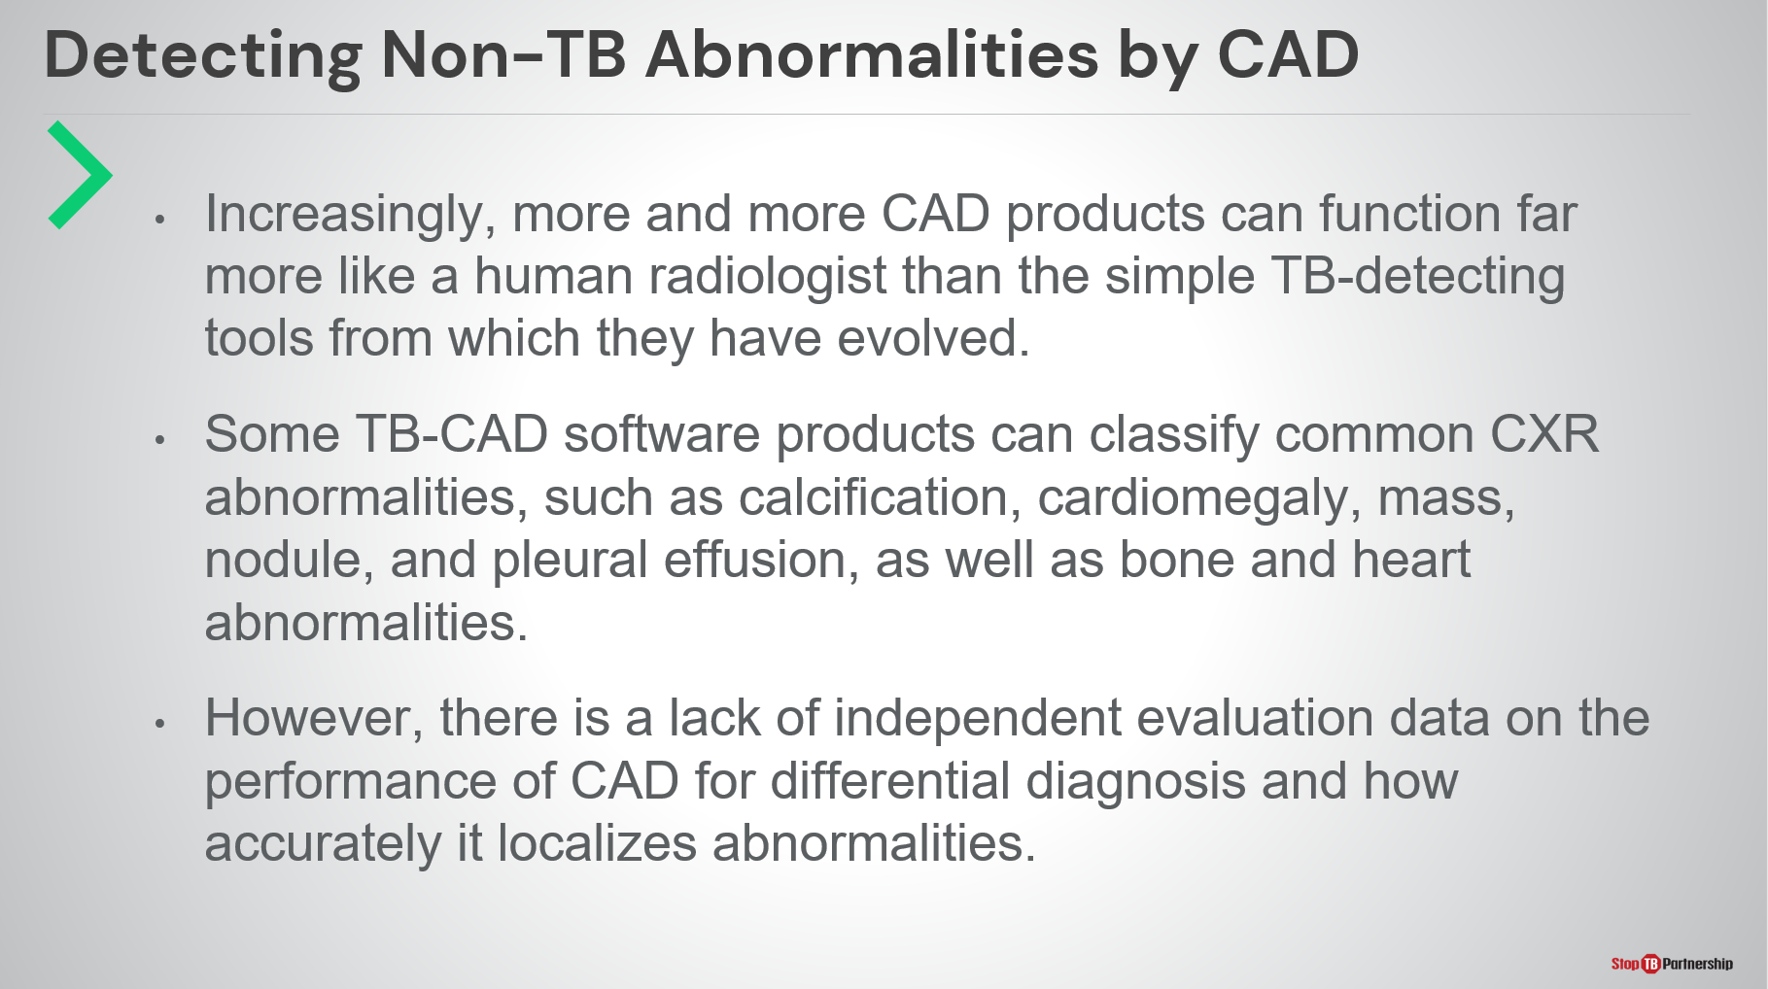
SAY: So far, we have only talked about CAD’s ability to detect TB. Increasingly, CAD products can also detect non-TB lung abnormalities (calcification, cardiomegaly, pleural effusion, for example), bone and heart abnormalities, and non-TB lung diseases (including Covid-19). The range of abnormalities identified depends on the brand and version of the CAD product.

However, CAD has currently only been validated for detecting TB-related abnormalities and its accuracy when detecting other abnormalities and diseases (including Covid-19) remains unknown.

Validation of CAD for Interpreting Digital X-ray | Slide: 11
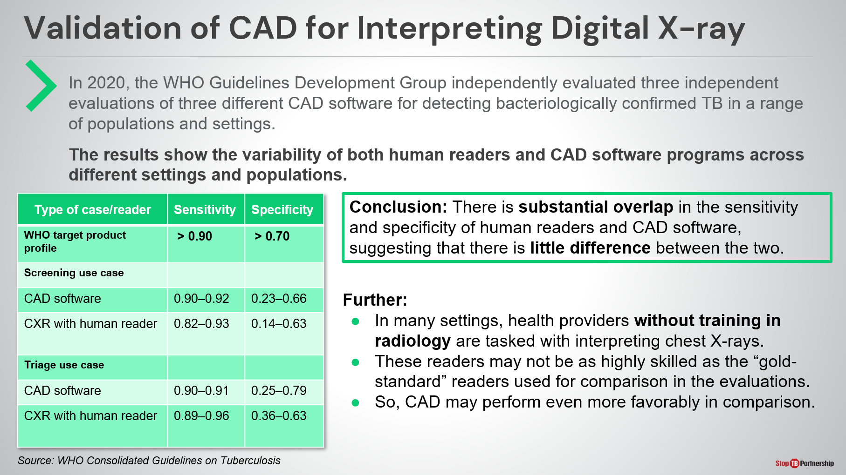
SAY: Next, we will discuss to the accuracy of CAD in identifying TB in chest X-rays. Preceding the update of the WHO guidelines in 2021, the Guidelines Development Group evaluated three independent evaluations of three different CAD products (CAD4TB, qXR, and Lunit INSIGHT CXR). The results are shown in this table and demonstrate the comparable range in sensitivity and specificity of human readers and CAD software.

It is also important to evaluate CAD in context: trained human readers are not available or in low number in many settings with high TB burden while non-specialist human readers may be used that would not perform as well as the “gold standard” human readers against which CAD is frequently compared.

Based on this, WHO made the decision to recommend CAD in the most recent update of the systematic TB screening guidelines.

Validation of CAD for Interpreting Digital X-ray | Slide: 12
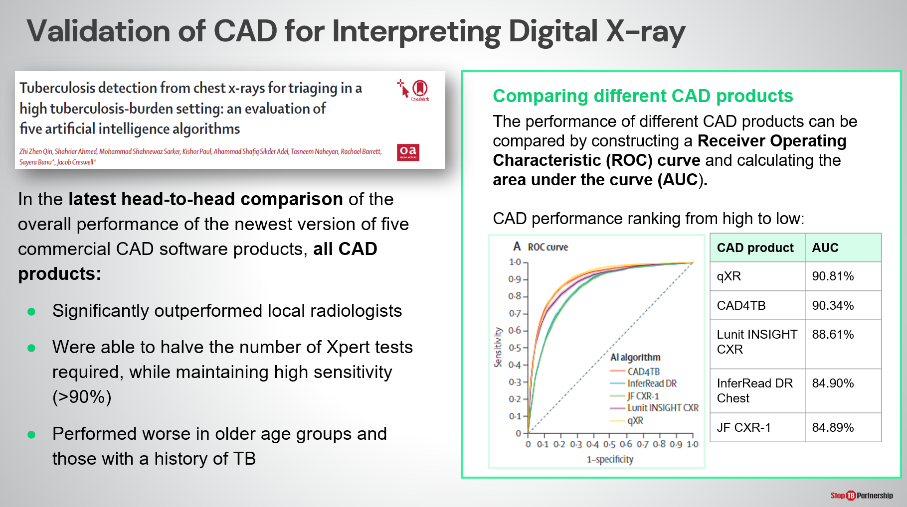
SAY: One of the latest peer-reviewed paper published on Lancet Digital Health evaluated the latest versions of the two CAD products provided through GDF. The evaluation was done in Bangladesh, Dhaka, among people referred by private physicians to test for TB. The prevalence of TB was around 15% - higher than that of a regularly ACF. This study found that CAD:
- Significantly outperformed local radiologists
- Was able to halve the number of confirmatory tests required, while maintaining high sensitivity.
- Performed worse in older age groups and those with a history of TB.

CAD literature also provides insights on how different software perform relative to each other. For example, (shown in the box on the right-hand side) qXR and CAD4TB were the top performing CAD products in this evaluation.
Another insight that can be gleaned from CAD literature is that product performance can vary based on population, epidemiological, and programmatic factors and so results from one evaluation may not hold true for all evaluations and for your prospective implementing population.

Where to Place CAD in the TB Screen Algorithm | Slide: 13
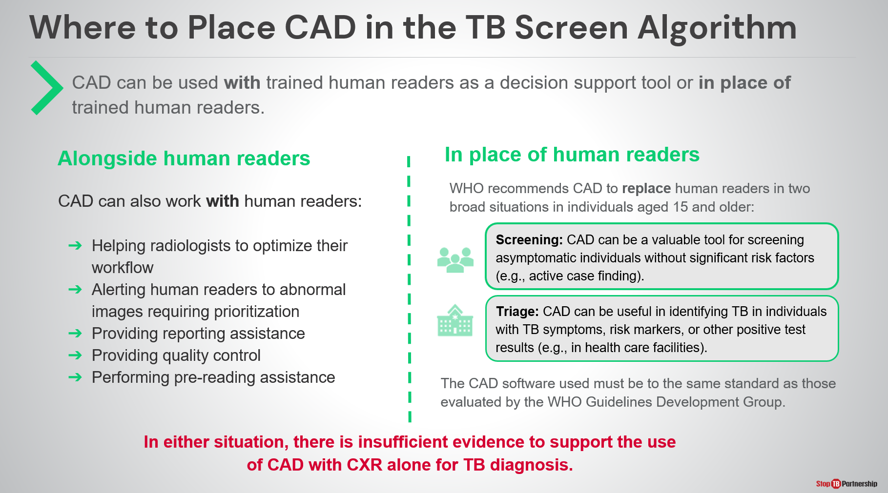
SAY: Given our new knowledge of CAD, we will now move on to discuss how CAD can be integrated with TB screening algorithms.

As previously mentioned, CAD can be used in place of trained human readers according to WHO’s recommendation, but CAD can also be used WITH human readers.
- Alongside human readers, CAD can be useful for helping radiologists optimize their workload and flow, prioritizing follow-up of abnormal images, providing image quality checks, pre-reading and reporting assistance.
- CAD is only recommended to be used in place of trained human readers for individuals aged 15 years and older. Here, it can be used as a rapid screen particularly among asymptomatic individuals without significant risk factors (e.g., in active case finding), or for triage in individuals with symptoms, or risk factors.

Any CAD algorithm used must meet the standard of those evaluated by WHO for the guideline update.

Where to Place CAD in the TB Screen Algorithm | Slide: 14
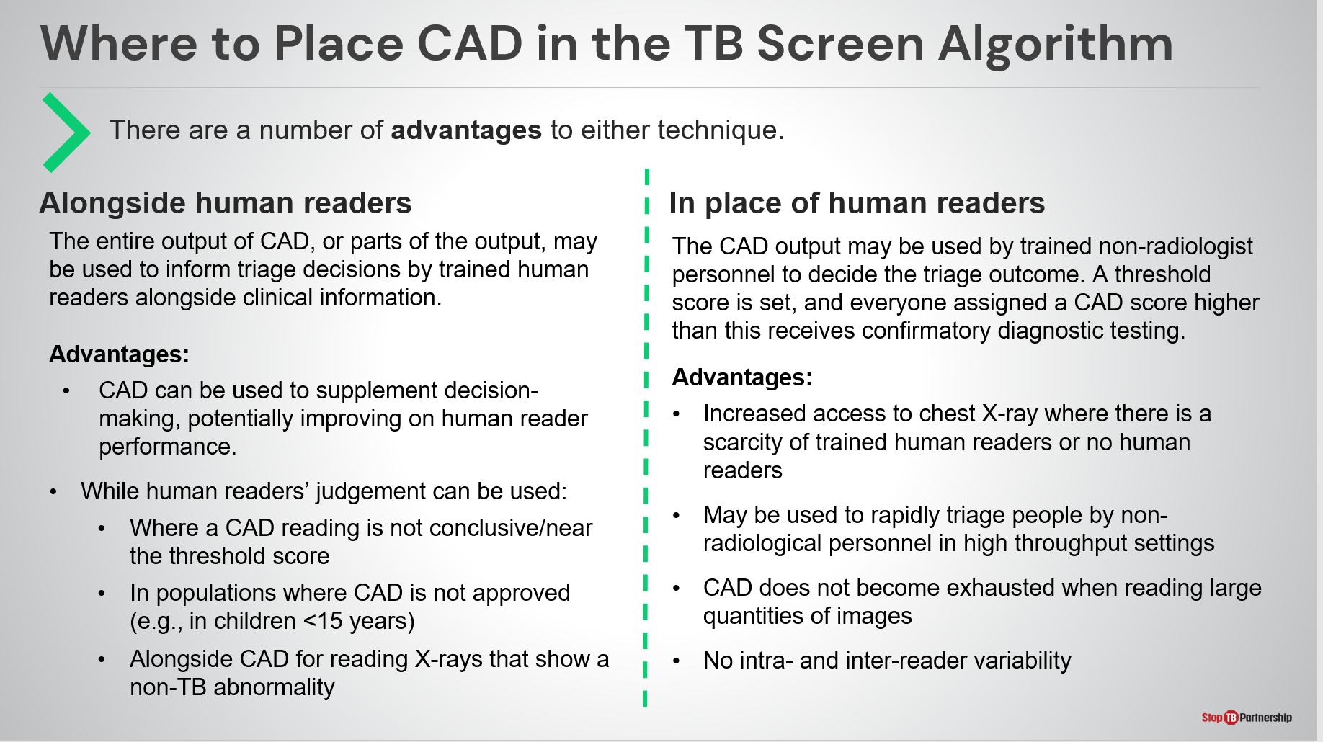
SAY: There are advantages to both approaches.

When used alongside with human readers, CAD outputs can inform the triage decisions of trained human readers, potentially improving upon performance, while the human reader judgement may be helpful to supplement CAD where an output is near the threshold, in children, or for identifying non-TB abnormality.

Meanwhile, when used without experienced human readers, or with non-radiologist personnel, CAD outputs can determine the triage outcome . This approach is particularly helpful where there is a scarcity of trained human readers, or none at all, as well as in high throughput settings.

ASK: With our combined knowledge of [this country’s] current TB recommendations and practices, where are some potential places CAD could supplement our workflows?
DO: Receive answers, encourage note-taking

Where is CAD used in the project TB screening algorithm? | Slide: 15
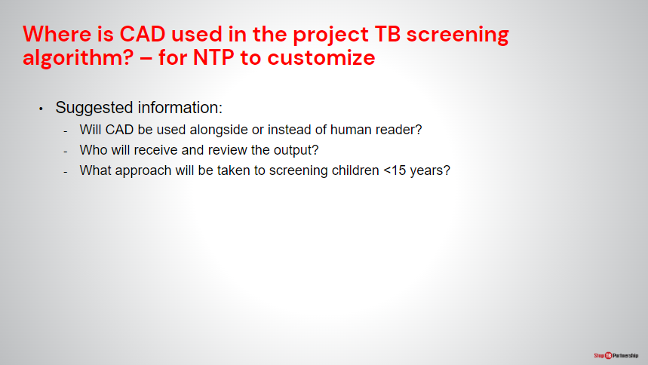
SAY: Thanks for your suggestions of where CAD could be used. For this particular project CAD will be used following the algorithm on this slide

ASK:
DO: Describe how CAD will be used in the project.

CAD Products in the GDF Catalogue

CAD4TB | Slide: 17
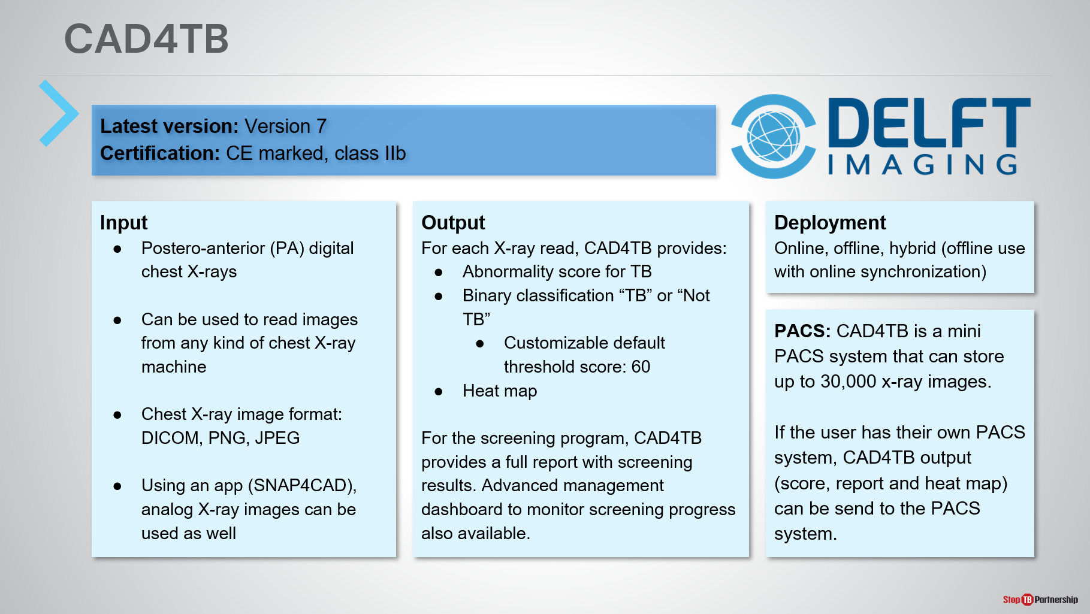
SAY: Now we will stop talking about CAD generally and focus on the products available through Stop TB Partnership’s GDF Catalog. The manufacturer will provide details in their hands-on training so today we will give an overview.

The CAD software provided is CAD4TB by Delft Imaging Systems.
ASK: Does anyone in the room have experience with CAD4TB?
DO: Receive answers and prompt them to provide an overview of where and how they used it.
SAY: The latest version of CAD4TB is version 7 and this is the version procured under this project.

CAD4TB can be used to read chest X-rays from any kind of machine (not just Delft’s own) and reads postero-anterior (PA) digital images in DICOM, JPEG or PNG format. For sites using analog X-ray, an app can be used to take a picture of the film for reading by CAD4TB. This feature exists but not provided through the GDF package.

In terms of output, CAD4TB provides an abnormality score between 0-100 and “No TB” or “Possible TB” classification, as well as a heatmap highlighting areas of abnormality. The threshold score is fully customizable.

CAD4TB can be used online, offline, or in a hybrid mode. Hybrid allows use in areas without internet connection, followed by result synchronization when internet connection is restored.

During installation, CAD4TB can be configured by the manufacturer to integrate with health information systems such as PACS.

Finally, the AI reading is provided within a software package that also includes patient registration, a space to input confirmatory test data, and a program management dashboard.

On subsequent slides we’ll show some brief snippets of the software for the purposes of this training. The manufacturer will provide comprehensive training as part of their training package.

END-USER ONLY: CAD4TB | Slide: 18
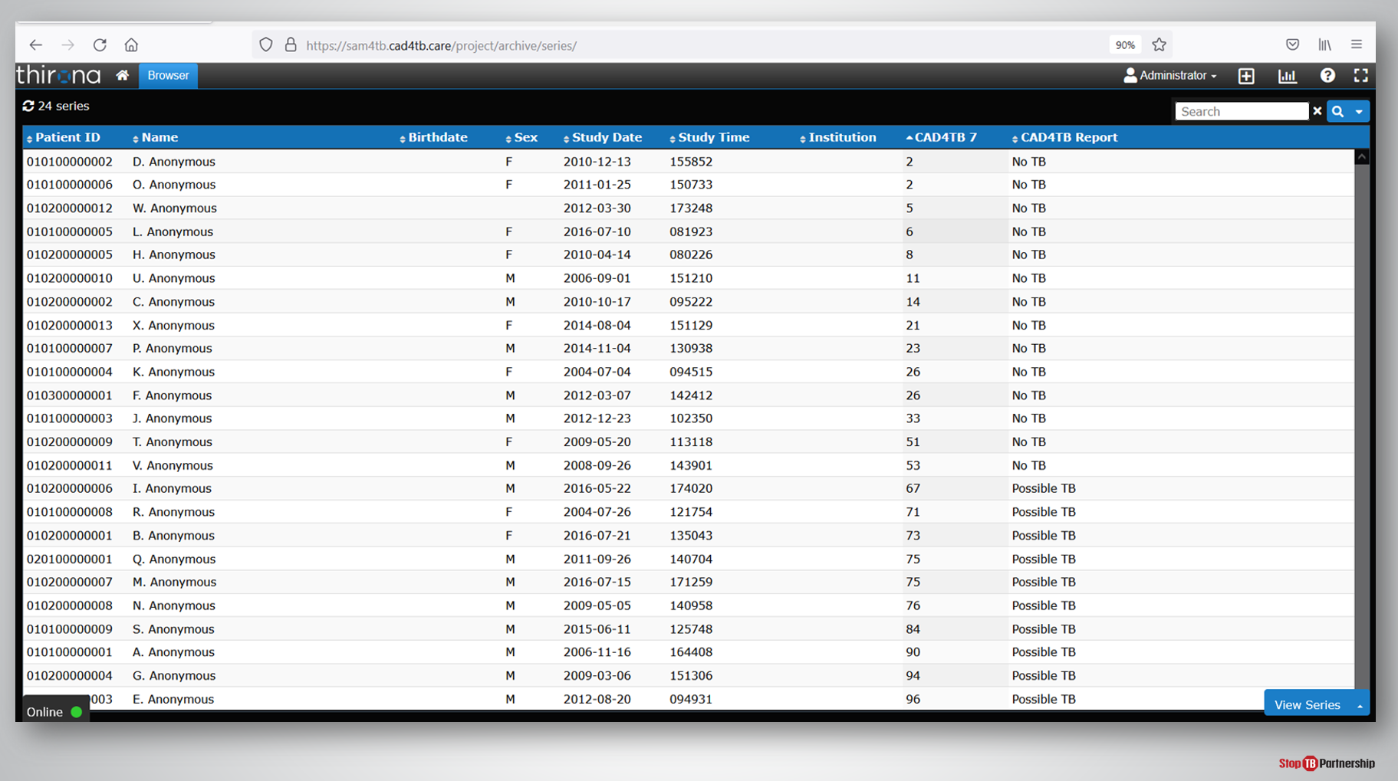
SAY: This first screen shows us the patient register on the CAD4TB software. A complete list of registered patients is provided, the patient ID is automatically generated by the software upon patient registration, while personal information (name, birthdate, sex) are all inputted into the system by community health workers at the screening site.

The final two columns show the corresponding CAD4TB abnormality score and classification (either “No TB” or “Possible TB”) for each patient.

CAD4TB Viewer Window Showing Heatmap and Score | Slide: 19
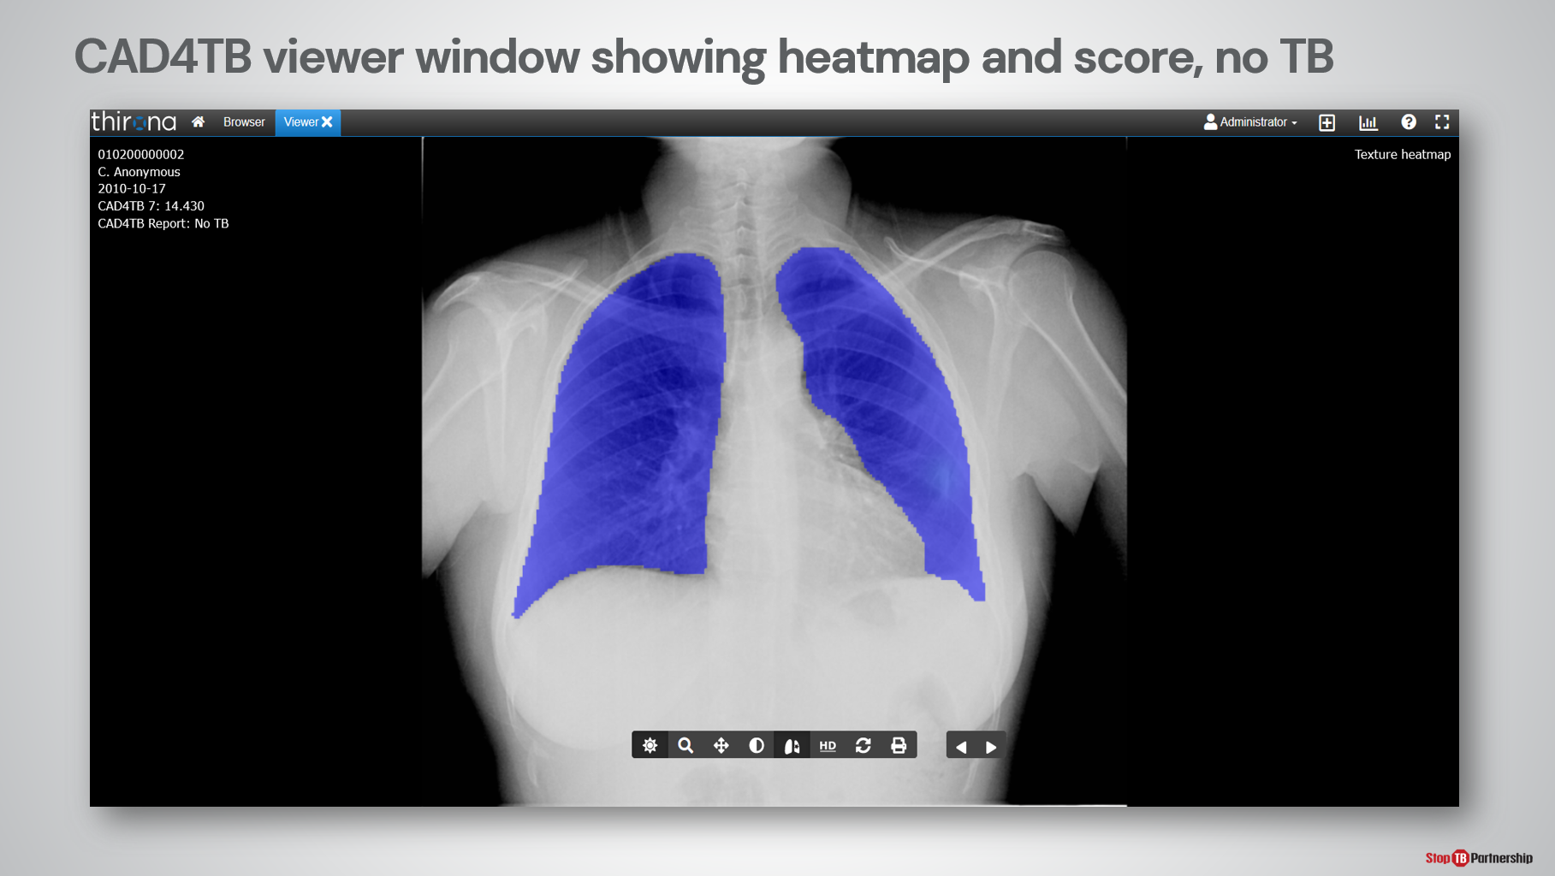
SAY: This is an example output from CAD4TB. The abnormality score and classification are provided in the top left corner.
ASK: Look closely at the image, can someone tell me whether this image shows TB according to CAD?
DO: Give time to receive an answer to the question, prompt the person answering to give a reason why (e.g., the abnormality score is low, the classification assigned is “No TB”, there are no areas highlighted on the heatmap).

CAD4TB Viewer Window Showing Heatmap and Score | Slide: 20
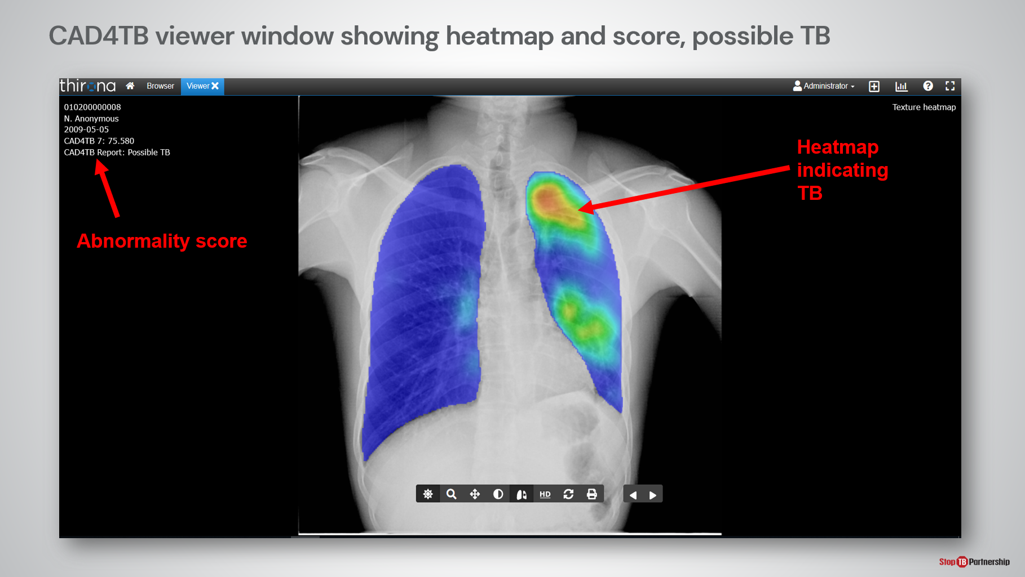
SAY: This is an annotated example of a heatmap showing TB. We can see the abnormality score is much higher in this image than the previous one, the classification by CAD4TB is “Possible TB” and the heatmap shows areas in yellow and orange which indicates abnormality has been detected.

This person should be directed to receive a diagnostic test.

CAD4TB Symptom and GXP Report | Slide: 21
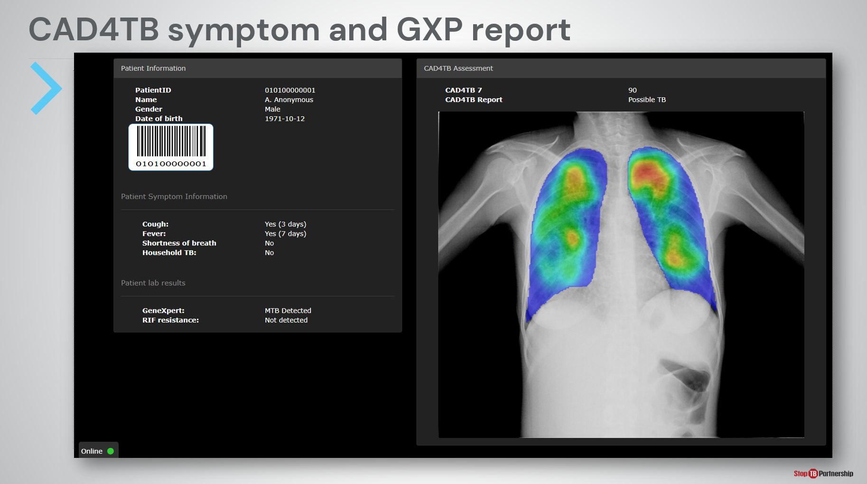
SAY: As mentioned previously, CAD4TB can summarize findings in a radiologist style report.

On the left-hand side “Patient Information” shows information inputted into the CAD4TB system during registration, including patient details and symptoms, as well as confirmatory test results, which can be manually inputted later. The ID and barcode is automatically generated by CAD4TB and can be printed and used with a barcode scanner to link the CAD output with subsequent diagnosis and follow-up.

On the right-hand side “CAD4TB Assessment” shows the 3 CAD outputs: abnormality score, classification, and heatmap.

This report sheet could be printed and kept with paper-based records or stored in electronic health information systems.

CAD4TB Insights Module | Slide: 22
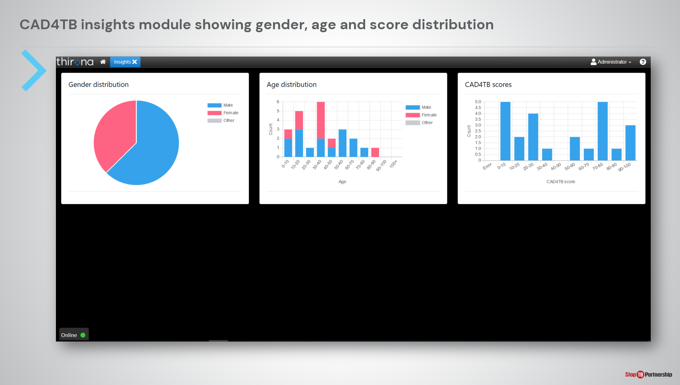
SAY: Finally, new to version 7, is the CAD4TB program management dashboard which displays aggregate data from the screening program, including the gender, age, and CAD4TB abnormality score distributions.

Introducing Ultra-Portable X-Ray

Types of X-ray Technology | Slide: 24
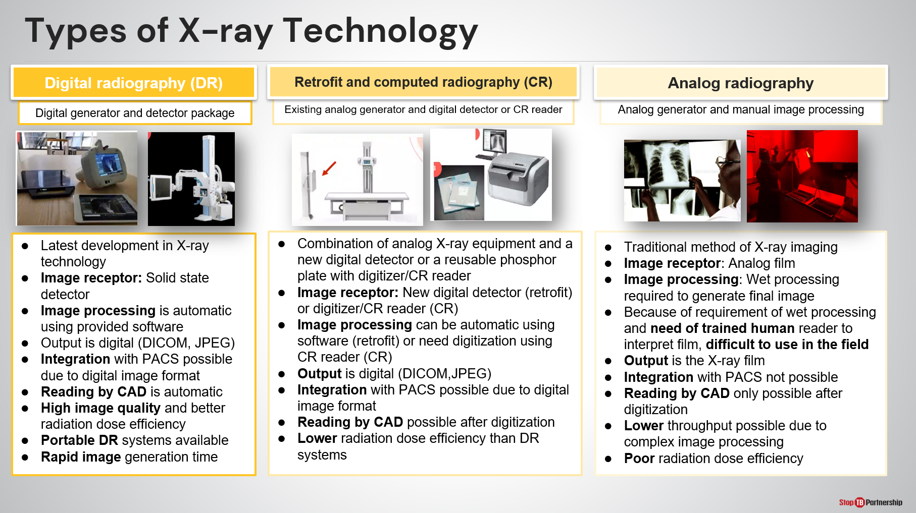
SAY: Taking a break from CAD, we will now move on to discuss the other innovative screening tool provided: ultra-portable X-ray technology. X-ray technology is featured alongside CAD in the WHO recommendations and is widely used for TB screening.

Four different types of X-ray equipment can be used in TB programming: analog, computed, retrofit, and digital. Each has its advantages and disadvantages, though consensus is that digital systems provide rapid, automatic image processing and generation, higher radiation dose efficiency, and can be more portable than computed or analog radiography.

The digital images generated from digital and computed equipment can be automatically inputted into CAD. Digital equipment, however, may not yet be available at all sites and some CAD (CAD4TB included) provide the ability to digitize analog chest X-ray films for reading by AI using a mobile phone app.
ASK: What kind of X-ray equipment is most available in your setting?
DO: Encourage participation and receive answers.

Introducing Ultra-Portable X-Ray (UP-XR) | Slide: 26
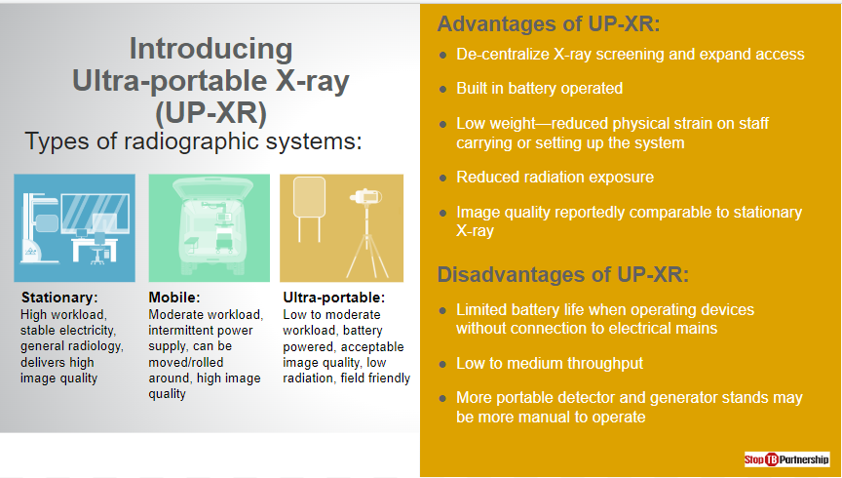
SAY: Digital radiography (DR) systems can be further classified as stationary, mobile, or more-recently ultra-portable.

As the name suggests, stationary X-rays are those that remain in a facility with stable electrical connection and are capable of delivery high quality images and a high workload. Meanwhile, mobile X-rays can be rolled around or transported in vans and are capable of a moderate workload and high image quality, with access to an intermittent electrical connection.

Ultra-portable systems are a new generation of “field friendly” X-ray technology, recognized by WHO and the IAEA as a sub-type of DR system alongside stationary and mobile X-ray. These are battery-powered, lightweight, and can be packaged into a backpack or carry case; they also emit less radiation while producing images of adequate quality. Unlike alternatives, ultra-portable systems are not designed for high workload and have limited exposure capacity without electrical connection.

The portable digital radiography system technical requirements published in August 2021 provide more details to support the selection, allocation, and use of ultra-portable X-ray systems.
As with any new tool, there are certain advantages and tradeoffs of using ultra-portable X-ray.

We already touched upon the advantages, ultra-portable X-ray systems:
- Can decentralize X-ray screening and expand access to hard-to-reach populations.
- Have lower weight, reduced radiation exposure, while maintaining image quality similar to stationary systems.

As a consequence of their smaller size, a few compromises are made with ultra-portable X-ray systems including:
- Limited battery life, meaning ultra-portable systems are not suitable for high throughput settings with more than 200 exposures a day.
- More manual operation required of generator and detector stands.

When selecting sites for ultra-portable systems, it will be important to consider both advantages and limitations of the devices.
ASK: Before we continue on to learn more about [Delft Light/ Fujifilm Xair] does anyone have any questions about ultra-portable X-ray systems?
DO: Leave time for respondents to ask questions and provide adequate responses.

Delft Light

Core System | Slide: 28
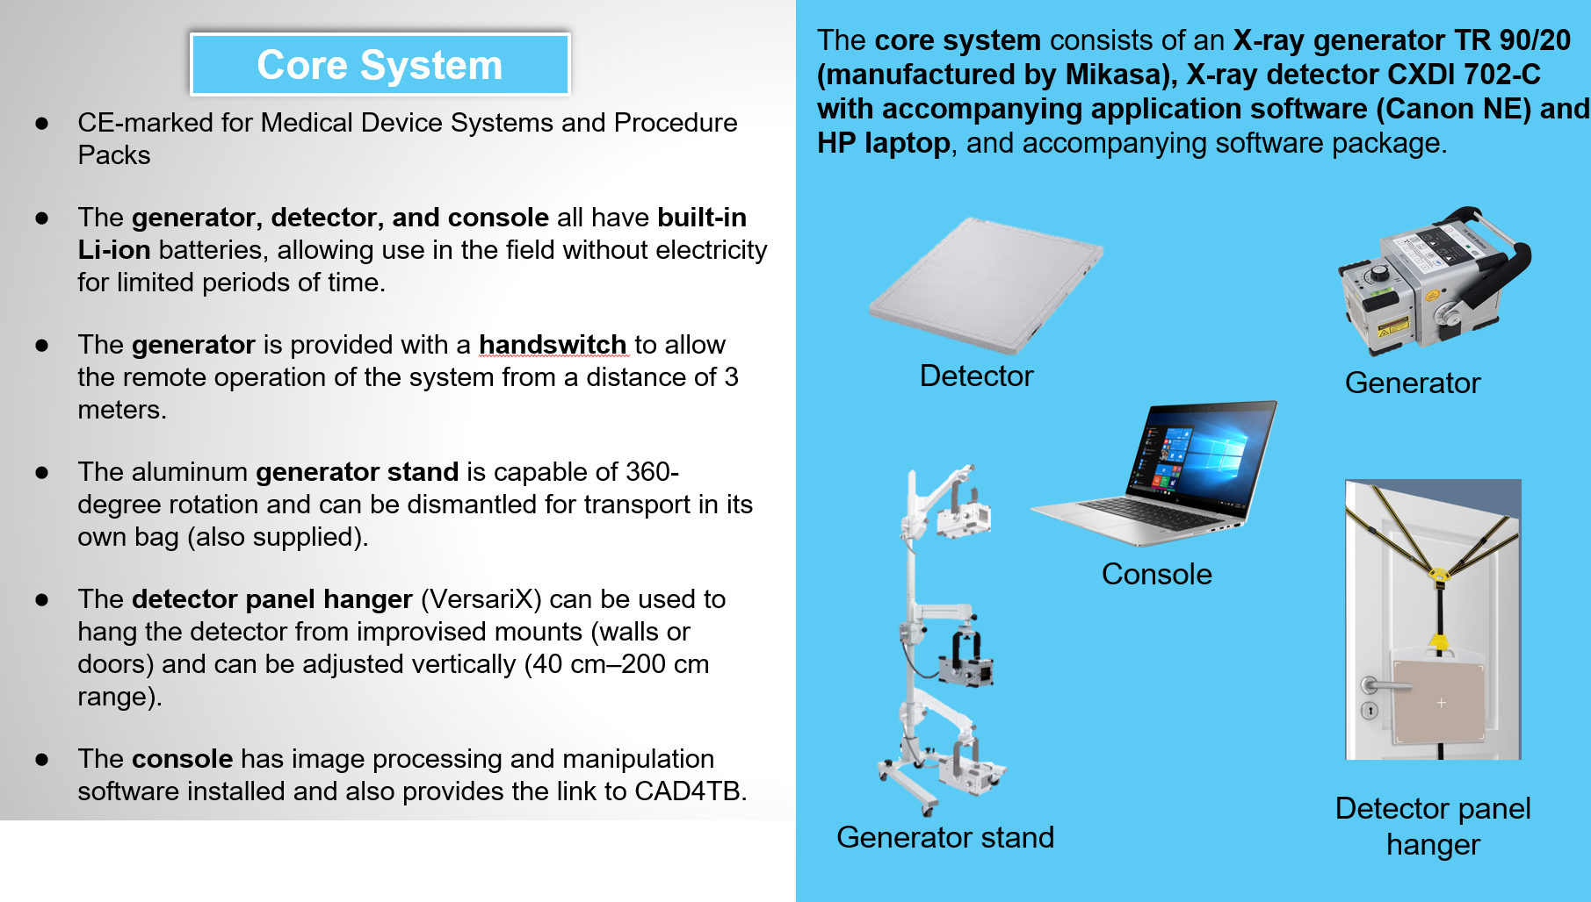
SAY: Now, we will focus on the Delft Light ultra-portable X-ray system which is available through the GDF catalog. The components provided through GDF can be seen on the slide.
- The core system consists of an X-ray generator, detector, and HP laptop. All have built-in lithium-ion batteries to allow for use in settings without electrical power connection.
- Exposures can be taken from a safe distance using the generator hand switch.
- A generator stand is also provided that is capable of 360-degree rotation and can be dismantled for transport in its own bag.
- To position the detector, a panel hanger is provided that can be used to hang the detector from improvised surfaces (walls or doors for example) and can be adjusted vertically.
- The console comes with a software package that allows for chest X-ray image optimization and provides the connection to the AI software.

You will have the opportunity to gain hands-on practice with this equipment during the manufacturer training.
DO: Point out each component while describing them.

Accessories | Slide: 29
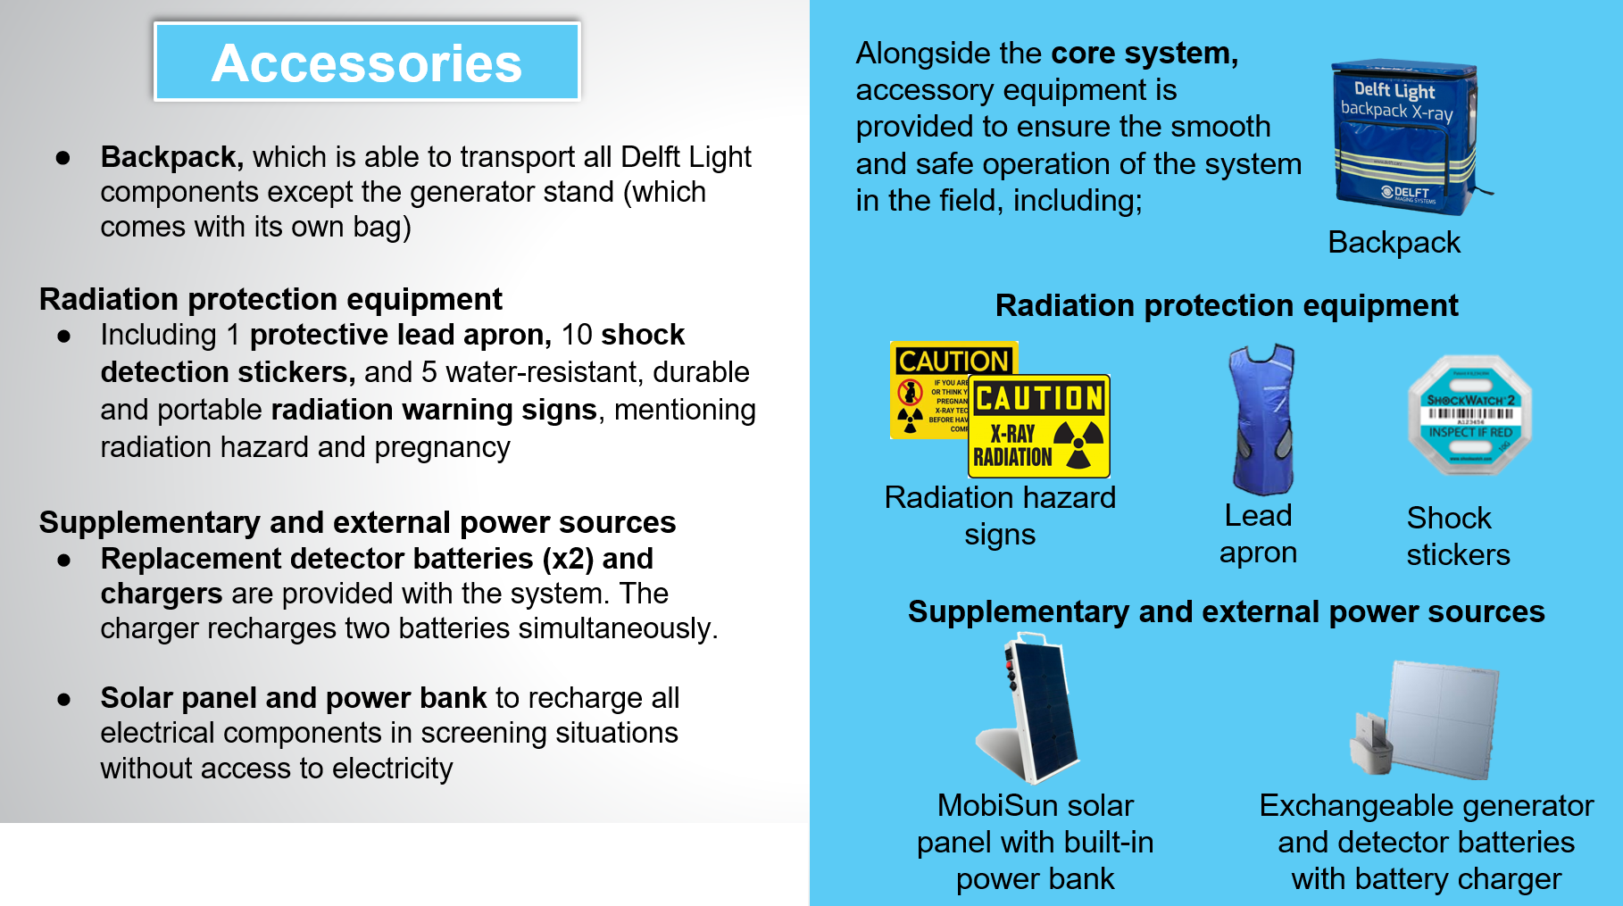
SAY: As well as the core components, several accessories are also provided free of charge when the system is procured through GDF. These include:
- A backpack for packaging up all components except the generator stand which comes with its own bag, for transport.
- Radiation safety equipment: lead apron, shock stickers, hazard signs. These can be used in conjunction with any equipment already available on site.
Supplementary and external power sources to prolong operation in settings without electrical connection. These include one set of replacement detector batteries, with charger, and a combined solar panel/ power bank capable of recharging the generator, detector, or laptop in the field.
DO: Point out each component while describing them.

Connection with CAD4TB | Slide: 31
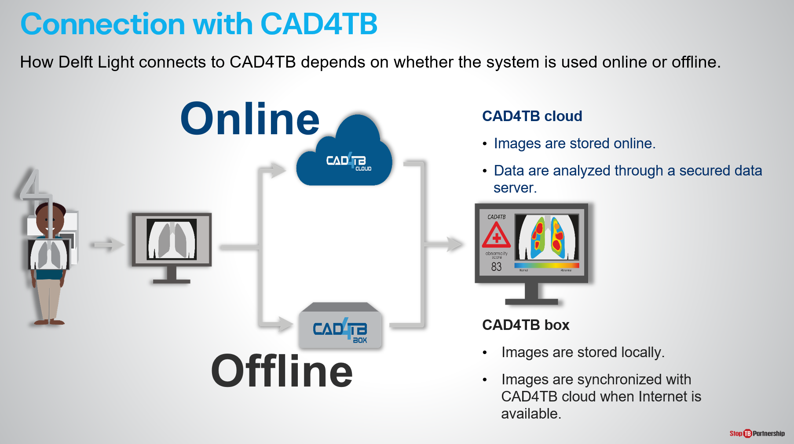
SAY: We will now move on to discuss using the two innovations- CAD and ultra-portable X-ray- together to aid TB screening. For each X-ray exposure taken two different results will be generated: the first is the black and white X-ray from the Delft Light, the second is the output from CAD4TB.

How the Delft Light sends the chest X-ray to the CAD4TB system depends on whether CAD4TB is used online (images analyzed on secure cloud server) or offline (images analyzed on box).

Connection with CAD4TB | Slide: 32
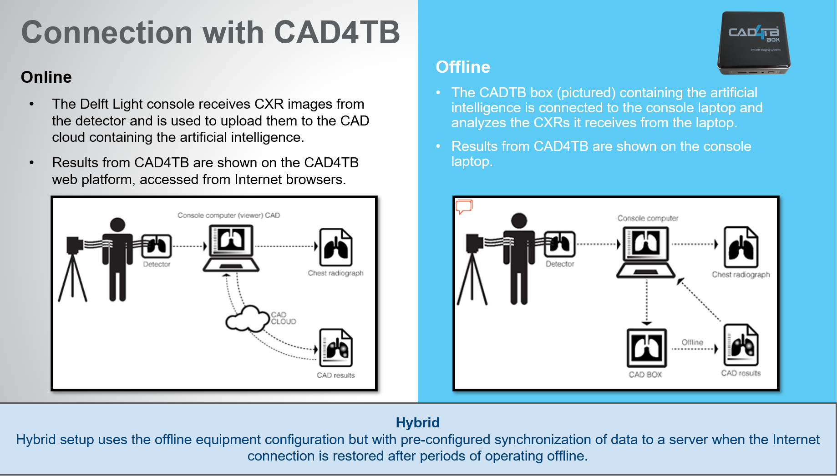
SAY: The schematics on the slide show how the ultra-portable X-ray and CAD systems interact with each other.
- On the left, CAD4TB is being used online. Chest X-ray images taken by the Delft Light are uploaded to the CAD4TB cloud from the console laptop. Both the X-ray image and CAD4TB result can be viewed on the console laptop of the Delft Light.
- If using CAD4TB offline, the offline box containing the AI will be connected to the Delft Light console computer so chest X-ray images can be transferred from the computer to the AI box without internet connection. Both the X-ray image and CAD4TB result can be viewed on the console laptop for the Delft Light.
- Hybrid mode will use the offline equipment configuration.
During the manufacturer training, installation, and integration of the two systems will be completed.

CAD and UP-XR | Slide: 33
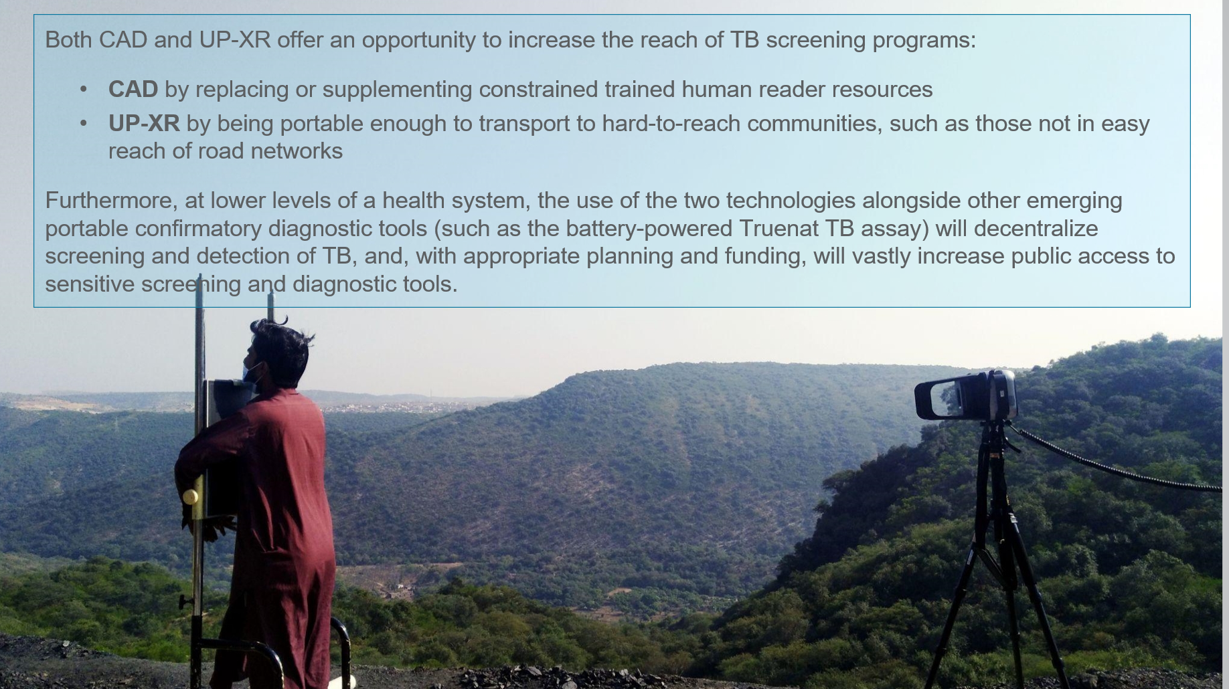
SAY: To conclude this module, together CAD and ultra-portable X-ray can increase the reach of TB screening programs by replacing or supplementing trained human reader resources and by being portable enough to reach hard-to-reach communities.

The use of the two technologies, alongside emerging portable confirmatory diagnostics, could decentralize TB screening and diagnosis. With appropriate planning and funding, these have the potential to vastly increase public access to sensitive screening and diagnostic tools.

Summary

Summary | Slide: 34
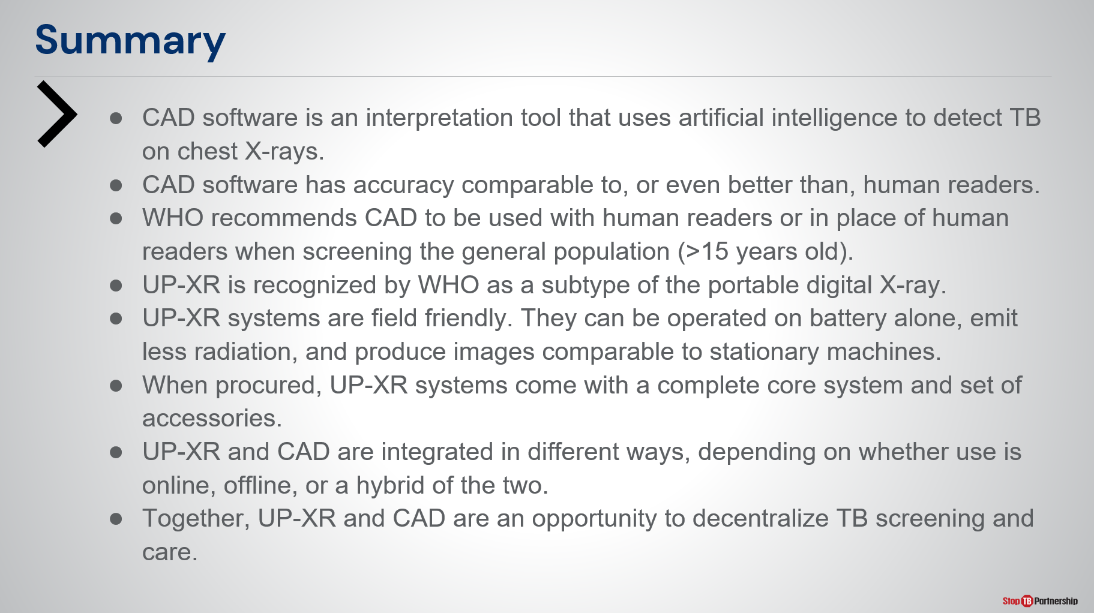
SAY: In summary of this module:
- CAD software is an interpretation tool using AI to detect TB on chest X-rays.
- CAD software has accuracy similar to, or better than, human readers.
- WHO recommends CAD to be used for TB screening and triage in place of human readers for individuals >15 years old.
- Ultra-portable X-ray is a WHO-recognized sub-type of digital X-ray.
- Ultra-portable X-ray systems are “field friendly”: They operate on battery alone, emit less radiation, and produce images of comparable quality to stationary machines.
- Ultra-portable X-ray systems procured from GDF include the core system components and accessories.
- Ultra-portable X-ray and CAD can be integrated in two different ways depending on whether CAD is used online or offline/hybrid.
Together, ultra-portable X-ray and CAD provide an opportunity to decentralize TB screening and care.
ASK: Before we move onto the knowledge check, are there any questions about the content covered in this module?
DO: Receive questions and respond appropriately.

Knowledge Check

Knowledge Check
Slide: 35, 36, 37, 38, and 39
DO: Explain that you will ask participants five knowledge check questions and may call on participants randomly to provide an answer. (These can also be programmed as poll questions in a virtual training – ensure that all participants respond before proceeding if using the poll feature).

If an answer provided in incorrect, ask if other participants would like to answer. Correct any incorrect answers that are given. If multiple participants get a question wrong, you may need to revisit the topic.

Note that knowledge check questions are not included in participant guides to avoid participants seeing them during the lesson and only focusing on those pieces. Encourage participants to write down the answers in their guides in the notes field for future reference.
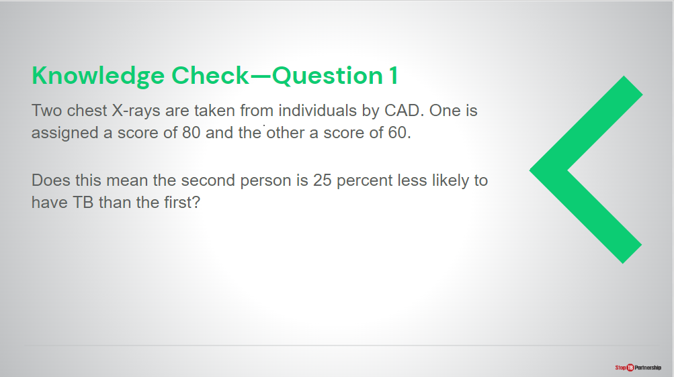
Answer: No, because the CAD output is not linearly related to the probability of having TB. There is no relationship between the two scores.
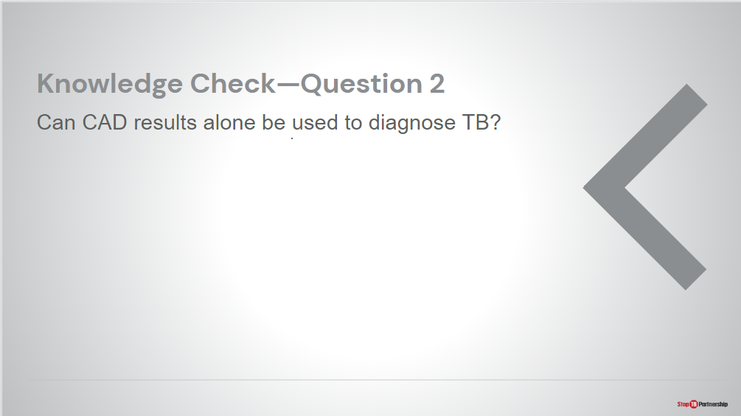
Answer: No, CAD is not validated to diagnose TB and is not recommended by WHO to do so. Anyone with a high score on CAD should receive confirmatory diagnostic testing, for example using Xpert or Truenat.
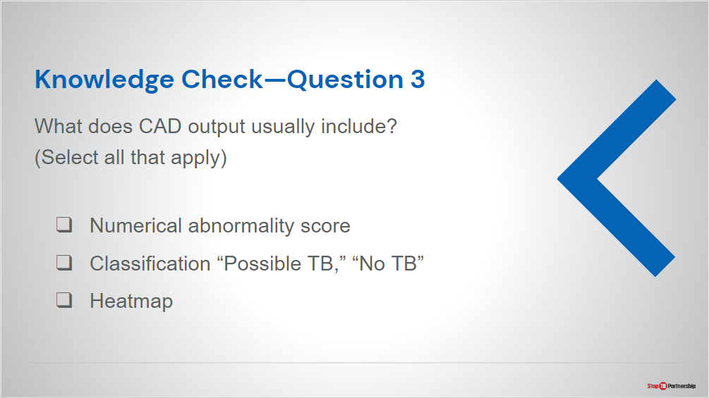
Answer: Answer: all
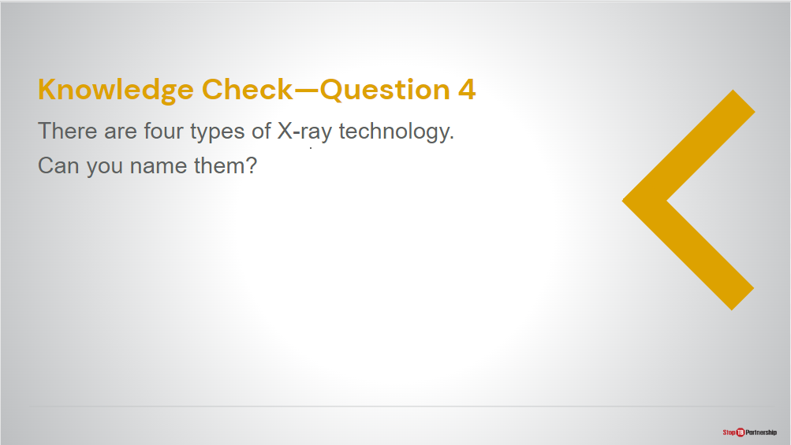
Answer: digital (DR), computed (CR), retrofit, analog
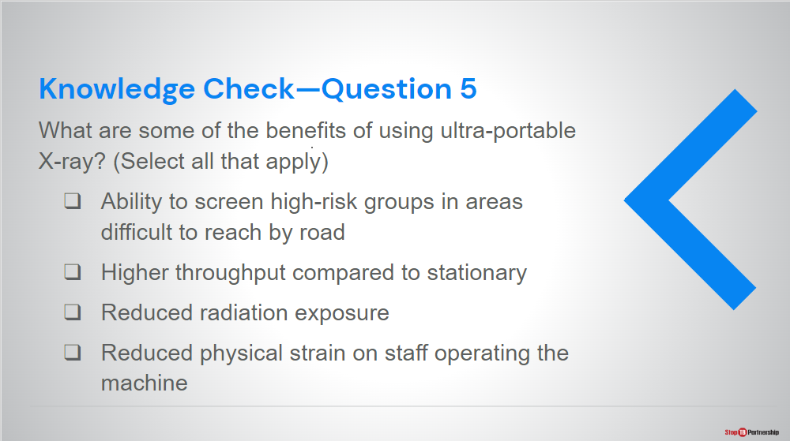
Answer: All are benefits of ultra-portable X-ray except for number 2 as throughput tends to be lower than stationary with these devices.

Module 3: Program Planning and Implementation Considerations

Target Audience
The target audience for this course is:

- X-ray technicians
- Radiographers
- Clinicians

Learning Objectives
Terminal Objective
- At the end of this module, participants will have a better understanding of key considerations when using ultra-portable X-ray systems with CAD software to screen and triage for TB

Module Objectives:
- By the end of this module, participants should be able to
  - Understand the general screening workflow involving CAD and UP-XR programs.
  - Be aware of key implementation considerations for CAD and UP-XR.
  - Be aware of some challenges and lessons learned from pilot projects.

Materials
- Facilitator Guide
- Pens/Pencils

Advance Preparation
- Instructors will need to customize slides in this module for the project screening workflow (slides 5 and 6), as well as any experiences from early implementers in the country (slide 19).

Introduction

Introduction | Slide: 2
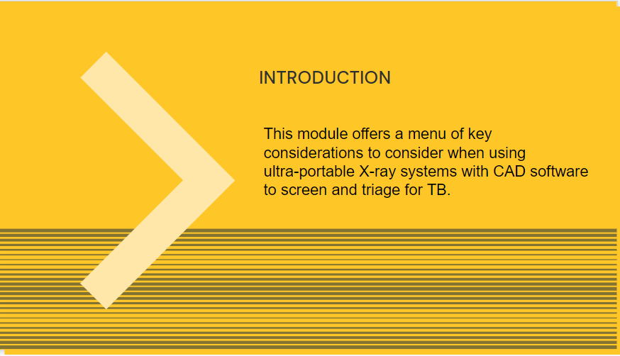
SAY: Now that Module 2 has given us an overview of ultra-portable X-ray and CAD, we will now move on to consider how to best use these two technologies for TB screening and triage.

This module offers a menu of considerations when using ultra-portable X-ray systems with CAD software to screen and triage for TB.

Outline | Slide: 3
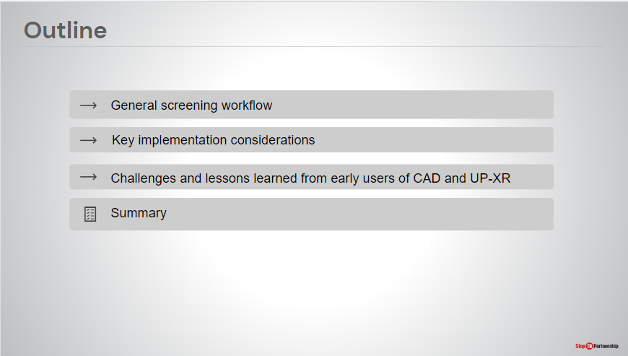
SAY: We will start by describing a general screening workflow using the two tools, and then we will conclude with key implementation considerations, and challenges and lessons learned from early users of the tools.

Learning Objectives | Slide: 4
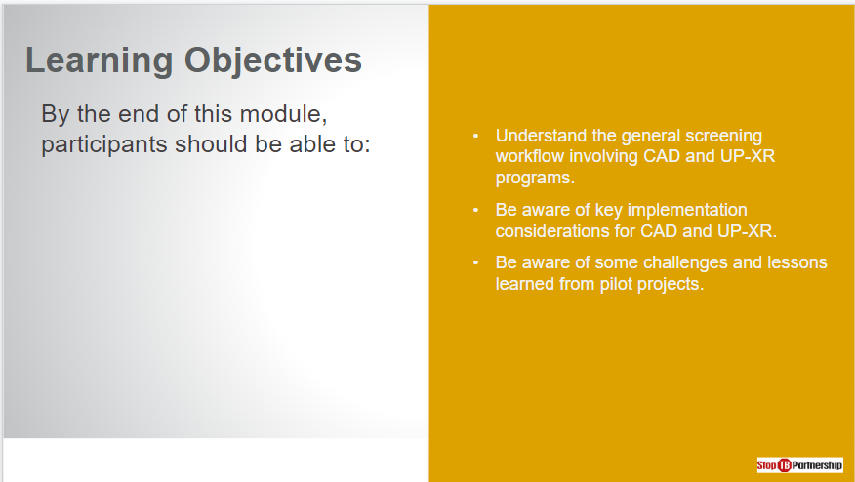
SAY: By the end of this session, you should be able to:
- Understand the general screening workflow.
- Be aware of key implementation considerations for CAD and ultra-portable X-ray.
- Be aware of some challenges and lessons learned from pilot projects.
ASK: Before we start, are there any questions about this session?
DO: Allow time for people to ask questions and respond appropriately.

General Screening Workflow

General Screening Workflow | Slide: 5
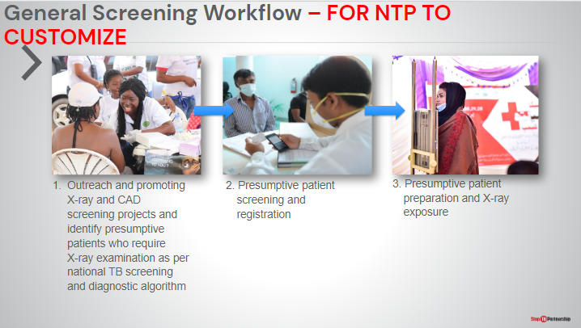
SAY: Describe general screening workflow for using X-Ray and CAD in the project across this slide and next
ASK:
DO:

General Screening Workflow | Slide: 6
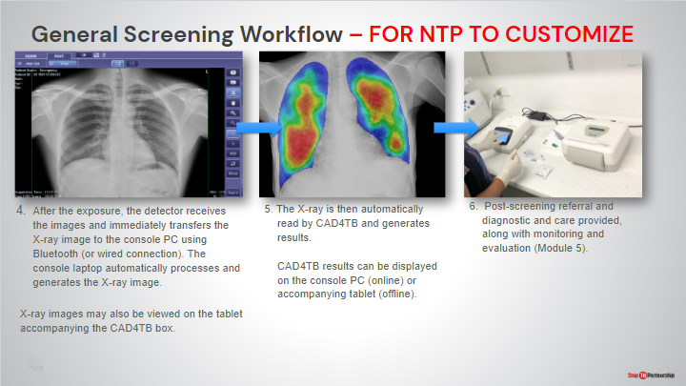
SAY: Describe general screening workflow for using X-Ray and CAD in the project
ASK:
DO:

Implementation Considerations – Delft Light

Electricity and Power | Slide: 8
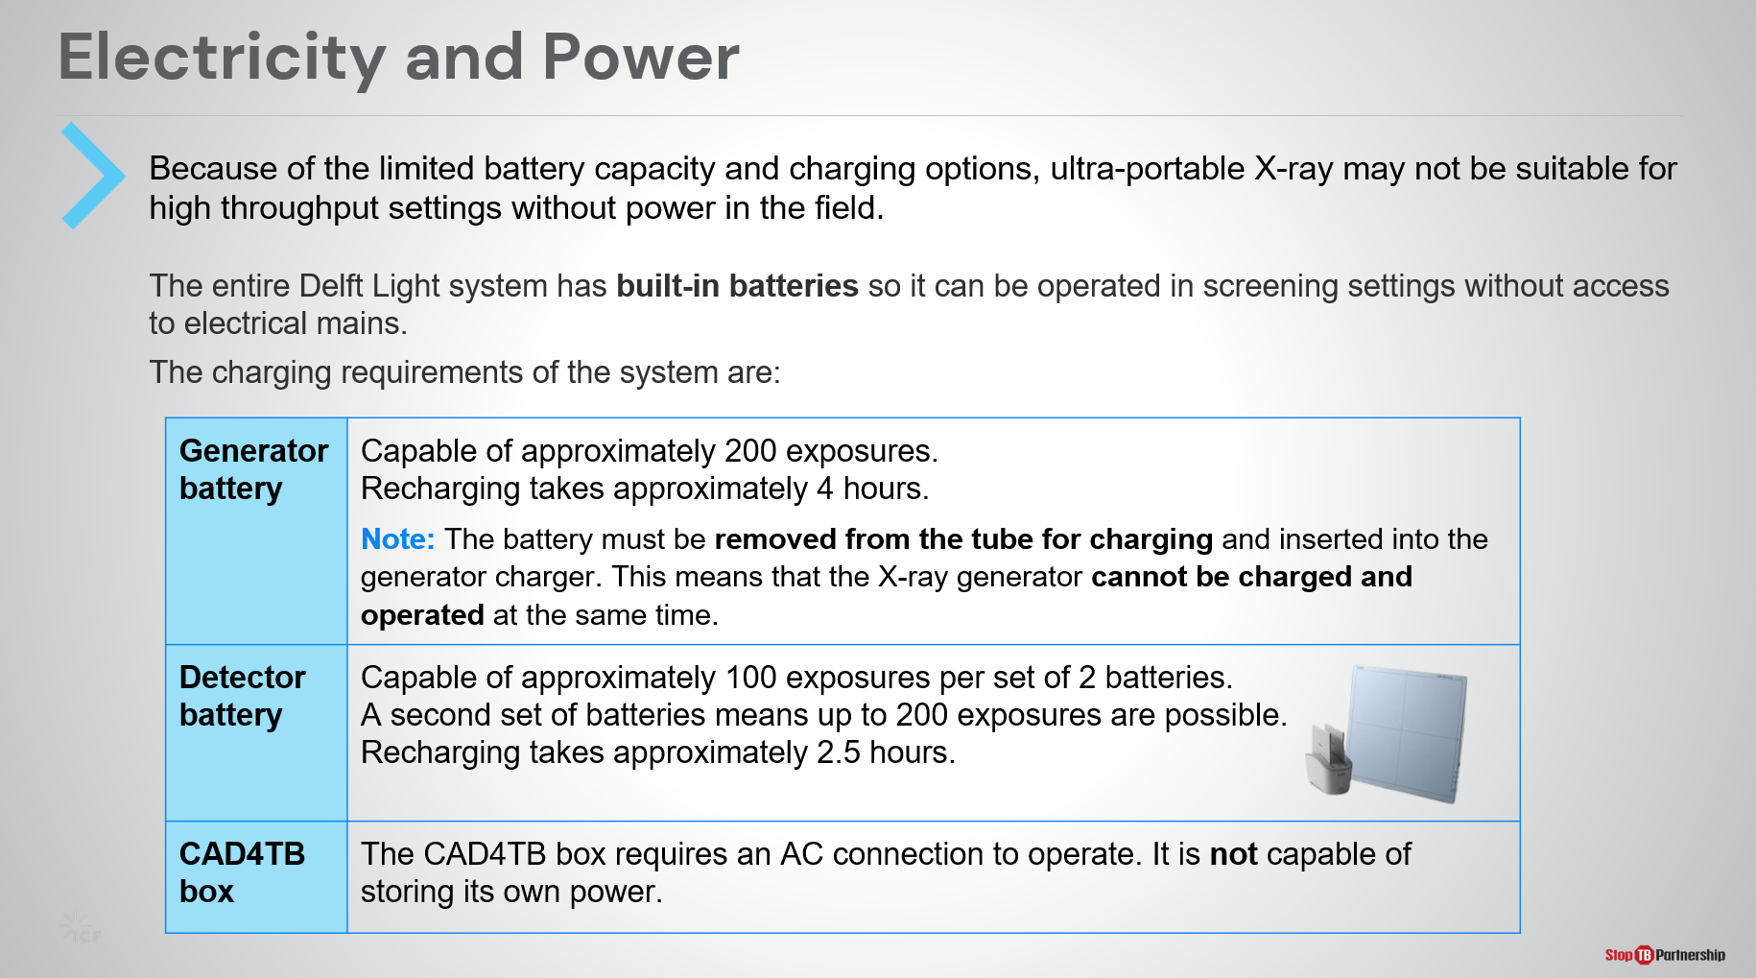
SAY: During the second part of our session, we will discuss some key implementation considerations of CAD and ultra-portable X-ray to keep in mind during program planning.

The first is electricity and power. As mentioned before, operating ultra-portable X-ray devices on battery power may limit the throughput the system is capable of in the field as batteries become flat after a large number of exposures.

- The Delft Light generator battery is capable of approx. 200 exposures without recharging and takes around 4 hours to recharge. Note that the generator cannot be charged and operated at the same time, so while recharging is occurring screening should be paused.
- The Delft Light detector battery is capable of approx. 100 exposures per set of 2 batteries. Recharging batteries takes approx. 2.5 hours. But, a second set of detector batteries is provided with the detector, meaning up to 200 exposures are possible in the field by exchanging the set of batteries.
- The CAD4TB offline box is not capable of storing its own power and must be connected to an AC power source to operate at all times.

Electricity and Power | Slide: 9
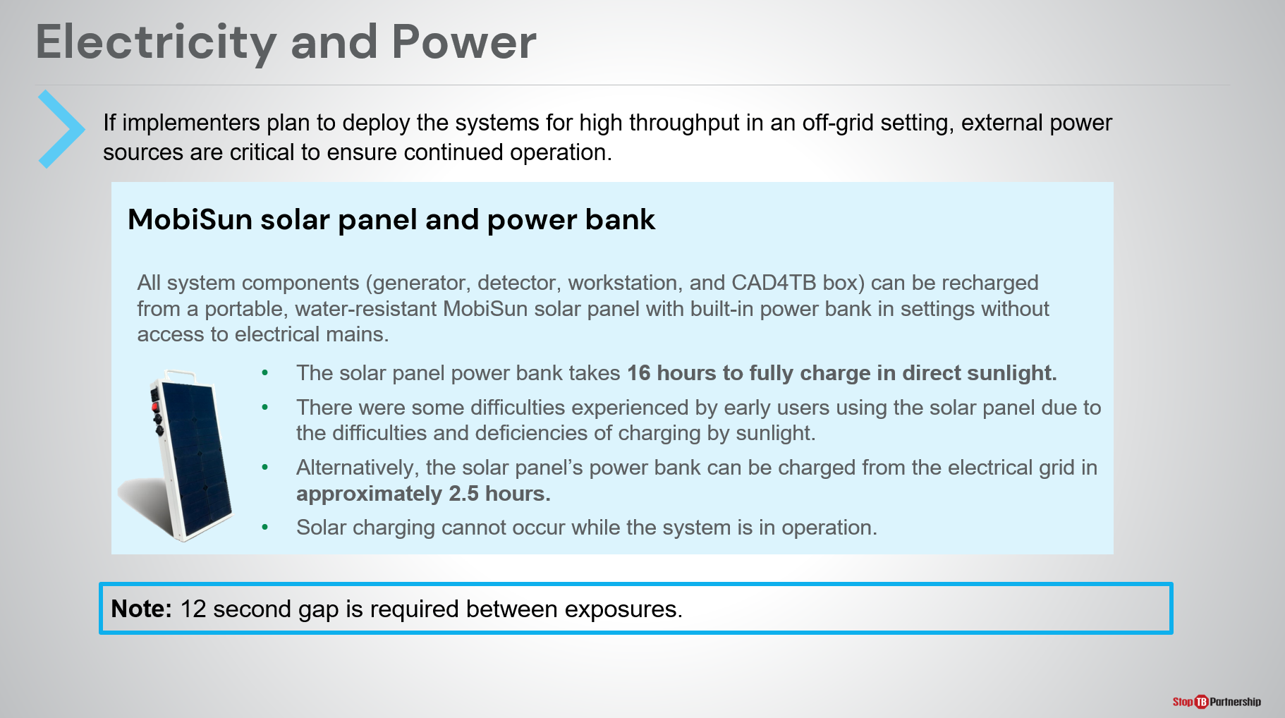
SAY: Because operating on battery power limits the number of exposures the system is capable of in the field, manufacturers have provided innovative ways of recharging the system in situations without access to electrical mains.

For the Delft Light, a water-resistant MobiSun solar panel with built-in power bank is provided that can recharge all system components, including the generator, detector, and console laptop. Solar charging cannot occur while operating the system, meaning a pause in screening will be necessary to recharge the system.

The solar panel itself takes 16 hours to fully charge in direct sunlight, or can be charged through connection to electrical power sources in approximately 2.5 hours.

Because of the limitations of battery power, it is advised not to use ultra-portable X-ray systems at sites with high throughput (greater than 200 exposures per day). A 12 second gap is also required between exposures as per the generator cycle time.

Portability and Setup | Slide: 10
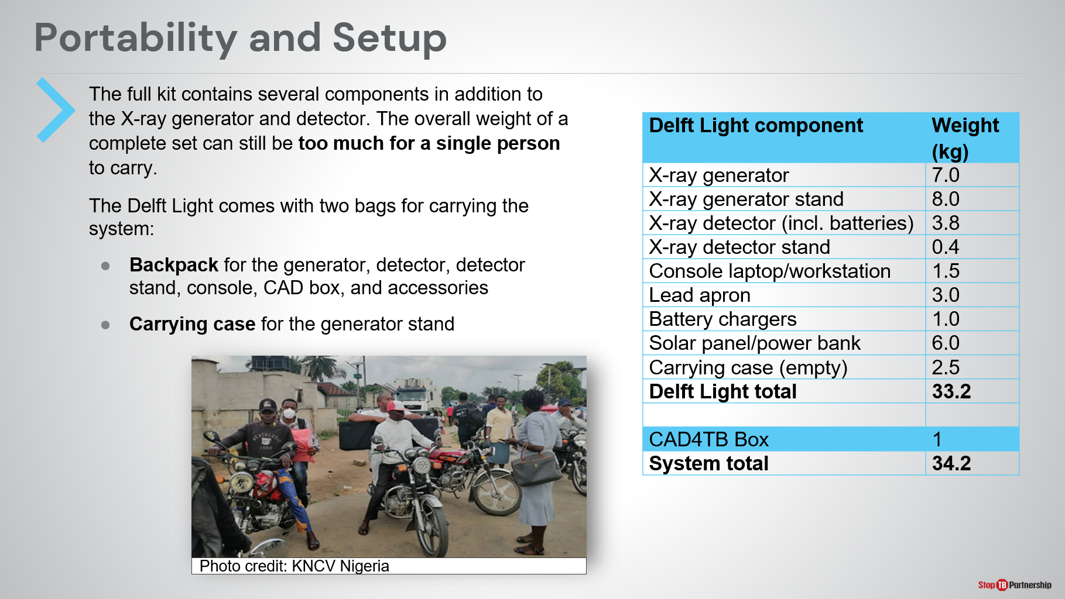
SAY: Another essential consideration is the portability of the system. Although, as the name suggests, “ultra-portable” X-ray systems are easier to transport than alternatives, they are not compact nor light enough to be carried by hand by one person alone.

The entire Delft Light system (including all components listed in the table and the CAD4TB box) weighs just over 34kg and can be packaged into two bags: a backpack and carry case. Some transport solutions include a dividing the components over a small team of people (2 or more) to carry by hand or using motorbikes.

Portability and Setup | Slide: 11
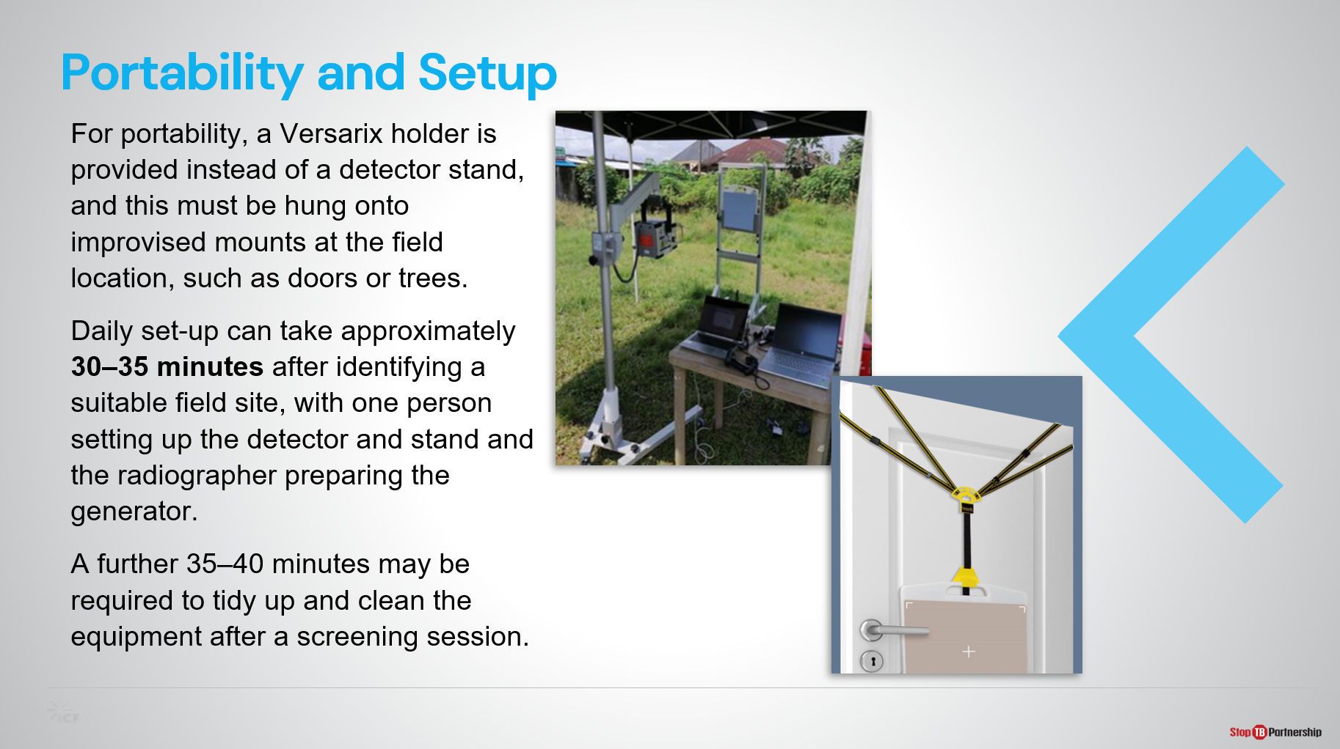
SAY: Another innovation for portability made in the Delft Light system package is the replacement of the detector stand with the Versarix detector panel hanger. This must be hung onto a mount such as a wall or tree at the screening sites, meaning sites should have suitable surfaces to enable this.

After identifying a field site, set up of the Delft Light reportedly takes around half an hour using a team of two people. Further time may be used to clean up at the end of the session.

During their training, the manufacturers will provide time for radiographers/X-ray technicians to get hands-on with the equipment set-up.

Radiation Safety | Slide: 12
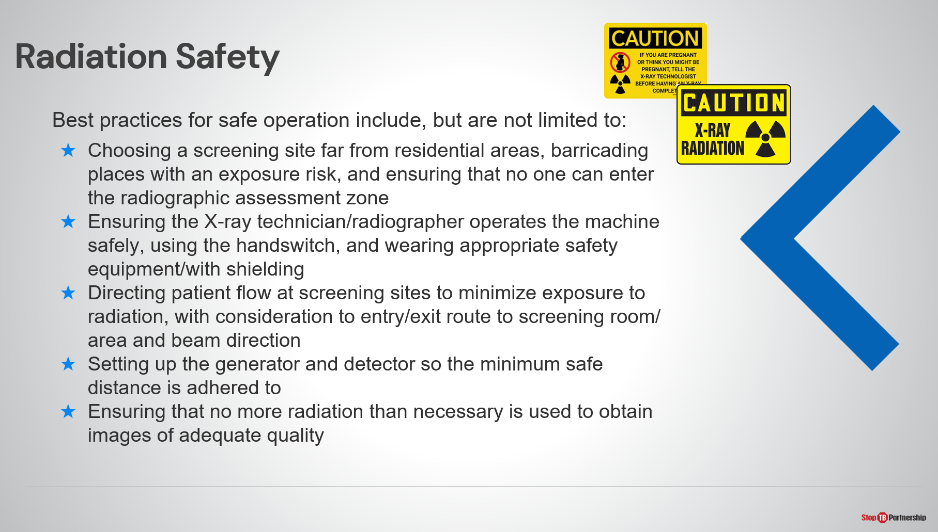
SAY: Continuing, some ideas of best practices for safe operation of X-ray equipment include:
- Choosing a screening site far from residential areas, barricading the location with exposure risk, and ensuring no-one enters the radiographic assessment zone.
- Safe operation of the X-ray system such as wearing appropriate safety equipment and operation from a distance using the handswitch.
- Controlling patient flow to minimize exposure to radiation, including planning the patient entry/exit route around the X-ray beam direction.
- Adhering to the minimum safe distance when setting up the generator and detector.
- Ensuring no more radiation than necessary is used to obtain images of adequate quality.
ASK: Can anyone think of any additional radiation safety requirements that we could all take note of?
DO: Allow time for participants to volunteer additional safety measures and encourage participants to note these down.

Digital Data—Data Privacy and Security | Slide: 13
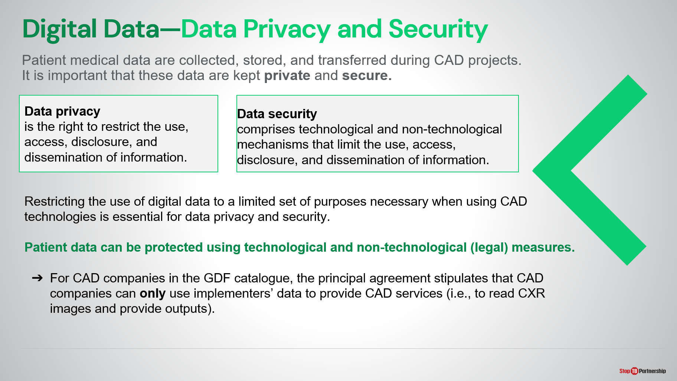
SAY: Using CAD requires collection, storage, and transfer of patient medical data. It is the responsibility of the project to keep patient data private and secure.

First, we will take a look at these two terms:
- Data privacy is the right to restrict the use, access, disclosure and dissemination of information;
- Whereas, data security is the technological and legal mechanisms that limit use, access, disclosure, and dissemination of information.

Employing these two concepts, we can ensure patient data is protected using legal and technological methods.
When procuring from the GDF catalog

Further Considerations | Slide: 14
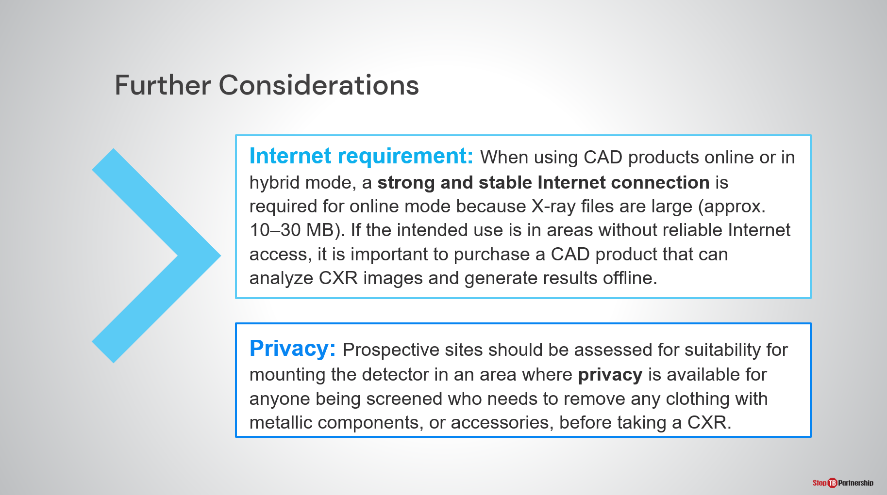
SAY: Briefly, two final considerations when setting up your X-ray and CAD screening site are internet requirement and patient privacy.

When using CAD products online or even in hybrid mode, a strong and stable internet connection is required in order to successfully transfer and process the large X-ray image files. If such a connection is not available, an offline CAD product should be purchased.

Finally, when considering patient flow through the site it is important to ensure a private space is available near the area where the exposures are taken so any clothing or accessories containing metallic components can be removed before taking a CXR.
ASK:
DO:

What to Expect from Suppliers | Slide: 15
SAY: As we talk about implementation of CAD products, you may be left wondering what is the role of the CAD and X-ray suppliers?

Under the terms negotiated by GDF, the suppliers are expected to provide support with the following:
- Onboarding training and installation. Training and installation occur in the same session. Training is both theoretical and practical, so it is important to have the tools on-hand to get the most out of the training session.
- In addition to onboarding training, Delft also provide additional training through their eLearning platform.
- Delft also provide a monthly virtual support call that project staff can dial into. We hope this will facilitate organizational knowledge sharing and allow for any concerns to be addressed swiftly by the manufacturer.
- The CAD manufacturer also provides some support for the selection of an initial threshold score for operation.
- An onboarding toolkit will also be provided that includes the IT, infrastructure, and human resource requirements for successfully running CAD.
- A user manual for both the CAD and ultra-portable X-ray.

If you have any questions relating to the type or level of service from the manufacturer, these can be answered by the manufacturer themselves during their training sessions.
ASK:
DO:

Challenges and Lessons Learned from Early Users of CAD and UP-XR
Challenges and Lessons Learned | Slide: 17
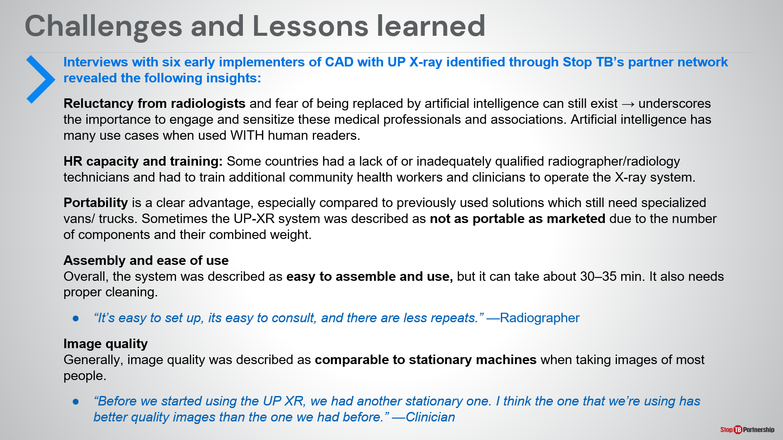
SAY: Lastly, we wanted to share with you the preliminary findings from interviews with implementers of CAD and ultra-portable X-ray in pilot studies. These are related to particular topics as shown on the slide. Direct quotes are in blue:
- Some sites experienced reluctancy from radiologists due to the perception that CAD will replace their role. This underscores the importance of engaging and sensitizing these medical professionals and associations with emphasis on the fact that in many use cases AI is a tool to supplement the work of human readers, rather than replace them.
- Some sites struggled to identify a suitable number of trained operators for the ultra-portable X-ray and so had to train additional community health workers to operate the system.
- Though the ultra-portable devices are easier to transport than their predecessors, especially those systems used in specialized vans/trucks, sometimes sites felt they were not as portable as marketed due to the number of components and their combined weight. A small team of people was still required to transport them.
- Overall, the system was found to be easy to assemble and use.
- And image quality was described as being comparable to stationary devices, even though is sometimes a concern due to the reduced size and power of the generator.

Challenges and Lessons Learned | Slide: 18
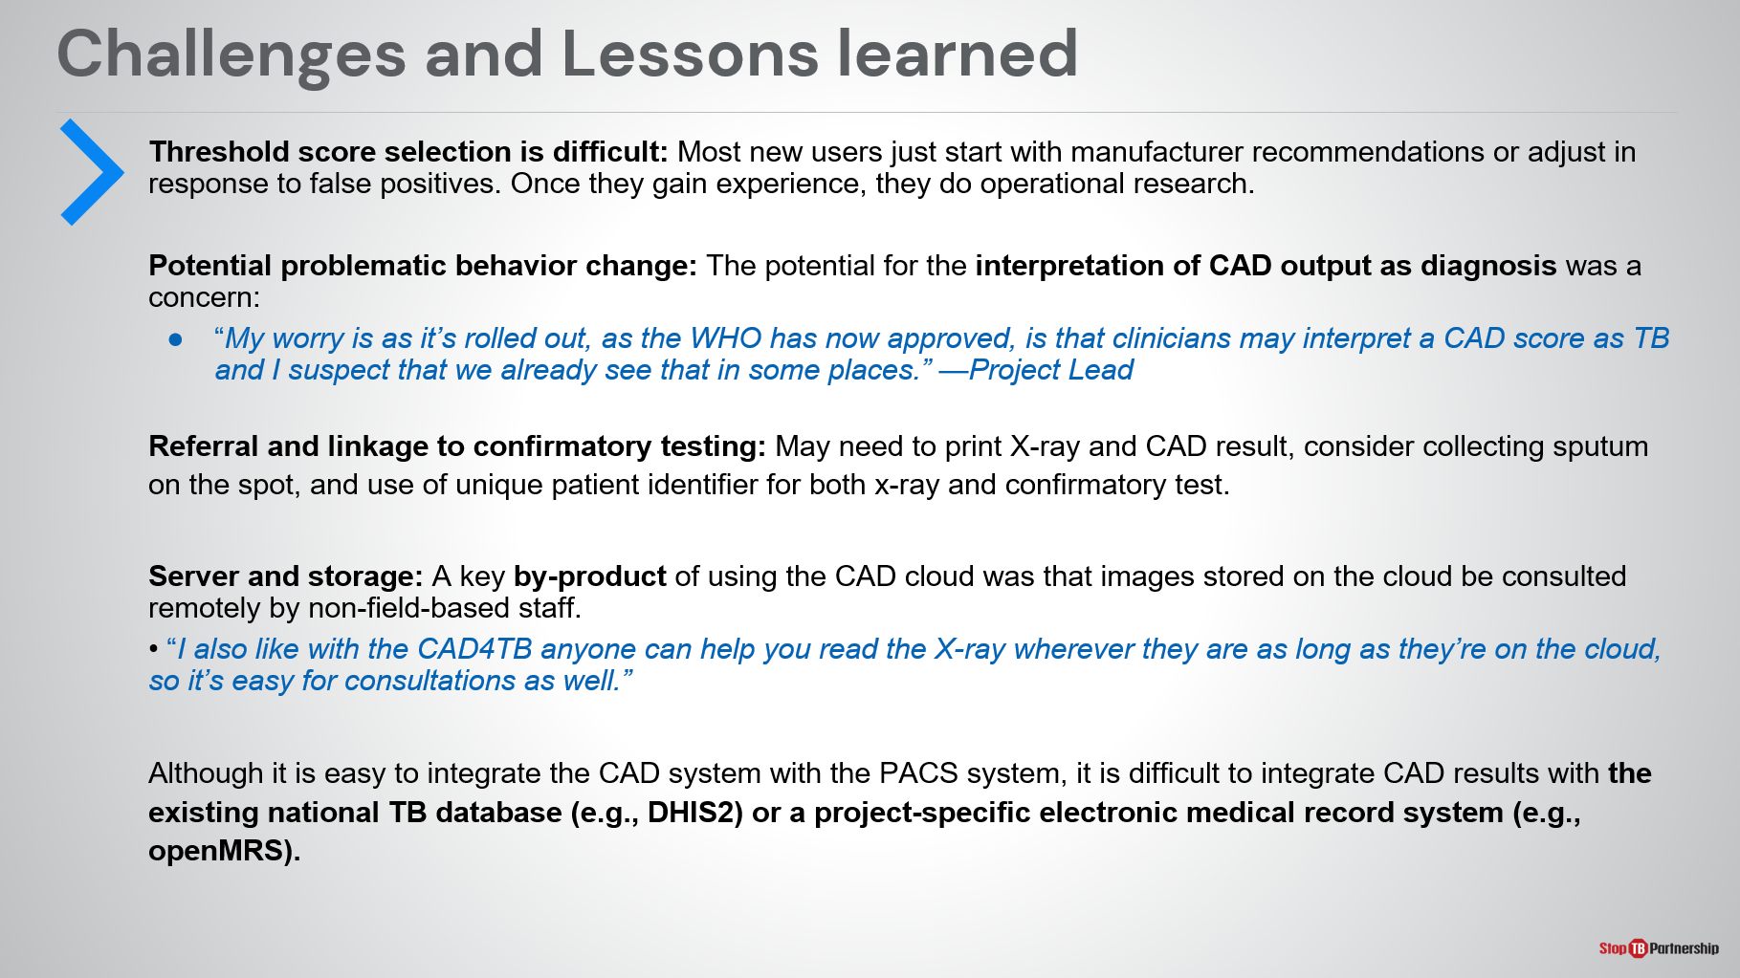
SAY: Continuing,
- Threshold score selection was a pain point for new implementers, with most choosing to use the score recommended by the manufacturer and later adjust through operational research (as recommended by WHO) as their confidence grows. We’ll address threshold score selection in Module 4 of this training.
- Another key concern was those receiving the CAD result interpreted it as diagnostic, even though CAD is only validated and recommended as a screening tool.
- Because of the speed at which the CAD result is available, to facilitate instant linkage to further diagnosis and care many sites had to print the X-ray and CAD result for referral to diagnostic facilities, or have the resources and systems to collect sputum on the spot at the screening site, and use a unique patient identifier to link the de-identified data from CAD and X-ray to the confirmatory test result.
- A key by-product of CAD for sites operating online using the CAD cloud was that X-rays and CAD results stored on the cloud could be accessed through web browsers by non-field-based colleagues. This facilitated remote consultation on particular images. Through GDF, 5 additional viewing licenses are provided for this purpose.
- Finally, though CAD has come a long way and can be integrated in PACS systems, it is not currently possible to integrate with existing national TB databases (for example DHIS2) or project electronic medical record systems (for example openMRS).

Challenges and Lessons Learned | Slide: 29
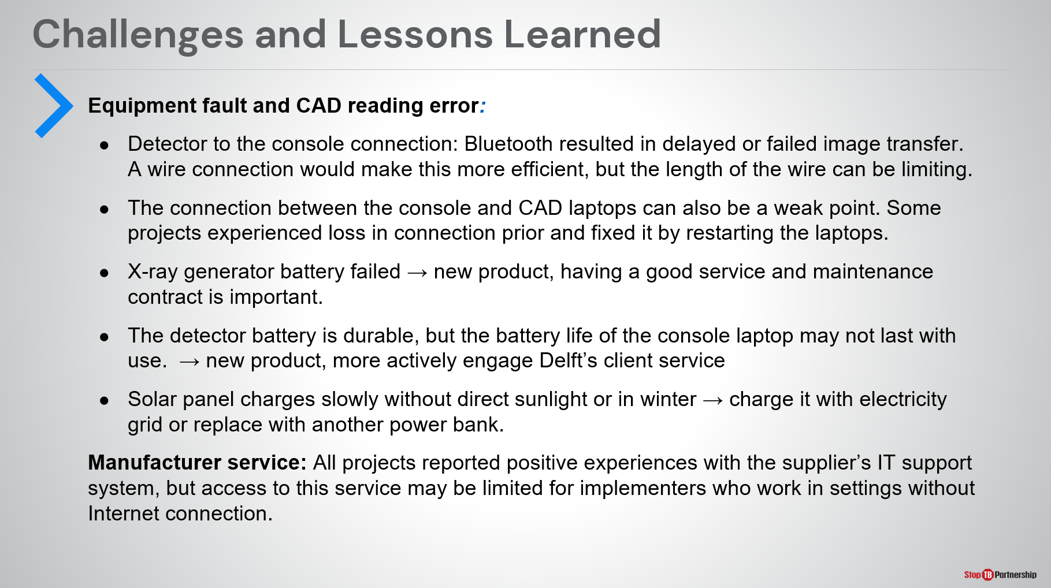
SAY: Early implementers were also asked whether they encountered any equipment fault or reading errors during their pilot projects. Some faults reported included:
- The Bluetooth connection between the detector and computer resulting in delayed or failed image transfer.
- Loss of connection between the X-ray console and CAD laptops
- Failing X-ray generator batteries – though these were quickly replaced thanks to the service and maintenance contract.
- Failing battery life of the battery in the console laptop
- Slow recharging of the solar panel without direct sunlight or in winter- it should be recharged by electricity where possible and could be supplemented with an additional power bank.
In general, experience with manufacturer support and customer service were all good, however access to this service can be limited if work is in a setting with little or no internet connection.

Experiences from Early Users | Slide: 19
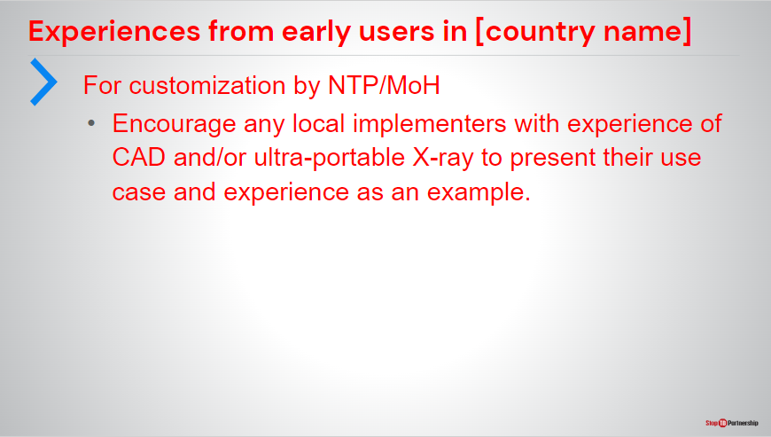
SAY:
ASK: Does anyone here have any experience with either CAD or Ultra-Portable X-Ray
DO: Encourage any local implementers with experience of CAD and/or UP-XR to present their use case and experience as an example

Summary

Summary | Slide: 21
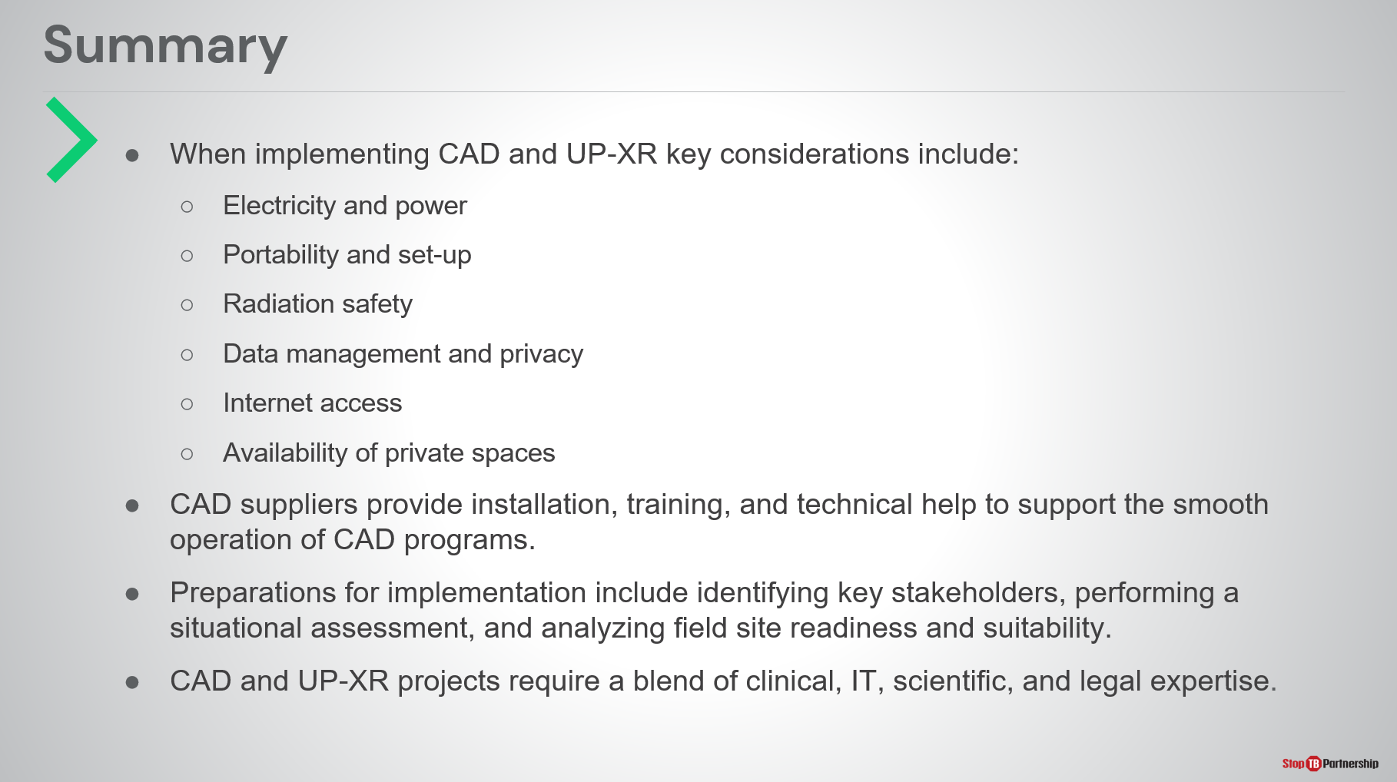
SAY: That concludes the third module of our training summarizing the implementation aspects of ultra-portable X-ray and CAD. To summarize:
- When implementing CAD and ultra-portable X-ray, some key considerations include electricity and power, portability and set-up, radiation safety, data management and privacy, internet access, and the availability of private spaces.
- You should expect CAD suppliers to provide installation, training, and technical help to support the operation of CAD programs.
- Preparations for implementation include identifying key stakeholders, performing a situational assessment, and analyzing field site readiness and suitability.
CAD and ultra-portable X-ray projects require a blend of clinical, IT, scientific, and legal expertise.
ASK: There are no knowledge check questions for this module, are there any questions on the topics covered?
DO: Receive and answer questions appropriately.

Module 4: Introduction to Threshold Selection

Target Audience
The target audience for this course is:
- Clinicians
- radiologists
- radiographers
- X-ray technicians

Learning Objectives
Terminal Objective
- At the end of this session, participants should understand the basis behind threshold score selection and what threshold selection strategies may work best in their context.

Module Objectives
- By the end of this module, participants should be able to
  - Understand what a threshold score is and how to set it.
  - Know the effect of changing threshold on key screening targets.
  - Describe why a threshold score needs to be chosen based on the local context.
  - Understand some of the current strategies for adapting and optimizing a threshold in the local context.

Materials
- Facilitator Guide
- Pens/Pencils

Advance Preparation
- Instructors will need to customize slide 17 in this module describing the threshold score set for the country/project

Introduction
Course Outline | Slide: 2
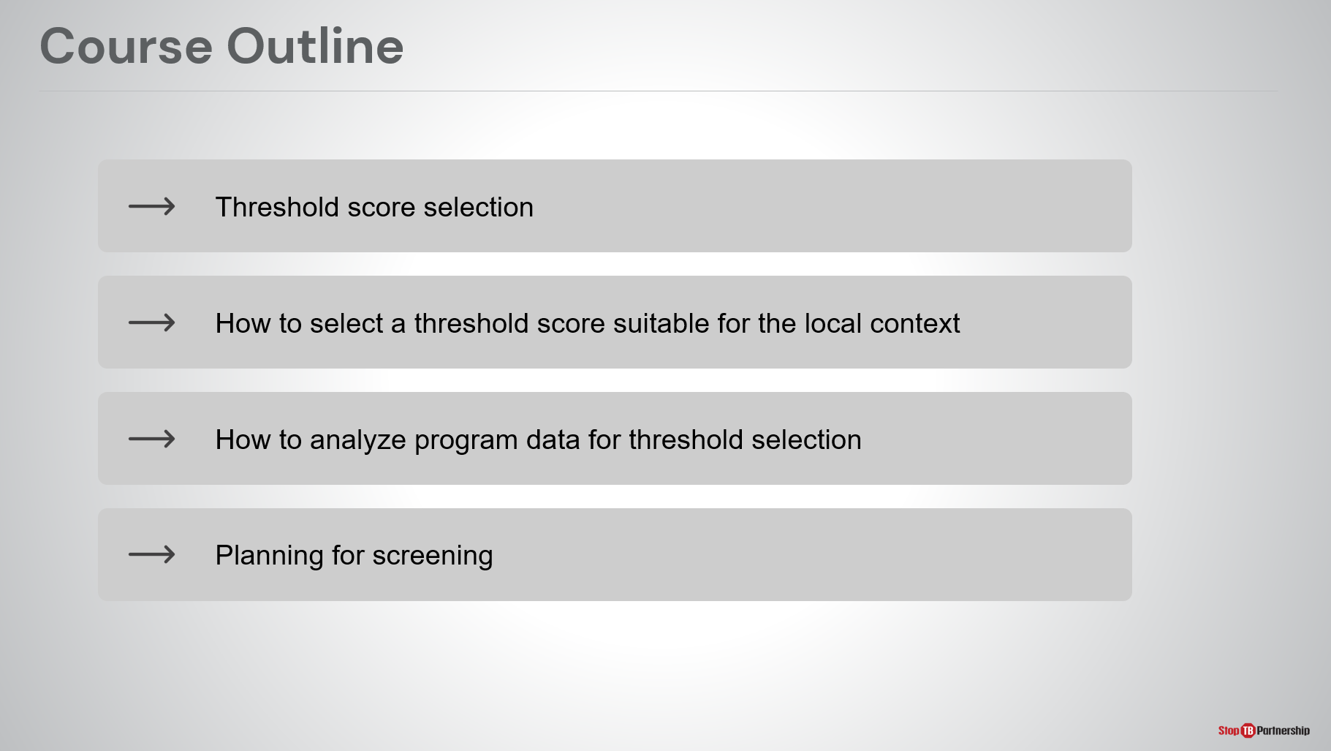
SAY: Our outline for today is threshold score selection, how to select a threshold score suitable for the local context, how to analyze programmatic data for threshold selection, and planning for screening.

Introduction | Slide: 3
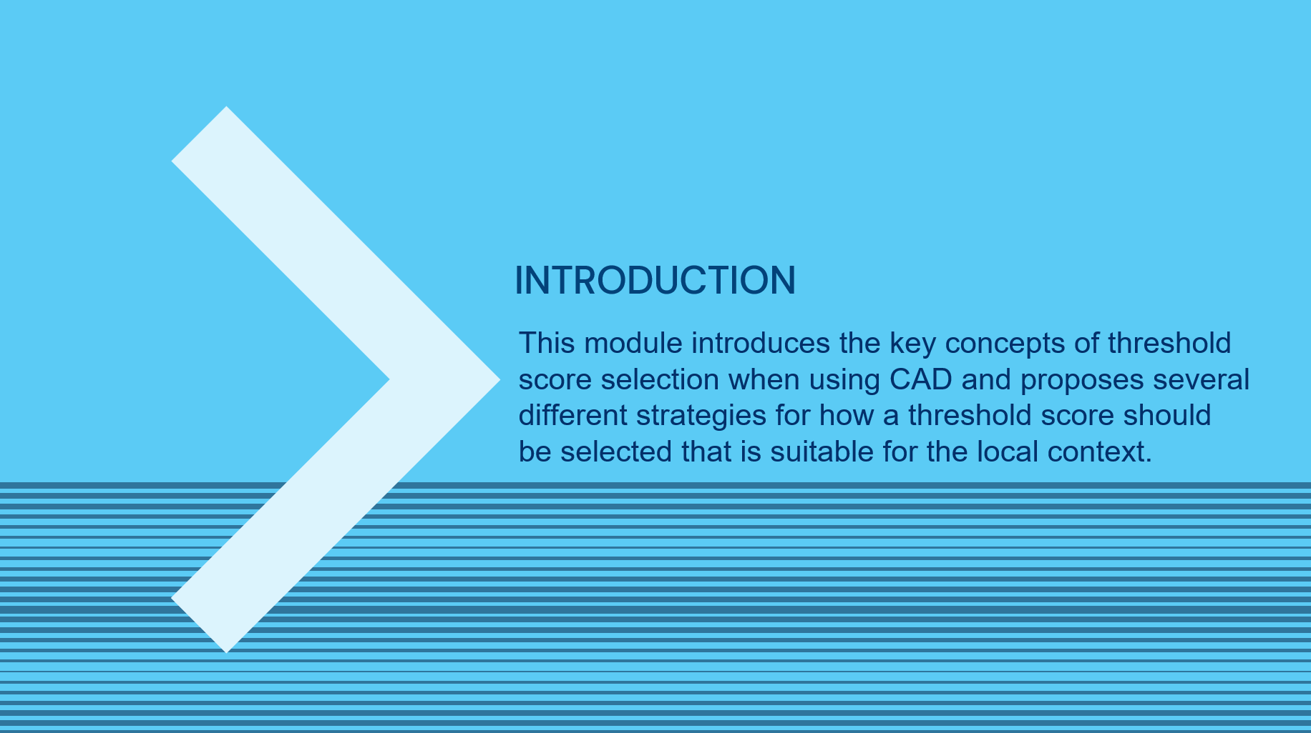
SAY: This module introduces the key concepts of threshold score selection when using computer-aided detection and proposes several different strategies for how a threshold score should be selected that is suitable for the local context.

Learning Objectives | Slide: 4
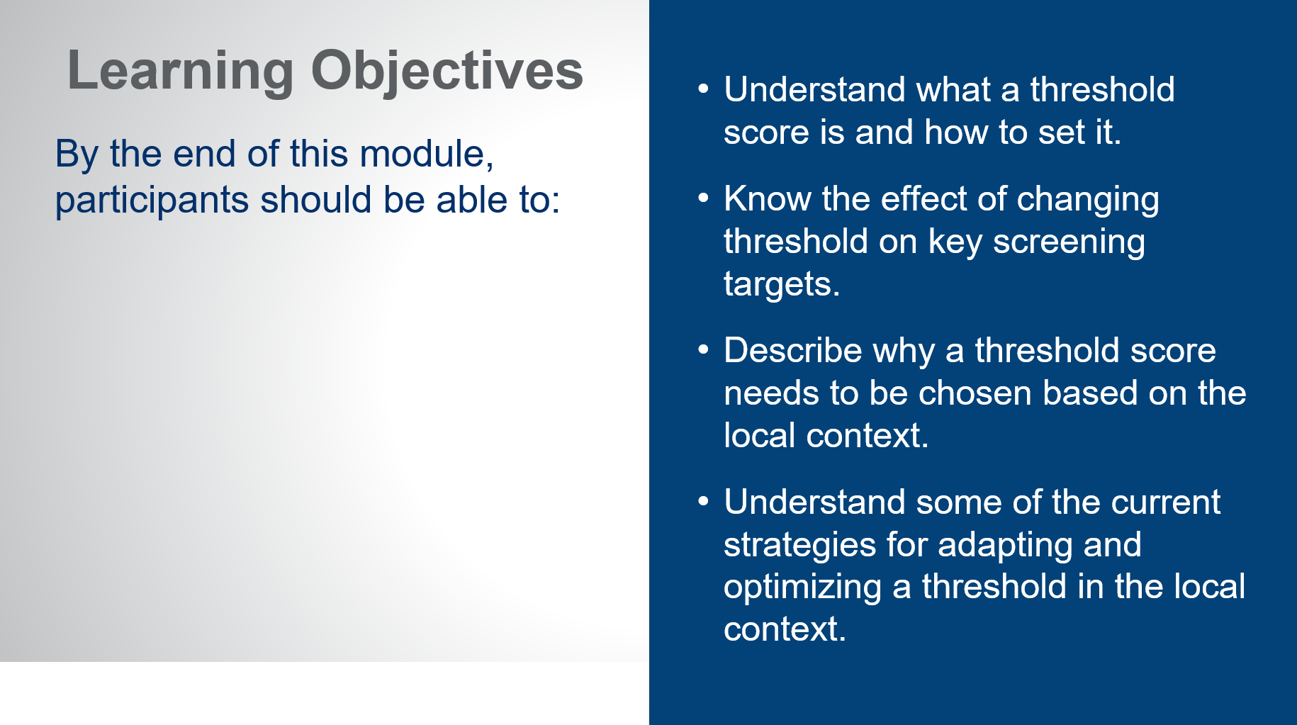
SAY: By the end of this modules, you should be able to:
- Understand what a threshold score is and how to set it.
- Know the effect of changing threshold on key screening targets.
- Describe why a threshold score needs to be chosen based on the local context.
- Understand some of the current strategies for adapting and optimizing a threshold in the local context.

Threshold Score Selection
What is a “Threshold Score”? | Slide: 6
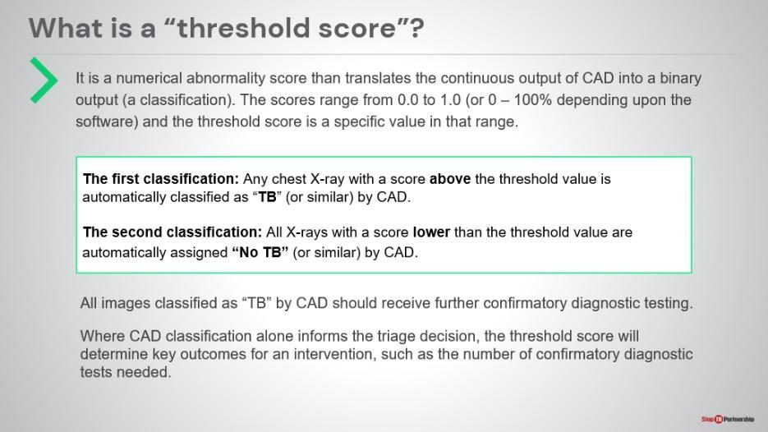
SAY: Let’s start with the basic question: what is a threshold score? It is a value that the CAD system uses (on a scale of Zero to One or Zero to 100 ) to identify what is an abnormal reading based on whether an image has an abnormality score greater or less than the threshold value. Depending on this, the system provides a classification, either:
- “Possibility of TB”: any x-ray with an abnormality score above the threshold value .
OR
- “No TB”: Any x-ray scores lower than the threshold value .
Any images classified as “Possibility of TB” or similar should receive further confirmatory diagnostic testing based on your algorithm, ideally with rapid molecular testing.
Where CAD classification alone informs the triage decision, the threshold score will determine key outcomes for an intervention, such as the number of confirmatory diagnostic tests needed. More on this later.

Basic Concepts in Threshold Selection | Slide: 7
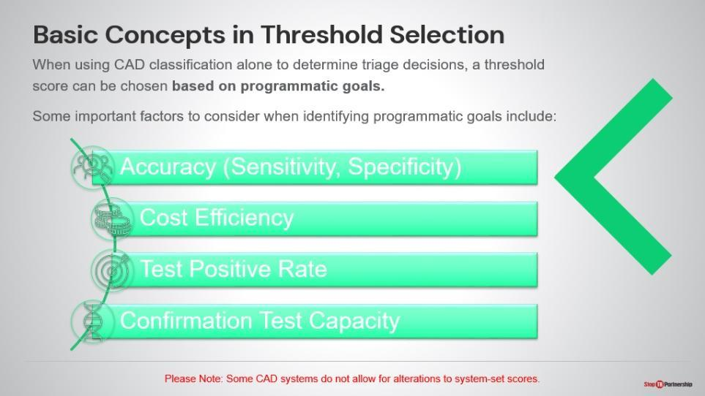
SAY: Let’s understand the basic concepts in threshold selection. When you are using CAD classification alone to determine triage , the threshold should be chosen based on programmatic goals. When identifying programmatic goals, you want to think about the sensitivity of the test, cost efficiency, test positive rate, and critically, your capacity to do confirmation tests. Every image classified as “Possibility of TB” based on your threshold selection should then be immediately referred for confirmatory testing.
ASK: Start to think about what your programmatic goals may be, based on these or other factors. Write down a few ideas.

Impact of Threshold Selection | Slide: 8
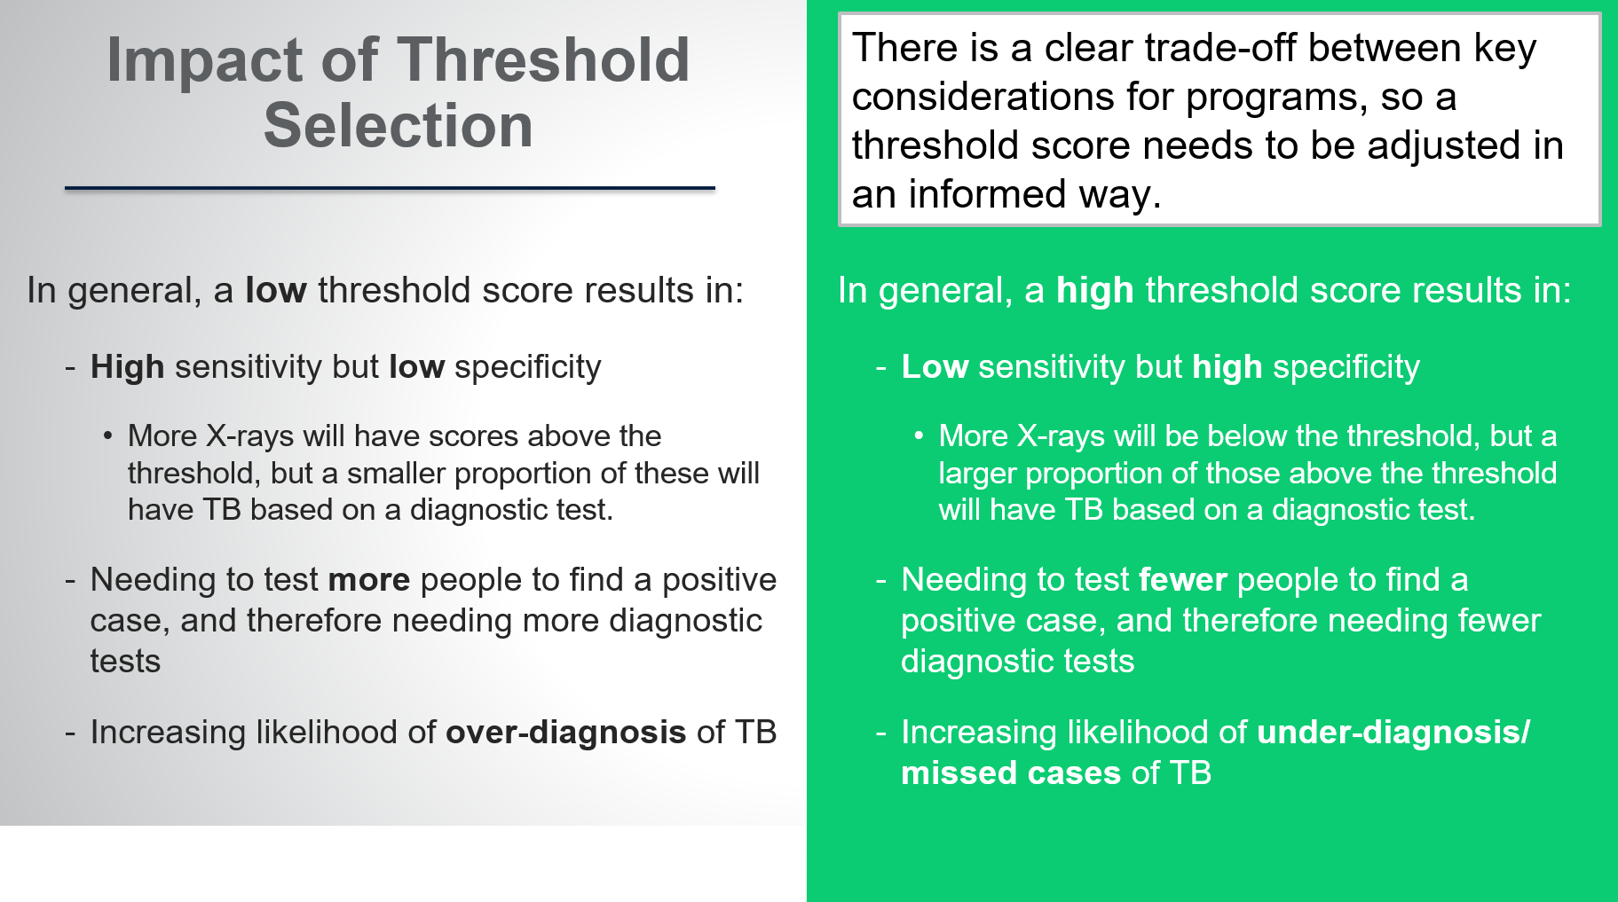
SAY: Let’s talk about the impact of your threshold selection. In general, a low threshold score (for example, 30) results in high sensitivity but low specificity. Since, more X-rays will have scores above the threshold, but a smaller proportion of these will have TB based on a diagnostic test. You will need to test more people to find a positive case and need more diagnostic tests, increasing the likelihood of over-diagnosis, so more false positive tests.

Alternatively, if you set a high threshold score (for example, 80), that leads to low sensitivity – since fewer images will be above this threshold- but high specificity – images above the threshold will be more likely to have TB. Therefore, you will conduct fewer confirmatory tests but that means likely underdiagnosing TB and missing cases.

This creates a clear trade-off between key programmatic considerations, with the most appropriate threshold score likely anywhere between these extremes. You will need think about adjusting your threshold score in an informed way.
ASK: Are you comfortable with more false positives or more false negatives? Why?

Threshold Score Trade-offs in Action | Slide: 9
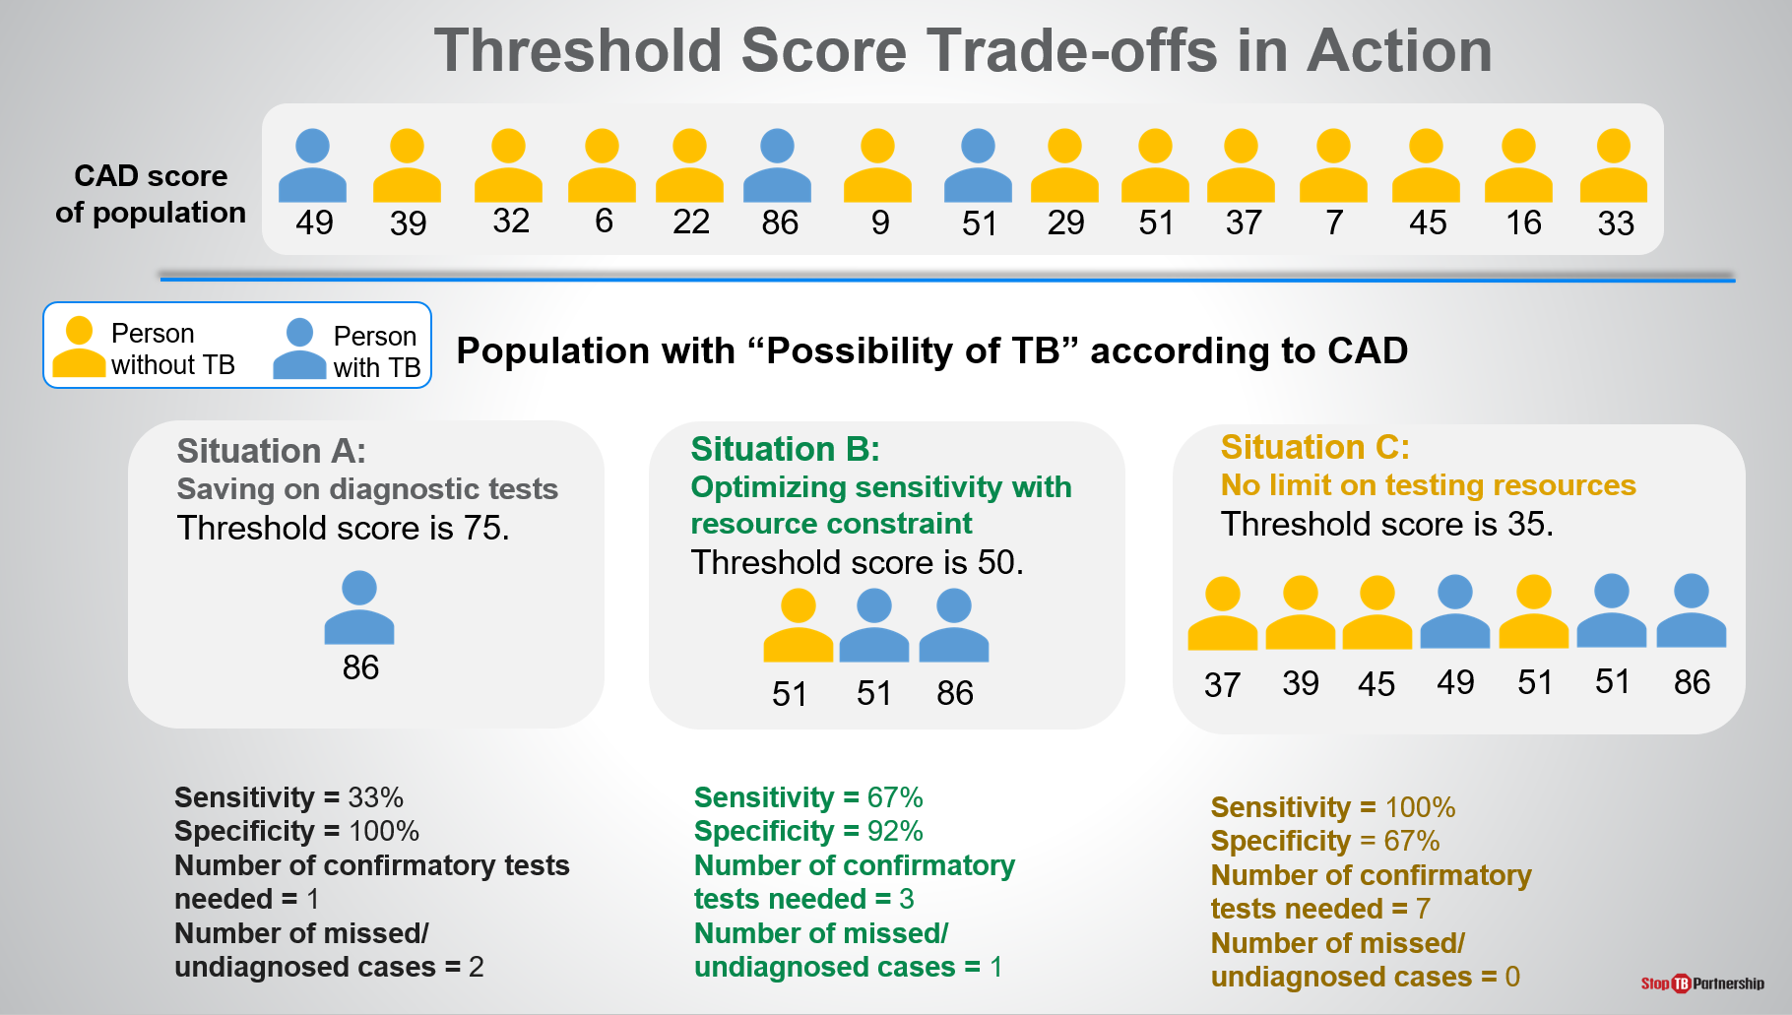
SAY: We can now look at these trade-offs in action using a small hypothetical population . Persons without TB are color-coded in yellow, and persons with TB are color-coded in blue.
- In situation A, what we have done is set our threshold score fairly high at 75. As a result, we only identified 1 person with TB who had an abnormality score of 86 according to CAD. This does result in savings on diagnostic tests. It gives us a fairly low sensitivity at 33% but very high specificity at 100%. Therefore, we need one confirmatory test, but we miss two other TB cases with scores lower than the threshold.
- Let’s say we lower our threshold score to 50 in situation B. We end up with a higher sensitivity and a somewhat lower specificity, identifying two of the possible three TB cases. We need three times as many confirmatory tests as with the threshold set at 75, but we cut the missed cases. .
- In situation C, we really have no limit on our testing resources. We set our threshold low to make sure that we identify as many people with TB as possible. That means that we end up needing seven confirmatory tests. We identified all the people with TB, but we also tested four people that did not have TB, . No missed cases, but higher confirmatory test numbers.

Again, we are trying to figure out what threshold score is most suitable for out context, in line with our testing capacity and prevalence .
ASK: Before we get into specific ways of adjusting your threshold score, which of these situations do you think would make the most sense for your context?

Factors that Influence CAD Performance | Slide: 10
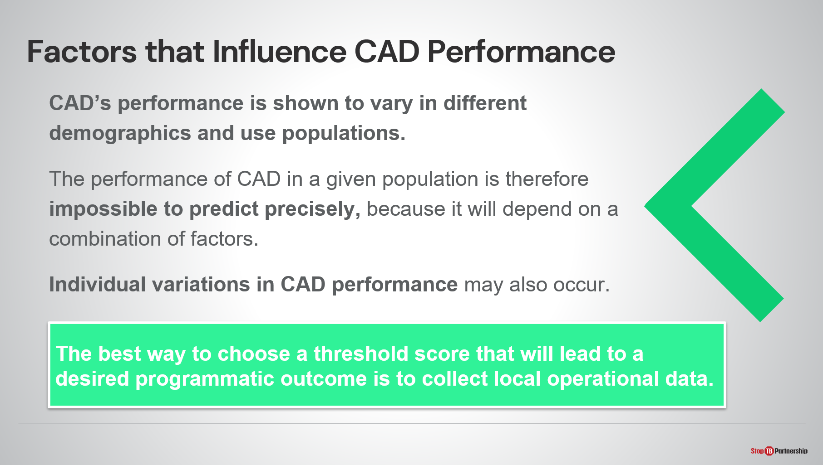
SAY: There are a number of factors that influence CAD performance, and we need to take those factors into account when setting the threshold score. We know this because the CAD performance does vary in different demographics and populations, studies show that CAD is less able to detect TB in older age groups, for example. Although, we don’t have evidence to predict how much certain factors affect the performance of CAD, we do know what are the known influence factors.

Factors that Influence CAD Performance | Slide: 11
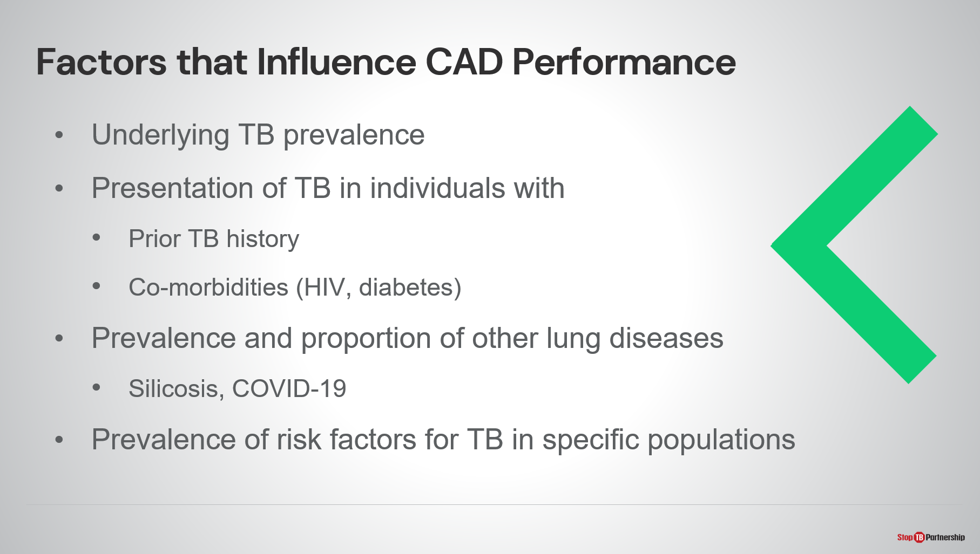
SAY: What affects CAD performance? There is the underlying TB prevalence (how many cases are in the population). There is the presentation of TB in individuals with prior TB history (those with prior TB will often get a false positive result, so we need to be mindful of that) and persons with co-morbidities (may often get missed in an x-ray situation). There’s also the prevalence of other lung diseases (silicosis, COVID-19, pneumonia, and lung cancer). We also need to look at the prevalence of risk factors for TB in specific populations. All these factors can impact CAD performance, so we must take them into account when we set our thresholds.
If we are going to think about choosing our threshold, the best way to do it is to test performance in the target population.

Performance Change between Versions | Slide: 12
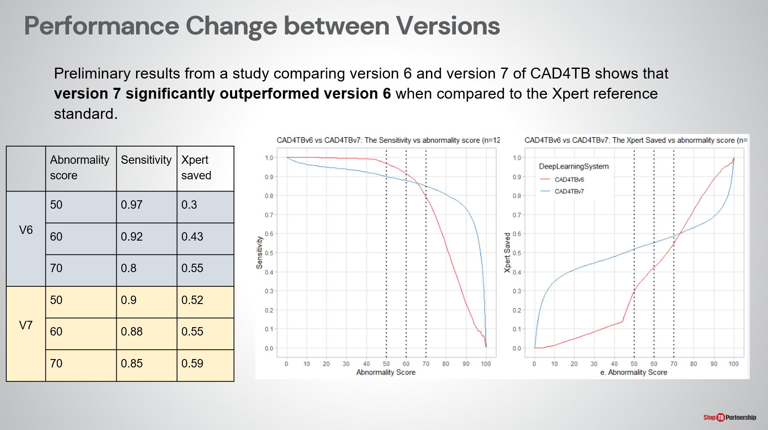
SAY: Finally, it is also important to know that performance may also vary between different versions of the same product. For example, for CAD4TB, the Delft software product, there has been a significant change in the underlying algorithm between version 6 and version 7. Preliminary results show that version 7 has significantly outperformed version 6 when compared to the reference standard. This tells us that the machine learning is improving over time.

For threshold selection, this means that operating at the same threshold between the two versions would not necessarily produce the same results. As shown in the table, if using a threshold score of 50 with version 6 sensitivity is around 97% and 30% of confirmation tests would be saved. Using the same threshold with version 7 results in lower sensitivity (90%) but higher confirmation test saving.

How to Select a Threshold Score Suitable for the Local Context

How to Choose a Threshold Score | Slide: 13
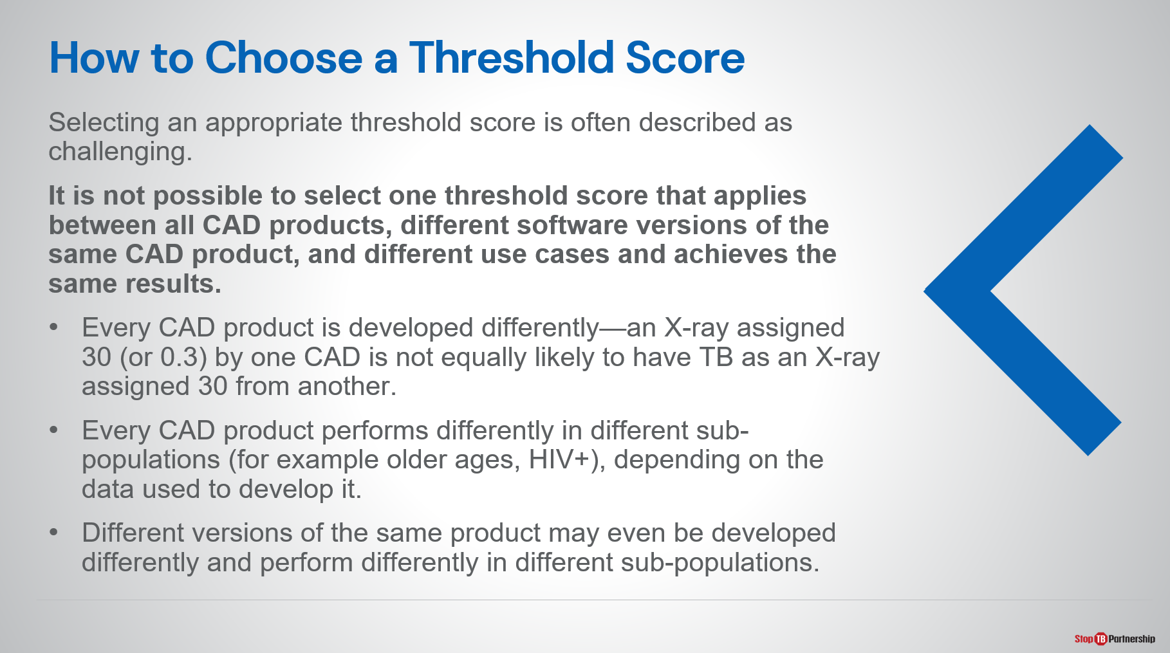
SAY: How are we going to pick the right threshold score for our context?
Start to recognize the question of how we choose a threshold score can be challenging. It because it’s impossible to select one threshold score that will apply to all CAD products because there is no relationship between the scores of different products, and different versions of the same product may also be vastly altered, , and there are also different use cases.

Optional:
  - Every CAD product is developed differently—an X-ray assigned 30 (or 0.3) by one CAD is not equally likely to have TB as an X-ray assigned 30 from another.
  - Every CAD product performs differently in different sub-populations (for example older ages, HIV+), depending on the data used to develop it. CAD is developed by using thousands of x-ray screens (confirmed positive or negative) and learns from them. If these screens come from different populations, the computer will learn based on those populations.
  - Different versions of the same product may even be developed differently and perform differently in different sub-populations. For example, earlier versions may have been developed using smear microscopy for confirmation, which is less sensitive than rapid molecular tests.

How to Choose a Threshold Score | Slide: 14
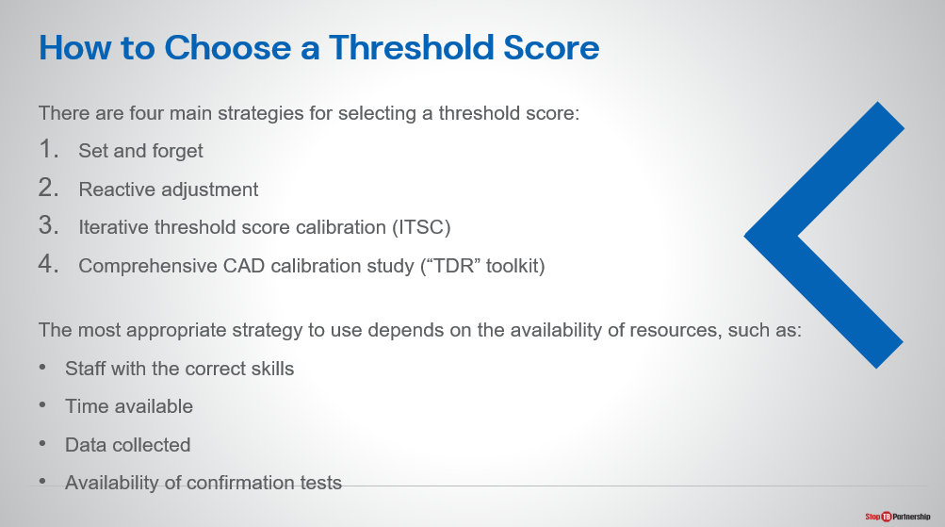
SAY: What we want to offer to you are four main strategies for selecting your threshold score. Again, there is no right answer because there are variations and trade-offs. Some of these strategies may require substantial investment.

Starting with the first one, we have set and forget. Then there is reactive adjustment. We could do an iterative threshold score calibration. Finally, we have comprehensive CAD calibration study, using the WHO-TDR toolkit .

As you think about how you are going to set your threshold score, you need to think about the availability of your resources. You need to make sure you have staff with the correct skills—skills we will discuss. You need to determine the time available and what data can be collected, as well as the availability of the confirmatory tests.

Threshold Score Selection Strategy | Slide: 15
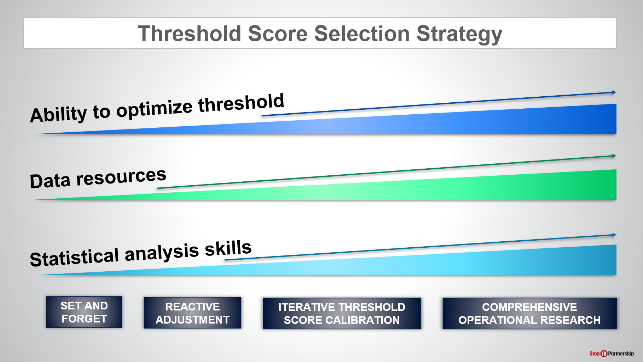
SAY: Keep in mind that as we increase the complexity of the threshold selection strategy, it does require additional data resources and analytical skills. At the same time, it does allow you to better optimize the threshold. There are clear benefits to using a strategy like comprehensive operational research, but that comes at programmatic costs for data collection, data review, and the time required to conduct the tests.
ASK: What would be your primary consideration in deciding a threshold score selection strategy?

Threshold Score in This Programme

Threshold Score in [country name] | Slide: 17
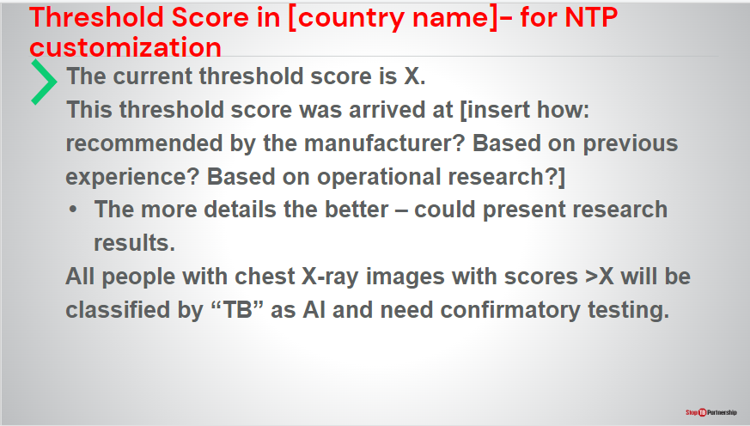
SAY: State selected threshold score and how it was arrived at

Summary

Summary | Slide: 18
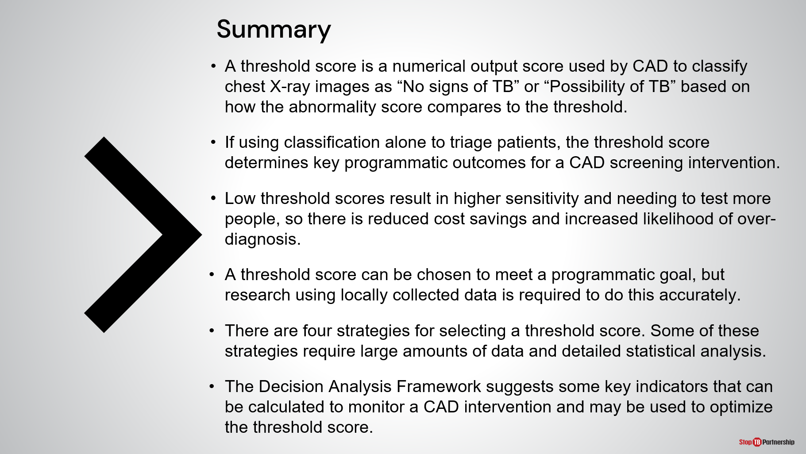
SAY: I’d like to try and summarize here for us all:
- First, a threshold score is a numerical output score used by CAD to classify chest X-ray images as “No signs of TB” or “Possibility of TB” based on how the abnormality score compares to the threshold.
- If using classification alone to triage patients, the threshold score will determine key programmatic outcomes for a CAD screening intervention.
- Lower threshold scores result in higher sensitivity and needing to test more people, so there is reduced cost savings and increased likelihood of over-diagnosis. (Low threshold scores mean more false positives.)
- A threshold score can and should be chosen to meet a programmatic goal, but research using locally collected data from the target population is required to do this accurately.
- We have presented to you four strategies for selecting a threshold score. Some of these strategies require large amounts of data and detailed statistical analysis. Do not be frightened by these needs but understand that there are trade-offs that are made.
- Finally, you may use the Decision Analysis Framework, which suggests some key indicators that can be calculated to monitor a CAD intervention and may be used to adjust the threshold score over time.
ASK: Any questions or topics you need a few more minutes with?
DO: Allow participants time to think and respond.

Knowledge Check

Knowledge Check
DO: Explain that you will ask participants three knowledge check questions and may call on participants randomly to provide an answer. (These can also be programmed as poll questions in a virtual training – ensure that all participants respond before proceeding if using the poll feature).

If an answer provided in incorrect, ask if other participants would like to answer. Correct any incorrect answers that are given. If multiple participants get a question wrong, you may need to revisit the topic.

Note that knowledge check questions are not included in participant guides to avoid participants seeing them during the lesson and only focusing on those pieces. Encourage participants to write down the answers in their guides in the notes field for future reference.
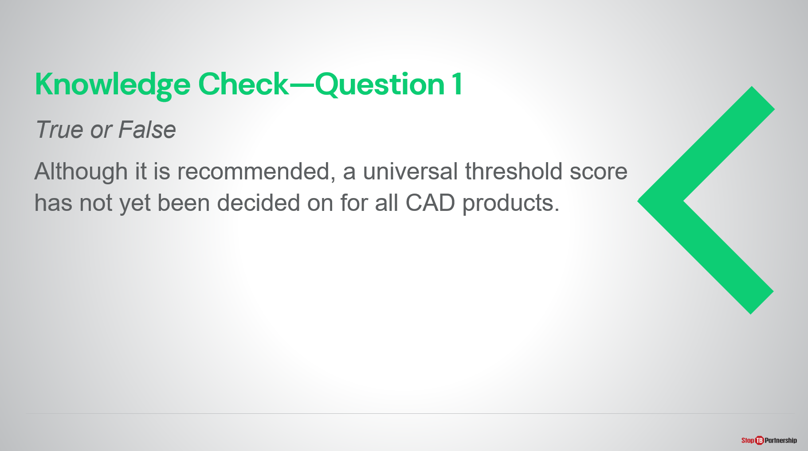
Answer: False, a universal threshold score is not recommended for all CAD products because there is no relationship between the abnormality scores assigned by different products.
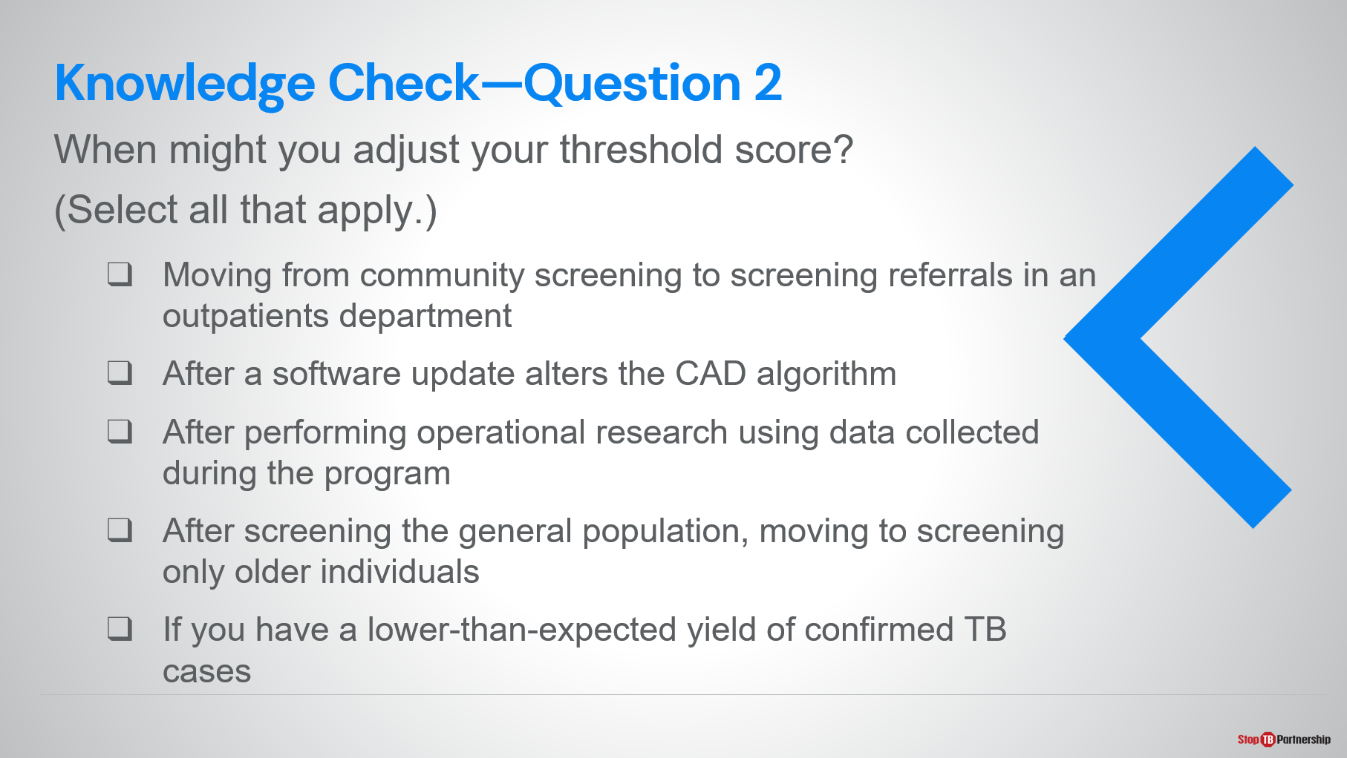
Answer: All are correct
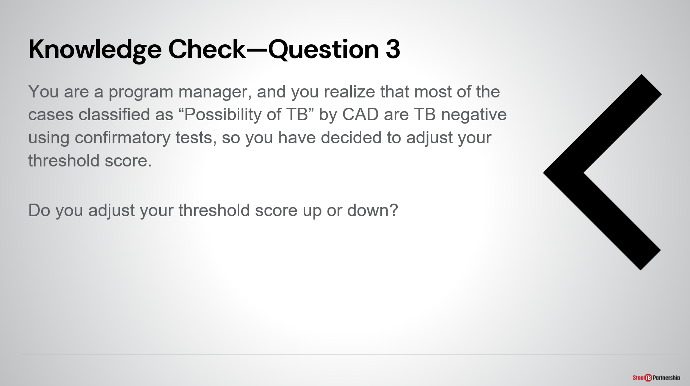
Answer: Adjust the score up, so fewer images are classified as “Possibility of TB” by CAD so the CXR receiving this classification are more likely to have TB. This will reduce the number of confirmation tests needed and increase the confirmation test positive rate.
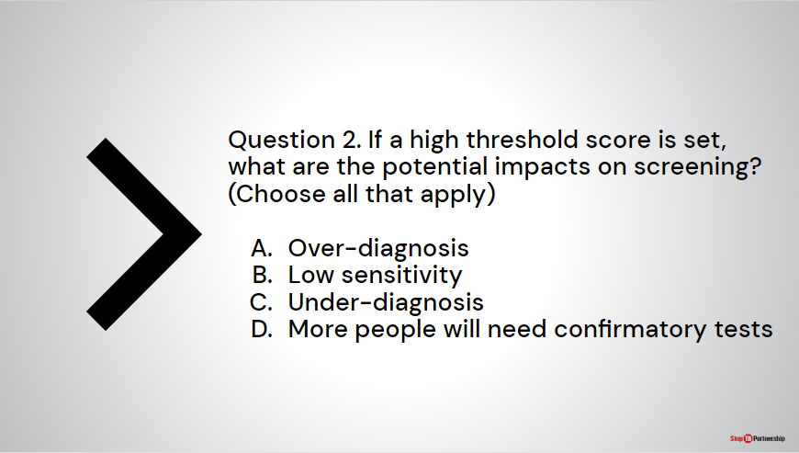
Answer: A and C are the answers

Module 5: Monitoring & Evaluation for CAD-enabled digital X-ray as part of TB screening​

Target Audience
The target audience for this course is:
- Clinicians
- Radiologists
- Radiographers
- X-Ray technicians

Learning Objectives
Terminal Objective
- At the end of this session, participants should understand how CAD-enabled X-ray can fit within their national monitoring and evaluation systems.

Module Objectives
- By the end of this module, participants should be able to
  - Describe how to integrate CAD-enabled X-ray into the diagnostic algorithm.
  - Describe monitoring & evaluation requirement for a CAD-enabled X-ray system.
  - Select indicators to use when establishing a screening program using CAD-enabled X-ray.
  - Describe how they would do these in their own country.

Materials
- Facilitator Guide
- Pens/Pencils

Advance Preparation
Instructors will need to customize slides 7, 8, and 9 in this module.

Introduction
Introduction | Slide: 2
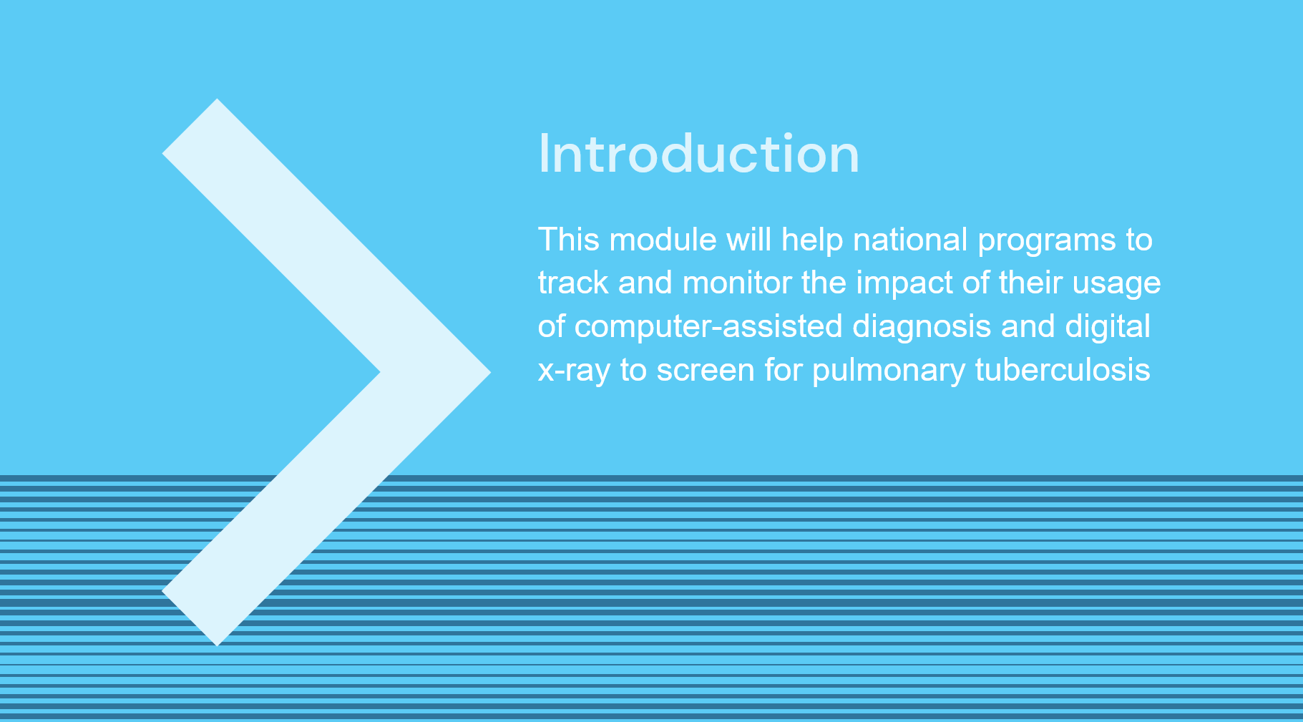
SAY: In this module, we will discuss how national programs can track and monitor the impact of their usage of computer-assisted detection and ultra-portable digital x-ray to screen for pulmonary tuberculosis.

Course Outline | Slide: 3
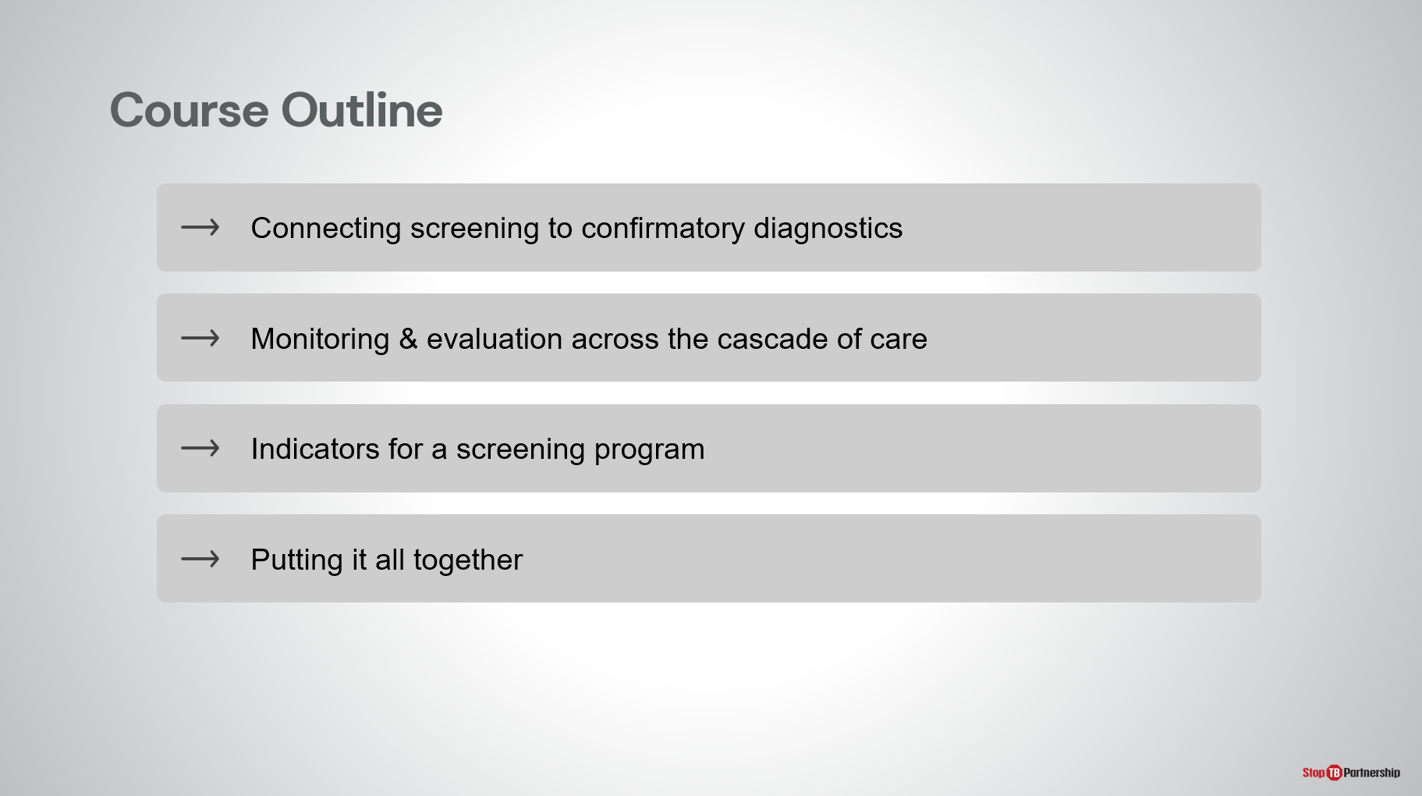
SAY: Our course outline consists of, first, connecting screening to confirmatory diagnosis; second, monitoring and evaluation across the cascade of care; next, the right indicators for a screening program that uses these tools; and finally, putting it all together with a team exercise.

Learning Objectives | Slide: 4
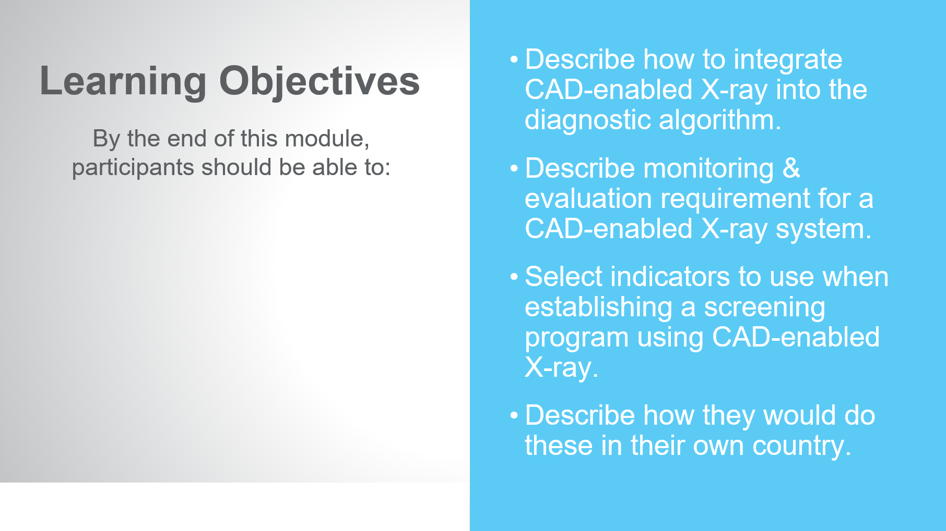
SAY: By the end of this modules, you should be able to:
- Describe how to integrate CAD-enabled X-ray into the diagnostic algorithm.
- Describe monitoring & evaluation requirement for a CAD-enabled X-ray system.
- Select indicators that you would use when establishing a screening program using CAD-enabled X-ray.
- Finally, describe how you would do these in your country.

Reminder: WHO Guidelines on Systematic Screening | Slide: 5
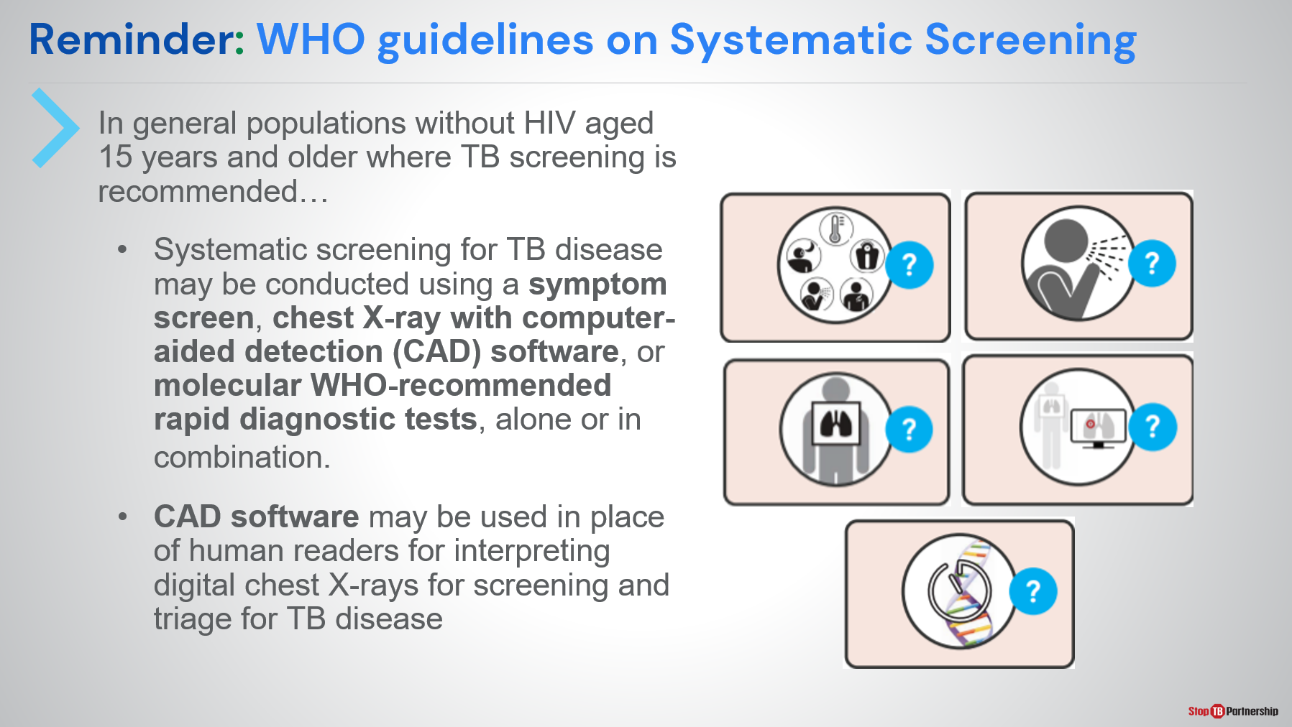
SAY: Let’s go back and review. Remember, WHO guidelines on systematic screening: in general populations without HIV aged 15 years and older, where TB screening is recommended:
- Systematic screening for TB disease may be conducted using a symptom screen, chest X-ray with computer-aided detection software, or molecular WHO-recommended rapid diagnostic tests, alone or in combination, through parallel or sequential screening techniques
- CAD software may be used in place of (or to augment) human readers for interpreting digital chest X-rays for screening and triage for TB disease

Connecting CAD-Enabled X-Ray to Confirmatory Diagnosis
Putting it all together: National screening algorithm using CAD and X-ray | Slide: 7
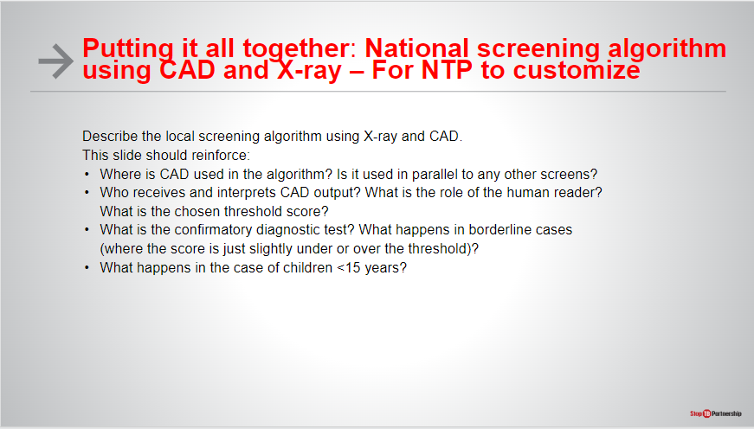
SAY: Describe national screening algorithm
DO: Invite participants to take notes

CAD-Enabled X-Ray Results Lead to Confirmatory Testing | Slide: 8
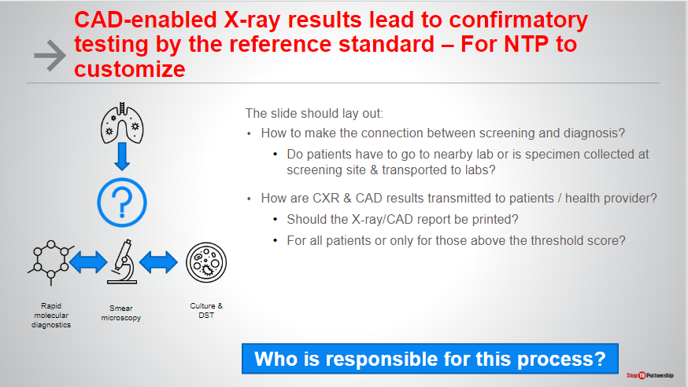
SAY: The most important thing is that any CAD-enabled x-ray result that is suggestive of TB symptoms needs to lead to confirmatory testing by the reference standard. Then how do we make the connection between screening and diagnosis? If someone is presenting at a healthcare clinic that has both x-ray and confirmatory testing, they can do both in a single stop. If this is not the case, do patients that get an x-ray suggestive of TB have to make the trip to a nearby lab for confirmatory testing, or can we collect the sputum specimens at the screening site to be transported to the lab for confirmatory testing?
Once we’ve done that part (the test to wherever the laboratory is), how are we getting those results transmitted back to the patient and to the provider? Do we need a printed x-ray or CAD report? Do we only want x-ray reports for patients above the threshold, or for all patients?
In addition, how are we linking our x-ray data with diagnostic data? Are patients registered for x-ray screening? Are patients registered for lab diagnosis? How do we go from one to the other? Do we have unique patient identifiers for both the X-ray/CAD system and all diagnostics?
Lastly, I can’t stress this enough: who is responsible for this process? How does this work when a patient gets an x-ray presumptive of TB, and how do they get to the point where they are able to access confirmatory testing? If they do not close that loop, how do we ensure that the loop is closed? How do we ensure that someone with an x-ray suggestive of TB (whether CAD-read or radiologist-read) gets to confirmatory diagnosis?
ASK: Start to think about how these systems for getting the patient from screening to confirmatory testing are already set up for your program? Will it need to be changed with the introduction of CAD? Write down a few notes.

How is CAD data linked to confirmatory test data? | Slide: 9
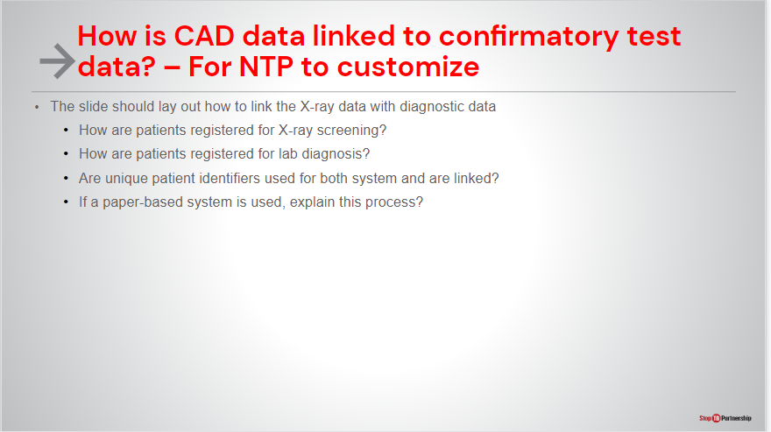
SAY: Let’s talk about how we are going to connect CAD-enabled x-ray to confirmatory diagnosis. Starting with, how are we using CAD-enabled x-ray? Let’s be sure that we have integrated it into the diagnostic algorithm. We spoke earlier in module one about the algorithms and how this new technology would fit into use with symptom screening or replacement of symptom screening. Know that the integration may look different whether we are talking about active case-finding or passive case-finding. However, the outcome should be the same, and that is the x-ray results informing diagnostic decision-making. X-ray can also augment or replace symptom screening. Often times, symptom screening has been shown to be less effective in prevalence surveys, where we have seen 50 percent to 70 percent of persons with confirmed TB are actually asymptomatic.

Closure

Ask Yourself | Slide: 10
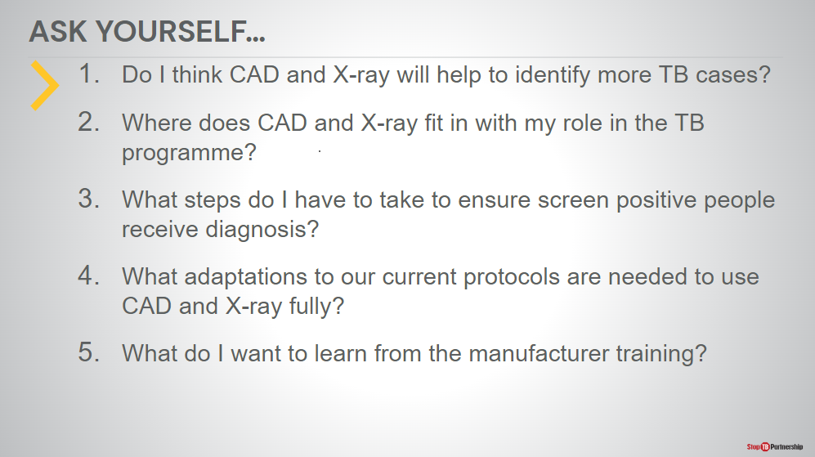
ASK: As we go through this exercise, I’d like you to ask yourself the following questions:
- Do I think CAD and X-ray will help to identify more TB cases?
- Where does CAD and X-ray fit in with my role in the TB programme?
- What steps do I have to take to ensure screen positive people receive diagnosis?
- What adaptations to our current protocols are needed to use CAD and X-ray fully?
- What do I want to learn from the manufacturer training?

Closure | Slide: 11
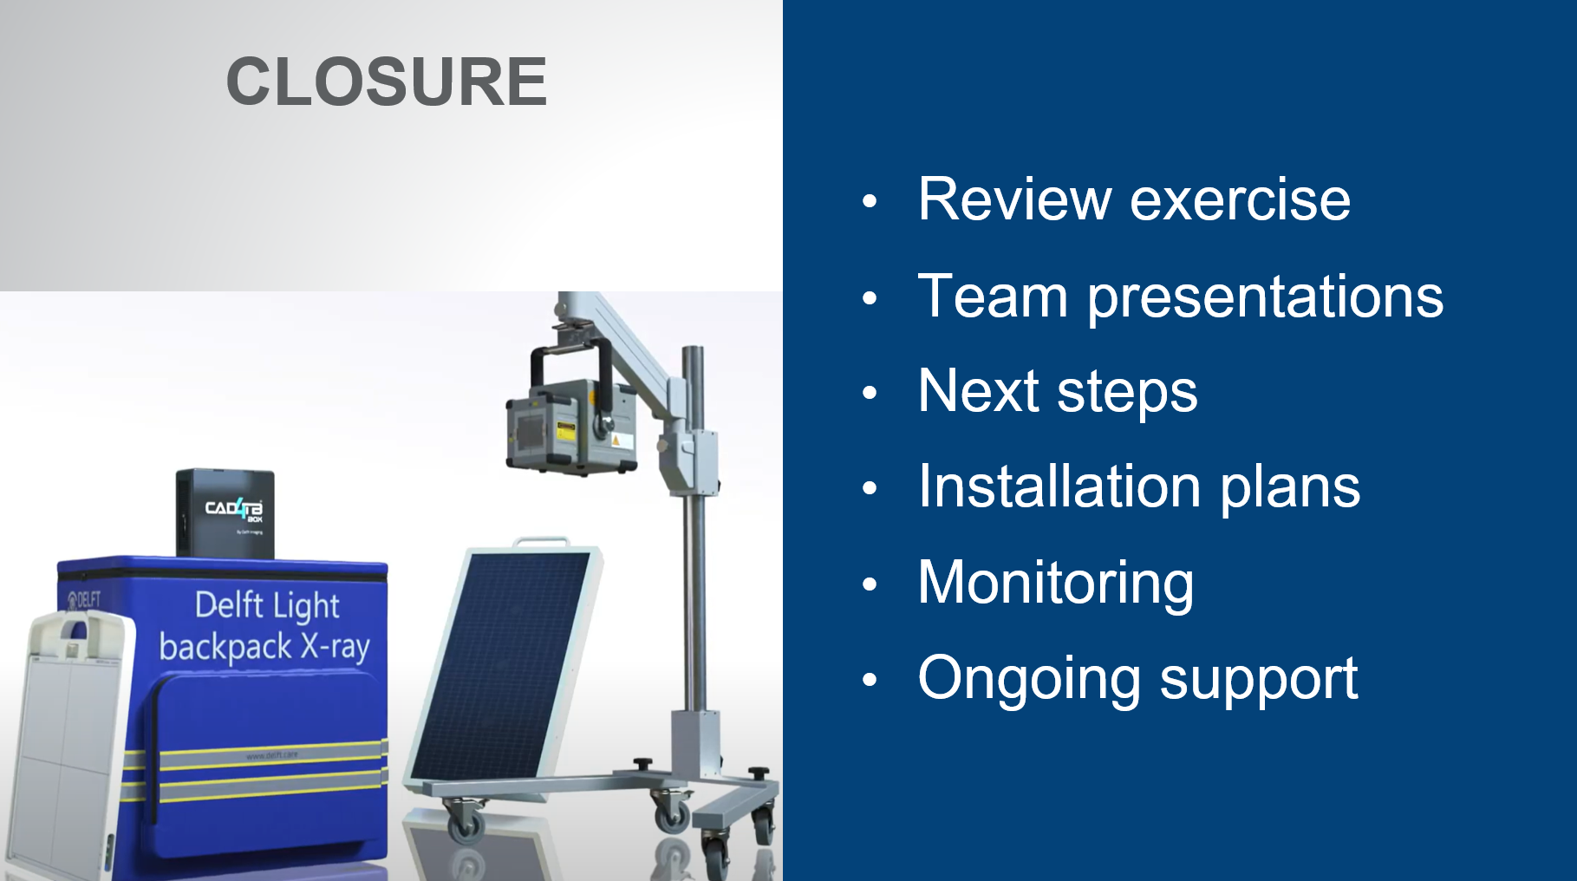
SAY: We are about to close, but first we are going to break up into teams to review this exercise. We will then do team presentations, and we will come back at that point. Thank you.
DO: Split participants into small teams to work through these questions.
SAY: [following the exercise]: Welcome back from the exercise. I hope you found the process helpful and thought-provoking as you considered the practicalities of introducing CAD-enabled x-ray in your country. The exercise asked several questions [can return to the previous two slides to show the questions]:
- What changes would be needed to adopt CAD-enabled X-ray?
- How will you track CAD-enabled X-ray outputs and link them to confirmatory testing?
- What screening threshold would you use? How would you decide the threshold?
- What indicators will you use to track the process and outputs of the implementation?
- What adaptations to your current national M&E system would be needed to capture these indicators?
- What is the use case? Will CAD-enabled X-ray be used in active and / or passive case finding strategies? Does the strategy impact the implementation?
- How will you inform stakeholders about the opportunities from and availability of CAD-enabled X-ray? We need to think about communities, radiologists, and clinicians. How will results be interpreted and used?
- How will we ensure that clinicians are aware of and accepting of the technology? We are used to working with human readers, and we are asking people to take the step of accepting a computerized result. What information do we need to share to ensure that people are comfortable and trusting of the software.
I’m looking forward to hearing the outcomes of these exercises and hope these exercises will inform how we proceed with use of this technology. Thank you.
DO: Ask participants to share what they discussed in their groups as a wrap-up to the training.

